Multidrug resistant Egyptian isolates of Acinetobacter baumannii
¹ Shabaan Hashem Ahmed; ²Sayed Fekry Abdelwahab; ³ Ayman Mohammed Hasanen; ⁴Doaa Safwat Mohammed*

¹Department of Microbiology and Immunology, Faculty of Pharmacy, University of Assuit, Egypt.
² Department of Microbiology, Faculty of Medicine, University of Minia, Egypt.
³ Department of General Surgery, Faculty of Medicine, University of Minia, Egypt.
⁴Department of Microbiology, Faculty of Pharmacy, University of Beni-Suef, Egypt.
doaa.safwat@yahoo.com

Abstract: The resistance of Acinetobacter baumannii to antimicrobial agents is mediated by all of the major resistance mechanisms, including modification of target sites, enzymatic inactivation and active efflux of drugs. Antibiotic susceptibility testing has been performed on fifty-two A. baumannii isolates. Twenty isolates have been recovered from patients suffering from wound and burn wound infections attending general surgery, plastic surgery and obstetrics and gynecology departments and thirty-two isolates have been recovered from the environment of these departments. Different mechanisms of antimicrobial resistance have been detected among resistant isolates. Broth dilution method have been used to investigate antimicrobial susceptibility pattern, iodometric method have been used to detect β-lactamase enzymes and polymerase chain reaction has been used to detect bla_{oxa-51-like} genes, aph (3’)-VIa genes and adeB gene. Tetracycline was the most effective antimicrobial agent against A. baumannii. It has showed high resistance to both of amikacin and meropenem (76.9%), cefipime (80.8%) and both of cephradine and imipenem (96.2%). An extreme resistance to the other antimicrobial agents has been shown by the same organism. β-lactamase enzyme has been detected in β-lactam resistant isolates, bla_{oxa-51-like} carbapenemase genes have been detected in carbapenem resistant isolates, aph (3’)-VIa genes have been detected in amikacin resistant isolates and adeB gene have been detected in some multidrug resistant strains. So, resistance to β-lactams, carbapenems and amikacin has been high in A. baumannii isolates which has caused appearance of multidrug resistant isolates with different resistance mechanisms like bla_{oxa-51-like} genes, aph (3’)-VIa genes and adeB gene.
[Shabaan Hashem Ahmed; Sayed Fekry Abdelwahab; Ayman Mohammed Hasanen; Doaa Safwat Mohammed. Multidrug resistant Egyptian isolates of Acinetobacter baumannii. Journal of American Science 2011; 7(1):1013-1019]. (ISSN: 1545-1003). http://www.americanscience.org.

Keywords: A. baumannii, bla_{oxa-51-like} genes, aph (3’)-VIa genes, adeB gene.

1. Introduction
The resistance of A. baumannii to antimicrobial agents is mediated by all of the major resistance mechanisms that are known to occur in bacteria. β-lactamases are the most diverse group of enzymes that are associated with resistance, and more than 50 different enzymes, have been identified so far in A. baumannii. OXA-51-like carbapenemases are class D β-lactamases which are intrinsic to A. baumannii and confer resistance to carbapenems (1). Aminoglycoside resistance has been attributed to at least nine distinct modifying enzymes. The emergence of APH (3') enzymes has effectively removed aminoglycosides such as kanamycin and neomycin from clinical use. Resistance to other aminoglycosides such as amikacin and lividomycin serve as the basis for classification into seven distinct classes (I-VII). Another chromosomal system that is typical of A. baumannii is the AdeABC efflux system (2). Upregulation of AdeABC is so far the only mechanism that has been proven to decrease susceptibility to multiple antimicrobial classes in A. baumannii. This work aims to investigate antimicrobial susceptibility pattern among different A. baumannii isolates and detect possible mechanisms of resistance in multidrug resistant strains.

2. Material and Methods
Antimicrobial Susceptibility testing. Susceptibility testing was performed on fifty-two A. baumannii isolates by using broth dilution method (3) in accordance with the guidelines established by EUCAST Standards. Twelve different antimicrobial agents were used as follows: Imipenem, meropenem, cephradin, cefipime, amoxycilline/clavulanic acid (Sigma), ciprofloxacin, nalidixic acid, ceftazidme, tetracycline, chloramphenicol, oxacillin (Himedia) and amikacin (Bristol-Myers Squibb).
Detection of β-lactamases . β-lactamase detection was performed using iodometric method (4).
Sample preparation for PCR. Isolation of bacterial DNA was performed using DNA extraction kits (Qiagen).
Amplification by PCR. The bla_{oxa-51-like} primers (laboratories of The Midland Certified Reagent Company Inc. of Midland) used to amplify bla_{oxa-51-like} genes as follows: (5’-TAA TGC TTT GAT CGG CCT TG-3’) as the forward primer and (5’-TGG ATT GCA CTT CAT CTT GG-3’) as the reverse primer (5). PCRs were carried out using thermal cycler (Techne PROGENE) in 50 µl reaction volumes with 5 µl extracted DNA, 50 pmole of each primer, 25 µl of Go Taq® Green Master Mix (Promega). Conditions were the following: 94°C for 3 min, and then 35 cycles at 94°C for 45 s, at 60°C for 45 s and at 72°C for 1 min, followed by a final extension at 72°C for 5 min. The aph (3’)-VIa primers (laboratories of The Midland Certified Reagent Company Inc. of Midland) used to amplify aph (3’)-VIa genes as follows: (5’-ATACAGAGACCACCATAC AGT-3’) as the forward primer and (5’-GGACAATCAATAATAGCAAT-3’) as the reverse primer (6). PCRs were carried out in 50 µl reaction volumes with 5 µl extracted DNA, 50 pmole of each primer, 25 µl of Go Taq® Green Master Mix. Conditions were the following: 94°C for 3 min, and then 30 cycles at 94°C for 1 min, at 55°C for 1 min and at 72°C for 1 min, followed by a final extension at 72°C for 5 min. The adeB primers (laboratories of Eurofins MWG Operon) used to amplify adeB genes as follows: (5’-GTATGAATTGATGCTGC-3’) as the forward primer and (5’-CACTCGTAGCCAATACC-3’) as the reverse primer (7). PCRs were carried out in 50 µl reaction volumes with 5 µl extracted DNA, 50 pmole of each primer, 25 µl of (Taq PCR Master Mix (2X)) (USB Corporation). Conditions were the following: 94°C for 2 min, and then 35 cycles at 94°C for 30 s, at 55°C for 30 s and at 72°C for 2 min, followed by a final extension at 72°C for 2 min. After amplification, 10 μl of the PCR mixture was analyzed by agarose gel electrophoresis (2% agarose in Tris-borate-EDTA stained with ethidium bromide). The Gene Ruler 100 bp DNA ladder (Fermentas ) was used as a DNA size marker.

3. Results
A- Antimicrobial susceptibility testing:
In Table 1, tetracycline was the most effective antimicrobial agent against A. baumannii. It showed high resistance to both of amikacin and meropenem (76.9%), cefipime (80.8%) and both of cephradine and imipenem (96.2%). An extreme resistance to the other antimicrobial agents was shown by the same organism.
B- Detection of β-lactamases:
Out of 52 A. baumannii strains resistant to different β-lactams tested, 51 strains were β-lactamase producers constituting 98% of the total tested strains (Figure 1).
C- Detection of bla_{oxa-51-like} genes:
In Figure (2), a group carbapenem resistant A. baumannii was tested for detection of bla_{oxa-51-like} genes using PCR. It was found that, all tested isolates have been bla_{oxa-51-like} enzyme producers giving amplicons of 353 bp. size.
D- Detection of aph (3’)-VIa genes :
A group of amikacin resistant A. baumannii were tested for detection of aph (3’)-VIa genes using PCR. It was found that, all resistant isolates were aph (3’)-VIa enzyme producers giving amplicons of 234 bp. Size, (Figure 3).
E- Detection of adeB gene:
In Figure (4), a group of multidrug resistant A. baumannii isolates was tested for detection of adeB genes using PCR. It was found that some of the tested isolates were adeB gene positive giving amplicons of 979 bp. size and the other A. baumannii isolates were adeB gene negative.

Table 1: Incidence of antimicrobial resistance among A. baumannii isolates (52).

Antimicrobial agents | Number of resistant strains (%)*
Imipenem | 50 (96.2%)
Meropenem | 40 (76.9%)
Ciprofloxacin | 52 (100%)
Nalidixic acid | 52 (100%)
Chloramphenicol | 52 (100%)
Tetracycline | 0 (0%)
Amikacin | 40 (76.9%)
Cefipime | 42 (80.8%)
Oxacillin | 52 (100%)
Amoxycilline/ clavulanic acid | 52 (100%)
Cephradine | 50 (96.2%)
Ceftazidime | 52 (100%)
* Percentage was correlated to the no. of A. baumannii isolates.

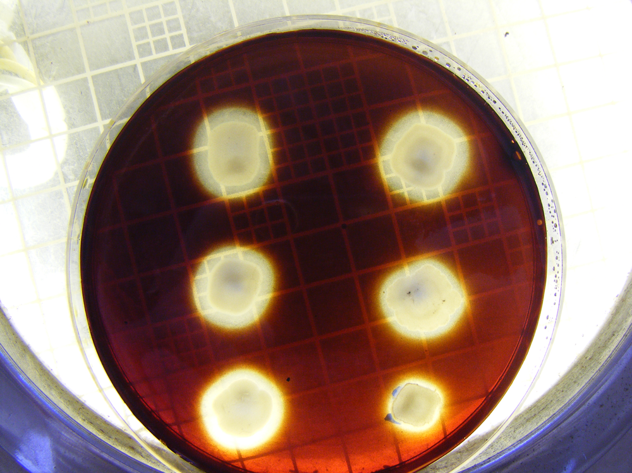
Figure (1): β-lactamase production by A. baumannii isolates.
The bottom right of the picture: control strain, The other strains: β-lactamase +ve strains

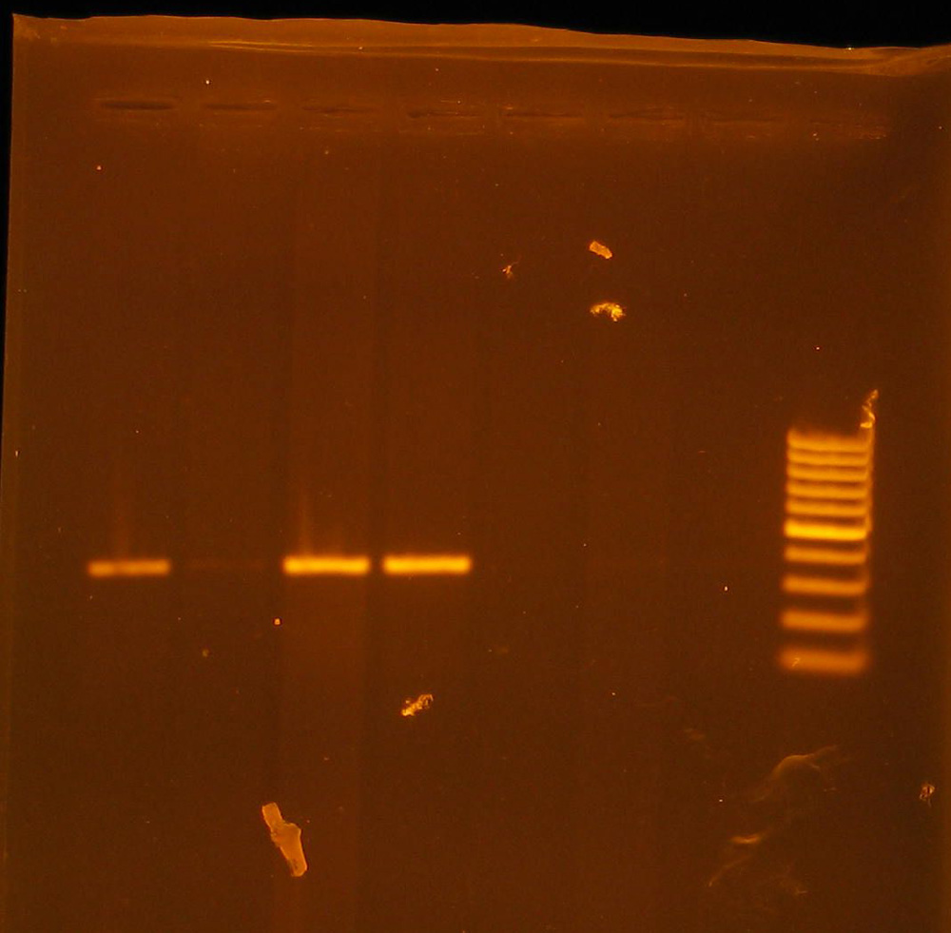
Figure (2): PCR results to amplify fragments of bla_{oxa-51-like} genes in different carbapenem resistant A. baumannii isolates.
From right to left: Lane 1: DNA ladder, lanes 2 and 3: two control E. coli isolates, lane 4: control Klebsiella isolate, lanes 5, 6, 7 and 8: four carbapenem resistant A. baumannii isolates.

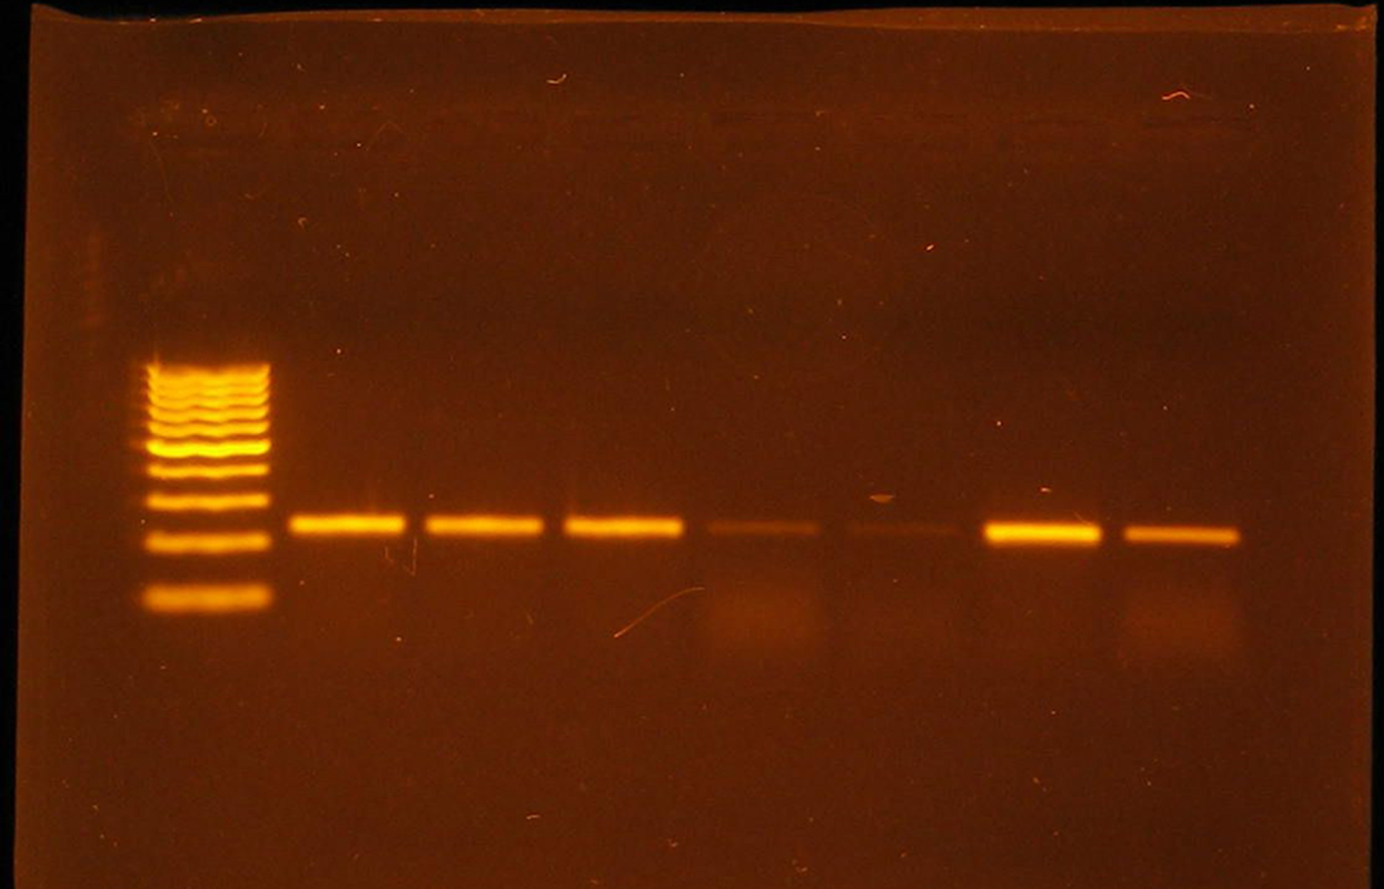
Figure (3): PCR results to amplify fragments of aph (3’)-VIa genes in different amikacin resistant A. baumannii isolates.
From left to right: Lane 1: DNA ladder, lanes 2, 3, 4, 5, 6, 7 and 8: seven amikacin resistant A. baumanni isolates.

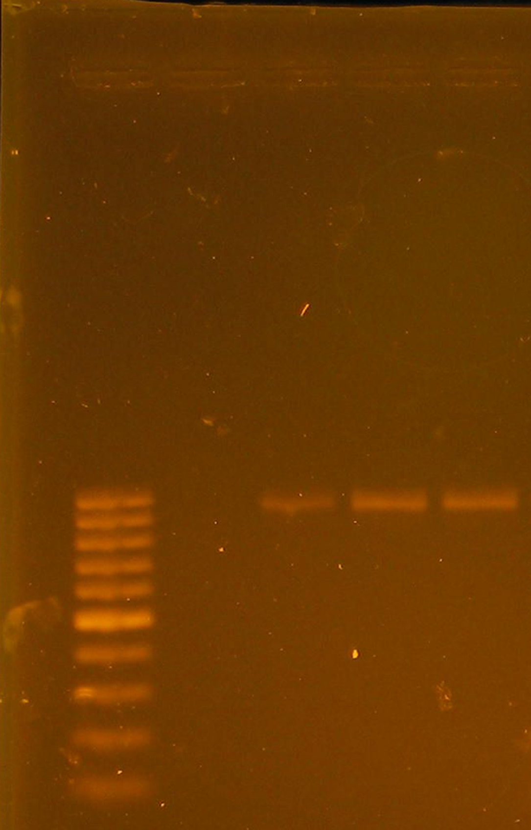
Figure (4): PCR results to amplify fragments of adeB genes in multidrug resistant A. baumannii isolates.
From left to right: Lane 1: DNA ladder, lane 2: adeB negative A. baumannii isolate, lanes (3-5): adeB positive A. baumannii isolates.

4. Discussions
Antimicrobial Susceptibility Testing:
A. baumannii isolates have showed high resistance to imipenem, meropenem, cefipime, ceftazidime, ciprofloxacin and β-lactam combination (100%), amikacin (98.8%) and no resistance to tigecycline. These results agree with the results obtained in our study for tetracycline derivative (Tetracycline) (most effective), ceftazidime, ciprofloxacin and β-lactam combination, but it showed higher resistance with imipenem, meropenem, cefipime and amikacin (8).
A. baumannii have showed high resistance to ceftazidime (94.6%), tetracycline (81.2%), meropenem (80.4%), imipenem (78.6%) and ciprofloxacin (76.8%) and low resistance to cefipime (34.8%). These results are in agreement with the results obtained in the present study for ceftazidime, meropenem, imipenem and ciprofloxacin (high resistance) but it indicates higher incidence of resistance to tetracycline and lower incidence of resistance to cefipime (9).
It has been found that A. baumannii isolates have showed high resistance to cefipime (79.1%), meropenem and imipenem (70.5%), amikacin (61.2%) and low resistance to tigecycline (7.9%) (10). These results agree with the results obtained in our study.
It has been reported that A. baumannii strains had high resistance to ciprofloxacin (90.53%), cefipime (82.30%), imipenem (81.61%) and meropenem (75.31%) and low resistance to amikacin (33.33%). Our results showed the same behaviour with ciprofloxacin, cefipime, imipenem and meropenem (high resistance) but indicates higher resistance to amikacin (11).
It has been found that A. baumannii strains had high resistance to ciprofloxacin (98%), amikacin (96%), meropenem (95.5%) and imipenem (87.8%). These results are in agreement with the results obtained in the present study for ciprofloxacin, amikacin, meropenem and imipenem (12).
A. baumannii showed high resistance to ceftazidime (83.3%) and amikacin and ciprofloxacin (77.8%) and low resistance to meropenem (11.1%) and imipenem (9.1%). Our results showed the same behaviour with ceftazidime, amikacin and ciprofloxacin (high resistance) but indicated higher resistance to meropenem and imipenem (13).

Detection of β-lactamases and bla_{oxa-51-like} genes:
Among imipenem-susceptible and resistant A. baumannii which were screened by PCR for different β-lactamases. The bla_{oxa-51-like} gene was the only one detected, even in imipenem-susceptible strain (14). It has been reported that among A. baumannii isolates with bla_{oxa-51-like} as sole carbapenemase gene, imipenem and/or meropenem resistance was associated only with isolates in which ISAba1 was upstream of bla_{oxa-51-like}, suggests that ISAba1 is providing the promoter for this gene (1). Oxa-51-like subgroup enzyme may be involved in the expression of carbapenem resistance under certain circumstances. Also, all imipenem-resistant A. baumannii isolates were positive for carbapenemase production and negative for metallo β-lactamase. They all possessed the encoding gene for an intrinsic oxa-51-like carbapenemase and an acquired oxa-23-like carbapenemase (15).

Detection of aph (3’)-VIa genes:
All 16 clinical amikacin resistant A. baumannii isolates had positive PCRs with primers specific for the amplification of the aph (3’)-VIa gene which confirms the contribution of the aph (3’)-VIa gene to the incidence of amikacin resistance in A. baumannii (6). 97% of A. baumannii isolates that are amikacin resistant contained the phosphotransferase gene aphA6 (aph (3’)-VIa) (16). Among 106 multidrug resistant clinical A. baumannii strains from hospitals in the Czech Republic and other European countries, aph A6 gene was predominant in 55 strains representing (52%) (17). It has been illustrated that among 49 clinical isolates of multidrug resistant A. baumannii identified at a tertiary medical center in Pennsylvania, the aph (3’)-VIa gene was detected in 3 isolates representing (6.1%) (18).

Detection of adeB efflux pump gene:
All tested 39 multidrug resistant Acinetobacter strains had the adeB gene and disruption of the adeB gene has greater effect on resistance to meropenems than adeA gene in Acinetobacter spp. isolated from university Malaya medical centre (19). High distribution of adeB (91.8%) gene in multidrug resistant A. baumannii isolates from the three military hospitals in China has been observed (12). The majority of the A. baumannii isolates (75%) that generally display high-level multidrug resistance were positive for adeSR-adeABC, suggesting a potential linkage between these genes and multidrug resistance (20).

Corresponding Author:
Doaa Safwat Mohammed
Running title: Resistant A. baumannii in Egyptian hospital
E.mail. doaa.safwat@yahoo.com

References
- Turton, J. F., Woodford, N., Glover, J., Yarde, S., Kaufmann, M. E., and Pitt, T. L.( 2006a). Identification of Acinetobacter baumannii by detection of the bla_{OXA-51-like} carbapenemase gene intrinsic to this species. Journal of Clinical Microbiology. 44 (8): 2974-2976.
- Magnet, S., Courvalin, P., and Lambert, T.( 2001). Resistance-nodulation-cell division-type efflux pump involved in aminoglycoside resistance in Acinetobacter baumannii strain BM4454. Antimicrobial Agents and Chemotherapy. 45 (12): 3375-3380.
- Collee, J. G., Duguid, J. P., Fraser, A. G., and Marmion B. P. (1989). Mackie & McCartney practical medical microbiology.13th ed. ch.8. pp: 152.
- Sykes, R. B. (1978). Methods for detecting β - lactamases. In Reeves, D. S., Phillips, I., Williams, J. D. and Wise, R. (eds.), Laboratory methods in antimicrobial chemotherapy, pp. 64 -69. Churchill Livingstone.
- Turton, J. F., Ward, M., Woodford, N., Kaufmann, M. E., Pike, R., Livermore, D. M., and Pitt, T. L. (2006b). The role of ISAba1 in expression of OXA carbapenemase genes in Acinetobacter baumannii. FEMS Microbiology Letters. 258: 72-77.
- Vila, J., Ruiz, J., Navia, M., Becerril, B., Garcia, I., Perea, S., Lopez-Hernandez, I., Alamo, I., Ballester, F., Planes, A. M., Martinez-Beltran, J., and Jimenez De Anta, T. (1999). Spread of amikacin resistance in Acinetobacter baumannii strains isolated in Spain due to an epidemic strain. Journal of Clinical Microbiology. 37 (3): 758-761.
- Nemec, A., Maixnerova, M., Van der Reijden, T. J. K., Vn den Broek, P. J., and Dijkshoorn, L. (2007). Relationship between the AdeABC efflux system gene content, netilmicin susceptibility and multidrug resistance in a genotypically diverse collection of Acinetobacter baumannii strains. Journal of Antimicrobial Chemotherapy. 60: 483-489.
- Bier, K. E. S., Luiz, S. O., Scheffer, M. C., Gales, A. C., Paganini, M. C., Nascimento, A. J. D., Carignano, E., and Costa, L. M. D. (2010). Temporal evolution of carbapenem-resistant Acinetobacter baumannii in Curitiba, southern Brazil. American Journal of Infection Control pp. 1-7.
- Kulah, C., Aktas, E., Comert, F., Ozlu, N., Akyar, I., and Ankarali, H.( 2009). Detecting imipenem resistance in Acinetobacter baumannii by automated systems (BD Phoenix, Miceoscan WalkAway, Vitek 2); high error rates with Microscan WalkAway. BMC Infectious Diseases. 9 (30): 1-7.
- Tan, T. Y., Hsu, L. Y., Koh, T. H., Ng, L. S., Tee, N. W., Krishnan, P., Lin, R. T., and Jureen, R.( 2008). Antibiotic resistance in gram-negative bacilli: A Singapore perspective. Annals Academy of Medicine. 37 (10): 819-825.
- Savov, E., Mihaylova, G., Borisova, M., Stoeva, T., Kjoseva, E., and Trifonova, A. (2009). Multidrug-resistant Acinetobacter baumannii: A major threat worldwide. Counteraction to chemical and biological terrorism in East European countries. Dishovsky and Pivovarovi (eds.). Ch. 25. pp. 213-218.
- Yan, Z., Shen, D., Cao, J., Chen, R., Wei, X., Liu, L., and Xu, X. (2010). Susceptibility patterns and molecular epidemiology of multidrug-resistant Acinetobacter baumannii strains from three military hospitals in China. International Journal of Antimicrobial Agents. 35: 269-273.
- Gaur, A., Garg, A., Prakash, P., Anupurba, S., and Mohapatra, T. M. (2008). Observations on carbapenem resistance by minimum inhibitory concentration in nosocomial isolates of Acinetobacter species: An experience at a tertiary care hospital in north India. Journal of Health, Population and Nutrition. 26 (2): 183-188.
- Takagi, E. H., Lincopan, N., Cassettari, V. C., Passadore, L. F., Mamizuka, E. M., and Martinez, M. B. (2009). Carbapenem-resistant Acinetobacter baumannii outbreak at university hospital. Brazilian Journal of Microbiology. 40: 339-341.
- Yang, H. Y., Lee, H. J., Suh, J. T., and Lee, K. M. (2009). Outbreaks of imipenem resistant Acinetobacter baumannii producing oxa-23 β-lactamase in a tertiary care hospital in Korea. Yonsei Medical Journal. 50 (6): 764-770.
- Hujer, K. M., Hujer, A. M., Hulten, E. A., Bajaksouzian, S., Adams, J. M., Donskey, C. J., Ecker, D. J., Massire, C., Eshoo, M. W., Sampath, R., Thomson, J. M., Rather, P. N., Craft, D. W., Fishbain, J. T., Ewell, A. J., Jacobs, M. R., Paterson, D. L., and Bonomo, R. A. (2006). Analysis of antibiotic resistance genes in multidrug resistant Acinetobacter sp. isolated from military and civilian patients treated at the Walter Reed army medical center. Antimicrobial Agents and Chemotherapy. 50 (12): 4114-4123.
- Nemec, A., Dolzani, L., Brisse, S., Broek, P. V., and Dijkshoorn, L.( 2004). Diversity of aminoglycoside-resistance genes and their association with class 1 integrons among strains of pan-European Acinetobacter baumannii clones. Journal of Medical Microbiology. 53: 1233-1240.
- Adams-Haduch, J. M., Paterson, D. L., Sidjabat, H. E., Pasculle, A. W., Potoski, B. A., Muto, C. A., Harrison, L. H., and Doi, Y. (2008). Genetic basis of multidrug resistance in Acinetobacter baumannii clinical isolates at a tertiary medical center in Pennsylvania. Antimicrobial Agents and Chemotherapy. 52 (11): 3837-3843.
- Wong, E. W., Mohd Yusof, M. Y., Bt Mansor, M., Anbazhagan, D., Ong, S. Y., and Sekaran, S. D. (2009). Disruption of adeB gene has a greater effect on resistance to meropenems than adeA gene in Acinetobacter spp. isolated from university Malaya medical centre. Singapore Medical Journal. 50 (8): 822-826.
- Lin, L., Ling, B. D., and Li, X. Z. (2009). Distribution of the multidrug efflux pump genes, adeABC, adeDE and adeIJK, and class 1 integron genes in multiple antimicrobial resistant clinical isolates of Acinetobacter baumannii-Acinetobacter calcoaceticus complex. International Journal of Antimicrobial Agents. 33: 27-32.

12/21/2010

