Genotoxic Effects of Acrylamide in Adult Male Albino Rats Liver

Khlood M. El- Bohi¹, Gihan G. Moustafa¹, Nabela I. El sharkawi¹ and *²Laila M. E. Sabik

¹Dept of Forensic Medicine &Toxicology. Faculty of Veterinary Medicine , Zagazig University, Egypt.
*²Dept. of Forensic Medicine & Clinical Toxicology. Faculty of Medicine, Zagazig University, Egypt.
*Lailasabik714@hotmail.com

Abstract: Background: Acrylamide is a common chemical which is used in both industrial and laboratory processes. It is formed in heated starchy foods especially potato products. Aim of the work: The aim of the present study was to clarify the possible involvement of genotoxic mechanisms in acrylamide-induced hepatotoxicity by measuring the role of cytochrome P450 2E1 (CYP2E1) gene protein and mRNA in rats intoxicated with acrylamide and recording the DNA changes in their hepatic tissues by the in vivo alkaline single cell gel electrophoresis (Comet assay).
Material and Methods: Thirty mature male albino rats were used in this study. Rats were classified randomly into three groups; the first group daily received 50 mg/kg acrylamide orally for 21 days. The second group received twice the previous dose (100 mg/kg) by the same route and duration and the third group was administered distilled water and kept as control. Results: The results revealed that, acrylamide caused marked alterations in animal behaviour and mortality % in both treated groups which reached 30% (in the first group) and 40% (in the second group) . Acrylamide elicited a highly significant increase in serum AST and ALT, while a significant decrease of total protein, albumin and globulin levels were recorded. Acrylamide caused down regulation of both CYP 2E1 protein and its mRNA expression concomitant with a dose dependent significant increase in number of DNA single strand breaks. Histopathological investigation revealed necrotic and degenerative changes in the liver of acrylamide treated rats.
Recommendation: Acrylamide exposure either occupationally or dietary must be restricted. In addition to, raising awareness of people about its hazards.

[Khlood M. El- Bohi, Gihan G. Moustafa, Nabela I. El sharkawi and Laila M. E. Sabik. Genotoxic Effects of Acrylamide in Adult Male Albino Rats Liver. Journal of American Science 2011; 7(1):1097-1108]. (ISSN: 1545-1003). http://www.americanscience.org.

Keywords: Acrylamide, Glycidamide, Genotoxicity, CYP2E1, Comet assay .

1. Introduction:
Contaminants are a vast subject area of food safety and quality and can be present in our food chain from raw materials to finished product (Erkeoglu and Baydar, 2010). Acrylamide (ACR) is one of the most important contaminant in the environment, which was shown to be a neurotoxicant, reproductive toxicant and carcinogen in animals (El-Assouli, 2009) .
ACR is an alpha, beta- unsaturated vinyl monomer of poly acrylamide (conjugated) reacted molecule. The co-polymers and polymers of ACR have a wide range of applications, it is used in paper manufactures, waste water treatments and as soil stabilizers, in addition, it is used worldwide to synthesize polyacrylamide. Both polyacrylamide and ACR have numerous applications in cosmetic industries, plastic and aesthetic surgeries, ophthalmic operations, oil recovery processes and other industrial and laboratory processes (Klaunig and Kamendulis, 2005 & Asha et al., 2008 and Schwend et al., 2009).
Dietary ACR is largely derived from heat – induced reactions ( Maillard reaction) between the predominantly amino group of the free amino acid precursor asparagine and carbonyl groups of glucose and fructose during heat processing (baking and frying) of plant-derived foods such as potato fries and cereals. Orally consumed ACR is absorbed into the circulation then distributed to various organs, and reacts with DNA, neurons, hemoglobin, and essential enzymes Baum et al.,(2008) and Rayburn and Friedman , (2010), causing several toxic effects as animal carcinogen and germ cell mutagen Ghanayem et al., (2005) , also human neurotoxicant and suspected carcinogen (Klaunig and Kamendulis , 2005 and Nuno et al., 2008). ACR is not genotoxic by itself but becomes activated to its primary epoxoide genotoxic metabolite glycidamide (GA) via epoxidation Baum et al.,(2008), by CYP2E1 which leads to the formation of GA-DNA and hemoglobin adducts (Ghanayem et al., 2005).
Nowadays appreciable amounts of ACR are formed in western diets which extensively invade our markets, this prompted renewed interest in its potential toxicity.
So the aim of this study was to clarify the possible involvement of genotoxic mechanisms in ACR-induced hepatotoxicity by measuring the role of CYP 2E1 (gene protein and its mRNA) in the liver of rats intoxicated with ACR and recording the DNA changes by the in vivo alkaline single cell gel electrophoresis (Comet assay).

2. Material and Methods
ACR compound purity is 99% and purchased from Sigma Chemical Company. It is a water-soluble vinyl monomer (Shan et al., 2006).
ACR synonyms: 2- propenamide; acrylic acid amide; acrylic amide; acrylamide monomer; acrylamide; propenoic acid amide ; vinyl amide ; ethylene carboxamide
Molecular formula: C₃H₅NO
Chemical formula : CH₂CHCONH₂
Chemicalstructure:CH₂=CH-C-NH₂ (Ghanayem, et al., 2005). ׀ ׀
O

Animals and dosing
Thirty mature male albino rats with an average body weight ranging from 160-180 g were obtained from the Animal Research Unit of the Faculty of Vet. Medicine Zagazig University. Animals were kept in metal cages during the whole experimental period under hygienic conditions, fed on well balanced ration and provided with water ad- libtum, through the experiment. Rats were divided into three equal groups the first group daily received 50 mg/kg ACR by oral gavage for 21 days, the second group received twice the previous dose (100 mg/kg) by the same route and duration , (Sumner et al. ,1999& 2003). And the third group was administered distilled water and kept as control.
Clinical signs and mortality percentage (%) were recorded along the experimental period. At the end of the experiment blood samples were collected from medial canthus of the eyes of all male rats in plain tubes for serum separation according the method of Renwick (1989). Serum samples were kept at -20°C till analysis. Then the animals were sacrificed, tissue samples from the livers of both treated and control groups were taken and immediately preserved in liquid nitrogen till RNA extraction and semi- quantitative RT-PCR analysis and Comet assay. Another liver samples were preserved at -80°C till western immuonoblotting analysis.
For histopathological study, liver samples preserved in 10% neutral-buffered formalin.
Biochemical analysis
Serum samples were analyzed for estimation of alanine aminotransferase (ALT) and the aspartate aminotransferase (AST) activities (Bergmeyer,et al. 1978), total proteins (Henry, and Harper, 1964) and albumin (Doumas et al. 1971), were determined . Serum globulin was calculated by substraction of albumin from total protein.

Microsomal preparation
The liver tissues were homogenized in 3 volumes of 1.15% potassium chloride solution and centrifuged at 9,000 g for 20 min. The supernatant fraction was centrifuged at 105,000 g for 70min. The washed microsomes were then suspended in 0.1M potassium phosphate buffer, pH7.4 (Omura and Sato 1964). Microsomal protein concentrations were determined by the method of Lowry (1951) using bovine serum albumin (Sigma Chemical Co.) as a standard.

Western immunoblotting analyses of CYP2E1 protein
Liver microsomes (5mg protein) were electrophoresed (Mini-Protean II, Bio-Rad Lab., Richmond, CA) through 10% Sodium dodecyl sulfate-polyacrylamide gel electrophoresis (SDS-PAGE) slab gels (Towbin et al., 1979). Resolved proteins were transferred to nitrocellulose Trans-Blot membranes (Bio-Rad Laboratories, Hercules CA). The blots were stained with Ponceau S to confirm that protein content is approximately the same in all lanes. Filters were soaked in phosphate buffer solution, pH7.5 (PBS) to remove the Ponceau S and were incubated overnight in PBS containing 5% dried skimmed milk and 0.1% Tween-20, to block excess protein binding sites. The membranes were then incubated with a primary goat polyclonal anti-rat CYP2E1 antibody (Gentest Co., Woburn, MA), detected with horseradish peroxidase-conjugated secondary antibodies and enhanced chemiluminiscence reagents (Amersham Pharmacia Biotech, Ltd, Buckinghamshire, UK), and visualized. The CYP2E1 content was quantified by analysis densitometrically scanned using NIH image software 1.61.

RNA extraction
Total RNA was isolated from 50mg of liver using Trizol reagent (Life Technologies Inc, Grand Island, NY, USA). Briefly liver tissue samples were homogenized in 1ml of Trizol then 0.3ml of chloroform was added to the sample. The mixtures were then shaken for 30sec followed by centrifugation at 4°C and 15,000g for 20min. The supernatant layer were transferred to a new set of tubes, and an equal volume of isopropanol was added to the samples, shacked for 15sec and centrifuged 4°C and 15,000g for 15min. The RNA pellets were washed with 70% ethanol. RNA was dissolved in DEPC water. The prepared RNA was checked by electerophoresis, and showed that the RNA integrity was fine, and then it was further checked by measuring the optical density (OD) on specterophotometer. The OD of all RNA samples were 1.7 to 1.9 based on the 260/280 ratio.

Semi-quantitative RT-PCR
A mixture of 5µg of total RNA and 0.5ng oligo dT primer in a total volume of 24µl sterilized ultra-pure water, was incubated at 70 ºC for 10min and then removed from the thermal cycler and completed to 40µl with a mixture of 8 µl (5X) RT-buffer, 2µl 10mM dNTP, 2µl DEPC water, and 2µl of reverse transcriptase (Toyobo CO., Ltd., Osaka, Japan) and incubated in the thermal cycler at 30 ºC for 10min, 42ºC for 1h, and 90 ºC for 10min. For PCR, 1µl aliquots of the synthesized cDNA were added to 20µl of a mixture containing sterilized ultra-pure water, 2µl of PCR buffer, 2µl of dNTP (2.5mM), 0.3µl of sense and anti-sense primers (10µM) and 0.1µl of Taq polymerase (Takara, Kyoto, Japan). Specific CYP2E1 primers were designed according to Gonzalez et al. (2003), the sequence: GAAAAAGCCAAGGAACACC (sense) and GCAGACAGGAGCAGAAACA (antisense) as published PCR For semi-quantitative RT-PCR assays, a co-amplification approach was used with glyceraldehyde-3-phosphate dehydrogenase (G3PDH) as the control gene. Rat liver and the PCR conditions were the same as described above, except that 10pmol G3PDH primers (sense): TGAAGGTCGGTGTGAACGGATTTGGC and (antisense): CATGTAGGCCATGAGGTCCACCAC. Amplification was initiated by denaturation of 1 cycle at 95ºC for 1min followed by denaturation at 94ºC for 1min, and annealing at the proper temperature for 1min then extension at 72ºC for 1min for the proper number of cycles for each gene using a DNA thermal cycler (BioRad, Hercules, CA, USA). The samples were finally incubated for 7min at 72ºC after the last cycle of amplification. The amplified PCR products were separated by electrophoresis through 1-1.5% agarose gel. Bands of cDNA were stained with ethidium bromide and visualized by ultraviolet illumination. The CYP2E1 and G3PDH contents were densitometrically scanned using NIH image software 1.61. G3PDH mRNA levels were used for the correction of CYP2E1 mRNA expression as endogenous genes; the ratio between CYP2E1 and G3PDH was determined by densitometry.

Comet assay
Small piece of the hepatic tissue was collected and placed onto a small Petri dish with ice-cold mincing solution (Ca²⁺- and Mg²⁺-free HBSS containing 20 mM EDTA and 10% DMSO). The viability of the liver cells was indirectly determined by analyzing the comet images after electrophoresis Endoh et al, (2002). The liver samples were cut into smaller pieces, using a disposable microtome razor blade, and the solution was aspirated. Then, a fresh mincing solution was added and the liver samples were minced again to finer pieces. Resulting cell suspensions were collected and filtered (100 µm nylon mesh). All samples were stocked on ice in appropriate conditions to avoid light until the comet assay procedures. The quantity of liver cells in the cell suspensions was determined in Giemsa-stained smears.
The Comet assay was performed under alkaline conditions according to a previously described standard protocol Collins and Dunsinka, (2002), Briefly, an aliquot of 5 µl of each prepared hepatic cell suspension was mixed with 120 µl of 0.5% low melting point agarose at 37ºC and layered onto conventional microscope slides, precoated with 1.5% normal melting point agarose. The slides were placed overnight in freshly prepared cold lysing solution (1% Triton X-100, 2.5 mM NaCl, 0.1 mM Na₂EDTA, 10 mM Tris with 10% DMSO, pH 10.0) and then in a horizontal electrophoresis cube with alkaline electrophoresis solution (0.3 M NaOH, 1 mM Na₂EDTA, pH >13) at 4ºC for 20 min. The electrophoresis was performed at 25 V and 300 mA for 20 min. After electrophoresis, the slides were washed twice for 5 min in neutralizing buffer (0.4 M Tris-HCl, pH 7.5), fixed for 5 min in absolute alcohol, air-dried, and stored at room temperature. In order to evaluate extremely low molecular weight DNA diffusion, two slides from each animal were removed after lysis procedure, rinsed with neutralizing solution, fixed and air-dried, and stored until analysis.
Immediately before analysis, the DNA was stained with 50 µl of 20 µg/ml ethidium bromide. The slides were examined with a 40X objective lens with epi-illuminated fluorescence microscopy (Olympus-Bx60, excitation filter: 515-560 nm; barrier filter: 590 nm) attached to a color CCD video camera and connected to an image analysis system (Comet II, Perspective Instruments, UK). Coded slides were scored blindly and 100 hepatic cell images were randomly analyzed for each animal (50 images per slide).
The Comets were analyzed by a visual scoring method and computerized image analysis. The comets were classified into five categories, defined as types 0, 1, 2, 3 and 4 - where 0 indicates no or very low damage, 1, 2 and 3 indicate low, medium and Long DNA migration, respectively, and 4 indicates apoptotic or necrotic DNA migration. Based on the extent of strand breakage, cells were classified according to their tail length in five categories, ranging from 0 (no visible tail) to 4 (still detectable head of the comet but most of the DNA in the tail). The following formula Liu et al, (2002) ^{was} used to calculate scores in which N is the number of cells in each category (e.g. N3 is the number of cells in category 3).
Score= (N0+N1+2xN2+3xN3+4xN4)/ (N0+N1+N2+N3+N4)
Experiments were done in duplicate and repeated at least twice.

Histopathological examination
Liver specimens were routinely processed and sectioned at 4-5um thickness. The obtained sections were stained with H&E according to Horobin, and Bancroft , (1998).

Statistical analysis
The results were analyzed using the Statistical Package of Social Science (SPSS) version 10 software. Analysis of variance, one way (ANOVA) for comparison between more than two groups. Least significant difference (LSD) for multiple comparison (Norusis, 1997).

3. Results:
Clinical signs:
Administration of ACR to male rats resulting in marked alterations in behaviour, revealing nervous manifestations (abnormal neurobehavior) in the treated groups as ataxia, increased landing of the limbs, weakness of the muscles, general emaciation. The severity of the clinical signs was dose and time dependant as these manifestations appeared on the 7th and 12th days of high and low ACR treated groups respectively.

Mortality and post-mortem picture:
Mortalities started at 3rd and 9th day of administration in high and low dose treated groups which reached 40% and 30 % respectively by the end of the experiment. Post-mortem (P.M.) lesions of either dead or sacrificed rats revealed generalized enlargement and paleness of body organs.

Serum biochemical parameters
There were a highly significant changes between mean values of (AST, ALT, total protein, albumin and globulin) in all treated groups all over the period of the study by ANOVA. By LSD, there were a highly significant increment in serum AST and ALT activities on comparing each treated group with the control and with each other. On the other hand each treated group revealed a highly significant decrement of total protein, albumin and globulin levels comparing with control group and with each other, except for globulin, which showed non significant changes on comparing both treated group (Table 1).

Expression level of CYP2E1 protein
On measuring the expression level of CYP2E1, the immune-blot of CYP2E1 protein revealed that, its gene protein in ACR treated rats was significantly down regulated and which was dose dependent, (Fig. 1A-B). Similarly a significantly down regulated mRNA expression of CYP2E1 was recorded in comparison to control group (Fig. 2A-B).
Comet assay
The role of ACR on the direct DNA single strand (ss) breaks was evaluated with Comet assay which could detect DNA ss breaks in hepatocytes after treatment. A statistically significant increase of the number of DNA ss breaks was evident with both examined concentrations of ACR and this increase was dose dependent (Fig. 3)

Histopathology findings
The examined livers of ACR treated rats with a dose of 50 mg /kg b.wt. Showed mild reversible degenerative changes characterized by cloudy swelling or hydropic degeneration of some hepatic cells, hypotrophied Kupffer's cells together with dilated and congested blood vessels and hepatic sinusoids beside numerous bile ductules (Fig. 4). Some portal areas exhibited edema and proliferative biliary epithelium with round cell infiltration. While ACR treated rats with a dose of 100 mg /kg b.wt. showed mild necrotic changes in the hepatic parenchyma represented by granular eosinophlic cytoplasm and karyolysis of some nuclei together with portal mononuclear cell infiltration (Fig.5). Moreover, round cell infiltration could be seen in portal and interstitial tissues beside telangiectiasis in some hepatic sinusoids.

Table 1. Effects of low and high dose of acrylamide administration on serum ALT,AST, total protein, albumin and globulin of male albino rats after 21 days by ANOVA and LSD tests.
P | ACR  high dosed group (100mg/kg) | ACR  low dosed group (50mg/kg) | Control | Groups  Parameters
*<0.001 | 58.6+3.4ab | 42.8+1.9a | 34.6+2.3 | AST (U/L)
*<0.001 | 37.6+1.6 ab | 32.2+2.2a | 23.8+1.7 | ALT(U/L)
*<0.001 | 4.5+0.3 ab | 5.3+0.6a | 6.9+0.3 | Total protein(gm/dl)
*<0.001 | 2.3+0.2 ab | 3.2+0.4a | 4.1+0.1 | Albumin(gm/dl)
*<0.001 | 2.2+0.1 a | 2.1+0.2 a | 2.8+0.2 | Globulin(gm/dl)

* : Significant of ANOVA. Significant of LSD:
a : P < 0.001 when each treated group compared with the control.
b : P < 0.001 when ACR group(100mg/kg) compared with ACR group (50mg/kg).

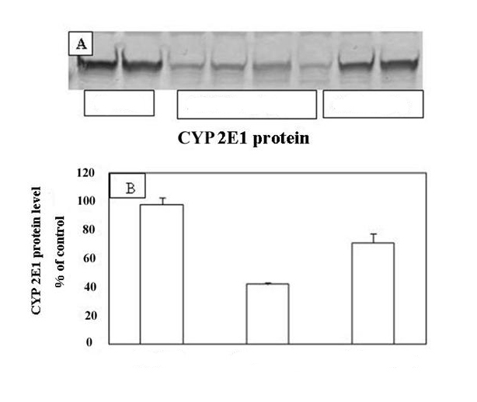

Control

ACR 100mg/kg

ACR 50mg/kg

Control
ACR high dose
ACR low dose

Fig.1 (A-B): Effects of acrylamide administration on expression levels of CYP2E1 protein, ACR was orally administered daily for 21 days by two dose levels 50 and 100mg/kg.
*p < 0.05 was considered statistically significant compared to control group.

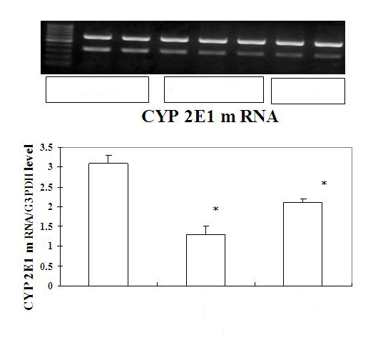
A

Control
ACR 100mg/kg

B

ACR 50mg/kg

Control
ACR high dose
ACR low dose

Fig. 2(A-B): Effects of acrylamide administration on Semi-quantitative CYP2E1 mRNA expression in the liver of control and acrylamide treated rats.
ACR was orally administered daily for 21 days by two dose levels 50 and100mg/kg. The values of CYP2E1 expression were corrected to G3PDH expression levels.
*p < 0.05 was considered statistically significant compared to control group

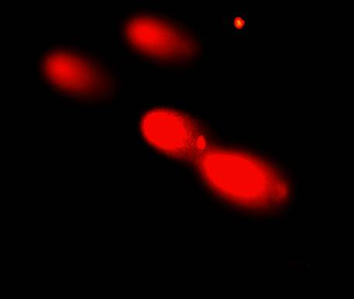
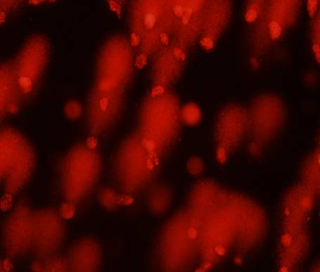

ACR 100mg/kg 1100mg/kg
Control
ACR 50 mg/kg

Fig. 3: Comet images of liver cells / PBS treated cells (Control group); ACR 50mg /kg daily for 21 days; ACR 100mg /kg daily for 21 days

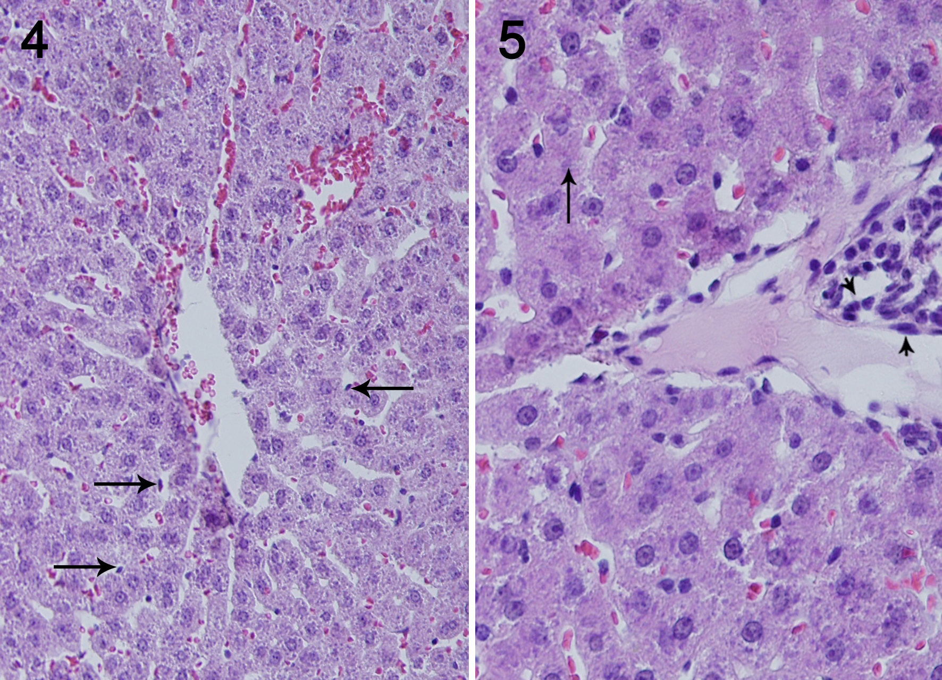

Fig. 4: Section in liver of adult male rat orally administered acrylamide daily at dose of 50 mg/kg b.wt for 21days showing degenerative changes characterized by cloudy swelling or hydropic degeneration of some hepatic cells, hypotrophied Kupffer cells (arrow) (H&E X 300) .
Fig. 5: Section in liver of adult male rat orally administered acrylamide daily at dose of 100 mg/kg b.wt for 21days showing mild necrotic changes in the hepatic cells ( arrow) with focal mononuclear cells infiltration ( head of arrow) in portal area (H & E x 1200).

4. Discussion:
In the current study, the administered doses of ACR were high compared with that estimated in cooked food which is as high as 70 μg per day (Tareke et al., 2002). However to clarify the effect of ACR on CYP2E1 expression in the present study, we administered ACR to rats at 50and 100mg/kg.
The results of the present study revealed that marked abnormal neurobehavior which was dose and time dependant. These findings were parallel with LoPachin (2000) who determined the time of onset and development of neurotoxicity which were observed on day 11 after 50 mg/kg after ACR treatment. Hind limb dysfunction and abnormal gait recorded in the present work, coincide with Shukla et al.,(2002)who found that exposure of rats to ACR caused hind limb paralysis in 58% of the animals on day 10 , they attribute these findings to ACR neurotoxicity.
The mortalities that observed in the current study may be attributed to high dose of ACR administrated to rats, ACR neurotoxicity that causing hind limb dysfunction which lead to inability to get food , in addition, ACR may caused alterations in thirst and hunger regulation centres in hypothalamus (WHO, 1985).
There was a significant increase in serum AST and ALT activities, which was dose dependent. These results are similar to those recorded by Chinoy and Memon ,( 2001)& Yousef and El-Demerdash (2006) in serum and plasma of mice and rats respectively post ACR intoxication.
These results confirmed by the hypothesis that recorded by Chinoy and Memon ,( 2001) who attributed the significant increase in serum AST, ALT levels to the bipolar nature of ACR , where the CH2=CH part may undergo hydrophobic
interactions while the CONH2 part can form hydrogen bonds with the cell components. This property may enhance its ability to alter the cell membrane structure and make the parenchymal cell membrane of liver more permeable, thereby causing the active retention of enzymes and making them appear first in the extracellular space and then in the blood. The previous changes were confirmed by histopathological findings .
Both biochemical and histological findings may be attributed to protein degradation which manifested by the low level of total protein, albumin and globulin in our result. The obtained results were found to be supported by the results of Asha et al. (2008) who reported that there were steady decreases in hepatic protein level with higher doses of ACR which can be resulted from retarded protein synthesis, or to change in protein metabolism or to the leaking out of protein reserves from hepatocytes. ACR molecule has two reactive sites, viz, the conjugated double bond and the amide group which can conjugate with the -SH group of a sulfur containing amino acids and α-NH2 group of a free amino acid. The above scenario can explain the unavailability of few amino acids for protein synthesis. Further being an electrophilic compound ACR can bind with proteins which can make them undetectable.
CYP2E1, a superfamily of hemoproteins involved in the metabolism of numerous xenobiotics with unrelated chemical structures comprises several isoforms with overlapping substrate specificity. Many of these substrates form reactive intermediates, thus becoming potent toxicants, mutagens or carcinogens. Among of them is CYP2E1, an isoform involved in the biotransformation of several small organic chemicals, including ACR and many others (Jasso et al, 2003).
Treatment of male albino rats with both doses of ACR for 21 days cause down regulated hepatic CYP2E1 which postulate that ACR requires CYP2E1-associated bioactivation producing GA causing liver injury. The immune-blot of CYP2E1 revealed that, the protein level of CYP2E1 in ACR treated rats was significantly down regulated and this inhibition was dose dependent. This observation is in accordance with the kinetic data, which showed that CYP2E1 is the rate- limiting factor of metabolic activation of ACR to GA (Tareke et al., 2002, HSDB, 2003& PHS, 2004). The down regulation of CYP2E1 gene protein was accompanied by reduction of the expression of CYP2E1 mRNA in a dose – dependent manner in comparison to control group . This down regulation may be due to direct cytotoxicity of GA which leads to reduction in the expression of CYP2E1 protein and mRNA due to inhibition of its transcription from the damaged hepatocytes. Our results are supported by the findings of Naoki et al., (2011) which revealed that the down regulation of CYP2E1 may indicates and confirm its role in the metabolism of ACR as it is predominantly active at high ACR concentrations. Previous findings have shown that ACR and its metabolite GA have affinity to bind with DNA, causing abnormalities in its structure which affect transcription and ultimately protein synthesis (Dearfield et al., 1995, CERHR, 2004 & Husoy et al., 2005 ) .
The present study revealed that there was a significant increase in the number of hepatic DNA ss breaks which was dose dependent.
Our results coincide with Gamboa da Costa et al.,( 2003) Who found that several adducts of GA with the purine bases of DNA have been described as supralinear dose–response relationship which appeared in DNA of liver, lung and kidney of mice treated with ACR which are consistent with saturation of oxidative biotransformation of acrylamide at higher doses. This may be attributed to the alkylating properties of ACR (alpha , beta – unsaturated vinyl monomer) or its reactive metabolites GA which cause cytotoxic effects (Schwend et al., 2009).
On the same context , Nicole et al., (2005) stated that ACR possess clastogenic and mutagenic properties in vivo and in vitro due to its reactive metabolites GA which act as ultimate mutagenic agent.

5. Conclusion:
ACR caused marked alterations in animal behaviour and early mortality level, it elicited a significant increase in serum AST and ALT, and a significant decrease of total protein, albumin and globulin levels, these biochemical changes coincide with histopathological alteration in liver tissues. The expression level of both CYP2E1 gene protein and mRNA were significantly down regulated. A significant increase in the number of DNA single strand breaks was evident with Comet assay. All recorded changes in all studied parameters were dose-dependent. So, ACR exposure either occupationally or dietary must be restricted. In addition to, raising awareness of people about its hazards.

ACKNOWLEDGEMENT
We recorded our thanks to Prof. Dr. Abd El-Monem A. Ali, The professor of pathology, Faculty of Vet. Medicine, Zagazig University for his help in the histopathological examination.

Corresponding author
Dr.Laila M. E. Sabik
Dept. of Forensic Medicine & Clinical Toxicology. Faculty of Medicine, Zagazig University, Egypt.
Lailasabik714@hotmail.com

5. References:
- Asha S. Renu S. and Jyotsna J. (2008): Biochemical changes in the liver of Swiss albino mice orally exposed to acrylamide. Mj. Int. J. Sci. Tech.; 2(03):542-550.

- Baum M.; Loeppky R.N.; Thielen S. and Eisenbrand G. (2008): Genotoxicity of glycidamide in comparison to 3-N-nitroso-oxazolidin-2-one. J Agric Food Chem.;56(15):5989-93.

- Bergmeyer, HU, Scheibe,P and Wahlefeld, AW(1978): Optimization of methods for aspartate aminotransferase and alanine aminotransferase Clinc. Chem ;24:58-73

- CERHR (Center for the Evaluation of Risks to Human Reproduction) (2004): Meeting Summary, National Toxicology Program, Research Triangle Park, N.C.

- Chinoy N. J. and Memon, M. R. (2001): Beneficial effects of some vitamins and calcium on fluoride and aluminium toxicity of gastrocnemius muscle and liver of male mice. Fluoride; 34: 21-33.

- Collins, A.R. and Dunsinka, M. (2002): Oxidation of cellular DNA measured with the comet assay. In Armstrong D. (ed.), Methods in Molecular Biology: Oxidative stress Biomarkers and antioxidant Protocols (Humana Press, New Jersy). pp147-159.

- Dearfield, K. L.; Douglas, G. R.; Ehling, U. H.; Moore, M. M.; Sega, G. A. and Bruisick, B. J. (1995): Acrylamide: A review of its genotoxicity and an assessment of heritable genetic risk. Mutat.Res.; 330: 71-99.

- Doumas B. (1971): Colorimetric method for determination of albumin. Clin. Chem., Acta ;31:87.

- El-Assouli S. M. (2009): Acrylamide in selected foods and genotoxicity of their extracts. J Egypt Public Health Assoc.; 84(3-4):371-92.
- Endoh D, Okui T, Ozawa S, Yamato O, Kon Y, Arikawa J, Hayashi M. (2002): Protective effect of a lignan-containing flaxseed extract against CCl(4)-induced hepatic injury. J Vet Med Sci.; 64(9):761-5

- Erkeoglu,p and Baydar,T (2010): Toxicity of acrylamide and evaluation of its exposure in body foods.Res.Rev;16 :1-11.

- Gamboa da Costa, G., Churchwell, M. I., Hamilton, L. P., Von Tungeln, L. S., Beland, F. A., Marques, M. M., and Doerge, D. R.(2003): DNA adduct formation from acrylamide via conversion to glycidamide in adult and neonatal mice. Chem. Res. Toxicol. ; 16: 1328–1337.

- Ghanayem,B.I; McDaniel, LB; Churchwell,MI; Twaddle,N.C; Snyder,R; Fennell,TR and Doerge,DR(2005): Role of CYP2E1 in the Epoxidation of Acrylamide to Glycidamide and Formation of DNA and Hemoglobin Adducts. Toxicol. Sci. ; 88 (2): 311-318.

- Ghanayem, B. I.; Witt, K. L.; El- Hadri, L.; Hoffler, U.; Kissling, G. E. and Shelby, M. D. (2005): Comparison of germ cell mutagenicity in male CYP2E1- null and wild type mice treated with acrylamide: Evidence supporting a glycidamide-mediated effect, Biol. Reprod.;72:157-163.

- Gonzalez J.E.; Lopez T.; Lucas D.; Berthou, F.; Manno, M.; Ortega, A. and Albores A. (2003): CYP2E1 regulation by benzene and other small organic chemicals in rat liver and peripheral lymphocytes. Toxicol Lett.; 144: 55-67.

- Henry,RG and Harper,K. (1964): Clinical chemistry; Harper &Low publisher. New York pp 181.

- Horobin R.W. and Bancroft J.D. (1998): Hematoxylin and Eosin as an oversight stain .In: Troubleshooting Histology Stains. 1st ed., Chapter 22 Churchil Livingston, Pearson Professional limited Press, New York, London, and Madrid Melbourne, Sanfrancisco and Tokyo: 88-93.

- HSDB(Hazardous Substance Data Bank) (2003): Acrylamide, MEDLARS Online Information Retrieval System, US National Library of Medicine.

- Husoy, T.; Abramsson-Zetterberg, L.; Olstorn, H. B.; Paulsen, J. E. and Alexander, J. (2005): Adenomatous polyphonic coli influences micronuclei induction by PhiP and acrylamide in mouse erythrocytes. Mutat. Res.; 580: 111-118.

- Jasso, E. G.; López, T.; Lucas, D. ; Berthou, F; Manno, M. Ortega, A. and Albores, A.(2003): CYP2E1 regulation by benzene and other small organic chemicals in rat liver and peripheral lymphocytes. Toxicology Letters; 144(1): 55-67

- Klaunig, J. E. and Kamendulis L.M. (2005): Mechanisms of acrylamide induced rodent carcinogenesis. Adv Exp Med Biol. ;561:49-62.

- Liu, X.; Yao, J.; Pisha, E.; Yang, Y.; Hua, Y.; Breemen R. B. and Bolton J. L. (2002): Oxidative DNA damage induced in equine estrogen metabolites: role of estrogen receptor alpha. Chem. Res. Toxicol. ;15:512-519.

- LoPachin, RM, Lehning, EJ, Opanashuk, LA, Jortner, BS (2000): Rate of neurotoxicant exposure determines morphologic manifestations of distal axonopathy. Tox Appl Pharmacol; 167: 75-86.

- Lowry,O.H. Rosebrough, N. J.;Farr, A. L. and Randall, R.J. (1951): Protein Measurement with the Folin Phenol Reagent. J.Biol. Chem. ;193: 269–275.

- Naoki, K.; Manabu, Y.; Yoshimitsu, O.; Satoshi, S.; Tetsuo, S.; Takuya, S.; Tomonari, M. and Naohide. K. (2011): Genotoxicity of acrylamide in vitro: Acrylamide is not metabolically activated in standard in vitro systems. Environmental and Molecular mutagenesis;52(1): 11-19. Article first published online: 7 MAR 2010

- Nicole, P.; Zeina, T.; Florian, F. and Doris, M.(2005): DNA standard breaking capacity of acrylamide in mammalian cells. Mutation Research Genetic Toxicology and Environmental Mutagenesis; 580: 71-80.

- Norusis, MJ(1997): Statistical package for science (SPSS) version 10 for windows user's guide's Chicago.

- Nuno, G.O.; Célia M.; Marta P.; Gonçalo G. D.; Vanda M.; Maria M. M.; Frederick A. B.; Mona I. C.; Daniel R. D.; José R. and Jorge F. G. (2008): Cytogenetic damage induced by acrylamide and glycidamide in mammalian cells: correlation with specific glycidamide-DNA adducts. J Agric Food Chem.;56(15):6054-60.

- Omura T. and Sato R. (1964): The carbon monoxide-binding pigment of liver microsomes .II. Solubilization, purification, and properties. J Biol Chem.; 239: 2379-2385.

- PHS(Public Health Services) (2004): The Health Consequences of smoking : A report of the surgeon general center for disease control& prevention. US department of health and human services. (http://www.cdc.gov/tobacco/sgr/sgr_2004/index.htm).

- Rayburn J.R. & Friedman M. (2010): l-Cysteine, N-Acetyl-l-cysteine, and Glutathione Protect Xenopus laevis Embryos against Acrylamide-Induced Malformations and Mortality in the Frog Embryo Teratogenesis Assay. J Agric Food Chem.; 58 (20): 11172–1117858.

- Renwick AG (1989): Pharmaco-kinetics in Toxicology. In principal & methods: of Toxicology. 2nd ed. Hayes WZ Avoreu Press : PP 764.
- Schwend T.; Möller M.; Schabacker J.; Ruppert T. and Wink M. (2009): Alkylation of adenosine deaminase and thioredoxin by acrylamide in human cell cultures. Z Naturforsch C.; 64(5-6):447-53.

- Shan-x. L. ;Ning C.; Cui-li Z.; Xiu-lan Z.; Su-fang Y. and Ke-qin X. (2006): Effect of subchronic exposure to acrylamide induced on the expression of bcl-2, bax and caspase-3 in the rat nervous system, Toxicology ; 217 : 46–53.

- Shukla, P. K., Khanna, V. K., Ali, M. M., Maurya, R. R., Handa, S. S. and Srimal, R. C. (2002), Protective effect of Acorus calamus against acrylamide induced neurotoxicity. Phytotherapy Research, 16: 256–260.

- Sumner S. C.;Fennell T. R.; Moore T. A.; Chanas B.; Gonzalez F. and Ghanayem B.I. (1999): Role of cytochrome P450 2E1 in the metabolism of acrylamide and acrylonitrile in mice. Chem Res Toxicol.;12(11):1110-6.

- Sumner, S. C., Williams, C. C., Snyder, R. W., Krol, W. L., Asgharian, B., and Fennell,T. R. (2003). Acrylamide: a comparison of metabolism and hemoglobin adducts in rodents following dermal, intraperitoneal, oral, or inhalation exposure. Toxicol Sci; 75: 260-270.

- Tareke, E. ; Rydberg, P. ; Karlsson, P.; Eriksson, S. and Tornqvist, M. (2002): Analysis of acrylamide, acarcinogen formed in heated foodstuffs”, J. Agric. Food Chem.; 50:4998-5006.

- Towbin,H; Staehelin, T and Gordon,J (1979): Electrophoresis transfer of proteins from polyacrylamide gels to nitrocellulose sheets: procedure and some applications.proc Natl Acad Sci USA ;76: 4350-4354.

- WHO (World Health Organization) (1985): Acrylamide. Environmental Health Criteria 49. Geneva: WHO
- Yousef M.I. and El-Demerdash F.M. (2006): Acrylamide-induced oxidative stress and biochemical perturbations in rats. Toxicology ;219( 1-3): 133-41

12/12/2010

