Detection of Community Acquired Methicillin Resistance Staphylococcus aureus among Staphylococcus aureus isolates.

Ola Kader ¹, Samia Ebid ², Nancy Mostafa ²¹, Shimaa El Sayed ² and Abeer Ghazal ¹

¹ Microbiology Department and ²Applied Medical Chemistry Department, Medical Research Institute, Alexandria University.

ABSTRACT: The rates of MRSA infections in the hospital, as well as the disease in the community, have continued to rise. Staphylococcal cassette chromosome mec (SCCmec) is a variable genetic element that contains the methicillin resistance determinant, mecA. SCCmec typing is one of the most important molecular tools available for distinction between community-acquired MRSA and HA-MRSA occurring on a worldwide basis. CA-MRSA has been reported to carry the loci for Panton Valentin leukocidin (PVL) in high frequency in association with the type IV SCCmec. Aim of this study was to differentiate between HA-MRSA and CA-MRSA by detection of SCCmec and determination the prevalence of PVL gene among MRSA isolates. Material &methods: A total of 34 Staphylococcus aureus isolates were included in this study. Susceptibility of Staphylococci was determined by, Disc diffusion method including methicillin, oxacillin and cefoxitin discs. Penicillin Binding Protein (PBP_{2a}) Latex Agglutination test was done to detect the presence of PBP_{2a} responsible for methicillin resistance. In addition genotypic identification of MRSA was carried out by detecting mec gene by real time PCR. Conventional PCR was carried using different set of primers for the amplification of SCC mec for differentiating the HA-MRSA and CA-MRSA; moreover detection of PVL as virulence factor was also done. Results: The antibiotic sensitivity of CA-MRSA ranged from (11.76% for ceftazidime) to (47.06% for Imipenem, Erythromycin and Gentamycin); while the sensitivity of HA-MRSA ranged from (2.94% for Amoxicillin and Ampicillin/sulbactam) to (29.41% for Amikin). Out of 34 S. aureus strains; 26(76.47%) isolates were found to be resistant to oxacillin disc, 30(88.24%) isolates were resistant to methicillin; and all strains were resistant to cefoxcitin disc. All MRSA strains were confirmed to be methicillin resistant by detection of mecA gene using real time PCR. Out of 34 MRSA strains 32 (94.12%) were PBP_{2a} producer. In the present study, though, the majority (25out of 34) of our strains were not SCC mec typable, yet among the nine typable strains the six hospital strains belonged to type II and III as reported in the literature and the three CA-MRSA belonged to the novel type V reported by other workers to be associated with CA-MRSA and the only PVL positive CA MRSA strain was untypable.
[Ola Kader, Samia Ebid, Nancy Mostafa, Shimaa El Sayed and Abeer Ghazal. Detection of Community Acquired Methicillin Resistance Staphylococcus aureus among Staphylococcus aureus isolates. Journal of American Science 2011; 7(1):1109-1117]. (ISSN: 1545-1003). http://www.americanscience.org.

Keywords: Community; Methicillin; Resistance; Staphylococcus; Staphylococcus; aureus

INTRODUCTION
Methicillin-resistant Staphylococcus aureus (MRSA) is a serious threat to hospitalized patients globally and now represents a challenge for public health, as community-acquired infections appear to be on the increase in various regions and countries, ^{(1,2)} including North America ⁽³⁾, Australia ^{(1),} Saudi Arabia ⁽⁴⁾ and Finland ⁽⁵⁾. Rising colonization rates lead to increased infection rates in the community and in hospitals. The consequence to the health care system is longer hospital stays and greater costs. ⁽⁶⁾ Patient risks include significantly higher mortality and morbidity rates with invasive MRSA infection. ⁽⁷⁾
MRSA strains produce penicillin binding protein2a, which possesses reduced affinities for binding to β lactam antibiotics resulting in β lactam resistance. The mecA gene, encoding PBP2a, is carried on a peculiar type of mobile genetic element inserted into the staphylococcal chromosome, designated staphylococcal cassette chromosome mec (SCCmec) elements. SCCmec elements typically share four characteristics: first, they carry the mec gene complex (mec) consisting of the methicillin resistance determinant mecA and its regulatory genes and insertion sequences; second, they carry the ccr gene complex (ccr) consisting of ccr genes that are responsible for the mobility of the element and its surrounding sequences; third, they have characteristic directly repeated nucleotide sequences and inverted complementary sequences at both ends; and last, they integrate into the 3_ end of an open reading frame (ORF), orfX.⁽⁸⁾
In S. aureus, three major mec complex classes have been described, and concerning the ccrAB locus, three major allotypes (ccrAB1 to ccrAB3) ⁽⁹⁾ and one sporadic allotype (ccrAB4) ⁽¹⁰⁾ have been identified. Recently, a new type of ccr gene complex, which consists of only one gene (ccrC) not closely, related to the ccrA or ccrB gene, was reported ⁽¹¹⁾. SCCmec carries other sequences that define the overall genetic organization of the resistance cassette. These regions may be used as targets for typing strategies ⁽¹²⁾, and polymorphisms within these regions, particularly in the region downstream of the ccrAB genes (the J1 region), define SCCmec subtypes or variants.⁽¹³⁾
Based on the class of mecA gene complex and the type of ccr gene complex present, SCCmec cassettes are classified into seven major types. ⁽¹⁴⁾ The hospital-associated strains of MRSA (HA-MRSA) strains contain the larger type I, II, or III cassettes ⁽¹³⁾ , while the two smallest SCCmec types, SCCmec IV and SCCmec V, have been associated with community-associated MRSA (CA-MRSA) ^{(2,15)}
Clinically, CA-MRSA usually causes skin and soft tissue infection. However, it can cause serious life-threatening conditions, which in addition to necrotizing pneumonia include necrotizing fasciitis, bloodstream infection, and septic shock ⁽¹⁶⁾. Reports have suggested that certain strains of CA-MRSA may be more virulent than HA-MRSA ^{(17, 18)}. The expression of Panton-Valentine leukocidin (PVL), a two-component, pore-forming, cytolytic toxin that targets mononuclear and polymorphonuclear cells and causes cell death by necrosis or apoptosis, has been strongly associated with CA-MRSA ⁽¹⁷⁾. The PVL toxin consists of two synergistic proteins, LukS-PVL and LukF-PVL, encoded by the pvl genes lukF and lukS, which are carried on a temperate bacteriophage. ^{(2, 19)}
Clinicians are now faced with emergence of (CA-MRSA) strains that are genetically different from MRSA strains originating in the hospital. Moreover, with the recent trend and shift in epidemiology, CA-MRSA is now being found in hospitals and in some instances displacing classic (HA-MRSA). ⁽²⁰⁾
The present study aimed to differentiate between hospital acquired MRSA and community acquired MRSA by detecting different Staphylococcal Chromosomal Cassette mec types (SCCmec), and detecting the prevalence of Panton Valentine Leukocidin as virulence factor for CA-MRSA and determining whether its carriage could be used as a surrogate marker for CAMRSA

MATERIAL AND METHODS
I-Bacterial Isolates:
Thirty nine Staphylococcal isolates were included in this study. Data recording previous hospital admission during the 6 months ago were collected.
I-Identification of staphylococcal isolates ⁽²¹⁾:
The staphylococcal isolates were identified morphologically and biochemically by standard laboratory procedures. The coagulase plasma test was performed on organisms exhibiting typical staphylococcal colony morphology to allow for discrimination of S. aureus from coagulase-negative staphylococci.

II-Antibiotic susceptibility testing ⁽²²⁾: Methicillin resistance (using Methicillin, Oxacillin and Cefoxitin) and susceptibility to different antibiotics were determined by the agar disk diffusion method.
III-Detection of Penicillin Binding Protein 2a (PBP2a) Latex Agglutination Test (Oxoid®)⁽²³⁾ based on the agglutination of latex particles sensitized with monoclonal antibodies against PBP2a, was used according to the manufacturer's instructions. Agglutination was visualized and was scored as positive, negative, or weakly positive.
IV- Polymerase Chain Reaction (PCR)
Staphylococcal DNA extraction: staphylococcal colonies were emulsified in 200 μl sterile distilled water to produce a heavy suspension, and heated at 100°C for 15 min. then centrifuged at 14.000 rpm for 5 min.
PCR for mecA gene detection was performed using Real time (TaqMan) PCR. ⁽²⁴⁾. The primers and probe used were as follows: Forward primer, 5'TGCTAAAGTTCAAAAGAGTATTTATAACAACA 3'; Reverse primer, 5'TGTGCTTACAAGTGCTAATAATTCACC 3'; and
Probe, 5' FAM-ATTATGGCTCAGGTACTGCTATCCACCCTCAAA-TAMRA 3'.The PCR mixture was prepared using TaqMan® Universal PCR Master Mix (2X) with final PCR mixture volume of 25 μl. Five µl of template DNA and 30 pmole of each primer and 7.5 pmol of probe were added to each test. A negative control was prepared by the addition of the same contents to the tube with water instead of the extract. Amplification was performed using MX3000P TM (Stratagene) Real Time PCR System programmed to hold at 95°C for 10 min for AmpliTaq gold activation and 30 cycles of denaturation at 95°C for 15 sec and annealing and extension at 60°C for 1min with end point fluorescence detection.
PCR for detection of SCCmec gene and PVL: Polymerase chain reaction for detection of SCCmec and PVL gene was performed using genomic DNA from each MRSA isolate as template. Primers used to amplify the different SCCmec and PVL are listed in (Table1). For SCCmec, 2 sets of primers were used. The first set (Oliviera primers) is designed to type Sccmec (I-IV). ⁽²⁵⁾ based on selected loci (A through F) upstream and downstream the mecA gene. Another set of primers (zhang) ⁽²⁶⁾ was used for detecting SCCmec type II, III and the newly described SCC mec type V.
PCR Conditions: eight μl of DNA extract were amplified by PCR in a final volume of 25 μl using 2x PCR master mix (Fermentas life sciences®) containing 0.05 units/μl of Taq DNA polymerase,50 picomol of each primer, PCR buffer, 2 mMMgCl2, 0.2mM of each dNTP. A negative control was prepared by the addition of the same contents to the tube with water instead of the extract. Amplification was performed in a Perkin-Elmer 9600 thermocycler. For Oliveira primers the cycle program was performed with an initial denaturation for 5 min at 94°C, then 35 cycles of denaturation for30 sec at 94°C, annealing for 30 sec at 53°C and extension for 1min at 72°C and final extension for 5 min. While for Zhang primers: the cycles begin with an initial denaturation step at 94°C for 5 min followed by 10 cycles of 94°C for 45 seconds, 65°C for 45 seconds, and 72°C for 1.5 min and then another 25 cycles of 94°C for 45 seconds, 55°C for 45 seconds, and 72°C for 1.5 min, and end with a final extension step at 72°C for 10 min. For amplification of PVL gene ⁽²⁷⁾: the cycle program was performed with an initial denaturation for 5 min at 94°C, then 35 cycles of denaturation for 40 sec at 94°C, annealing for 40 sec at 53°C and extension for 1min at 72°C and final extension for 10 min.

(Table1) primers used for amplification of SCCmec and PVL
Locus | Oliveira's Primers ⁽²⁵⁾ | Oligonucleotide sequence (5'–3') | Amplicon size (bp) | Specificity (SCCmec type)
A | CIF2 F2  CIF2 R2 | TTCGAGTTGCTGATGAAGAAGG  ATTTACCACAAGGACTACCAGC | 495 | I
B | KDP F1  KDP R1 | AATCATCTGCCATTGGTGATGC  CGAATGAAGTGAAAGAAAGTGG | 284 | II
C | MECI P2  MECI P3 | ATCAAGACTTGCATTCAGGC  GCGGTTTCAATTCACTTGTC | 209 | II,III
D | DCS F2  DCS R1 | CATCCTATGATAGCTTGGTC  CTAAATCATAGCCATGACCG | 342 | I,II,IV
E | RIF4 F3  RIF4 R9 | GTGATTGTTCGAGATATGTGG  CGCTTTATCTGTATCTATCGC | 243 | III
F | RIF5F10  RIF5R13 | TTCTTAAGTACACGCTGAATCG  GTCACAGTAATTCCATCAATGC | 414 | III
Zhang's Primers: ⁽ ²⁶⁾ |  | Oligonucleotide sequence (5'-3') | Amplicon  size (bp) | Specificity
Type II-F  Type II-R |  | CGTTGAAGATGATGAAGCG  CGAAATCAATGGTTAATGGACC | 398 | SCCmec II
Type III-F  Type III-R |  | CCATATTGTGTACGATGCG  CCTTAGTTGTCGTAACAGATCG | 280 | SCCmec III
Type V-F  Type V-R |  | GAACATTGTTACTTAAATGAGCG  TGAAAGTTGTACCCTTGACACC | 325 | SCCmec V
PVL primers:⁽ ²⁷⁾ |  | Oligonucleotide sequence (5'-3') | Amplicon  size (bp) | Specificity
PVL-1  PVL -2 |  | ATCATTAGGTAAAATGTCTGGACATGATCCA  GCATCAASTGTATTGGATAGCAAAAGC | 433bp | PVL
Detection of PCR products was done using 2% agarose gel stained with ethidium bromide and using of the molecular weight markers (50 bp DNA ladder (Fermentas Life Sciences).
RESULTS
1-Bacterial isolates and identification: among the 39 Staphylococcus isolates, 34 (87.18%) were free coagulase positive by tube coagulase test.
2-Detection of methicillin resistance by Disc diffusion method: out of 34 S. aureus strains; 26(76.47%) isolates were resistant to oxacillin disc, 30(88.24%) to methicillin and all strains were resistant to cefoxitin disc (100%).
3-Antibiotic susceptibility: According to data regarding previous hospital admission, the 34 collected strains were divided into 18 CA-MRSA& 16 HA-MRSA strain. CA-MRSA were more sensitive, the sensitivity in CA-MRSA ranged from (22.22% for ceftazidime) to (88.89% for Imipenem, Erythromycin and Gentamycin); while the sensitivity in HA MRSA ranged from (6.25% for Amoxicillin and Ampicillin/sulbactam) to (62.5% for Amikin). All MRSA were sensitive to vancomycin.
4-Detection of mec A gene: All the 34 strains were mecA gene positive. The presence of mecA gene detected by real time PCR was considered to be the gold standard in evaluating the 3 disc diffusion methods to identify MRSA.
5- Gene expression (PBP2a Production) among the 34 mecA positive : out of 34 MRSA strains 32 (94.12%) were PBP_{2a} producer while 2 (5.88%) were PBP_{2a} non producer. The 2 PBP_{2a} non producers isolates were CA MRSA.
6- SCC mec Typing:
Out Of the 16 HA-MRSA: 5 isolates were SCCmec type II (Two by Oliveira primers and three by zhang primers) and only one was detected as type III. While out of the 18 CA-MRSA Three isolates belonged to the newly described Type V reported to be associated with CA MRSA. The remaining 25 MRSA strains could not be typed.(Fig 1(A-E)

(A) 284bp DNA ladderِ 284bp (B) DNA ladderِ 243bp
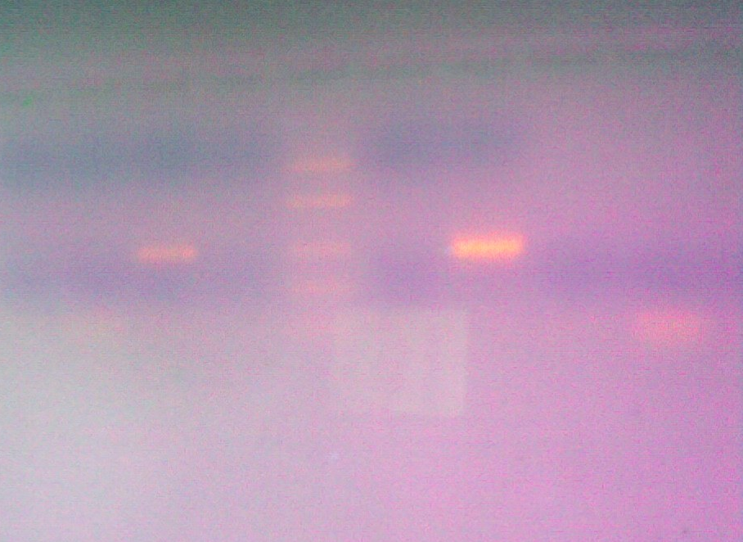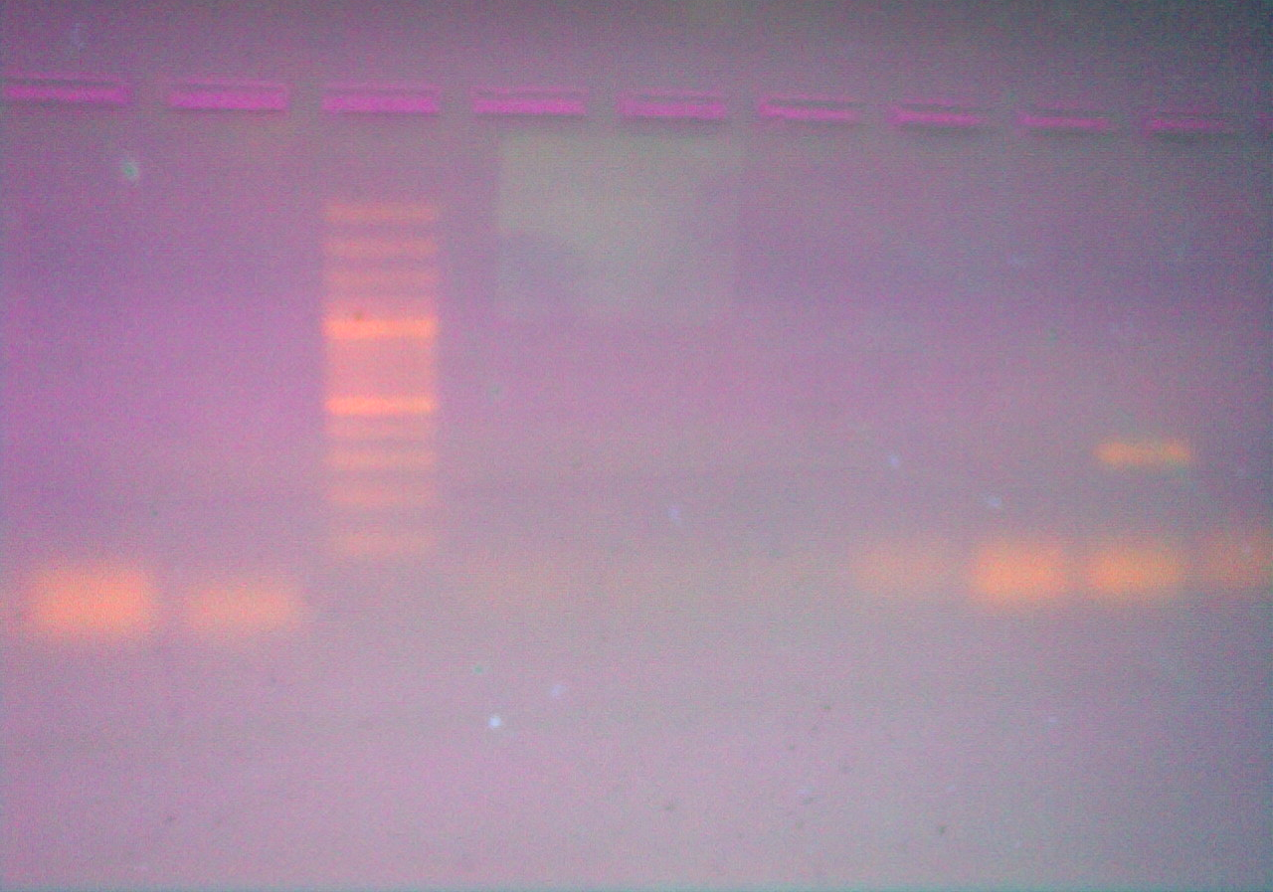
Fig (1A): Ethidium bromide stained agarose gel showing a single band of 284 bp specific for SCC mec type II at lanes 3 and 7 Lane 5 shows 50 bp DNA ladder. Fig (1B): show a single band of 243 bp specific for SCC mec type III at lanes 11. Lane 5 shows 100 bp DNA ladder.
(C) 398 bp DNA ladder 398 bp (D) 325bp DNA ladder 325bp
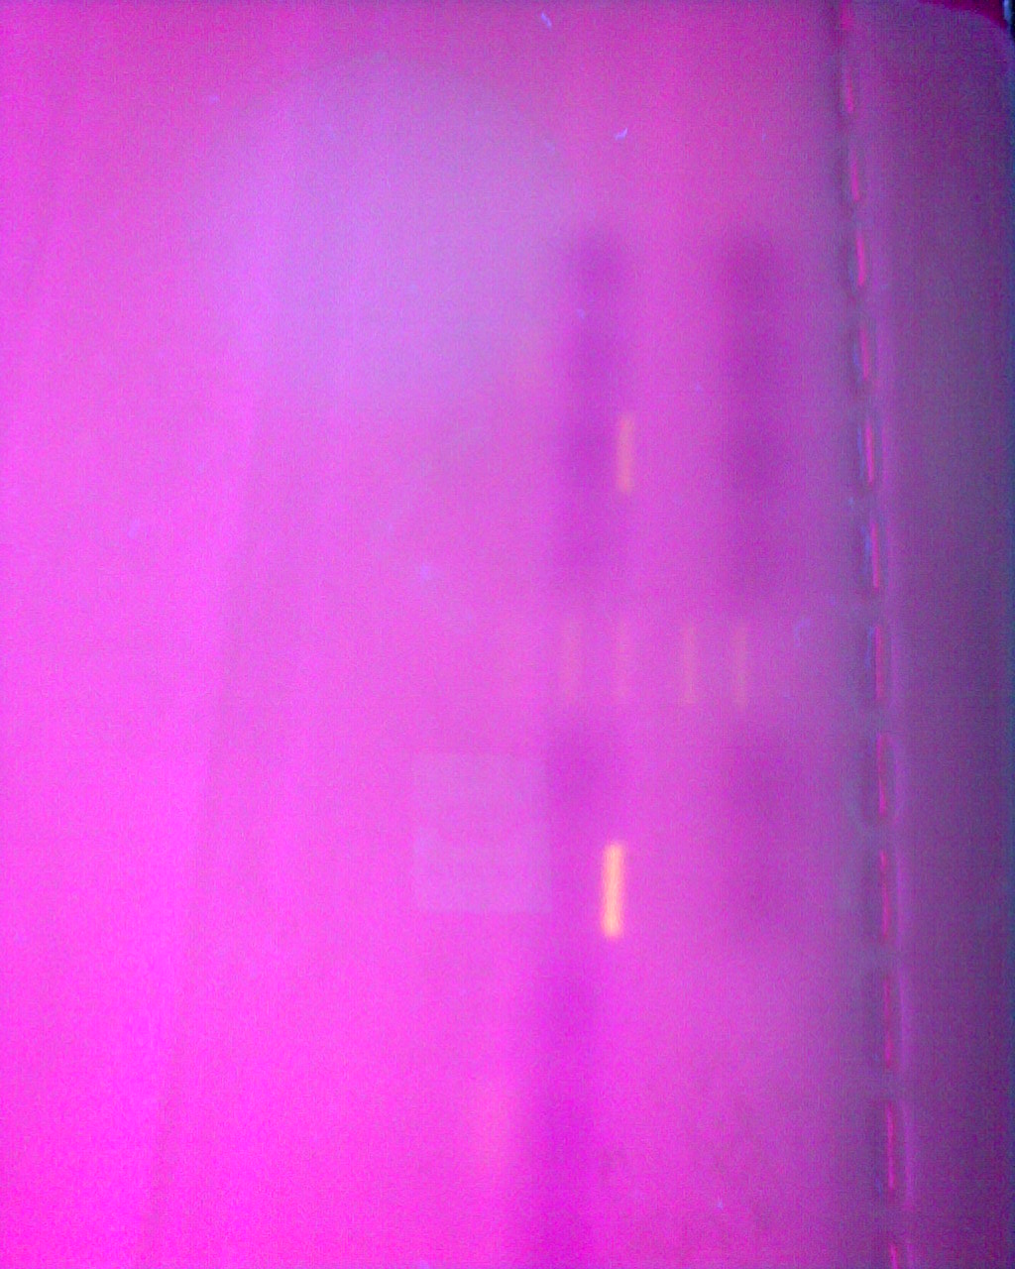
Fig (1C): Ethidium bromide stained agarose gel showing a single band of 398 bp specific for SCC mec type II at lanes 6 and 10. Lane 8 shows 50 bp DNA ladder. Fig (1D): show a single band of 325bp specific for SCC mec type IV at lanes 3 and 3 Lane 12 shows 50 bp DNA ladder
7-Detection of PVL: only one strain (CA-MRSA) out of the 34 MRSA was positive for Panton Valentine leukocidin (PVL) by PCR. (Fig 2)
Fig 2: 433bp of PVL DNA ladder
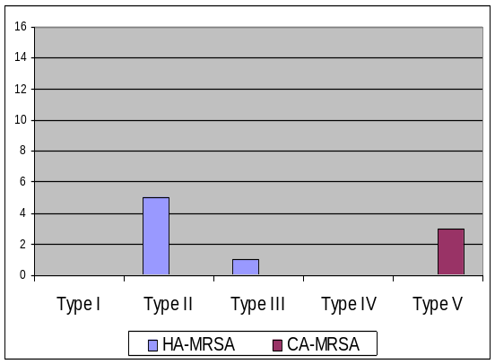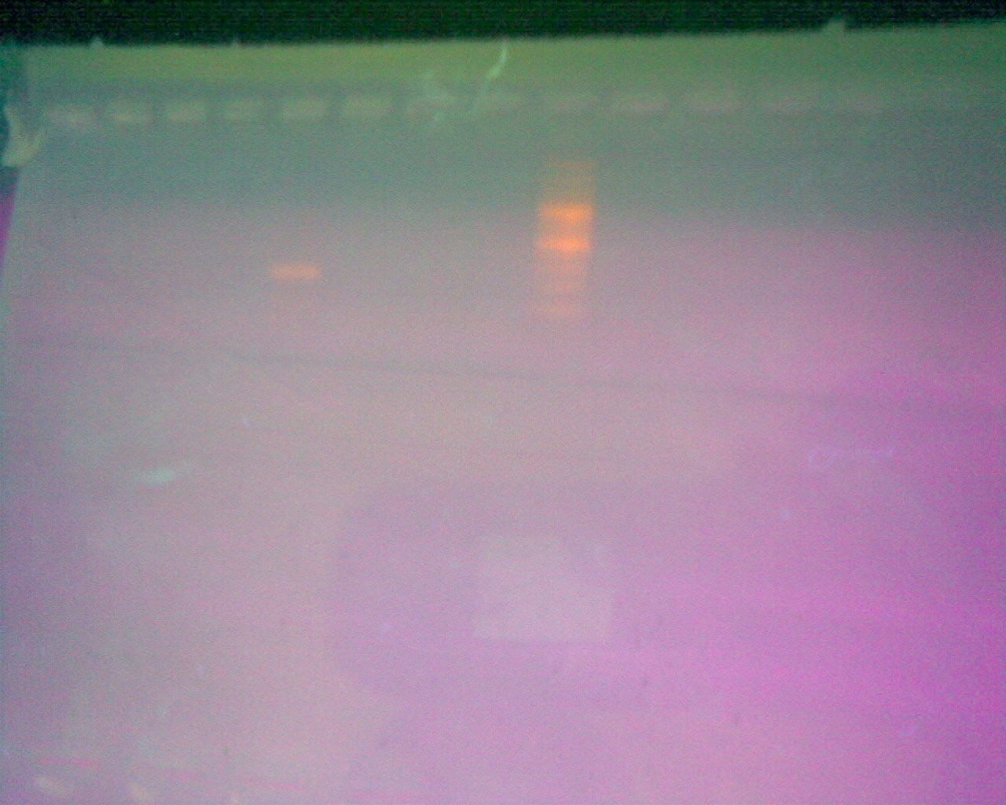
Fig 2: Ethidium bromide stained agarose gel showing a single band of 433 bp specific for PVL at lane 5. Lane 9 shows 100 bp DNA ladder

Figure 1E: SCC mec typing of the 34 MRSA

DISCUSSION

Methicillin resistance of S.aureus remains to be a significant problem. Rapid and accurate determination of methicillin resistance is important for initiation of appropriate antimicrobial therapy. Misdiagnosing this resistance leads to treatment failures and spread of infections with these resistant strains.
Phenotypic techniques as disk diffusion and microdilution methods are employed in routine laboratories for the detection of methicillin resistance. However, these methods are often not entirely reliable at detecting some strains that harbor the mecA gene. ⁽²⁸⁾ Identification of the mecA gene remains the most reliable method of detecting MRSA isolates, however not all laboratories can include molecular biology techniques in their routine clinical practice.
In this study cefoxitin disk diffusion tests was 100% sensitive for MRSA detection. Alternatively, only (76.47%) and (88.24%) isolates were resistant to Oxacillin and methicillin respectively. These results were in accordance with those of several studies ⁽²⁸⁻³⁰⁾ .This means that disc diffusion testing using cefoxitin disc is far superior to most of the currently recommended phenotypic methods and is now an accepted method for the detection of MRSA by many reference groups including CLSI^{. (31)}
Identification of MRSA, is more accurate by either directly detect the gene encoding the methicillin resistance determinant (mecA) or its product (PBP2a). ⁽³²⁾ MRSA-Screen test is a rapid and simple to perform method. Many studies reported that the accuracy of MRSA screen latex agglutination test for detection of PBP2a approaches the accuracy of PCR and more accurate than susceptibility testing methods with sensitivity of 97%-100% and a specificity of 97%-99.1% ^{(33,34)}. In this work, only two (5.88%) PBP2a non producer isolates (false negative) were identified. Other authors ^{(35, 36)} reported that false-negative results may occur with MRSA isolates with low oxacillin MICs (4 or 8 µg/ml) due to production of smaller amounts of PBP_{2a} or the failure to express the gene phenotypically.
MRSA infection can be categorized into 2 distinct groups: HA-MRSA and CA-MRSA. The community isolates are distinctly different from the hospital strains both epidemiologically and microbiologically. ⁽³⁷⁾ Both CA-MRSA and HA-MRSA are resistant to traditional anti-staphylococcal β-lactam antibiotics. However, CA-MRSA isolates tend to be more susceptible to other antibiotics (including to sulfa drugs, tetracyclines) than are HA-MRSA, ⁽³⁸⁾ and their narrow spectrum of resistance is solely due to determinants harbored on genetic elements present on the SCC. ⁽³⁹⁾ In this study, most of the 18 CA-MRSA isolates were susceptible to tetracyclines (83.3%) Erythromycin (88.9%), Gentamycin (88.9%), co-trimoxazole (77.8%), Ofloxacin (83.3%). On the other hand, the 16 HA- MRSA showed a wide spectrum of drug resistance ranging from 81.25% (ofloxacin, gentamycin and tetracyclines) to 68.7 % (erythromycin) and 56.2% (co-trimoxazole). Comparable results were obtained by various authors. ^{(40, 41)} Kaplan ⁽⁴⁰⁾ noted that most of the CA-MRSA isolates are susceptible to most antibiotics, while Anbumani et al., ⁽⁴¹⁾ reported that 250 MRSA isolated from different clinical specimens were multi-drug resistant.
SCCmec typing is one of the most important molecular tools available for understanding the epidemiology and strain relatedness of MRSA. ⁽²⁶⁾ In the present study, 2 sets of primers were used in an attempt to type our MRSA strains. The first set was chosen according to Oliviera typing scheme designed to type Sccmec (I-IV), ⁽²⁵⁾ and using six primer pairs only 3 of the 16 HA MRSA were typable by Oliviera primers. Two belonged SCC mec type II (amplified locus B) and one SCC mec type III. (amplified locus F), and none of the 18 CA MRSA could be typed by this scheme. As Oliveira’s assay has limitations in detecting the newly described SCCmec type V, misclassifying them as type III, while failing to discriminate type IV into subtypes a, b, c, and d ⁽²⁶⁾ Also, because of difficulties in assay optimization another trial of typing the SCC mec was carried using Zhang set of primers unique and specific for SCCmec types. So, another 3 out of 16 HA MRSA were classified as SCCmec type II, moreover another three belonged to SCCmec type V among 18 CA MRSA. So using both typing methods only 9 out of the 34 MRSA were typable. Similar data were noticed by others. Oliviera et al, ⁽²⁵⁾ reported that, 8% of their isolates were non-typeable for SCCmec by their primers used in this study. Also, Shore et al ⁽⁴²⁾ used also two typing methods the first for amplification of the ccr and mec genes, and the second method of Oliveira and de Lencastre, used in the present study and (50%) out of their 172 isolates harbored two apparently different SCCmec elements when tested by both typing methods. They suggested that PCR amplification and sequencing of the entire SCCmec element was necessary for the complete characterization of the SCCmec elements harbored by isolates with ambiguous multiplex patterns.
The differentiation between the typical HA-MRSA and CA-MRSA strains based on epidemiologic definitions becomes difficult, along with molecular distinction based on the (SCCmec) type is beginning to blur. ⁽⁴³⁾ In the present study, though , the majority (25out of 34 )of our strains were not SCC mec typable, yet among the nine typable strains the six hospital strains belonged to type II and III as reported in the literature and the three CA-MRSA belonged to the novel type V reported by other workers to be associated with CA-MRSA
CA-MRSA has been reported to carry the loci for PVL in high frequency, and to be associated with the type IV (SCCmec). ⁽⁴⁴⁾ In the present study, the only PVL positive CA MRSA was untypable. This was contrary to that noted by Berglund etal ⁽⁴⁵⁾ who detected PVL genes in 66% of the CA-MRSA isolates. However, Holms et al revealed that the PVL genes are carried by a relatively low number (1.6%) of S. aureus isolates from their clinical laboratories, indicating an unequal distribution of the genes encoding PVL among their strains. ⁽⁴⁶⁾ In addition, the overall proportion of MRSA isolates carrying pvl was 1.8% among the 1,389 MRSA isolated from Ireland. 7.5% of these isolates were CA-MRSA strains, of which only 6.7% carried pvl genes and the carriage of pvl was not restricted to CA-MRSA. ⁽⁴⁷⁾ Similarly, 78% of CA-MRSA isolates referred to a central reference facility were pvl negative and 25% of pvl-positive isolates in this group were HA. Additionally, Ko et al, ⁽⁴⁸⁾ was not able to detect PVL gene, in any of their MRSA isolates. Moreover, Kim et al, ⁽⁴⁹⁾ reported that none of their Korean CA-MRSA isolates contained the PVL genes. These findings agree with reports that carriage of pvl cannot be used as a sole marker for CA-MRSA. ⁽⁴⁷⁾
In the present study , the combination of SCC mec typing , in addition to the detection of PV leucocidin was not sufficient to discriminate between HA and CA MRSA due to the near absence of PVL among the CA MRSA and the limited capacity of the SCC mec typing methods among our strains.

REFERENCES
- Layton, M. C., W. J. Hierholzer, Jr., and J. E. Patterson. The evolving epidemiology of methicillin resistant Staphylococcus aureus at a university hospital. Infect. Control Hosp. Epidemiol. 1995;16: 12–17.
- Vandenesch, F., T. Naimi, M. Enright, G. Lina, G. Nimmo, H. Heffernan, N. Liassine, M. Bes, T. Greenland, M. E. Reverdy, and J. Etienne. Community - acquired methicillin - resistant Staphylococcus aureus carrying Panton-Valentine leukocidin genes: worldwide emergence. Emerg. Infect. Dis. 2003; 9:978–984.
- Jones, T. F., M. E. Kellum, S. S. Porter, M. Bell, and W. Schaffner. An outbreak of community-acquired foodborne illness caused by methicillin resistant Staphylococcus aureus. Emerg. Infect. Dis. 2002; 8:82–84
- Madani, T. A., N. A. Al Abdullah, A. A. Al Sanousi, T. M. Ghabrah, S. Z. Afandi, and H. A. Bajunid. Methicillin-resistant Staphylococcus aureus in two tertiary-care centers in Jeddah, Saudi Arabia. Infect. Control Hosp. Epidemiol. 2001; 22: 211–216.
- Salmenlinna, S., O. Lyytikainen, and J. Vuopio-Varkila. Community acquired methicillin-resistant Staphylococcus aureus, Finland. Emerg. Infect. Dis. 2002; 8:602–607.
- Kim, T., P. I. Oh, and A. E. Simor. The economic impact of methicillin resistant Staphylococcus aureus in Canadian hospitals. Infect. Control Hosp.Epidemiol. 2001; 22:99–104.
- Lodise, T. P., and P. S. McKinnon. Clinical and economic impact of methicillin resistance in patients with Staphylococcus aureus bacteremia.Diagn. Microbiol. Infect. Dis. 2005; 52:113–122
- Kondo, Y., Ito, T. Xue, X., M, Watanabe, S., Kreiswirth, B N. Etienne, J., and Hiramatsu, K. Combination of Multiplex PCRs for Staphylococcal Cassette Chromosome mec Type Assignment: Rapid Identification System for mec, ccr, and Major Differences in Junkyard Regions. Antimicrob. Agents Chemother. 2007;51:264–274.
- Ito, T., Y. Katayama, K. Asada, N. Mori, K. Tsutsumimoto, C. Tiensasitorn, and K. Hiramatsu. Structural comparison of three types of staphylococcal cassette chromosome mec integrated in the chromosome in methicillin resistant Staphylococcus aureus. Antimicrob. Agents Chemother. 2001;45:1323–1336.
- Oliveira, D. C., A. Tomasz, and H. de Lencastre. The evolution of pandemic clones of methicillin resistant Staphylococcus aureus: identification of two ancestral genetic backgrounds and the associated mec elements. Microb. Drug Resist. 2001; 7:349–361.
- Ito, T., X. X. Ma, F. Takeuchi, K. Okuma, H. Yuzawa, and K. Hiramatsu. Novel type V staphylococcal cassette chromosome mec driven by a novel cassette chromosome recombinase, ccrC. Antimicrob. Agents Chemother. 2004;48:2637–2651.
- Chongtrakool, P., T. Ito, X. X. Ma, Y. Kondo, S. Trakulsomboon, C. Tiensasitorn, M. Jamklang, T. Chavalit, J. H. Song, and K. Hiramatsu. Staphylococcal cassette chromosome mec (SCCmec) typing of methicillin - resistant Staphylococcus aureus strains isolated in 11 Asian countries: a proposal for a new nomenclature for SCCmec elements. Antimicrob. Agents Chemother. 2006; 50:1001–1012.
- Oliveira, D. C. Milheiric C.¸ and H. de Lencastre. Redefining a Structural Variant of Staphylococcal Cassette Chromosome mec, SCCmec Type VI. Antimicrob. Agents Chemother. 2006; 50: 3457–3459.
- Ma, X X, T Ito, C Tiensasitorn, M Jamklang, P Chongtrakool, S BoyleVavra, R S Daum , K Hiramatsu. Novel type of staphylococcal cassette chromosome mec identified in community-acquired methicillin-resistant Staphylococcus aureus strains. Antimicrob. Agents Chemother. 2002; 46: 1147–52.
- Boyle-Vavra, S., B. Ereshefsky, C. C. Wang, and R. S. Daum. Successful multiresistant community-associated methicillin-resistant Staphylococcus aureus lineage from Taipei, Taiwan, that carries either the novel staphylococcal chromosome cassette mec (SCCmec) type VT or SCCmec type IV. J. Clin. Microbiol. 2005; 43: 4719–4730.
- Diep, B. A., S. R. Gill, R. F. Chang, T. H. Phan, J. H. Chen, M. G. Davidson, F. Lin, J. Lin, H. A. Carleton, E. F. Mongodin, G. F. Sensabaugh, and F. Perdreau-Remington. Complete genome sequence of USA300, an epidemic clone of community-acquired methicillin-resistant Staphylococcus aureus. Lancet 2006; 367:731–739.
- Boyle-Vavra, S., and R. S. Daum. Community-acquired methicillin resistant Staphylococcus aureus: the role of Panton-Valentine leukocidin. Lab. Investig. 2007; 87:3–9.
- Said-Salim, B., B. Mathema, and B. N. Kreiswirth. Community-acquired methicillin-resistant Staphylococcus aureus: an emerging pathogen. Infect. Control Hosp. Epidemiol. 2003; 24:451–455.
- Said-Salim, B., B. Mathema, K. Braughton, S. Davis, D. Sinsimer, W. Eisner, Y. Likhoshvay, F. R. Deleo, and B. N. Kreiswirth. Differential distribution and expression of Panton-Valentine leucocidin among community-acquired methicillin-resistant Staphylococcus aureus strains. J. Clin. Microbiol. 2005; 43:3373–3379.
- Deresinki S. methicillin resistant Staphylococcus aureus: an evolutionary, epidemiologic, and therapeutic odessey. Clin Infect Dis.2005; 40: 562-73.
- Murray, P. R. (ed.). 2003. Manual of clinical microbiology, 8th ed. American Society for Microbiology Press, Washington, D.C.
- Lalitha M K. Manual on Antimicrobial Susceptibility Testing (Under the auspices of Indian Association of Medical Microbiologists). 2004.
- Louie L, Matsumura S O, Choi E. Evaluation of Three Rapid Methods for Detection of Methicillin Resistance in Staphylococcus aureus. J. Clin. Microbiol., 2000; 38: 2170-3.
- Killgore G, Holloway B, and Tenover F C. A 5' Nuclease PCR (TaqMan) High-Throughput Assay for Detection of the mecA Gene in Staphylococci. J. Clin. Microbiol., 2000. 38: 2516-2519.
- Oliveira DC, De Lencastre H. Multiplex PCR Strategy for Rapid Identification of Structural Types and Variants of the mec Element in Methicillin-Resistant Staphylococcus aureus, Antimicrobial Agents And Chemotherapy, July 2002; 46: 2155–61.
- Zhang K , McClure J A , Elsayed S , Louie T , M. Conly J, .Novel Multiplex PCR Assay for Characterization and Concomitant Subtyping of Staphylococcal Cassette Chromosome mec Types I to V in Methicillin-Resistant Staphylococcus aureus. Journal Of Clinical Microbiology, 2005;43: 5026–33.
- Johnes RN, Nilius AM, Akinland BK, Deshpande LM, Notario GF. Molecular Characterization of Staphylococcus aureus Isolates from a Clinical Trail of Uncomplicated Skin and Skin Structure Infections. Antimicrobial Agents and Chemotherapy 2007; 51: 3381-4.
- Velasco D, Del Mar Tomas M, Cartelle M, Beceiro A, Perez A, Molina F. Evaluation of different methods for detecting methicillin (oxacillin) resistance in Staphylococcus aureus. J. Antimicrob. Chemother., 2005; 55: 379-82.
- Salimnia H, Brown W J. Detection of Oxacillin Resistance in Staphylococcus aureus: Comparison of Phoenix Oxacillin and Cefoxitin MICs, MicroScan Oxacillin MIC, Oxacillin and Cefoxitin Disk Diffusion, and mecA Gene Detection. As presented at the Interscience Conference on Antimicrobial Agents and Chemotherapy (ICAAC), 2005.
- Cekovska Z, Panovski N, Petrovska M. Methicillin-resistant Staphylococcus aureus: Comparison of susceptibility test methods with mecA gene analysis for determining oxacillin (Methicillin) resistance in our clinical isolates. Bratisl Lek Disty, 2005; 106: 163-7.
- Skov R, Smyth R, Clausen M, Larsen AR, Frimodt-Møller N, Olsson-Liljequist B, et al. Evaluation of a cefoxitin 30 μg disc on Iso-Sensitest agar for detection of methicillin-resistant Staphylococcus aureus. J Antimicrob Chemother 2003;52:204-7.
- Skov R, Smyth R, Larsen AR, Bolmstrτm A, Karlsson A, Mills K, et al . Phenotypic detection of methicillin resistance in Staphylococcus aureus by disk diffusion testing and etest on Mueller-Hinton agar. J Clin Microbiol 2006; 44:4395-9.
- Sakoulas G, Gold H S, Venkataraman L, Degirolami P C, Eliopoulos G M, Qian Q. Methicillin-Resistant Staphylococcus aureus: Comparison of Susceptibility Testing Methods and Analysis of mecA-Positive Susceptible Strains. J. Clin. Microbiol., 2001; 39: 3946-51.
- Krishnan P U, Miles K, Shetty N. Detection of methicillin and mupirocin resistance in Staphylococcus aureus isolates using conventional and molecular methods: a descriptive study from a burns unit with high prevalence of MRSA. Journal of clinical pathology, 2002; 55: 745-8.
- Annie Felten, Bernadette Grandry, Philippe Henri Lagrange, and Isabelle Casin. Evaluation of Three Techniques for Detection of Low-Level Methicillin-Resistant Staphylococcus aureus (MRSA): a Disk Diffusion Method with Cefoxitin and Moxalactam, the Vitek 2 System, and the MRSA-Screen Latex Agglutination Test. Journal of Clinical Microbiology, 2002; 40: 2766-2771.
- Louie L, Majury A, Goodfellow J, Louie M, Simor A. Evaluation of a latex agglutination test (MRSA-Screen) for detection of oxacillin resistance in coagulase-negative staphylococci. J. Clin. Microbiol., 2001; 39: 4149-51
- Monica H, Jennifer T, Jeremy G, Francisco K. Community-Acquired Methicillin Resistant Staphylococcus aureus Skin Infection. Semin Cutan Med Surg .2006; 25: 68-71.
- Helen C, Maltezou, G.Helen. Community-acquired methicillin-resistant Staphylococcus aureus infections. International Journal of Antimicrobial Agents 2006; 27: 87–96.
- Donnio P Y, Preney L, Gautier-Lerestif A L, Avril J L, Lafforgue N. Changes in staphylococcal cassette chromosome type and antibiotic resistance profile in methicillin-resistant Staphylococcus aureus isolates from a French hospital over an 11 year period, J. of Antimicrobial Chemotherapy. 2004; 53: 808–13.
- Kaplan S L. Clinical implications of community-acquired methicillin-resistant Staphylococcus aureus. Program and abstracts of the Pediatrics Academic Societies Annual Meeting; May 14-17, 2005. Washington, DC. Course # 5102.
- Anbumani N, Wilson Aruni A, Kalyani J, Mallika M. Prevalence of Methicillin-Resistant Staphylococcus aureus in a Tertiary Referral Hospital in Chennai, South India. Indian Journal for the Practising Doctor, 2006; 3: 08-9.
- Shore A, Rossney AS, Keane C T, Enright M C, Coleman D C. Seven novel variants of the staphylococcal chromosomal cassette mec in methicillin-resistant Staphylococcus aureus isolates from Ireland. Antimicrob Agents Chemother 2005; 49: 2070–83.
- Deurenberg R H, Vink C, Kalenic S, Friedrich AW, Bruggeman CA, Stobberingh EE. The molecular evolution of methicillin-resistant Staphylococcus aureus. Clin Microbiol Infect. 2007; 13(3):222–235. doi:10.1111/j.1469-0691.2006.01573.x
- Okuma K, K Iwakawa, J D Turnidge, W B Grubb, J M Bell, F G O’Brien, G W Coombs, J W Pearman, F C Tenover, M Kapi, C Tiensasitorn, T Ito, K Hiramatsu. Dissemination of new methicillin resistant Staphylococcus aureus clones in the community. J. Clin. Microbiol. 2002; 40:4289–94.
- Berglund C, Pre´vost G, Laventie B, Keller D, So¨derquist B. The genes for Panton Valentine leukocidin (PVL) are conserved in diverse lines of methicillin resistant and methicillin susceptible Staphylococcus aureus. Microbes and Infection. 2008; 10: 878-84.
- Holmes A, Ganner M., McGuane S, Pitt T L, Cookson B D, Kearns A M. Staphylococcus aureus Isolates Carrying Panton-Valentine Leucocidin Genes in England and Wales: Frequency. Characterization, and Association with Clinical Disease, Journal of Clinical Microbiology, 2005; 43: 2384–90.
- Rossney Angela, Shore A C, Morgan P M., Fitzgibbon M M., O’Connell B, Coleman D. The Emergence and Importation of Diverse Genotypes of Methicillin-Resistant Staphylococcus aureus (MRSA) Harboring the Panton-Valentine Leukocidin Gene (pvl) Reveal that pvl Is a Poor Marker for Community-Acquired MRSA Strains in Ireland. Journal of Clinical Microbiology, 2007; 2554-63
- Ko K S, Kim Y S, Song J H , Yeom J S, Lee H, Jung S I, Jeong D R, Kim S W, Chang H H. Genotypic Diversity of Methicillin-Resistant Staphylococcus aureus Isolates in Korean Hospitals. Antimicrobial Agents and Chemotherapy, 2005;49:3583–5.
- Kim E S, Song J S, Lee H J, Choe P G, Park K H, Cho J H, Park W B, Kim S H, Bang J H, Kim D M, Park K U, Shin S, Lee M S, Choi H J, Kim N J, Kim E C, Myoung-don O, Kim H B, Choe K W, A survey of community-associated methicillin-resistant Staphylococcus aureus in Korea, Journal of Antimicrobial Chemotherapy. 2007; 60: 1108–14.

12/22/2010

