Inoculation of Geobacillus caldoxylosilyticus IRD into Maize (Zea mays L.) to sustain Tolerance against High Salt Stress
A.E. Abdel Kader, M.S. Aly and M.A. Esawy
Agricultural Microbiology Department, National Research Centre, Dokki, Cairo, Egypt
Phone: +20124055090; fax: +202-3337-0931; mohamed_saad_1@hotmail.com

Abstract: The Osmotic Stress in crop plants soil is unresolved yet problem primarily emerged from excess salt and considered a threat to plants survival and productivity. In the present investigation, a pond-isolate Geobacillus caldoxylosilyticus IRD was halophytic facultative aerobic bacterium, found tolerant until 1-2 % NaCl solution (w/v). Geobacillus was isolated inoculated into 5 d old maize cultivars (TH 321, TH 310, SH 10 and SH 162) prior treatment with 350 mM NaCl for ten days. Geobacillus improved maize growth and dry weight. The number of vascular bundles decreased in roots and increased in leaves upon inoculation with Geobacillus. In addition, the accumulation of toxic Na+ and Cl- was much in maize seedlings grown under saline without Geobacillus than grown under saline with Geobacillus. Proline is a stress indicator; became two to four times higher in seedlings under salt without Geobacillus than seedling inoculated with Geobacillus. We conclude that Geobacillus caldoxylosilyticus is potential for protecting crop plants from salt stress consequences.
[A.E. Abdel Kader, M.S. Aly and M.A. Esawy. Inoculation of Geobacillus caldoxylosilyticus IRD into Maize (Zea mays L.) to sustain Tolerance against High Salt Stress. Journal of American Science 2011;7(1):71-79]. (ISSN: 1545-1003). http://www.jofamericanscience.org.
Key words: Geobacillus caldoxylosilyticus IRD-Maize seedlings-Salt stress-NaCl- Anatomic structure

Introduction
The environmental contamination with high salt radicals is a fundamental threat to agriculture (Kijne 2006). Maize (Zea mays L.) is a principal nation's food and recently maize became a strategic source of biofule in number of countries worldwide. Maize was reported as crop sensitive to salinity and other stresses (Katerji et al. 1996), thus its production and propagation should be highly maintained. The inhibitory effect of salinity to plant growth is a consequence of ionic impacts (Munns 2007). Research papers highlighted the plants particular sensitivity to Na+ in addition to the mechanisms exploited by tolerant maize plants to avoid salt stress, which based mainly on the exclusion of excess Na+ from the photosynthetic apparatus of young leaves (Fortmeier and Schubert 2006). A group of discovered wild plants found capable to survive and reproduce in saline environments was termed "halophytes". These plants characterized by specific structural and physiological appearance and adapted to extreme conditions by building number of involved tolerance strategies, such as, reducing the osmotic potential through fluxing out inorganic ions (e.g. Na+, Cl-) from the cell (Hasegawa et al. 2000).
Salt stress impact varies and could be detected using biological indicators. Proline, for example, was yet discovered as endogenous amino acid accumulated intensively in plants tissue under favourable conditions such as; drought, salinity, extreme temperatures, or even invisible light intensity (Aspinall andPaleg 1981, Mansour 2000). Proline is therefore, known as stress indicator (Chen et al. 2001, Claussen 2005, Gadallah 1993, Grik 1996, Monreal et al. 2007, Rai et al. 2004) stabilizes macromolecules and organelles, such as protein complexes and membranes (Bohnert and Shen 1999, Bray et al. 2000). Proline also, controls pH in the cytosol and detoxify excess NH4 (Gilbert et al. 1998). Plant cell in saline environment is adapted to compartmentalize Na+ and Cl- in the vacuole via the Na+/H antiport. The activity of Na+/H antiport in the majority of salt-sensitive crop is extremely low (Mahajan and Tuteja 2005).
Symbiosis is a known relation during which a microorganism is attached to plant specific organs) to achieve dual benefits. Based on our understanding to that value, practice inoculation under varied purposes has started. For instance, introducing soil bacteria to some roots plants found potential in promoting growth level in these plants (Chanway 1997). Some 65 years, the biological control of soil pathogens was conducted by growing bacteria in rhizosphere of these plants (Weller 1988).
The target of the present investigation was isolation of salt-adapted bacterium which later known as (Geobacillus caldoxylosilyticus IRD). Geobacillus was inoculated it into maize plants before grow it with 350 mM NaCl to alleviate the stress consequences.
Materials and methods
Isolation of Geobacillus caldoxylosilyticus IRD (Geobacillus)
The bacterial strain was isolated according to (Esawy et al. 2007). The genus Geobacillus was first isolated from a pond named Marakopara in the Atoll Tikehau (French Polynesian 2005). The samples were stored in seawater at 4 °C until processing. The Hungate technique (Hungate 1969) been used throughout this study. The basal medium (BM) contained (1⁻¹ distilled water): 0.2 g NH4Cl, 0.13 g K2HPO4, 0.15 g Na2HPO4.3H2O, 9.5 g NaCl, 0.8 g Na2SO4, 3.2 g sodium lactate, 10 ml trace mineral 10 element solution of Balch et al. (1979). the pH was adjusted to 7.0 with 10 M KOH. Five-milliliter aliquots of medium were dispensed into Hungate tubes and 40 ml aliquots were dispensed into serum bottles (100 ml) under a stream of N2-CO2 (80:20, v/v), and the sealed vessels were then autoclaved for 45 min at 110 °C. Prior to inoculation, tree sterile stock solutions NaHCO3 (10% w/v), CaCl2.2H2O (0.3 % w/v), and MgCL2.2H2O, MgSO4.7H2O (2% and 0.7 % w/v) were injected to respective final concentrations of 0.3 %, 0.01 %, 0.08 %, 0.03 % (w/v). Before inoculation with 2 ml of sample, the gas phase of tubes and serum bottles was purged with a gas stream of N2-O2 (99:1, v/v). The serum bottles containing BM were incubated at 45 °C to initiate an enrichment culture. The culture was purified by using repeated Hungate roll tube method with BM solidified with 15 g 1⁻¹ agar.

Growth conditions of Geobacillus caldoxylosilyticus IRD
The pH, temperature, and NaCl growth experiment performed in duplicates, using Hungate tubes containing BM and glucose (20mM) as energy source. Prior to inoculation for growth experiments, the cultivar sub cultured at least once under the same experimental conditions. For all experiments, the bacterial growth was monitored by measuring the increase of turbidity at 600 nm in aerobic tubes inserted directly into a model UV-160A spectrophotometer (Shimadzu).The presence of spores was sought by microscopic examination of the culture at different phases of growth.

Substrates test
Substrates injected before tested, from sterile stock solutions, to a final concentration of 28 Mm into Hungate tubes containing BM. The use of elemental sulfur (2% w/v), thiosulfate (20mM), sulfite (20Mm), nitrate (10 mM), nitrite (10Mm) and fumarate (20mM) as terminal electron acceptors was tested using BM supplemented with glucose (20mM) as energy source.

Growth conditions of maize
Grains from four maize cultivars (Triple hybrids, TH 321, TH 310, Simple hybrids, SH 10 and SH 162) were pre-soaked overnight in distilled water then germinated in distilled water for five days. The growth conditions prepared as follow: a- control seedlings grown without salt and without inoculation for 10 days (C) b- seedlings grown with 350 mM NaCl for 10 days without inoculation (C+) c- seedlings inoculated with 0.2 ml Geobacillus suspension and grown for 10 days without salt (G+) d- seedlings inoculated with 0.2 ml Geobacillus suspension and then grown for 10 days with 350 mM NaCl (G+). Both seedlings heights and dry weights were determined.

Anatomical analysis
Sections from fresh root and leaf of maize seedlings were dehydrated and then placed in formalin–acetic acid–alcohol (FAA; 5:5:95) for 24 h. Small portions of the leaves were cut and then treated according to the glycol methacrylate (GMA) method of Feder and O'Brien (1968). This involves dehydrating the material through a graded alcohol series before infiltrating with GMA and embedding in capsules containing GMA. The capsules were placed in an oven at 60 °C for 24 h to polymerize. Sections, 3–5 µm thick, were made using an ultramicrotome. Staining was done with Schiff's reagent and toluidine blue. The microscope slides been observed under a light microscope equipped with a digital camera and a computerized data capturing system. On day fifteen from maize growth, the anatomy of leaf and root was examined using light microscopy.

Determination of Na+, Cl- and K+
The mineral contents were determined as described by (Cottenie et al., 1982).

Determination of proline content
Proline in dry maize seedlings investigated according to Bates et al. (1973) as follows:
The Acidic ninhydrin prepared by warming 1.25 g ninhydrin in 30 ml glacial acetic acid and 20 ml of 6 M phosphoric acid with agitation until dissolved. The mixture was kept to cool and stored at 4°C. The reagent remains stable for 24 hours. Approximately 0.1 g of ground dried tissue was homogenized in 10 ml of 3% aqueous sulfosalicylic acid, and then filtered through filter paper Whatman No.2. Two ml of the filtrate were mixed with equal volume of glacial acetic acid and 2 ml of acidic ninhydrin in a test tube and heated for 1 hour at 100°C. The reaction mixture was extracted with 4 ml toluene, mixed vigorously in a test tube for 15-20 second. The chromophore containing toluene was aspired from the aqueous phase and warmed to room temperature. The absorbance was read at 520 nm using toluene as a blank. Referring To proline standard curve the proline concentration was determined and calculated on dry matter basis as µg proline 10⁻³g ⁻¹.
Results and discussion
Characterization of Geobacillus caldoxylosilyticus
The isolate (Geobacillus) was isolated from Marakopara pond in the Atoll Tikehau (French polynesian). The analysis of the most recent 16S rRNA gene sequences available from the RDP and Gene Bank revealed that our isolate belonged to the genus Geobacillus, Geobacillus caldoxylosilyticus being its closest phylogenetic relative similarity of 95%, The level of DNA-DNA relatedness between our isolate and Geobacillus was 26.6% and therefore revealed that (Geobacillus) isolate should be assigned to a novel species of the genus Geobacillus (Esawy et al. 2007). the halophylic obligate aerobic isolate was characterized by Gram positive coci, central to terminal endospore. Generation time under optimum conditions was 1-2 h. Growth was observed in a pH range 4.5-9.5, with an optimum at 7.5. The isolate was moderately thermopile growing at temperature ranging from 37-52 ºC, the optimum growth was at 45 ºC and no growth was observed at 55 ºC. Geobacillus was capable of hydrolyze sucrose, starch, glucose, maltose, casein, lactose. No growth was observed with ribose, fructose, xylose, mannose and fumurate. Elemental sulfur, sulfate, thiosulfate, sulfite, nitrate and nitrite are not used as electron acceptors. It grew in a wide range of carbon sources including glucose, lactose, starch, sucrose, raffinose and xylose (Ahmed et al 2000). The NaCl not obligatory required for growth of the isolate. The NaCl concentration optimal for growth was 1% (w/v). The isolate was tolerant to 3.5% NaCl (w/v) Figure (1). In contrary, Ahmed et al 2000 reported that the isolate growth was inhibited in the presence of 3 % Na Cl.

Applications of Geobacillus to maize
For reaching multiple experimental targets, the scientists used NaCl often with high concentrations. For example, it was reported by Binzel et al (1987) that 428 mM NaCl exposed to tobacco cell revealed proline levels of induction and accumulation in the intracellular and cytoplasm. Under this investigation, using relatively high salt concentration (350 mM) in treating maize is preferred for two reasons: first, to study the shock effect, which known to induce endogenous abrupt and continuous physiological and structural variations inside plants (Abdelkader et al. 2007). Second, Geobacillus is salt-adapted bacteria; tolerate and grow efficiently in high osmotic stress (i.e 1-2% NaCl, Fig 1). The concentration used here equals to approximately 2% NaCl (w/v), therefore, NaCl concentration is still around the average concentration required for Geobacillus growth. The maximum growth obtained in seedlings grown normally or grown with salt stress was illustrated in Fig. 2. The height of control seedlings was similar to heights of control seedlings inoculated with Geobacillus. The control heights were 10, 10, 12 and 15, in cultivars TH 321, TH 310, SH 10 and SH 162, respectively. On the other hand, the height values of G+ seedlings were higher although not significantly surpassed those of C+ seedlings (Fig 2). Regarding shoot height parameter, maize response to salt stress was heterogeneous and the best growth was 6 cm detected in SH 10 cultivar. Geobacillus inoculation into maize lead to less reduction in cell elongation, observed within 10 days only of incubation.

Dry mass (DM)
The DM of maize seedlings was calculated on day ten from salinization, after detaching the grain. In Figure 3 salt stress lead to a significant increase of DM in maize. Several authors debated that reduction in shoot and root dry matter due to plant desiccation is a sign of stress adaptation and hence a good morpho-physiological indicator of tolerance in these plants (Azevedo Neto and Tabosa 2000, Azevedo Neto et al. 2004, Alberico and Cramer 1993). In the current investigation, Geobacillus inoculation enhanced both growth and DM in maize cultivars (TH 321, TH 310 and SH 10) whereas no significant change was detected in growth of SH 162 cultivar (Fig 3). Therefore Geobacillus affected growth criteria of three cultivars from four.

Anatomical structure of root and leaf
Salt stress influences the anatomical structure of plant different organs, reasoned by lipid peroxidation effects on membranes (Abdelkader et al. 2007), also causes leaf injuries and leaf size decrease via decreasing cell expansion and cell division (Curtis and Lauchli 1987, Fricke and Peters 2002, Hasegawa et al. 2000). Investigation of the anatomical characters of maize without and with Geobacillus inoculation, clarified the denatured structure of root cortex in Geobacillus- free seedling (Fig 4 G) compared to Figure 4 H, where considerable protections conferred to root appearance upon inoculation with Geobacillus. Upon salt stress, data revealed a decrease in leaf thickness at the midrib region in ST10 and ST162 cultivars and an increase in midrib thickness in TH321 and TH310 cultivars (Table1). This suggested the differential responses to salt stress by different plants genotypes (Azevedo Neto et al. 2004). Upon Geobacillus inoculation, the midrib thickness significantly increased in all cultivars which confirmed the bacterial role in minimizing the deleterious effects of salt stress. The number of root vascular bundles has not changed significantly in root sections of maize cultivars (Table1). Preservation of cortical layer from denature was significant phenomenon, occurred only when Geobacillus was inoculated (Fig 4H). Number of leaf vascular bundles in seedlings inoculated with Geobacillus surpassed those without Geobacillus inoculation. For example, number of vascular bundles in leaf sections increased significantly from 25-73 and from 84 -99 in TH321 and SH162 cultivars, respectively. The area of root increased upon Geobacillus inoculation as well even in seedlings under control conditions (Table1).

Mineral content (Na+,Cl- and K+)
Based on the literature, tolerant plants efficiently exclude Na+ from photosynthesizing young leaf (Moradi et al. 2003) and salt tolerance is strongly dependent on the net selection of K+ (less toxic) over Na+ (high toxic). Tolerance is further dependent on the ability of plant cells to re-establish ion homeostasis. Some authors (Alberico and Cramer 1993) debated that salt tolerance in maize was not particularly related to Na+ content in shoots as much as cells efficiency to compartmentalize ions in the vacuole (Rai and Takabe 2006). This process delays the effect of the ionic stress, which takes days; weeks or even months before the physical damage appears in the plant (Munns 2002). It is likely that Geobacillus after inoculation exploited NaCl to run the cellular activities necessary for growth, thereby, assisted in shielding salt effects from plants tissue. The data in hand showed that Na+ decreased in TH321, TH310 and ST10 seedlings inoculated with Geobacillus before exposure to salt stress (Fig 5A). The effect of Geobacillus was potential and clearly seen in the accumulation of Na+ in seedlings without Geobacillus. The protection efficiency, as noted, not solely related to Geobacillus presence as much as Geobacillus-plant interaction (Fig 5A).
In parallel, Cl- increased reaching 4-20 mg per gram dry weight in stressed seedlings without Geobacillus inoculation. When Geobacillus was injected before seedlings exposure to salt stress the level of Cl- dropped significantly and reached 2-6 mg per gram dry weight (Fig 5B). Surprisingly, Cl- level was below the control when Geobacillus introduced into ST162 cultivar. Here, we propose the efficiency potential of Geobacillus in encountering Cl- accumulation in maize plants under salt stress, which could be also beneficial for other crop plants.
The accumulation of K+ differed in behavior, as K+ decreased in level in salt stressed seedlings. This fact recently observed by Yilmaz et al. (2004) who discovered that NaCl lead to Na+ increase and K+ decrease, and subsequently K+/Na+ decrease in tomato plant seedlings. In four maize cultivars, K+ increased in the control seedlings compared to salt stressed seedlings whether were inoculated with Geobacillus or not. But this increase was even proportionally higher when Geobacillus was inoculated into seedlings (Fig 5C). The drop in K+ characterized the salt-stressed seedlings was greater when seedlings were inoculated with Geobacillus. These results argue that Geobacillus interferred to assist maize to display a proper physiological behavior under normal conditions and when plants bio-safeties were threatened by undesirable environmental conditions.

Proline content
An important mechanism to cope with salt and drought in plants was the osmotic adjustment, i.e. reduction of cellular osmotic potential by net solutes (carbohydrates, proline and amino acids) was considered (Hasegawa et al. 2000). Proline used as stress indicator (Zhu and Liu 1997) or as reference to tolerant and sensitive cultivars. Proline increased in seedlings under salt stress than control seedlings. Based on our data, salt sensitive plants must have accumulated higher proline than salt tolerant ones which also reached by Jain et al. (1991). Herein, TH321 and TH310 cultivars must be more sensitive than ST10 and ST162 cultivars (Fig 5D). The highest proline level was detected in TH310 cultivar followed by TH321 then SH162 and finally SH10. This suggested that SH10 cultivar builds the best tolerance mechanisms followed by SH162, then TH321, whereas TH310 was the salt stress sensitive cultivar. Upon Geobacillus introduction into some seedlings before exposed to salt stress, the ranking was changed slightly. This suggested that decreasing proline level was dependent on the interaction between Geobacillus-cultivar-salt all together. Therefore, the best tolerant cultivar with the inoculation was SH10 followed by, TH310; then TH321 and SH162, was the most sensitive cultivar. Proline participates in membrane and protein protection in plants and proline over accumulation point to one fact "the plant is under real stress, Binzel et al. 1987". These data highlighted the efficiency of Geobacillus in salt stress alleviation in maize plants.

Table.1 Effects of inoculation of Geobacillus caldoxylosilyticus into maize seedlings in improving some anatomical parameters of maize seedlings exposed to 350 mM NaCl medium. Control seedlings (C) salt-stressed seedlings (C+). Geobacillus inoculated into control seedlings (G) Geobacillus inoculated into salt-stressed seedlings (G+). Vascular bundles (VB).
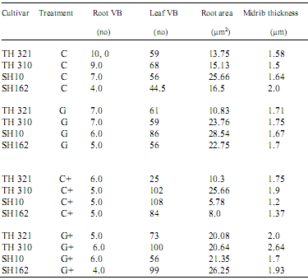

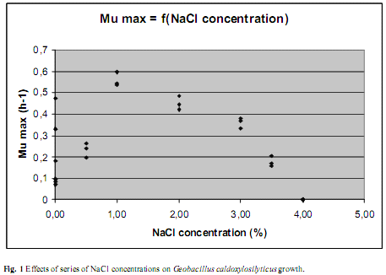

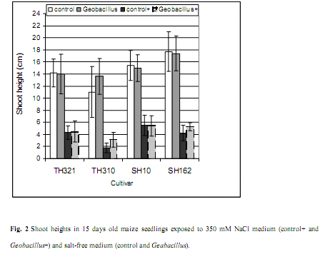

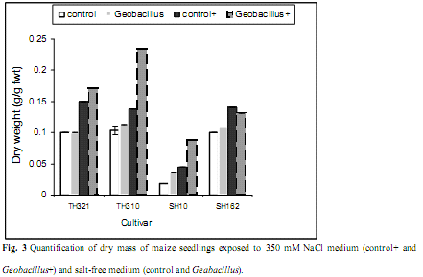

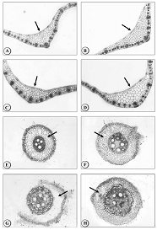
Fig. 4 Light microscope photographs view leaf and root sections of maize seedlings exposed to 350 mM NaCl. Control leaf (A) and salt-stressed leaf (B) control root (E) and salt-stressed root (F). Geobacillus treated control leaf (C) and Geobacillus treated salt-stressed leaf (D). Treated control root with Geobacillus (G) and s treated salt-stressed root with Geobacillu (H). Arrows point to midrib in leaf sections and to cortical layers in root sections. Magnification used (32 X).

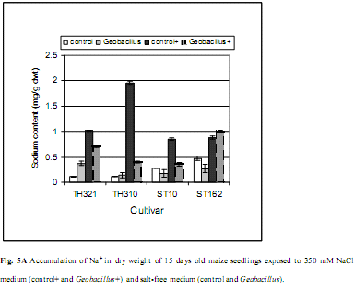

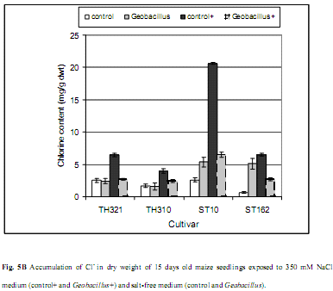
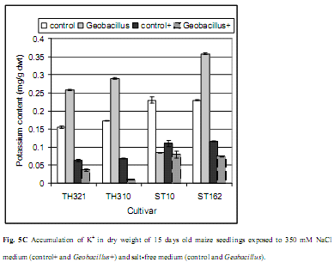

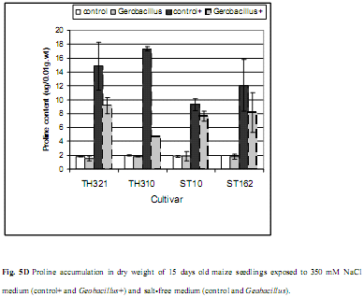

Legends to figures
Fig.1 Effects of series of NaCl concentrations on Geobacillus caldoxylosilyticus growth.
Fig.2 Shoot heights in 15 days old maize seedlings exposed to 350 mM NaCl medium (control+ and Geobacillus+) and salt free medium (control and Geabacillus).
Fig.3 Quantification of dry mass of maize seedlings exposed to 350 mM NaCl medium (control+ and Geobacillus+) and salt free medium (control and Geabacillus).
Fig.4 Light microscope photographs view leaf and root sections of maize seedlings exposed to 350 mM NaCl. Control leaf (A) and salt-stressed leaf (B) control root (E) and salt-stressed root (F). Geobacillus treated control leaf (C) and Geobacillus treated salt-stressed leaf (D). Treated control root with Geobacillus (G) and s treated salt-stressed root with Geobacillu (H). Arrows point to midrib in leaf sections and to cortical layers in root sections. Magnification used (32 X).
Fig.5A Accumulation of Na+ in dry weight of 15 days old maize seedlings exposed to 350 mM NaCl medium (control+ and Geobacillus+) and salt free medium unexposed to 350 mM NaCl (control and Geabacillus).
Fig.5B Accumulation of Cl- in dry weight of 15 days old maize seedlings exposed to 350 mM NaCl medium (control+ and Geobacillus+) and salt free medium (control and Geabacillus).
Fig.5C Accumulation of K+ in dry weight of 15 days old maize seedlings exposed to 350 mM NaCl medium (control+ and Geobacillus+) and salt free medium (control and Geabacillus).
Fig.5D Proline accumulation in dry weight of 15 days old maize seedlings exposed to 350 mM NaCl medium (control+ and Geobacillus+) and salt free medium (control and Geabacillus).
Table.1 Effects of inoculation of Geobacillus caldoxylosilyticus into maize seedlings in improving some anatomical parameters of maize seedlings exposed to 350 mM NaCl medium. Control seedlings (C) salt-stressed seedlings (C+). Geobacillus inoculated into control seedlings (G) Geobacillus inoculated into salt-stressed seedlings (G+). Vascular bundles (VB).

Conclusion
Maintenance of plant growth and productivity involves safe manipulation of environmental undesirable conditions via introduction of biological agent to achieve a biological control. Salt stress is a major stresses caused by ionic stress, frequently quantified by excess Na+, Cl- and K+. Exclusion of these ions is crucial for crop plants protection. Geobacillus caldoxylosilyticus is halophytic bacteria isolated from ponds then inoculated into maize plants prior exposed to 350 mM NaCl for ten days. In terms of the high salt stress and the short experimental span, Geobacillus efficiently acted to encounter number of deleterious impacts during this period. Geobacillus protected plant growth, structure and brought plant physiology to normal even within high ionic stress. Geobacillus retained homeostasis. In addition, Geobacillus-inoculated seedlings possessed less proline, which implies to that plants are not under salt stress. Geobacillus and its application are recommended for crop plants protection against salt stress.

References
- Abdelkader AF, Henrik A, Katalin S, Bela B, Christer S (2007) High salt stress induces swollen prothylakoids in dark grown wheat and alters both prolamellar body transformation and alters both prolamellar body transformation and reformation after irradiation. J. Exp. Bot 58:2553-2564
- Ahmed S, Scopes RK, Rees GN, KC Patel (2000) Saccharococcus Caldoxylosilyicus sp.nov., an obligatory thermophilic, xylose-utilizing, endospore-forming bacterium Int. J. Sys Evol Microbiol 50:517-523
- Alberico GL, Cramer GR (1993) Is the salt tolerance of maize related to sodium exclusion? I. Preliminary screening of seven cultivars. J. Plant Nutr 16:2289-2303
- Aspinall D, Paleg LG (1981) Proline accumulation: physiological aspects, in: L.G. Paleg, D. Aspinall (ed.), The Physiology and Biochemistry of Drought Resistance in Plants, Academic Press, Sydney, pp 205–241
- Azevedo Neto AD, Tabosa JN (2000) Salt stress in maize seedlings: I. Growth analysis. Rev. Bras. Eng Agric Amb 4:159-164
- Azevedo Neto AD, Prisco JT, Enéas-Filho J, De Lacerda CF, Silva JV, Da Costa PHA, Gomes-Filho E (2004) Effects of salt stress on plant growth, stomatal response and solute accumulation of different maize genotypes. Braz J Plant Physiol 1:31-38
- Balch WE, Schoberth S, Tanner RS, Wolfe RS (1977) Acetobaeterium, a new genus of hydrogen-oxidizing, carbon-dioxide-reducing, anaerobic bacteria. Int J Syst BacterioI 27:355-361
- Bates LS, Waldren RP, Teare ID (1973) Rapid determination of free proline for water-stress studies. Plant Soil 39:205–207
- Bohnert HJ, Shen B (1999) Transformation and compatible solutes. Sci Hortic 78:237-260
- Bray EA, Bailey-Serres J, Weretilnyk E (2000) Responses to a biotic stresses. In: Buchanan BB, Gruissem W, Jones RL (eds), Biochemistry and Molecular Biology of Plants, pp.1158-1203. ASPP, Rockville
- Binzel ML, Hasegawa PM, Rhodes D, Handa S, Handa AK, Bressan RA (1987) Solute accumulation in tobacco cells adapted to NaCl. Plant Physiol 84: 408-1415
- Chanway CP (1997) Inoculation of tree roots with plant growth promoting soil bacteria (an emerging technique for reforestation. Forest Sci 43:99-112
- Chen CT, Chen LM, Lin CC, Kao CH (2001) Regulation of proline accumulation in detected rice leaves exposed to excess copper. Plant Sci 160:283-290
- Claussen W (2005) Proline as a measure of stress in tomato plants. Plant Sci.168:241–248
- Cottenie A, Verloo M, Kiekens L, Velghe G, Camerlynck R (1982) Chemical Analysis of Plants and Soils. , Laboratory of Analytical and Agrochemistry, State University Ghent, Belgium. Hand Book.1-6
- Esawy MA, Wafaa A, Samia H, Ahmed A, Combet Y (2007) Natural Material Role in Production, Activation and Stabilization of Alkaline Protease Produced from a New Isolated Geobacillusbacillus caldoxylosilyticus IRD. J App Sci Res.10:1062-1068
- Feder N, O’Brien TP (1968) Plant microtechnique: some principles and new methods. Am J Bot 55:123–142
- Fortmeier R, Schubert S (2006) Salt tolerance of maize (Zea mays L.): the role of sodium exclusion. Plant Cell Environ. 11:1041 – 1047
- Gadallah MAA (1993) Effect of water stress, abscisic acid and proline in cotton plants. J Arid Environ 30:315-325
- Gilbert GA, Gadush MV, Wilson C, Madore MA (1998) Amino acid accumulation in sinks and source tissues of Coleus blumei Benth during salinity stress. J Exp Bot 49:107-114
- Curtis PS, Lauchli A (1987) the effect of moderate salt stress on leaf anatomy in Hibiscus cannabinus (kenaf) and its relation to leaf area. Am J Bot 74:538–542
- Fricke W, Peters WS (2002) the biophysics of leaf growth in salt-stressed barley. A study at the cell level. Plant Physiol 129:374–388
- Gzik A (1996) Accumulation of proline and α-amino acids in sugar beet plants in response to osmotic, water and salt stress. Environ Exp Bot. 36:29-38
- Hasegawa PM, Bressan RA, Zhu JK, Bohnert HJ (2000) Plant cellular and molecular responses to high salinity. Annu. Rev. Plant Physiol Plant Mol. Biol. 51:463-499
- Hungate RE (1969) A roll tube method for cultivation of strict anaerobes, p. 117-132. In J. R. Norris and D. W. Ribbons (ed.), Method Microbiol vol. 3B. Academic Press Inc., New York
- Jain S, Nainawatee HS, Jain RK, Chowdhury JB (1991) Proline status of genetically stable salt-tolerant Brassica juncea L. somaclones and their parent cv. Prakash. PLANT Cell Rep. 12:684-687
- Katerji N, Van Hoorn JW, Hamdy A, Karam F, Mastrorilli A (1996) Effect of salinity on water stress, growth, and yield of maize and sunflower. Agr Water Manage 30:237-249
- Kijne JW (2006) Abiotic stress and water scarcity: Identifying and resolving conflicts from plant level to global level. Field Crops Res 97:3-18
- Mahajan S, Tuteja N (2005) Cold, salinity and drought stresses: An overview. Arch. Biochem Biophys 444:139–158
- Mansour MMF (2000) Nitrogen containing compounds and adaptation of plants to salinity stress. Biol. Plant 43:491–500
- Monreal JA, Jiménez ET, Remesal E, Morillo-Velarde R, García-Mauriño S, Echevarría C (2007)
- Proline content of sugar beet storage roots: Response to water deficit and nitrogen fertilization at field conditions. Environ Exp Bot 60:257-267
- Moradi F, Ismail AM, Gregoria GB, Egdane JA (2003) Salinity tolerance of rice during reproductive development and association with tolerance at the seedling level. Ind. J. Plant Physiol 8:105-116.
- Munns R (2002) Comparative physiology of salt and water stress. Plant Cell and Environ 25: 239–250
- Rai AK, Takabe T (2006) A biotic stress tolerance in plants toward the Improvement of global environment and food. Springer
- Rai V, Vajpayee P, Singh SN, Mehrotra S (2004) Effect of Chromium accumulation in photosynthetic
- pigments, oxidative stress defense system, nitrate reduction, proline level and eugenol content of Ocimum tenuiflorumL. Plant Sci 167:1159-1169.
- Weller DM (1988) Biological control of soilborne plant pathogens in the rhizosphere with bacteria. Annu Rev Phytopathol 26:379-407.
- Yilmaz K, Akinci IE, Akinci S (2004) Response of tomato (Lycopersicon esculentum Mill.) to salinity in the early growth stages for agricultural cultivation in saline environments. J Environ Biol 25:351– 357.
- Liu J, Zhu JK (1997) Proline accumulation and salt-stress-induced gene expression in a salt- hypersensitive mutant of Arabidopsis. Plant Physiol 2:591-596.

11/19/2010

