Mapping water quality of Burullus Lagoon using remote sensing and geographic information system

Mohamed E. Hereher; Mahmoud I. Salem and Dina H. Darwish
Department of Environmental Sciences, Faculty of Science at Damietta, Mansoura
University, Egypt. dina_200777@yahoo.com

Abstract: The present study aims to utilize remote sensing and a geographic information system (GIS) for mapping surface conditions of the Burullus Lagoon, Egypt as a proxy to water pollution. Spatial distribution of suspended matter, nitrogen, phosphorous, chlorophyll, dissolved oxygen, water temperature, salinity, depth, lead, copper, cadmium, clay, and sediment organic carbon has been applied. A Landsat image from the Enhanced Thematic Mapper plus (ETM+) sensor acquired in June 2006 was processed based on a band by band as well as band rationing. Cartographic maps were generated depending on the correlation between the measured parameters and the radiance values of the ETM+ image. Parameters not correlated with the satellite image data have been processed through spatial analysis and interpolation technique using GIS. Results showed that the eastern and southern sections of the lagoon, which receive drainage wastewater, are more polluted than the northern and western sections of the lagoon. The study confirms that remote sensing coupled with GIS could afford an integrated scheme for mapping water quality.
[Mohamed E. Hereher; Mahmoud I. Salem and Dina H. Darwish. Mapping water quality of Burullus Lagoon using remote sensing and geographic information system. Journal of American Science 2011;7(1):138-143]. (ISSN: 1545-1003).
Keywords: Mapping; water quality; Burullus Lagoon; geographic information system

INTRODUCTION
Burullus is one of four shallow coastal lagoons at the Nile Delta of Egypt; namely: Manzala, Burullus, Edku and Maryout (Fig. 1). Burullus lagoon is located between the two Nile branches Rosetta to the west and Damietta to the east. It extends between longitudes 30°31` and 31°05` E and latitudes 31°25` and 31°35`. It occupies an area of 420 km² of which 370 km² are open water (Guirguis et al. 1996). The rest of the area comprises a group of islands distributed within the water body. The length of the lagoon is about 53 km, its width is about 13 km and it has water depths ranging from 0.5 to 2.5 m (Frihy and Dewidar, 1993). It connects to the sea through a narrow strait called Al-burg inlet or Boughaz El-Burullus at its northeast side. The lagoon is separated from the sea by a narrow coastal strip covered by sand sheets and sand dunes. The Burullus lagoon receives drainage water at its southern boundary through seven drains. It also receives fresh water from Brimbal Canal situated at its southwestern corner (Okbah and Hussein, 2006). Agricultural lands encompass the southern and eastern fringes of the lagoon. The environment of Burullus Lagoon has witnessed the significant change during the last three decades as many drains were constructed to convey agricultural wastes into the lagoon. In addition, substantial area has been dried up to agricultural land.
Remote sensing, which is the science of obtaining information about an object without being in physical contact, has been widely used with GIS in water quality studies (Usali and Ismail, 2010). Generally, turbidity, chlorophyll and nutrients can change the reflected or emitted electromagnetic radiation from surface water. These changes could be monitored by remote sensing. Empirical relationships between spectral properties and water quality parameters were established as early as 1970s (Morel and Gordon, 1980). Substances that do not affect the spectral properties of surface water could be mapped by other modeling surrogates (Ritchie and Schiebe, 2000). GIS is one of these techniques.
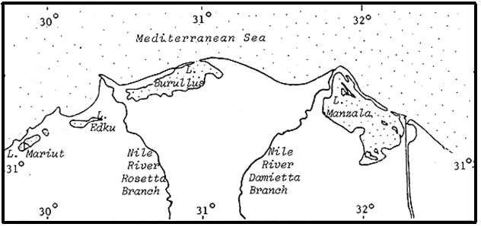
Figure (1): Location map of the Nile Delta showing the four coastal lagoons.

The ecology of Burullus Lagoon has been studied by El-Sherif (1993); Aboul Ezz (1995); Khedr (1999); Ramadani et al. (2001); and Radwan (2002). Bottom sediments and heavy metal pollution studies were carried out by El-Sabrouti (1984); El-Sammak and El-Sabrouti (1995); Abdel-Moati and El-Sammak (1997); Radwan and Lotfy (2000) and Abdel-Baky et al. (1998). Remote sensing is a new technique used to map water quality parameters, such as chlorophyll content and suspended matter (Arenz et al. 1996; Dewidar and Khedr, 2001 and Vincent et al., 2004). This technique can be applied for lakes and reservoirs (Lathrop and Lillesand 1989), and tropical coastal areas (Ruiz- zuara, 1995). Dewidar and Khedr (2005) utilized Thematic Mapper (TM) data combined with field data measurements during April 2004 to map the depth, salinity, sand, and sediment organic matter in the Burullus Lagoon. The major objective of the present study is to map water pollution in Burullus Lagoon using chemical analysis, remote sensing and GIS.

MATERIALS AND METHODS
a) Water and sediment analysis
Eighteen sites covering the entire Burullus Lagoon body were identified during May 2008, and each site was represented by a surface water sample and a bottom sediment sample. Sampling locations were grouped into three regions: east (6 samples), middle (7 samples) and west (5 samples) of the lake (Fig. 2). Water samples were taken by a cleaned one liter polyethylene bottle immersed 20 cm below the water surface. At each site, field measurements were carried out; including: 1- the geographic location using a Garmin Map GPS; 2- water depth using a pocket echo sounder; 3- water salinity using a portable TDS meter and 4- water temperature. In the laboratory, the following parameters were determined in water: 1- turbidity using the standard nephelometric method (Environmental Protection Agency, EPA, 1983); 2- dissolved oxygen using the standard Winkler method (American Public Health Association, APHA, 1985); 3- chlorophyll (a) according to APHA (1985); 4- ammonia-nitrogen according to APHA (1989); 5- dissolved reactive phosphorous (DRP) by the direct stannous chloride method (APHA, 1985) and 6- the heavy metals (Cd, Cu and Pb) by the solvent extraction method (APHA, 1992). The sediment samples were collected by a grab sampler. The samples were air dried and the following parameters were measured: 1- the grain size analysis using the Hydrometer methods (piper, 1955) and 2- the organic carbon content using the Walkley and Black rapid titration method (Black, 1965).
b) Remote sensing analysis
A Landsat ETM+ image acquired in 12 June 2006 (Path 177 and Row 38) was used in this study as this date was the most available for the analysis. This image contains 7 bands (three in the visible and four in the infrared portions of the spectrum). The thermal band was eliminated from the ETM+ image and the image processing was applied to the other 1-5 and the 7th bands. The image was registered to the Universal Transverse Mercator (UTM) Projection using several well distributed ground control points (GCPs) obtained from 1:50,000 topographic maps. A subset image covering the boundaries of the Burullus Lagoon was created. At this subset image, the raw digital numbers were converted to radiance value. Correlation matrices were used to explore the relationship between the measured water quality parameter and the ETM+ radiance data. Regression relationships were generated between the individual band readings and the water parameters as well as between band ratios (b1/b2, b1/b3, b1/b4, b2/b1, b2/b3, b3/b1, b3/b2, b3/b4, b4/b2, b4/b3 and b7/b5) and the water parameters. Statistical analysis was carried out using SYSTAT software (Wilkinson, 1997). Image processing techniques were performed using ERDAS Imagine software. Cartographic maps of the correlated parameters were created in ArcMap software.
c) GIS analysis
The GIS analysis was carried out using ArcGIS software in order to make spatial distribution maps of the parameters not correlated with the satellite data. The boundary of the lake was digitized using the polygon shapefile. The geographic locations (Longitudes and Latitudes) of the sampled sites were inserted as a basic separate layer and a database table containing the results of the different water and soil parameters was created. For each parameter, the spatial analysis was applied based on the interpolation and surface analysis methods yielding a contour map. Then a clip image containing the classified spatial distribution map for each measured water and sediment parameter was extracted.

RESULTS
The correlation matrix between the examined water and sediment parameters and the radiance values of the satellite image data is shown in Table (1). Only turbidity, chlorophyll-a, temperature and ammonia nitrogen are correlated with the radiance values of the ETM+ image. Turbidity is highly positively correlated with B4/B2 (P<0.01) and B4/B3 (P<0.05); chlorophyll-a is highly positively correlated with B4/B2, B4/B3 (P<0.001) and B7, B5 (P<0.01); temperature is highly positively correlated with B3/B1 (P<0.01) and B2/B1 (P<0.05); and ammonia nitrogen is positively correlated with B2, B3 and B2/B3 (P<0.05). The models representing the statistical relationships for the measured water parameters and the radiance value of the ETM+ satellite image are as follows:

Table (1): Correlation matrix between the environmental variables and the ETM+ data for Burullus Lake. * P<0.05, ** P<0.01, *** P<0.001.
N-NH₃  ppm | DRP  ppm | Pb ppm | Cu ppm | Cd  ppm | Chlo (a)  mg/l | Turb.  NTU | TDS, ppm | D.O., mg/l | Temp,  °C | Depth, m
0.300 | 0.0855 | -0.204 | 0.111 | 0.429* | 0.0333 | -0.0431 | -0.0859 | -0.206 | -0.633*** | 0.440* | B1
0.382* | 0.0137 | -0.0484 | 0.190 | 0.361* | -0.0858 | -0.208 | 0.204 | -0.128 | -0.443* | 0.200 | B2
0.363* | 0.0271 | -0.214 | 0.186 | 0.489** | 0.0712 | 0.0182 | 0.0671 | -0.283 | -0.406* | 0.315 | B3
0.164 | -0.184 | -0.323 | -0.209 | -0.0174 | 0.299 | 0.0684 | -0.223 | 0.240 | -0.631*** | 0.354* | B4
-0.0025 | 0.149 | -0.333 | 0.258 | 0.453** | 0.551** | 0.346 | -0.187 | -0.202 | 0.0634 | 0.214 | B5
0.0611 | 0.169 | -0.389 | 0.276 | 0.520** | 0.516** | 0.335 | -0.132 | -0.279 | -0.011 | 0.280 | B7
0.335 | 0.0947 | -0.144 | 0.152 | 0.447* | 0.00143 | -0.0814 | 0.0222 | -0.205 | -0.532** | 0.364* | B1/B2
0.311 | 0.113 | -0.187 | 0.136 | 0.465** | 0.0474 | -0.00937 | -0.00128 | -0.246 | -0.512** | 0.383* | B1/B3
0.0885 | 0.313 | 0.0391 | 0.345* | 0.652*** | 0.250 | 0.249 | -0.0637 | -0.287* | 0.176 | 0.122 | B1/B4
-0.0258 | -0.277 | 0.0962 | -0.0184 | -0.422* | -0.173 | -0.243 | 0.240 | 0.283* | 0.450* | -0.520** | B2/B1
0.354* | -0.0404 | 0.215 | 0.169 | 0.131 | -0.296 | -0.506** | 0.365* | 0.132 | -0.382* | 0.0129 | B2/B3
-0.0565 | -0.238 | -0.0659 | -0.0295 | -0.320 | -0.0209 | -0.0165 | 0.186 | 0.124 | 0.531** | -0.465* | B3/B1
0.262 | 0.122 | -0.370* | 0.152 | 0.564*** | 0.251 | 0.285 | -0.0549 | -0.437* | -0.271 | 0.390* | B3/B2
0.205 | -0.0768 | -0.0336 | 0.0362 | 0.0269 | -0.418* | -0.236 | 0.302 | -0.225 | -0.286 | -0.0039 | B3/B4
-0.132 | 0.102 | -0.155 | 0.104 | 0.281 | 0.648*** | 0.462** | -0.257 | 0.0609 | 0.155 | 0.132 | B4/B2
-0.120 | 0.0732 | -0.111 | 0.109 | 0.252 | 0.626*** | 0.413* | -0.253 | 0.115 | 0.161 | 0.094 | B4/B3
0.239 | 0.0585 | -0.461* | 0.255 | 0.518** | 0.326 | 0.197 | 0.0319 | -0.344* | -0.185 | 0.259 | B7/B5
TEMPERATURE MODEL:
Y _{temperature} = a + bX1 + cX2 +dX3
Where Y _{temperature} = Temperature expressed in degrees centigrade.
X1 = B1,
X2 = B4,
X3 = B1/B3, and
a = 21.747, b = - 276.678, c = - 1.538, and d = 20.776

TURBIDITY MODEL:
Y _{turbidity} = a + bX1 + cX2 +dX3
Where Y _{turbidity} = Turbidity expressed in NTU.
X1 = B2/B3,
X2 = B4/B2,
X3 = B4/B3, and
a = 100.409, b = - 68.853, c = 213.145, and d = - 187.046

CHLOROPHYLL (a) MODEL:
Y _{chlo.(a)} = a + bX1 + cX2 +dX3
Where Y _{chlo.(a)} = Chlorophyll (a) expressed in milligram per litter.
X1 = PC1,
X2 = B3/B4,
X3 = B4/B2, and
a = -8.145, b = 68.036, c = 25.986, and d = 44.195
AMMONIA-N MODEL:
Y _{Ammonia-N} = a + bX1 + cX2 +dX3
Where Y _{Ammonia-N} = Ammonia-N expressed in milligram per litter.
X1 = B2,
X2 = B3,
X3 = B2/B3, and
a = -100.988, b = -1911.345, c = 1486.719, and d = 273.861

Cartographic maps for the distribution of turbidity, chlorophyll, temperature and nitrogen based on these models are shown in Figure (2). These maps show that the chlorophyll concentration is higher at the southern part of the lagoon than the other sides and the lagoon has low water turbidity for its major basins. In addition, the nitrogen distribution coincides with the chlorophyll distribution and the water temperature is homogeneous throughout the water body (22-24°C) except some minor colder basins (20-22°C). Other parameters (depth, dissolved oxygen, salinity, phosphorous, Pb, Cd, Cu, OC, and clay content) did not have correlation with the image radiance values. Consequently these other parameters were spatially distributed using the interpolation method in ArcGIS (Fig. 3).
Figure (3) shows that the lake is generally shallow (<140 cm). The eastern side is shallower than the rest of the lake. The deepest region of the lake occurs at the middle basin (> 140 cm). Water salinity is generally lower at its western sector and the dissolved oxygen of the majority of the lake basins approaches 5 mg/l. Phosphorous is maximal in the middle part of the lake. The distribution of the clay and organ carbon is generally correlated, where most of the lake sediments range in clay content between 20-30% and in the organic matter between 2-3%. The heavy metals' distribution indicates that lead is lower at the northern part of the lake, whereas copper has a heterogeneous distribution. Cadmium generally increases westward.

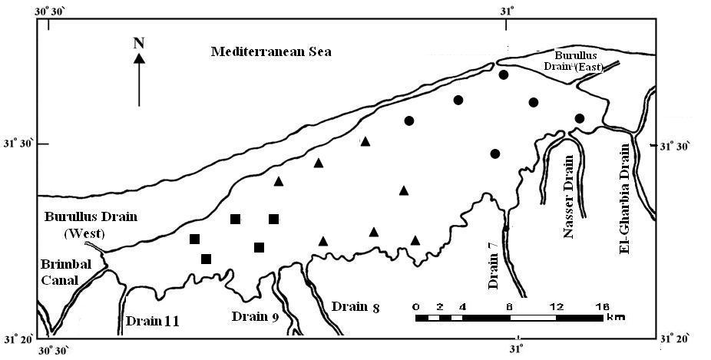
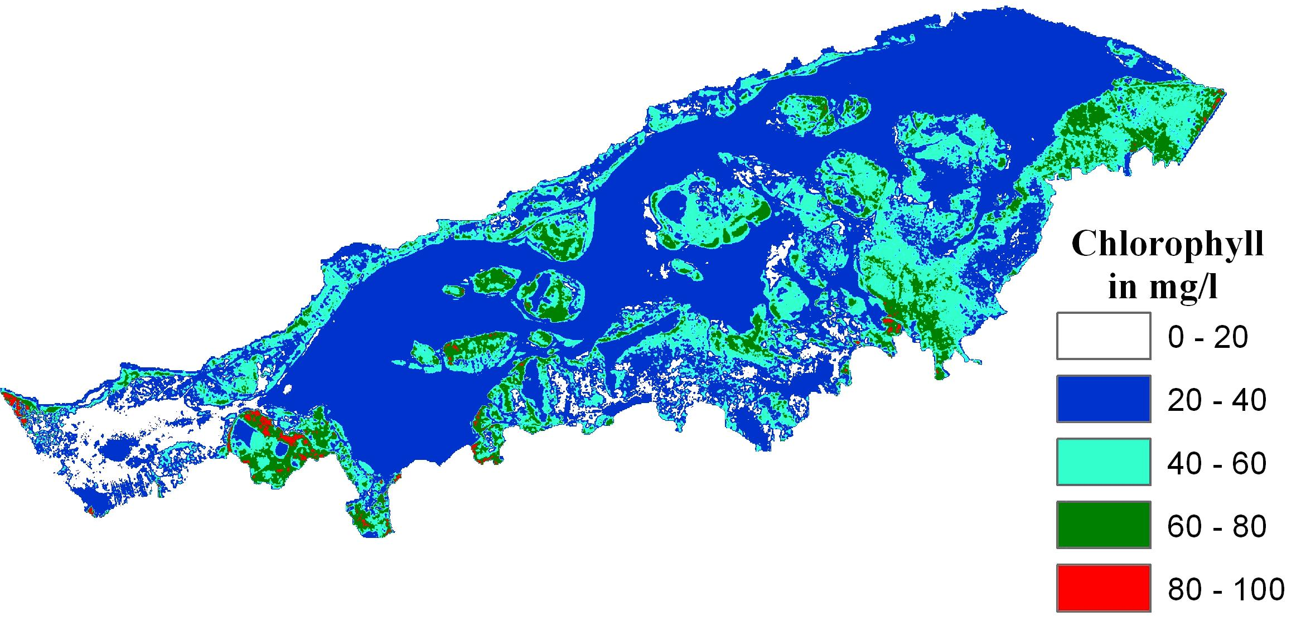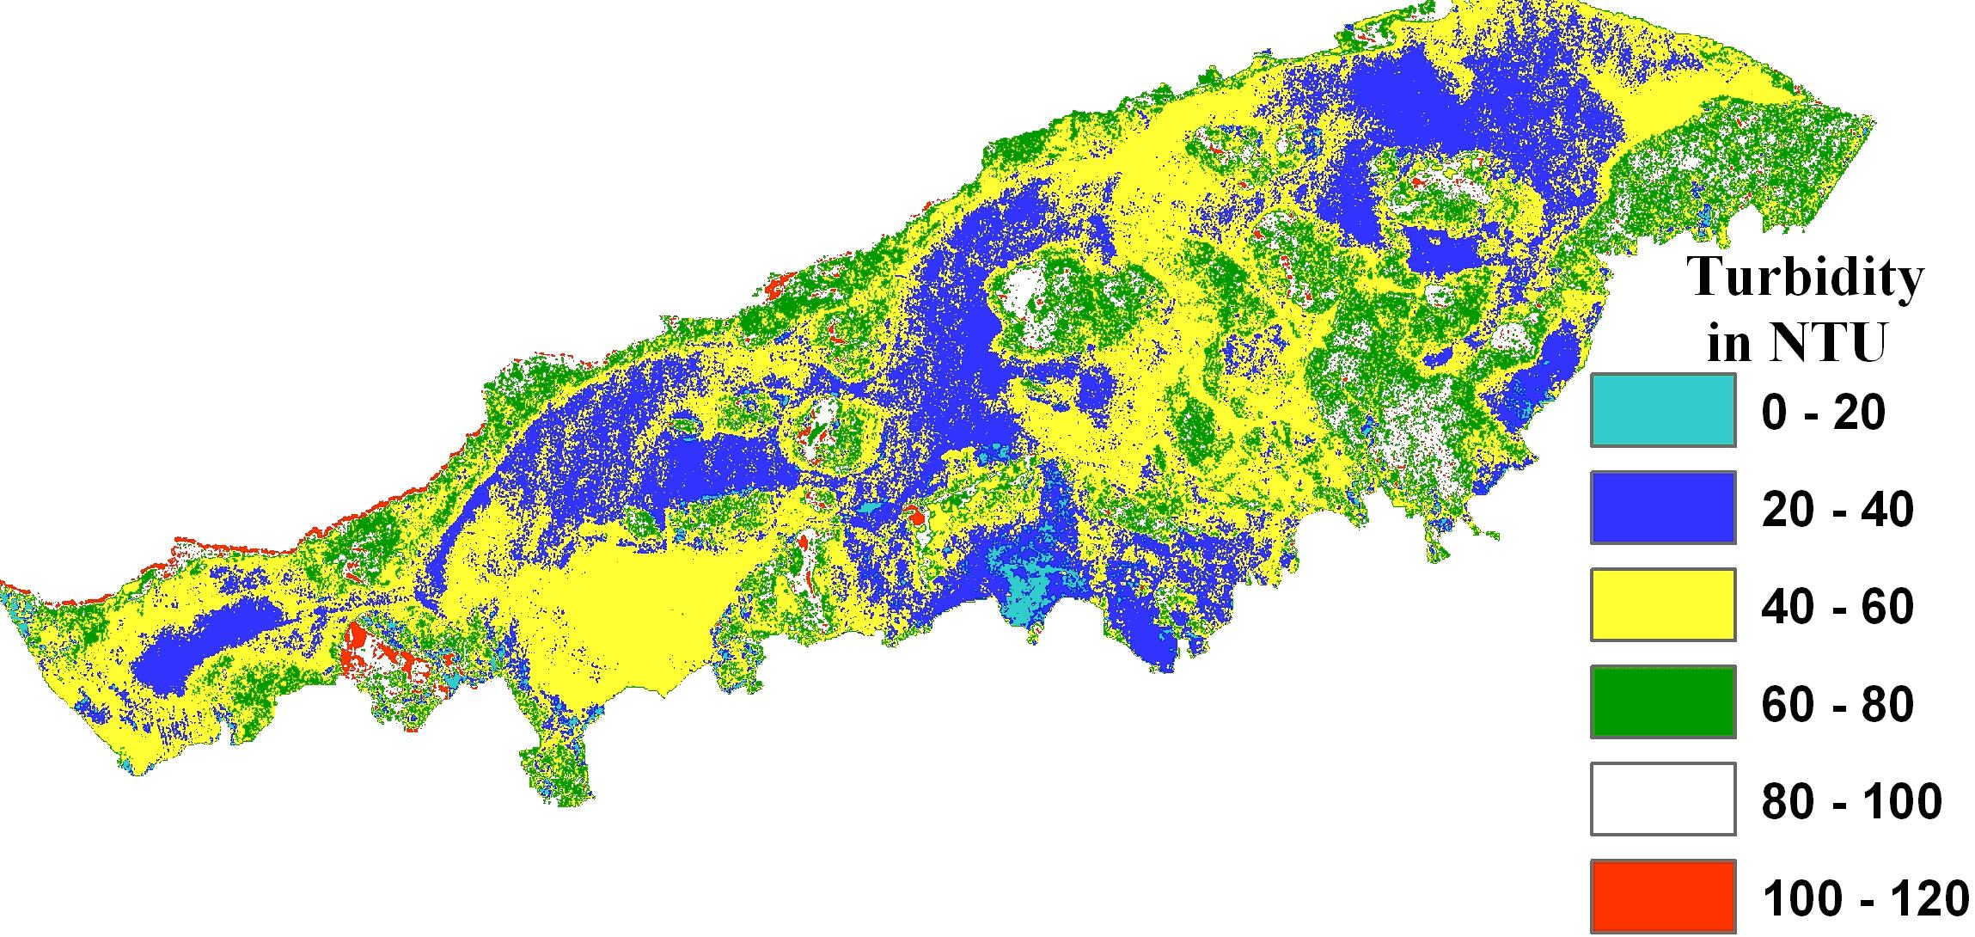
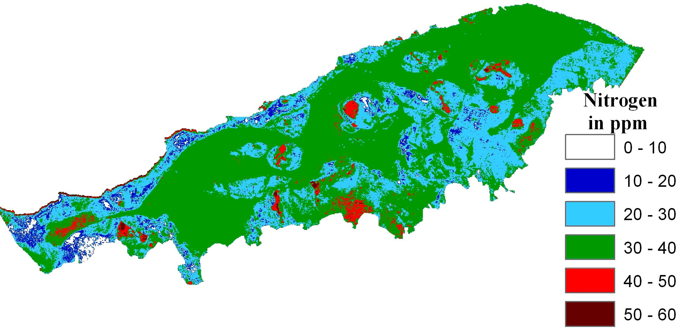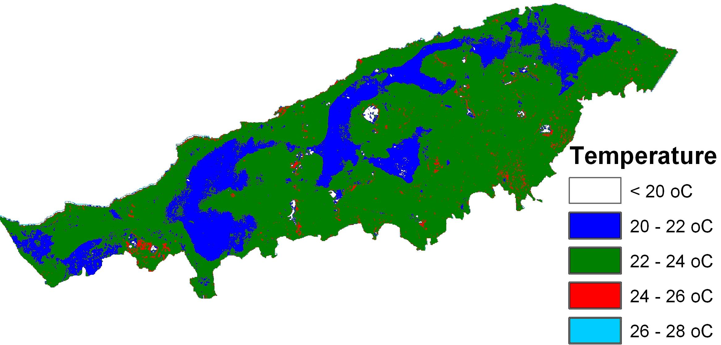
Figure (2): Sampling sites and cartographic maps of chlorophyll, turbidity, nitrogen and temperature distribution as obtained from remote sensing analysis.
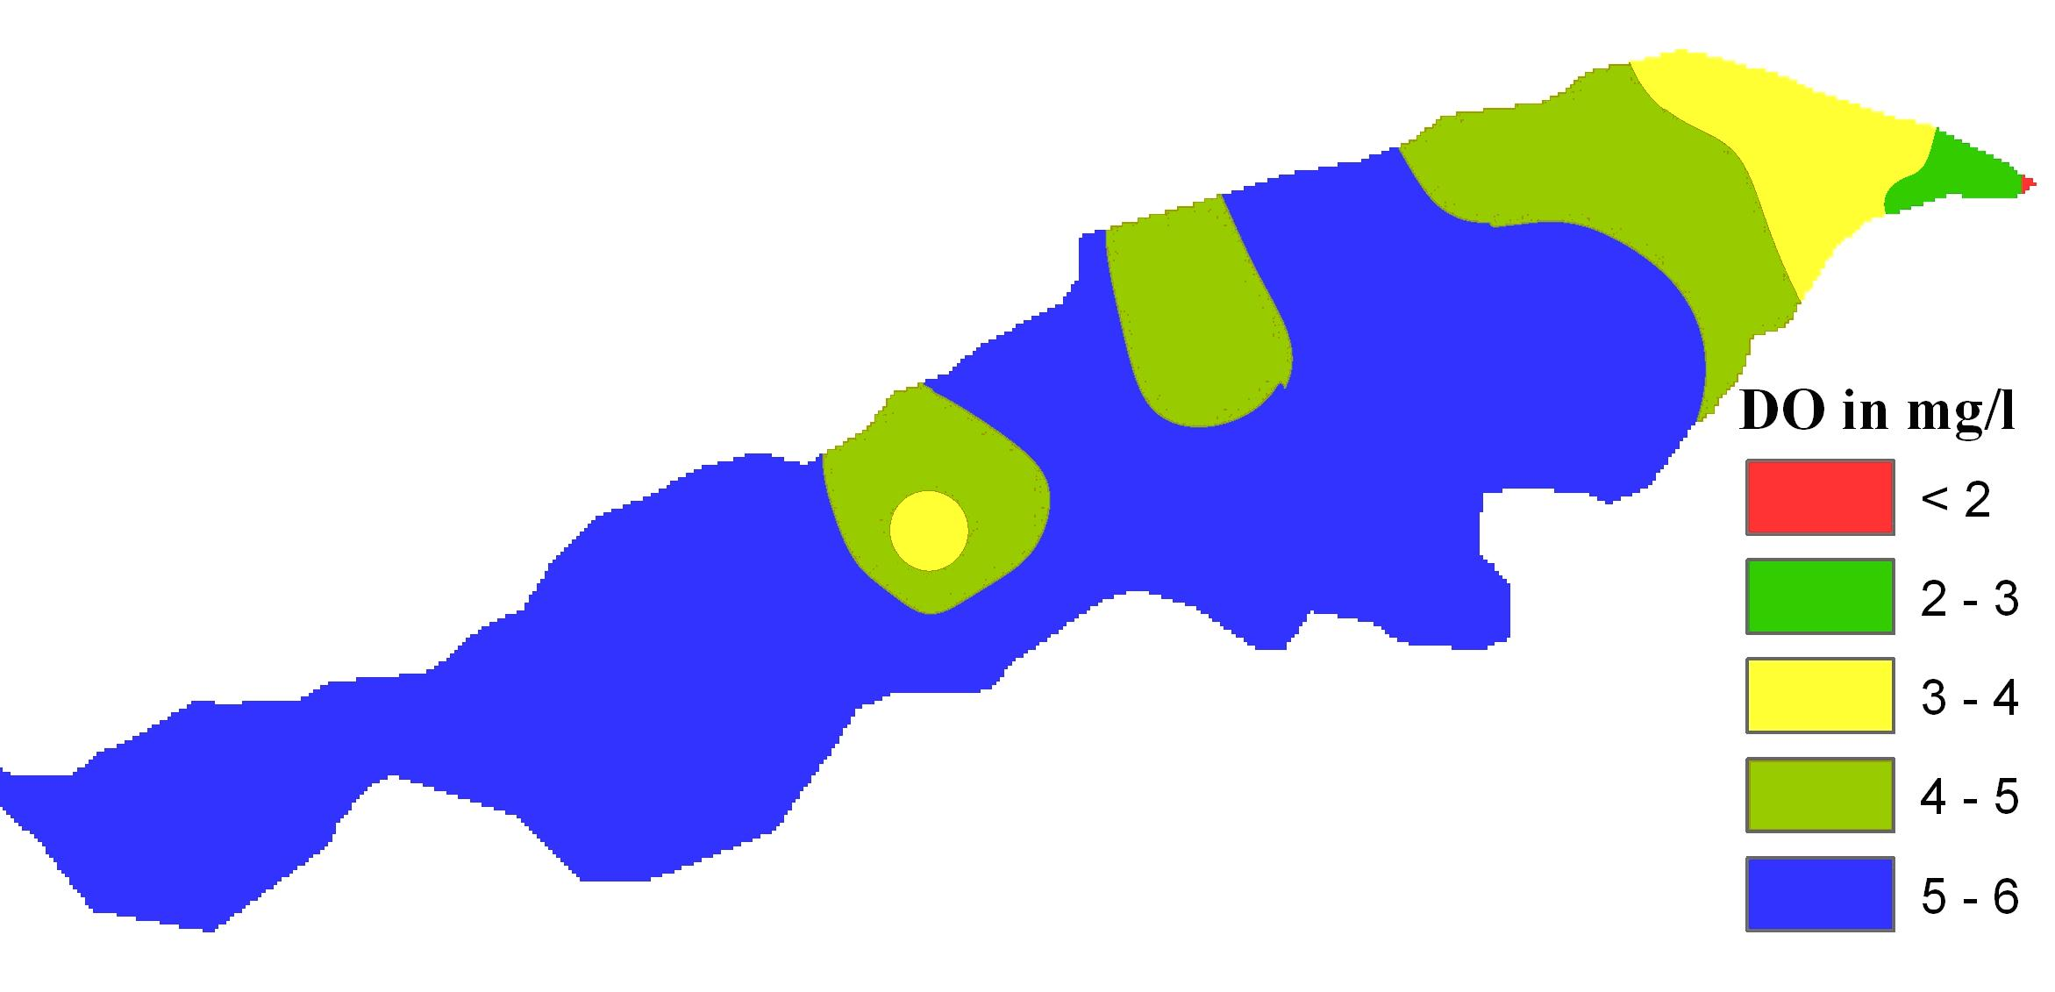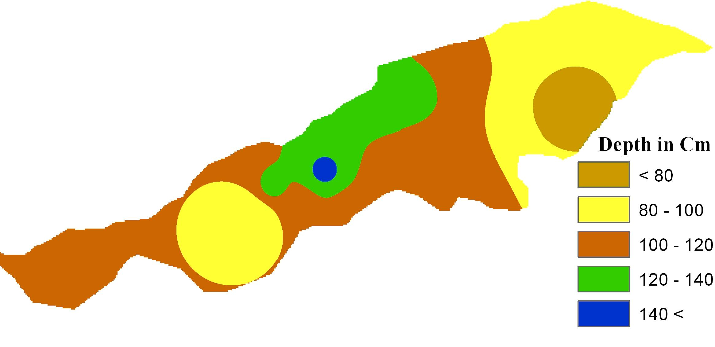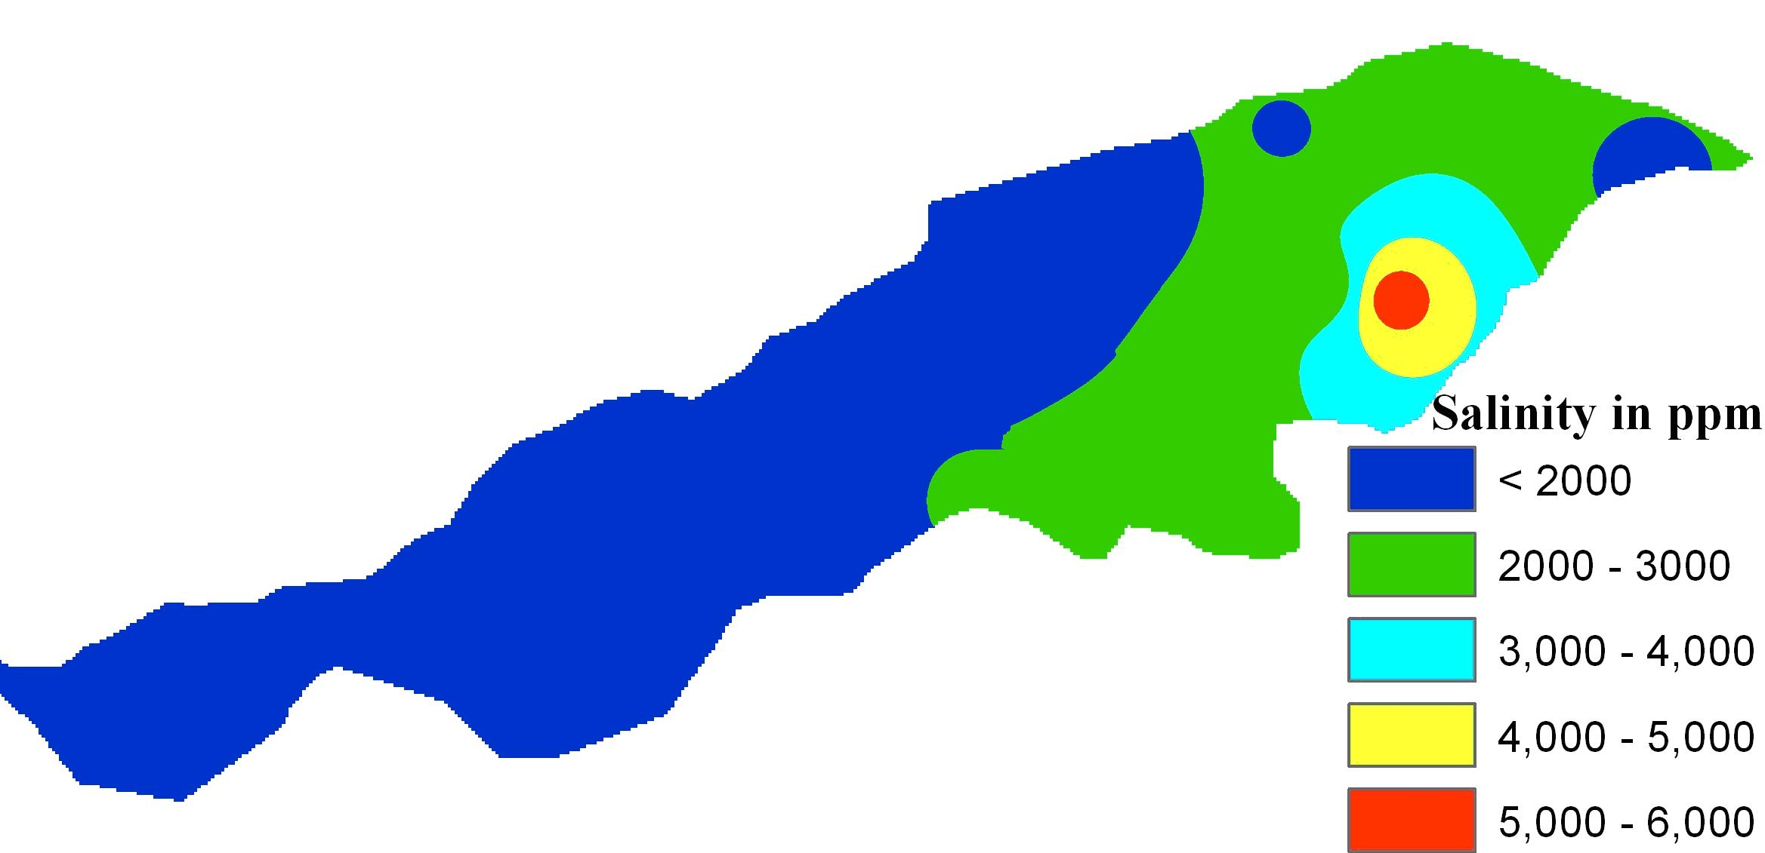

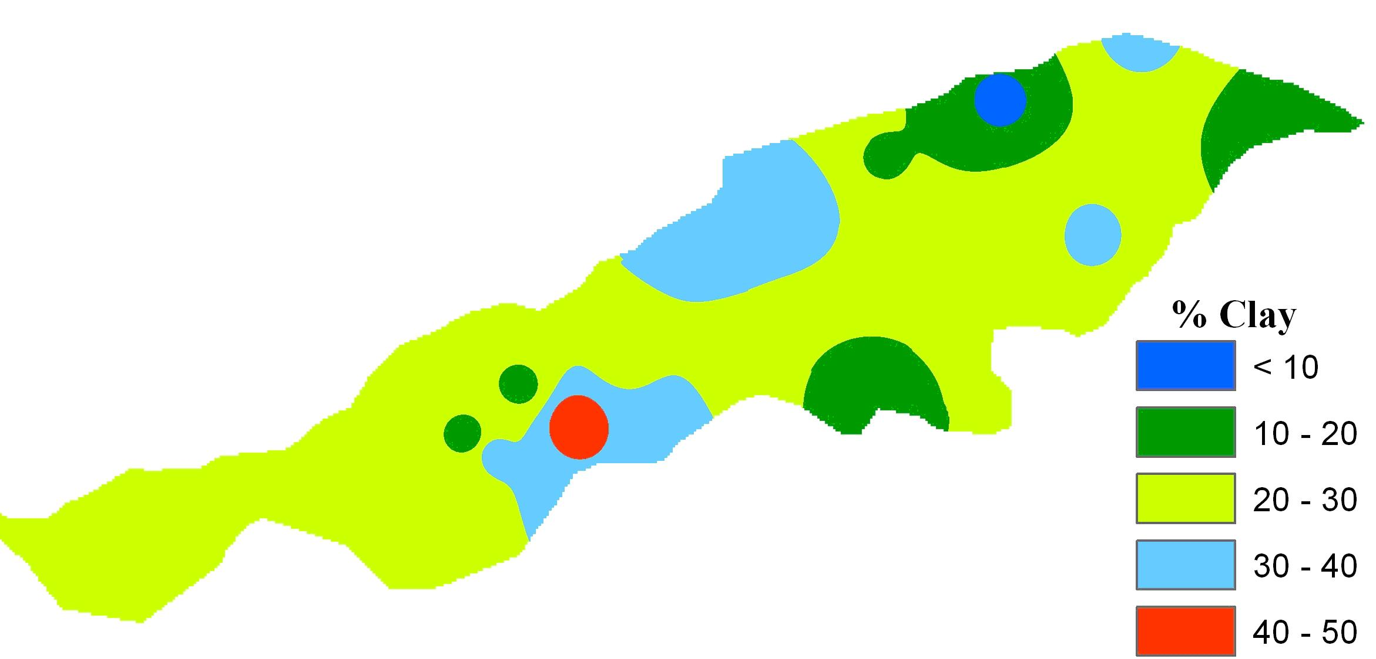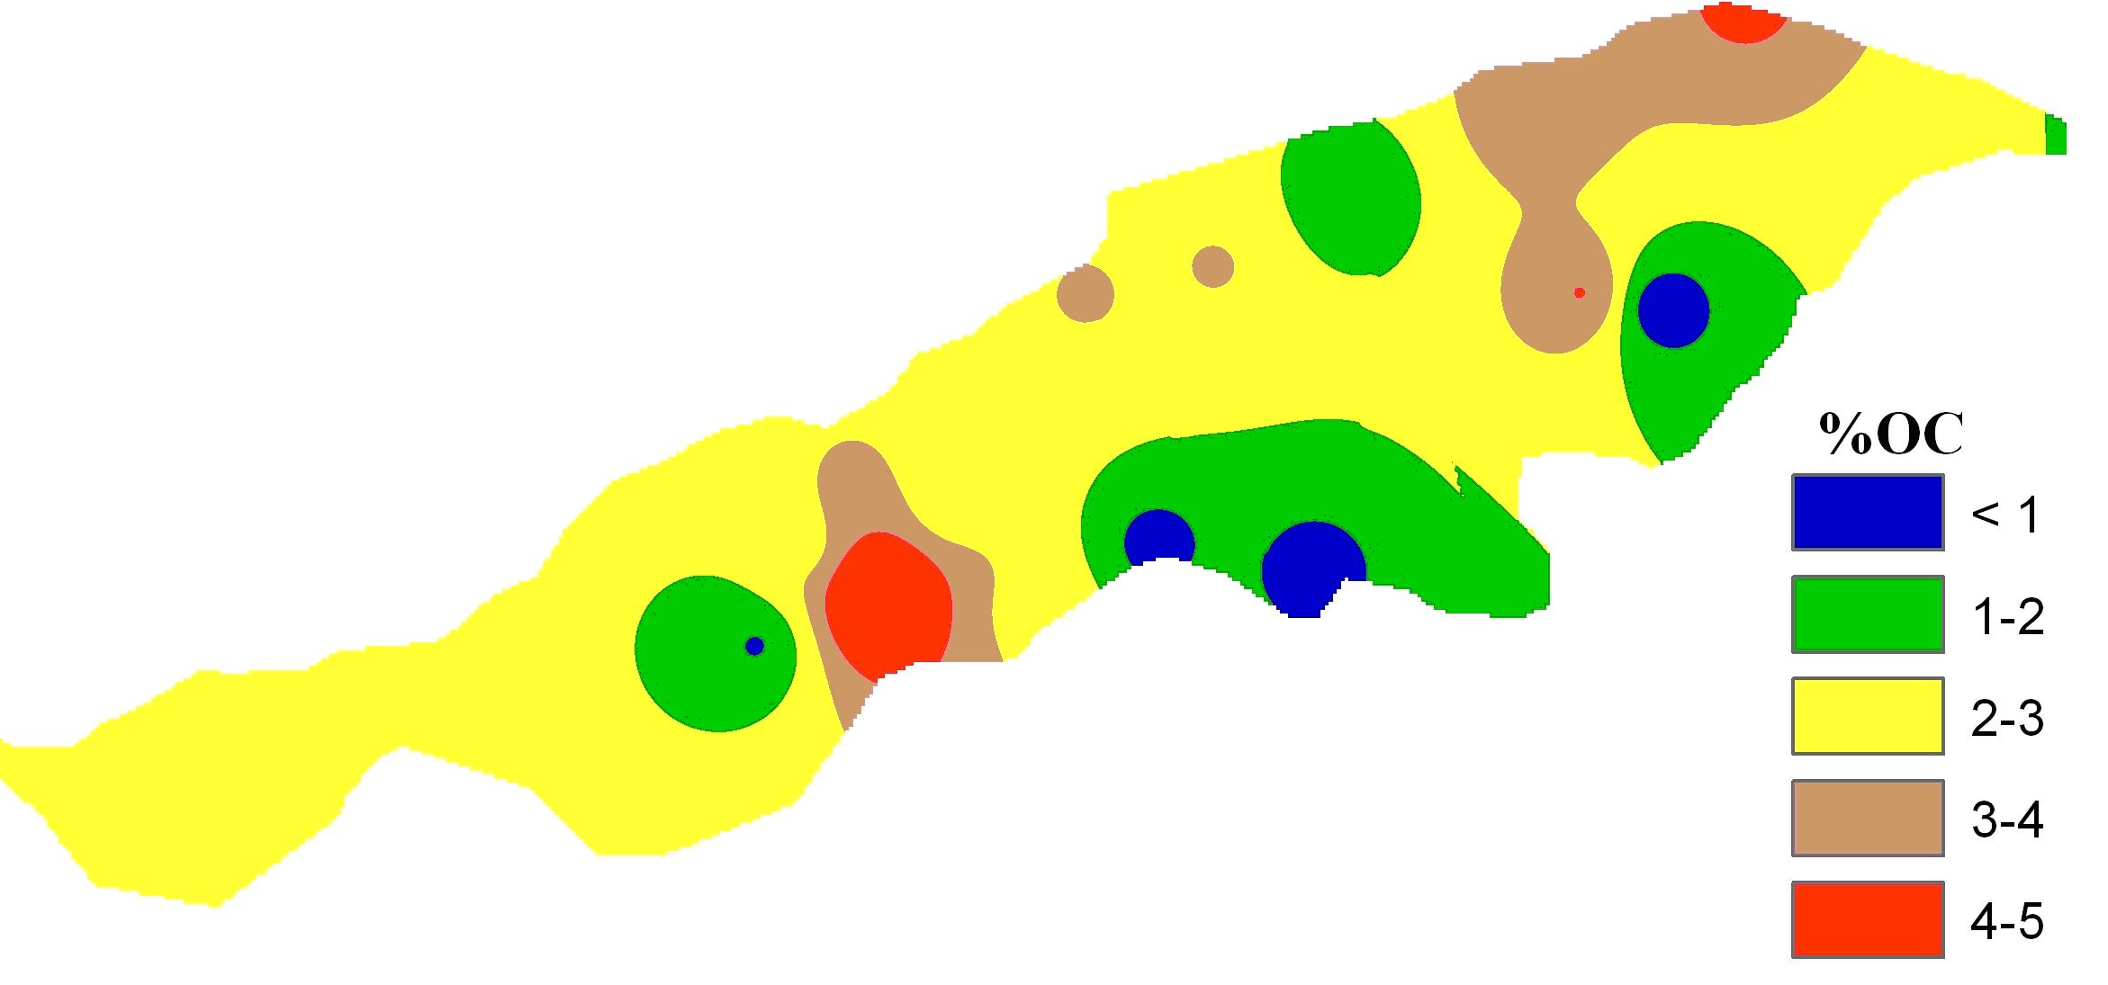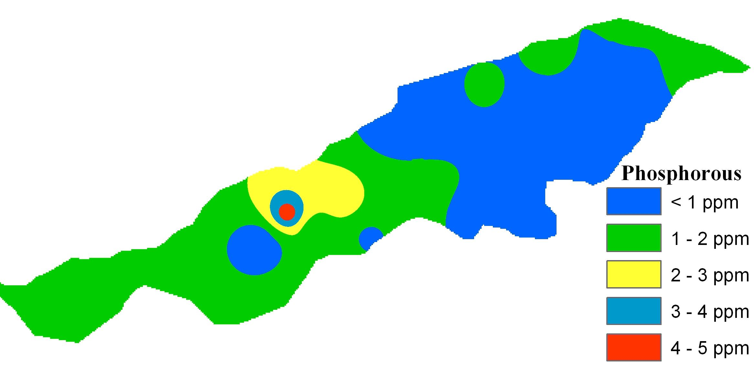

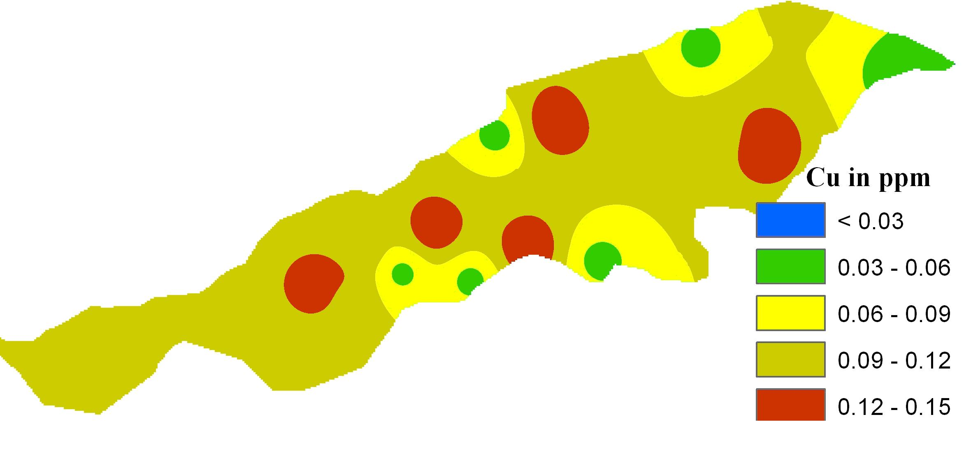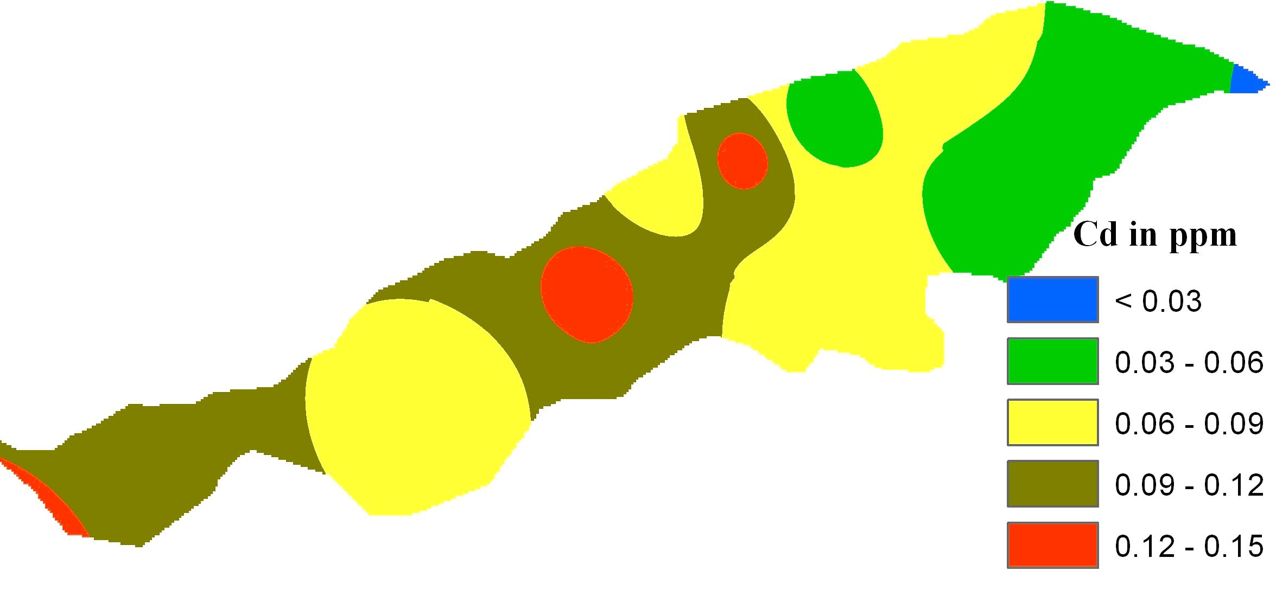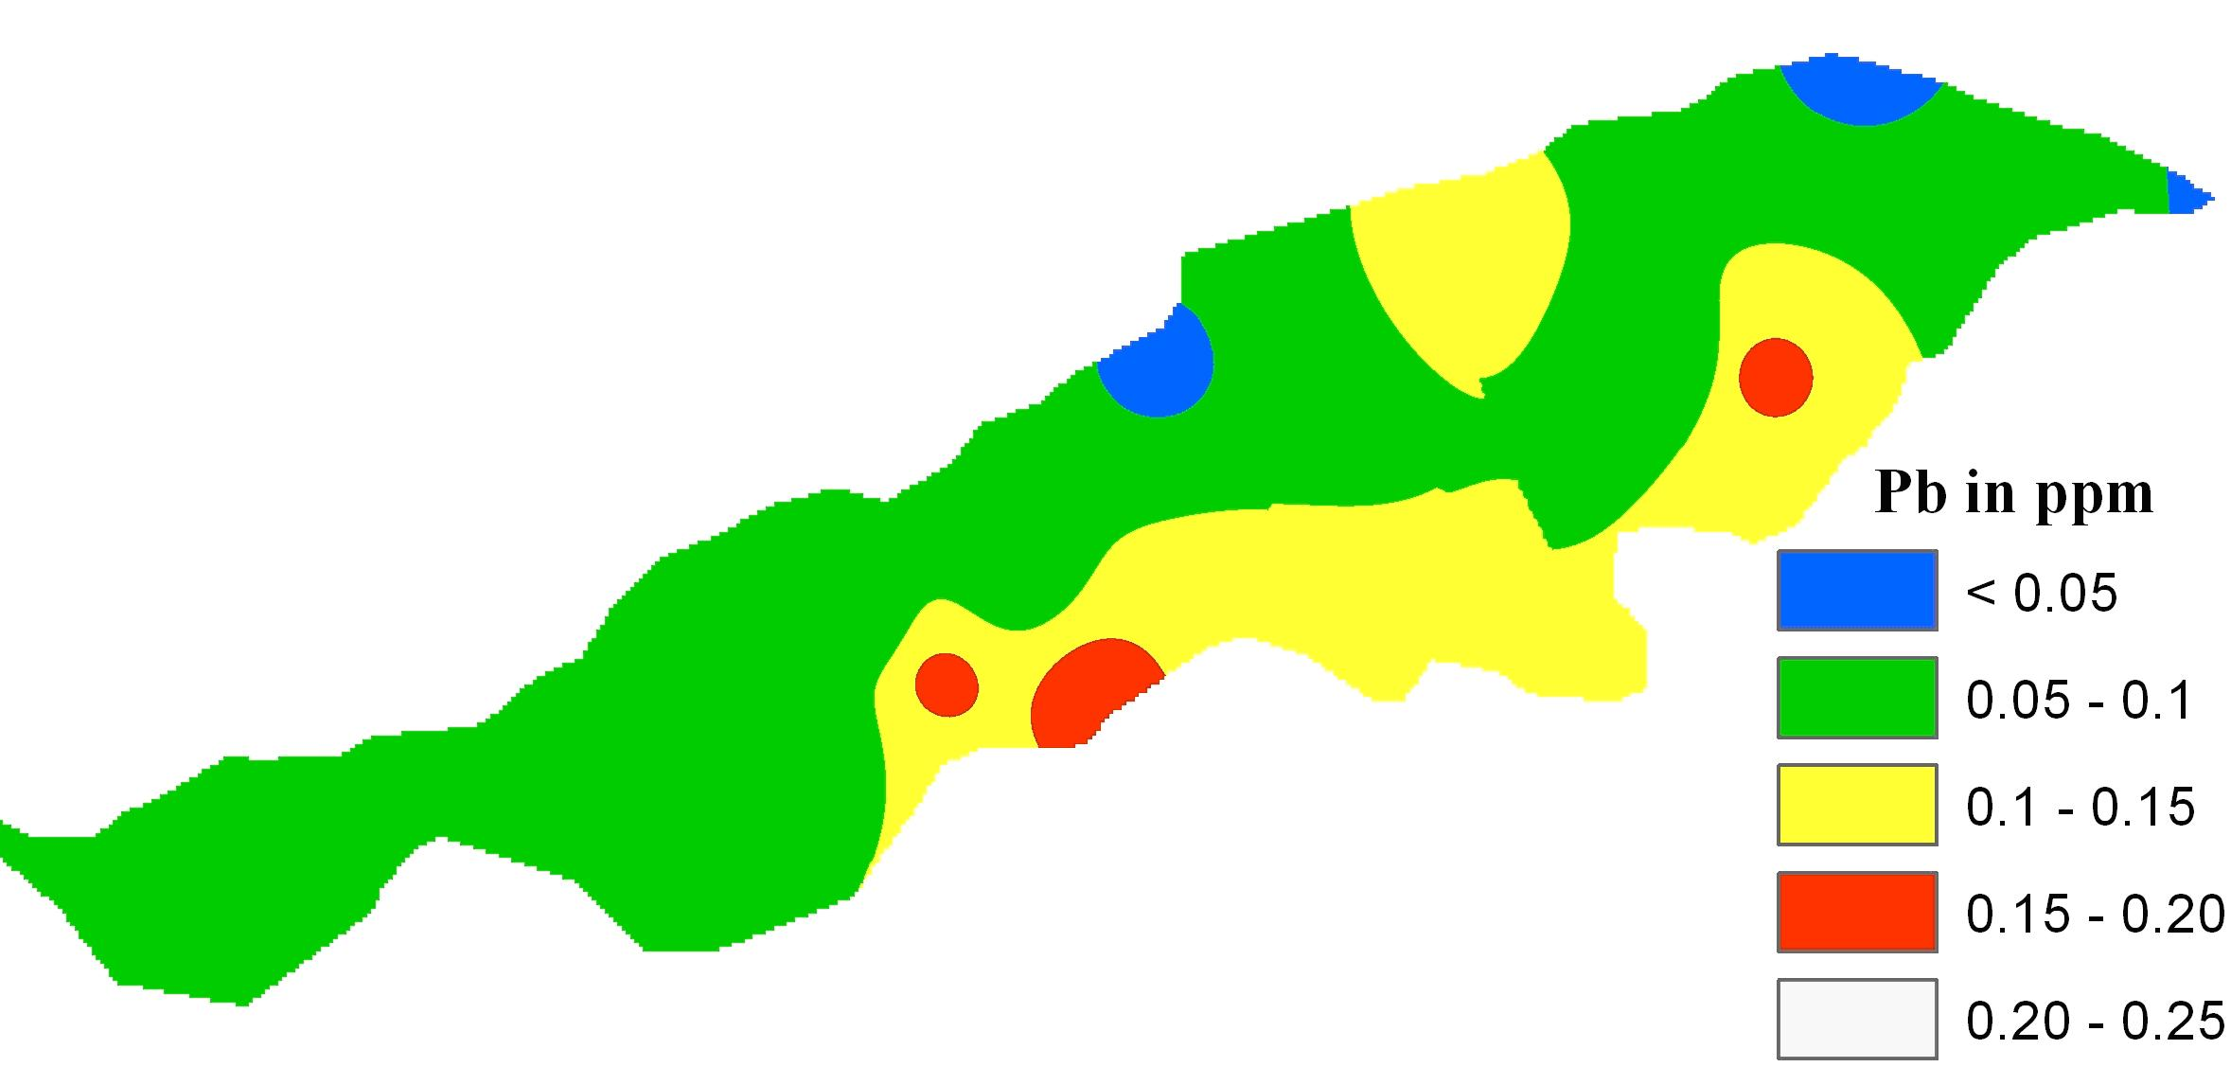
Figure (3): Cartographic maps of salinity, depth, DO, phosphorous, OC%, %clay, Pb, Cu, and Cd as obtained from the GIS analysis.

DISCUSSION AND CONCLUSIONS
The environmental conditions of the Burullus Lagoon have been impacted by the discharge of agricultural wastes into the water body. Although the lake receives seawater from a narrow straight at its northeastern section, continuous release of wastewater from the southern drains is much greater than seawater discharge into the lagoon. This situation has eventually accelerated eutrophication of the water body due to the increased nutrient inflow to the lake. Figures 2&3 highlight the significant increase of turbidity, nitrogen, and chlorophyll at the southern side of the lagoon, which receive the drainage water from six agricultural drains (Drain 11; Drain 9; Drain 8; Drain 7; Nasser Drain; and El-Gharbia Drain). Phosphorous concentration is observed to be higher in the middle part of the lagoon, which confirms with Okbah (2005). Water salinity of the lagoon is lower in the western section of the lagoon (< 2000 ppm) than in the eastern side. This variation of salinity is attributed to the difference of water salinity of the source water coming into the lagoon. The western section receives fresh Nile water from Brimbal Canal, which dilutes water within the lagoon to less than 2000 ppm. The eastern side of the lake receives water directly from the sea and therefore, water in this side is much salty. Moreover, the chlorophyll content is also minimal at the western side (Fig. 2) due to the discharge of fresh Nile water into this side through Brimbal Canal.
The dissolved oxygen of the lagoon is generally high (5-6 mg/l), particularly at the western side. The easternmost section of the lagoon, which receives the greatest wastewater effluents from four drains (Drain 7; Nasser Drain; El-Gharbia Drain; and Burullus Drain West) containing sewage and agricultural waste, exhibits the minimal dissolved oxygen content. The concentrations of the heavy metals lead, copper and cadmium ranged between (0.03 – 0.17); (0.05 – 0.15); and (0.03 – 0.17 ppm), respectively. The distribution of lead is greater in the southeastern section. Copper is released into water from the boat paintings of local fishermen. Cadmium is discharged with wastewater, and it is observed greater in the western section than in the eastern side. According to the United States Environmental Protection Agency (USEPA, 1986), both lead and cadmium concentrations are greater than the permissible limits of heavy metals in saltwater.
Bottom sediments of the lagoon have mainly a silty to clayey texture, where the majority of lake sediments contain 20-30% clay. Organic matter distribution coincides with clay distribution. Generally, the organic carbon of the lagoon is high, averaging 2-3% of the bottom sediments. These results agree with a previous study by Coutlier and Stanly (1987) who observed that the bottom sediments of the lagoon are mainly silty clay high in organic matter content. In a conclusion, the eastern and southern sides of the Burullus Lagoon are much polluted than the northern and western sides. The primary reason is the occurrence of many drains carrying sewage and agricultural waste at these sides.

REFERENCES
1- Abdel-Baky, T. E., Hagras, A. E., Hassan, S. H. and Zyadah, M. A., (1998): Environmental impact assessment of pollution in Lake Manzala, I-Distribution of some heavy metals in water and sediment. J. Egypt. Ger. Soc. Zool., 26: 25-38.
2- Abdel-Moati, M. A. and El-Sammak, A. A. (1997): Man-made impact on the geochemistry of the Nile Delta Lakes. A study of metals concentrations in sediments. Water, Air and Soil Pollution, 97: 413-429.
3- Aboul Ezz, S. M. (1995): Zooplankton of lake Burullus, Egypt. Bull. Nat. Inst. Oceangr. & Fish, 21: 233-261.
4- APHA (1985): Standard methods for the examination of water and wastewater, 16th Ed., American Public Health Association, Washington, D.C., USA.
5- APHA (1989): Standard Methods for the Examination of water and waste water, 17th Ed., American Public Health Association, Washington, D.C., USA.
6- APHA (1992): Standard Methods for the Examination of water and waste water, 18th Ed., American Public Health Association, Washington, D.C., USA.
7- Arenz, R. F., Lewis, W. M., and Saunders, J. F. (1996): Determination of chlorophyll and dissolved organic carbon from reflectance data for Colorado reservoirs. Int. J. Remote Sensing, 17: 1547–1566.
8- Black, C. A. (1965): Methods of soil analysis, Soil Society of America, Madison, USA.
9- Coutlier, V. and Stanley, D. J. (1987): Late quaternary stratigraphy and paleogeography of the eastern Nile delta, Egypt. Marine Geology, 27: 257-339.
10- Dewidar, Kh. and Khedr, A. (2001): Water quality assessment with simultaneous Landsat-5 TM at Manzala Lagoon, Egypt. Hydrobiologia, 457: 49–58.
11- Dewidar, K., and Khedr, A. (2005): Remote sensing of water quality for Burullus Lake, Egypt. Geocarto International, 20: 43-49.
12- El-Sabrouti, M.A. (1984): Mineralogy and sources of bottom sediments of Lake Burullus, Egypt. J. Afr. Earth Sci., 2: 151-153.
13- El-Sammak, A. A. and El-Sabrouti, M. A (1995): Assessment of metal pollution in the sediments of Lake Burullus, SE Mediterranean, Egypt. Qatar University Science Journal, 15: 451-455.
14- El-Sherif, Z. M., (1993): Phytoplankton standing crop, diversity and statistical multispecies analysis in Lake Burullus, Egypt. Bull. Nat. Inst. Oceangr. & Fish, 19: 213-233.
15- EPA (1983): Methods of chemical analysis of water and waste water USA. Environmental Protection Agency (EPA) 690: 4-79.
16- Frihy, O., and Dewidar, Kh. (1993): Influence of shoreline erosion and accretion on texture and heavy mineral compositions of beach sands of the Burullus coast, northcentral Nile delta, Egypt. Marine Geology, 114: 91–104.
17- Guirguis, S., Hassan, H., El-Raey, E. and Hussain, A. (1996): Multi-temporal changes of Lake Burullus, Egypt from (1983-1991). Int. J. Remote Sensing, 17: 2915-2921.
18- Khedr, A. A. (1999): Floristic composition and phytogeography in a Mediterranean deltaic lake (Lake Burullus), Egypt. Ecologia, Mediterranean, 25: 1-11.
19- Lathrop, R. G. (1992): Landsat Thematic Mapper monitoring of turbid inland water quality. Photogr. Engin. & Remote Sensing, 58: 465–470.
20- Morel, A. and Gordon, H. (1980): Report of the working group on water color. Boundary Layer Meteorology, 18: 343-355.
21- Okbah M. A. (2005): Nitrogen and phosphorous species of Lake Burullus water (Egypt). Egyptian Journal of Aquatic Research, 31: 186-198.
22- Piper, C. S. (1955): Soil and plant analysis. A laboratory Manual of Methods for Examination of soil and Determination of Inorganic Substituents of plant. New York Int. Pub. Inc., USA.
23- Radwan, A. and Lotfy, I. (2000): On the pollution of Burullus Lake water and sediments by heavy metals. Egypt. J. Aquat. Biol. & Fish., 6: 147-164.
24- Radwan, A. (2002): Comparative study on the phytoplankton standing crop in the different sectors of Burullus Lake during 1997-1998. Bull. Nat. Inst. Ocean. & Fish, 28: 269-305.
25- Ramadani, R., Flower, R., El-Khiativ, N, Kraiem, M., Fathi, A., Birks, A. and Patrick, T. (2001): North African wetland Lakes: characterization of nine sites included in the CASSARINA project. Aq. Ecology, 35: 281-302.
26- Ritchie, J. and Schiebe, F. (2000): Water quality. In: Remote Sensing in Hydrology and Water Management, Schultz, G. and Engman, E. (Eds), Springer-Verlag, pp. 287-303.
27- Ruiz-Azuara, P. (1995): Multitemporal analysis of "simultaneous" Landsat imagery (MSS and TM) for monitoring primary production in a small tropical coastal lagoon. Photogr. Engin. & Remote Sensing, 61: 877-198.
28- Usali, N. and Ismail, M. (2010): Use of remote sensing and GIS in monitoring water quality. J. Sust. Development, 3: 228-238.
29- USEPA, (1986): Quality criteria for water. EPA, Office of Water Regulations and Standards, Washington DC., USA.
30- Vincent, R. K., Qin, X., Michael, R., McKay, L., Miner, J., Czajkowski, K., Sayino, J. and Bridgeman, T. (2004): Phycocyanin detection form LANDSAT TM data for mapping cyanobacterial blooms in Lake Erie. Remote Sensing of Environment, 89: 381–392.
31- Wilkinson, L., (1997): SYSTAT: The system analysis for statistics. SYSTAT, Evanston, III.

11/23/2010

