Calculate effects of synergism and antagonism of nutrient elements: nitrogen, phosphorus, potassium and sodium in maize

Tayeb Saki Nejad
Assistant Professor Department of Agronomy Physiology, Islamic Azad University, Ahvaz branch
Corresponding Arthur: saki1971@iauahvaz.ac.ir *
Tayebsaki1350@yahoo.com
Abstract: Research projects in three consecutive years in 1999-2000 &2000-2001 and 2001-2002 years. Research Station - Research Azad University of Ahvaz were performed every three years in corn research using factorial experiment with a randomized complete block design with base 4 replications and two water stress factor with four levels as the first factor (I₀ : Full irrigation point of FC, control, without water stress, I₁: 75% of the amount of irrigation treatments I₀, mild stress, I₂: 50% of the amount of irrigation treatments I₀, severe stress, I₃: 25% of the amount of irrigation treatment I₀, very severe stress and point of PWP) , period of growth with three levels as the second factor (V₁: vegetative period (until the emergence of the first deployment of plant double ring) V₂: reproductive period, V₃: the grain filling period in 3 years (1999-2000 &2000-2001 and 2001-2002) (Research Station, Islamic Azad University of Ahvaz 3 km south of Ahvaz city was designed and executed. Fertilizer amounts given in the first and second year experiment (1999-2000 &2000-2001) the same (N₁₈₀ P₇₀ K₀) was the third year of experiment (2001-2002) 20 percent of the amount of nitrogen and phosphorus fertilizers (N₂₁₆ P₈₄) and the amount of 50 kg ha potassium fertilizer (K₂ O) to determine whether increased nutrient concentrations in the environment of plant roots in the same levels of water stress, changes in the process of accumulation of these elements in plant leaves, or not? Test results gathering process cluster to compare nutrient nitrogen, phosphorus, potassium and sodium in Different levels of water stress showed that the process of absorption and accumulation of nitrogen and phosphorus, two elements as well as potassium and sodium exclusively with each other at 1% level were similar. And because this was similar to that imposed different levels of water stress accumulation amount of both nitrogen and phosphorus element in the plant decreased, but the same amount of respect, two elements of K⁺ Plant showed an increasing trend Regression analysis of variance in nutrient interaction at different levels of water stress, nutrient interaction with nitrogen phosphorus level of 5%, sodium potassium, nitrogen and potassium at 1% level significant effects on the interaction of elements and showed sodium diet with phosphorus, potassium and sodium phosphate with nitrogen did not provide significant effects. P interaction with N elements with correlation coefficient, linear regression fit showed that with increasing accumulation of nitrogen, phosphorus accumulation also increased with exercise and stress levels decrease Nitrogen accumulation was. Phosphorus accumulation process also presented a significant decrease. fit linear regression interaction of sodium with potassium correlation coefficient showed that whatever amount was increased accumulation of potassium, sodium accumulation process of adjustment and provide significant levels Severe water stress that was greater accumulation of K, the process of absorption and accumulation of sodium than the control treatments (water stress) and mild stress (treatments) can be reduced. Increasing the nitrogen element, additive effect on the accumulation process with correlation coefficient K said that the effects on the control treatment (no water stress) was more evident at different levels of water stress by reducing nitrogen absorption, accumulation of ions to a very moderate state control part of his indicate that if the absorption of nitrogen in different treatments of water stress was not reduced, ion accumulation in the treatments than values obtained was estimated.
[Tayeb Saki Nejad. Calculate effects of synergism and antagonism of nutrient elements: nitrogen, phosphorus, potassium and sodium in maize. Journal of American Science 2011;7(1):325-333]. (ISSN: 1545-1003). http://www.jofamericanscience.org.
Key words: synergism & antagonism, nutrient elements, maize
1. Interoduction

Process of absorption and accumulation of nitrogen in corn because of the importance of this element in the growth and metabolism also play an important parameter for production and yield stability in the early stages of growth and value will be severely nitrogen during leaf 75 percent total nitrogen seems, rapid nitrogen accumulation process maturity seeds continue until the beginning of grain, 88 percent of plant N uptake, and only the remaining 12 percent is absorbed in the grain filling stage, the median between 25 between 75 days after green absorption is 65 percent nitrogen(1,18). When grain filling, nitrogen in leaf and stem and cob seed transmission 25 countries worldwide, announced that one of the important effects of drought which reduced the grain yield is the lack of absorption of nitrogen fertilizers is a significant limitation to the actual corn yield potential in these countries has created with the study of different sources, to determine the frequency of occurrence of drought and its effect on nitrogen uptake Research Station, plant response to nitrogen inputs under different moisture regimes evaluation will provide is(5):

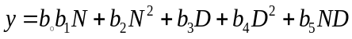
In this formula, expected product of corn to nitrogen fertilizer application rate and a drought index number (D) the relevant coefficients are constant(5).
Process of absorption and accumulation of phosphorus in the plants need different periods, is different, 75-25 days after emergence, nearly 55 percent of phosphorus uptake of corn is needed, this nutrient during the whole growth period, along with stored dry material is done, phosphorus during formation and filling Seeds, transmitted to the body and 75 percent of the seeds will be stored between canopy and the emergence of flower seeds to reach half of the phosphorus is needed to save the plant and finish reports Taylor (1992), Gomez and Bltrans (1992), Prmachandra and colleagues (1993) confirmed the following points are:
1 - Water stress increases the absolute amount of nitrogen, phosphorus, and decreased amounts of different effects on the absorption process are K.
2 - Adult corn water stress, accumulation of phosphorus, nitrogen, magnesium and potassium were 40, 50, 60, 65 and 91 percent planted plants without water stress, decreased.
3 - More water stress than nitrogen sorption permanent wilting point affected by development.
4 - Water stress on the lower left of Ca absorption, and thus ratios Ca / p and Ca / k is high.
5 - Water stress activity of older roots can stop and just the tip of roots to absorb nutrients do that bivalent cautions to a greater capacity to absorb, anion absorption is also limited.
6 - In corn, water stress decreased absorption of phosphorus, and has a direct linear relationship (17).
For plants such as corn and grain and fine grain that have short growing season, phosphorus solubility in water is very important, but for plants with a long growing season pasture plants such as these have less importance because during their long growing season gradually Solubility P2O5 occurs, increase in soil phosphorus solubility, increased corn production will be substantially Potassium absorption process in the early stages of growth, compared with dry matter accumulation is very high, which is why if potash deficiency, young corn plants show it. At the beginning of milky stage of maximum absorption of potassium in plant and at maturity occurs when grain, 2.3 potash in the leaves and 3.1 of its seeds have been saved. before the formation of potassium absorption aggregate one hundred percent and completely performed in compared with the elements nitrogen and phosphorus, potash plant gathering process, 30 days earlier reaches its maximum, and thus absorb potassium plant several weeks before the stop To be absorbed approximately potassium uptake in plant nitrogen has been reported When the ions K + sufficient and accessible, the condition that the amount of ions of potassium and the percentage of moisture is the result of corn absorbed K + completely done and the substitution K + by Na very minor and insignificant, the course in the absence of K and moisture content low, ions Na + and its absorption more was that salinity in the corn shows, comparing the size of ion hydrated 0.331 = K + and 0.358 = Na + nanometers, absorb ions of K + moisture adequate and optimal concentration of potassium, is more evident(10,17).

2. Material and Method
Research projects in three consecutive years in 1999-2000 &2000-2001 and 2001-2002 years. Research Station - Research Azad University of Ahvaz were performed every three years and as below soil samples were taken:
- Before planting and Sprinkle fertilizer
- After harvest and collect the full product
Samples from two 30-0 and 60-30 cm depth to the number 5 spot for each depth was performed separately for physical and chemical characteristics of soil, nutrients and determine the percentage Soil organic material was sent to the laboratory, the aim of measuring soil nutrients after the harvest is that the discharge process or absorb nutrients in the field will be investigated and evaluated (Table 1).

Table 1: Results of soil analysis
soil | Deep (cm) | EC | Organic matter (%) | PH | Nitrogen  (ppm)
Silty | 0-15 | 6.5 | 0.6 | 7.7 | 635
Silty | 15-30 | 6.6 | 0.3 | 7.6 | 648
Clay loam | 30-60 | 5.7 | - | 7.3 | 211

Curve to determine the characteristics of soil moisture, samples 30-0 and 60-30 cm depth by the drill samples were taken, these samples by method of pressure plates under pressure 0.1, 0.3, 1, 3, 5 and 15 were modified and the soil moisture curve in a field oriented coordinate system based on volumetric soil water potential and percent moisture were plotted (Figure 1) prepared purpose of this curve to determine the amount of water stored in Soil water potential in each soil, how soil and water use in determining soil moisture Tension meter or vice versa, to convert moisture to soil water potential was used.
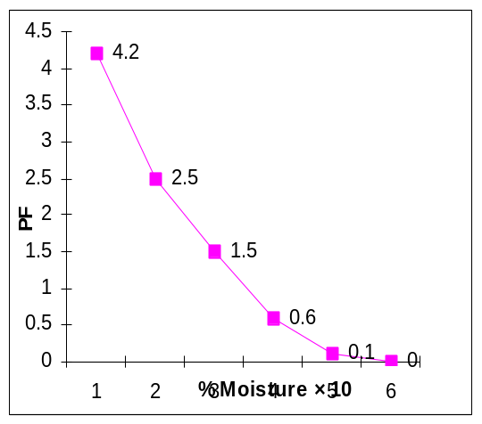
Figure 1: Curve of soil moisture field

Research projects in the form of factorial experiment with the basic design with two randomized complete block with four replications factor and mathematical model was performed following a three-year basis;
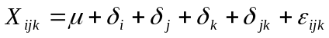
In this model, each view X_{ijk} value, the average population, the effect of first factor, the effect of the second factor, the effect of blocks, Interaction first and second factor and the effect of experimental error is. Because the use of a factorial
Experiment to prevent mixing of (soil × irrigation) and complete separation from the plot, to prevent water penetration to the adjacent plots and also the importance of the same first factor and the second is (Table 2).

Table 2: Review of different treatments tested
Main plot:  Drought stress Levels | Sub-plots:  Different growth phases
I₀ : Full irrigation point of FC, control, without water stress | S₀: growing phase, the establishment of the plant stem to the emergence
I₁ : 75% of the amount of irrigation treatments I₀, mild stress | S₁: natal phase: to stem the rise of coffee being resilient and end silk pollination
I₂ : 50% of the amount of irrigation treatments I₀, severe stress | S₂: grain filling phase: the end of pollen grain maturity and the emergence of black layer
I₃ : 25% of the amount of irrigation treatment I₀, very severe stress and point of PWP | -

For conducting water pressure care we used pressure layers, Field capacity points (FC), permanent wilting point (PWP) that equals 24.6 and 14.7 respectively, then we measured the special apparent weight of soil by using cylindrical, volume meter equals to 1.3 pa g/ cm³. These three parameter: FC, PWP, Pa are considered as constant during experiment. Soil moisture means every other day calculated in sampling by the following formula:

Weight moisture percentage:
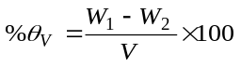

Volume moisture percentage: 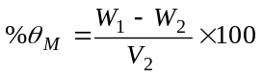
W₁: the weight of moist soil.
W₂: the weight of this sample soil after soil dried.

Since the volume of sampling drill cylinder (V) is stable so calculate soil moisture volume percentage and using calculated parameters, calculate the amount of water entered into each part of land (each small part of land is enclosed so that water could not flow out) by using this formula:

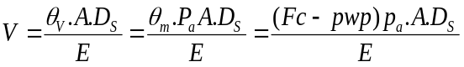
V: is equal to amount of water necessary for each irrigation
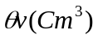 : equals to volume moisture percentage
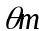: equals to weight moisture percentage
P_{a}: equals to apparent weight of soil. (G/cm3)
Fc: Field capacity points
PWP: permanent wilting point.
A: equals to experimental plate level (cm²)
E: equals to irrigation efficiency
D_{s}: equals to depth of root penetration (used tranche excavation) by installing parshal folum and meter we measured the amount of water entered into each part of land.

Sampled each plate based on 1m length (100×75cm²) one time in fourteen days. In each sample we planted 4-5 corn plant in plastic bag so that we could analyze the nutrient elements in plants. Installing Parshal Flume and also taking water meter, the amount of water input to each plot and control were applied.

Methods to estimate nutrient nitrogen, phosphorus, potassium and sodium
Determine the nutrient once every 14 days from each plot based on a linear meters (75 × 100 Cm²) were sampled, 5-4 plants in each sample after placing in a plastic bag immediately to the laboratory and analyzed to determine the nutrient was sent, that some of these samples to determine nutrient as follows were used:

1 - the principle; experiment, part of the plant that the best indication of the status element accumulation in plants Offering to give; high section, middle and lower plant samples weighing 2 g were prepared. Height Sample preparation (A = 70, B = 70-140, C> 140 Cm) from top floor was considered.
2 - Based on the recommendations of the researchers of Pennsylvania State University and Illinois, the best tissue samples to measure changes in plant nitrogen, plant and upper measuring phosphorus and potassium, lower part of the plant, which is in addition to implementing these recommendations, the average of The samples were estimated.
3 - Measurement and estimation of plant N Kjeldal method and apparatus by distillation using the following formula:
N₁ 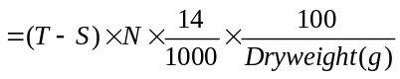

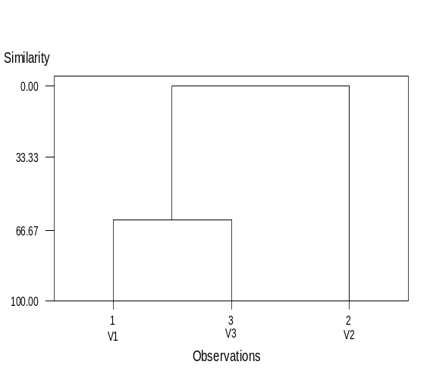
Amount of nitrogen in the sample based on percentage Normality sulfuric acid standard solution. N: sulfuric acid used for making Titration plant samples. S: sulfuric acid used for making Titration control.
4 - Measurement and estimation of ammonium Mulibdate by calorimetric method, using 2 grams of plant samples were dried, and then the samples were mixed with magnesium nitrate and postoperative get ashes , the ash in acid solution, and then smooth Finally phosphate was Calorimetric method were measured.
5 - Measurement of potassium and sodium in plants: the amount of 2 g of plant sample was beaten and practice get ashes dry heat than 480 ° C was performed after the ash in acid solution with a photometer methods to estimate the size of two elements were measured. To determine the number of sodium Samples from the device 2-5 Data analysis method and type of computer software Plan for statistical analysis of variance, raw data, a factorial experiment design based Randomized complete block with 4 replications that comparison data for analysis by a Duncan multiple range test was used. To perform analysis of variance and regression to determine the relationship between different variables, such as nutrient interactions, comparing the process of accumulation, the process of absorbing nitrogen and chlorophyll content, etc., MTB and software for the analysis of plant growth and seed MTB and SAS software and charts by 2000 Excel software were drawn. Atom - a spectral photometer was used.



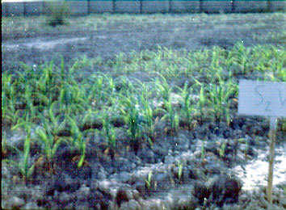

Figure 2: View from the farm

Figure 3: Comparison of the effect of drought stress accumulation process of nutrient nitrogen, phosphorus, potassium and sodium.

3. Result
Test results gathering process cluster to compare nutrient nitrogen, phosphorus, potassium and sodium different levels of water stress showed that the process of absorption and accumulation of nitrogen and phosphorus, two elements as well as potassium and sodium, Exclusively with each other at 1% level were similar. And because this was similar to that imposed various levels of water stress accumulation amount of both nitrogen and phosphorus element in plants, but decreased the amount of respect, two elements of K⁺ Plant showed an increasing trend (Table 3 and Figure 3).
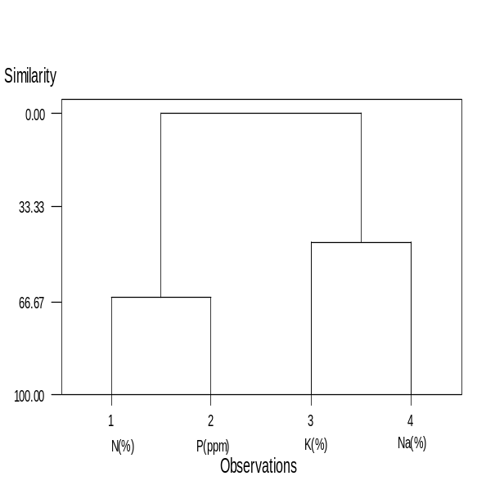
Comparison of uptake and accumulation process of nutrient nitrogen, phosphorus, potassium and sodium in different periods showed that the growth process of absorption and accumulation period of growth (vegetative phase until the formation of ring Double) and (grain filling phase) more than similar treatments (after double-ring formation and Reproductive period) were in the process of accumulation and growth period was much lower than in the test cluster results in a classification system were replaced. (Figure 4 Table 4).
Table 3: Results of tests for comparison of cluster process nutrient uptake at different levels of water tension

Grand centered | Cluster 3 | Cluster 2 | Cluster 1 | Variable
1.7375 | 1.47 | 1.78 | 1.85 | N (%)
0.99 | 0.58 | 1.07 | 1.55 | P(ppm)
2.1925 | 2.45 | 2.36 | 1.98 | K (%)
0.5525 | 1.04 | 0.8 | 0.185 | Na (%)

Center | Cluster | Between | Distance
 | Cluster 3 | Cluster 2 | Cluster 1
1.1946 | 0.7313 | 0.00 | Cluster 1
0.6340 | 0.00 | 0.7313 | Cluster 2
0.000 | 0.634 | 1.1946 | Cluster 3

Distance Level | Similarity Level | Number of cluster | Step
1.491 | 65.47 | 3 | 1
2.344 | 45.72 | 2 | 2
4.319 | 0.00 | 1 | 3

Comparison of uptake and accumulation trends in nutrient and water stress interaction term growth by cluster test showed that the growth period and separately at different levels of water stress were very similar presentation and classification of this test were together (Table 4, Figure 5).

Table 4: Cluster test results to compare nutrient uptake process in different periods of plant growth
Grand centered | Cluster 2 | Cluster 1 | Variable
0.0000 | 1.0095 | -0.5047 | N (%)
-0.000 | 1.1536 | -0.5768 | P(ppm)
0.000 | 1.000 | -0.5000 | K (%)
0.000 | 1.1524 | -0.5762 | Na (%)

Center | Cluster | Between | Distance
 | Cluster 2 | Cluster 1
 | 3.2443 | 0.000 | Cluster 1
 | 0.000 | 3.2443 | Cluster 2

Figure 4: Comparing the assembly process nutrients nitrogen, phosphorus, potassium and sodium in different periods of growth.

Table 5: cluster test results to compare nutrient uptake process in the interaction of water stress and plant growth periods
Distance Level | Similarity Level | Number of cluster | Step
1.402 | 62.0 | 2 | 1
3.69 | 0.00 | 1 | 2
Distance Level | Similarity Level | Number of cluster | Step
0.231 | 94.89 | 11 | 1
0.380 | 91.59 | 10 | 2
0.43 | 90.49 | 9 | 3
0.600 | 86.72 | 8 | 4
0.841 | 81.39 | 7 | 5
1.248 | 72.38 | 6 | 6
1.455 | 67.80 | 5 | 7
1.998 | 55.77 | 4 | 8
2.623 | 41.94 | 3 | 9
3.042 | 32.65 | 2 | 10
4.518 | 0.00 | 1 | 11

Figure 5: Comparison of nutrient accumulation process in the interaction of water stress and plant growth periods.

Nutrient interactions
With regression analysis of variance and presented as linear equations between nutrient, nutrient interaction on the process of gathering them at different levels of water stress and growth periods separately evaluated The following results were obtained:
1 - Regression analysis of variance in nutrient interaction at different levels of water stress, nutrient interaction with nitrogen phosphorus level of 5%, sodium potassium, nitrogen and potassium at 1% level significant effects on the interaction of elements and showed sodium diet with phosphorus, potassium and sodium phosphate with nitrogen did not provide significant effects. (Table 6)
2- P interaction element with the correlation coefficient with nitrogen, fitted linear regression showed that increased accumulation of nitrogen, phosphorus accumulation also increased by applying different levels of stress decrease Nitrogen accumulation was. Phosphorus accumulation process also offered a significant decrease (Figure 6).
3 - Fit linear regression interaction of sodium with potassium correlation coefficient showed that whatever amount was increased accumulation of potassium, sodium accumulation process of adjustment and provide significant levels Severe water stress that was greater accumulation of K, the process of absorption and accumulation of sodium than the control treatments (water stress) and mild stress (treatments) can be reduced. (Figure 6)
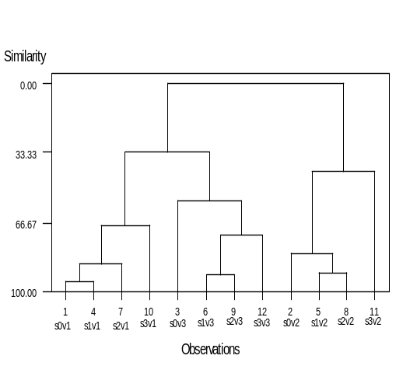
4 - Increase the element nitrogen, additive effect on the accumulation process with correlation coefficient K⁺ said that the effects on the control treatment (no water stress) was more evident at different levels of water stress by reducing nitrogen absorption, accumulation of ions to a very moderate state control part of his indicate that if the absorption of nitrogen in different treatments was not reduced water stress, ion accumulation in the treatments than values obtained were estimated. (Figure 6) Regression analysis of variance in nutrient interaction in the different periods of growth, nutrient interaction with nitrogen phosphorus and potassium, with nitrogen, respectively 5% and 1% level, significant effects on each other showed and nutrient interactions with sodium potassium, phosphorus, sodium, potassium and sodium phosphate with nitrogen did not provide significant effects (Table 6).

The following results can be investing:
1 - the process of accumulation of nitrogen in the vegetative period of treatment, the highest accumulation of this element in plants showed that Periods of growth and accumulation, adjustment was significant, with increased accumulation of nitrogen in each phase of growth, P accumulation time significantly and can be significantly increased with decreasing nitrogen accumulation Phases of growth, and phosphorus accumulation in the two-phase growth was reduced, in this regard, a go to the incidence of positive correlation did. (Figure 7).
2 - Effect of N accumulation onion accumulation in different periods of plant growth from the accumulation of phosphorus (Part 1) was much higher than the correlation with N accumulation process in each period, the accumulation of potassium
To be significant indicated that the three periods of growth phase and the process of accumulation of both elements N and K in terms of value, had a high correlation (Figure 7).
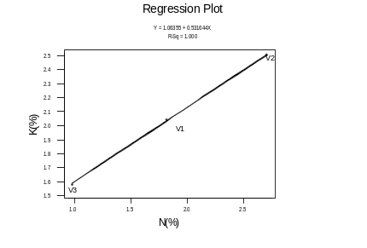
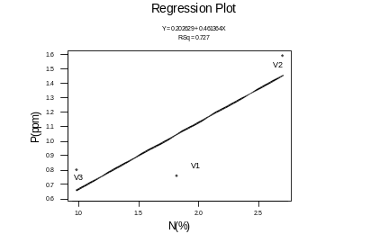

Figure 6: Fitting linear regression nutrient interaction at different levels of water stress
A) Nitrogen & phosphorus
B) Sodium & potassium
C) Potassium & nitrogen
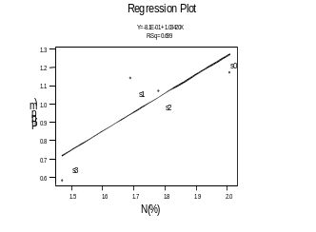
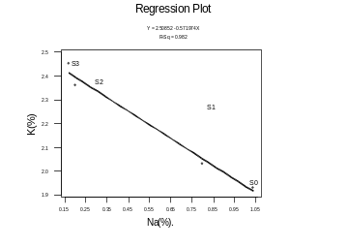
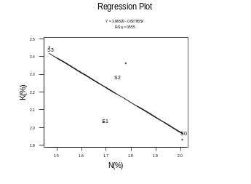

Figure 7: Fitting linear regression nutrient interaction in the different periods of growth
A) Nitrogen & phosphorus
B) Potassium & nitrogen
4- Discussion
Process of accumulation of nitrogen and phosphorus and potassium and sodium levels of water stress was also very similar process so that with increasing water stress, nitrogen and phosphorus accumulation in plants, but reduced accumulation of potassium and sodium in the plant increased (1, 17, and 5).
the process of accumulation of nitrogen, phosphorus and potash, especially nitrogen and potassium in corn also an increasing trend is similar, but Lopez (1992) proclaims that under water stress due to decreased absorption of nitrogen and phosphorus during the similarity of the process plant life process of change increased accumulation of potassium and sodium in a process similar to the levels of water stress were both single capacity of these elements under water stress were more absorbed in this connection about 50 times the absorption of potassium sodium adsorption was one of the reasons that attract little sodium presence of ions in the soil was tested certainly if the amount of potassium in the soil element was lower absorption of Sodium showed further increase(8).
Process of nutrient accumulation in different growth stages was different, the highest element in the process of gathering all four periods of plant growth was the highest growth rate was achieved, but the periods of growth and development was done in less and less because of this growth, less need elements had accumulation of N, phosphorus, potassium and sodium showed less (24).
The absorption and accumulation of nitrogen element in the plant increased accumulation of phosphorus and plant significant increase was in other words the process of absorption and accumulation of the element nitrogen phosphorus and potassium accumulation increased considerably increased Anthony (1998) proclaims that increased plant growth and nitrogen element required for the elements phosphorus and potash in order to increase the nitrogen element technique parameters such as root stages, resistance to water shortages, spread of LAI, etc. as necessary should that be due to increased water stress conditions reduce accumulation of potassium ions and nitrogen interaction of nitrogen and potassium, a negative trend shows that for increasing plant resistance to water stress and leaf area also decreased to prevent waste of water by sweating on different behavioral stress conditions takes (2000 cm ) so impaired absorption and accumulation of ions such as nitrogen and other increased uptake increased potassium uptake is reduced in several reports by Mashner (1985) stated that plants, if any negative effect on ion absorption capacity of single-caution of other ions such as affects(1,10).

Table 6: Analysis of variance regression nutrient interaction at different levels of water stress
Resource changes | df | Mean Squared
Resource changes |  | 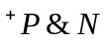 | 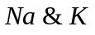 | 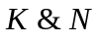 | 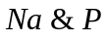 | 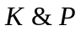 | 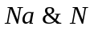
Regression | 1 | 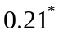 | 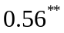 | 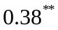 | 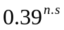 | 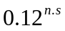 | 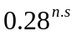
Error | 2 | 0.11 | 0.0006 | 0.02 | 0.086 | 0.036 | 0.14
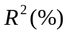 | ـ | 69.9 | 97.6 | 55.5 | 69.7 | 61.7 | 50.4
Linear regression equation |  | P=-0.8+1.03N | Na=2.51-0.57 K | K=3.65-0.89N | Na=1.85-1.32 P | K=2.9-0.7P | Na=2.96-1.38 N

*Each element being the first letter abbreviation represents the dependent variable (y) and the second letter independent variable (x) is.

Table 7: Analysis of variance regression nutrient interaction in the different periods of growth

Resource changes | df | Mean Squared
Resource changes |  |  |  |  |  |  | 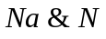
Regression | 1 | 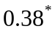 | 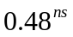 |  | 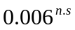 | 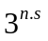 | 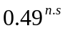
Error | 2 | 0.019 | 0.21 | 0.0001 | 0.003 | 0.12 | 0.2
 | ـ | 72.2 | 69.3 | 100 | 58.3 | 71.2 | 70.8
Linear regression equation |  | P=0.203+0.4N | Na=-1.76+1.07K | K=1.06+0.532N | Na=-1.01+1.2P | K=1.16+0.8P | Na=-6.4+0.57N

*Each element being the first letter abbreviation represents the dependent variable (y) and the second letter independent variable (x) is.

Reference

- Anthony (1998), drought and density stress in Canadian and European maize,agri:145
- Bader, S.A (1971) Effect of tillage practice on corn root distribution and morphology. Agron. J, 63:724.Hanway, j.j; (1952) plant analysis guile for corn needs). Better crops with plant food.
46 (3) 1.
- Black, C.A. (1968). Soil – plant Relationships and Ed john Wiley, New York.
- Denmed, O. T, and R.H. Shaw, (1962) Availability of soil water to plans as effected by soil mousier content and meteorological conditions Agron. J. 54: 385-90.
- Elings, A, J. white and G.O, Edmeades (1996) modeling the consequences of water limitation at flowering and Nitrogen shortage intropical maize Germplasm) CIMMYT, Apdo, Mexico PP 156
- Foth. H.D; L, kinra, and j, N, Pratt, (1960) corn root development Michigan State Univ. Agr. Exp. Sta. Quart. Bull, 43 (1): 2
- Hall, NS and W.V chandler, (1953) .Artier technique timesaver growth. And active of plant root systems. North Carolina Agr, Exp. Sta. Tech. Bull. 101.
- Lopez (1992), selection environments for improving maize for low-nitrogen. . Crop,110
- Lou, A, (1963) A contribution to the study ofinorganic nutrition in maize with special attention to potassium Fertilize 20.
- Mashner (1985), soil and water in agriculture. Intermediate Technology Publications. Mol Bio32-34
- Moss, D. N; R.B, muss Grave and E.R. Lemon (1961). Photosynthesis under field condition III some effects of light, carbondioxide, Temperature and soil moisture on photo synthesis, respiration and transpiration of Corn Crops. Sci. 1: 83-87.
- Portas, C.A.M., and H.M.Taylor. (1975) Growth and survival of young plant roots in dry soil. Soil SCI. 121:170-175.
- Scholander, P.F., T. Hamel. E.D. Bradstreet and E.A Hemming (1965). Sap Pressure in vascular plants/ Science 148: 339-346.
- Scharp, RE, and W.J. Davis. (1979). Solute regulation and growth by roots and shoots of water stressed plant. Plant 147: 73-49.
- Slavic, B. (1974). Methods of studying plant water Relations. Springier Overflag, New York.
- Swanson. E. R, (1966-71). Welled economically optional levels of Nitrogen fertilizer for corn: An analysis based on experimental data. I lioness Agriculture. E con. 13 (2): 16 (1973).
- Taylor (1992), Gomez and Bltrans (1992), Prmachandra and colleagues (1993), cimmit reporters
- Turner, N.C., and M.M.Jones. (1980). truer maintenance by osmotic adjustment: A review and evaluation. P. 87-103.Wiley Interscience, New York.
- Vows, R.D, (1970) (P- most limiting nutrient for corn in low) in proc. 22 ND Ann. Fertilizer Ag. Chem. Dealers conf., lowa state university Ames, low.
- Winker, W. (1981). The behavior of Osmotic potential in leaves of maize. Env. Expel. Botany 2:231-239.
- Wilson, J.P., and M.M.Ludlow. (1983). Time trends of solute accumulation and the influence of potassium fertilizer on osmotic adjustment of water stressed leaves of tropical grasses. Aust. J. Plant physiol. 10:52-337.
- Waggoner, P. E; D.N, moss and j.D, Hesketh (1963). Radiation in the plant environment and photosynthesis Agron. J. 55:36.
- Wiersum, L.K. (1967) themass – flow. Theory of phloem Transport; supporting collation j. exp. Bot 18: 160-162.
Stinson. H.T., J r., and D.N. Moss, 1960 some effect of ahead upon corn hybrids tolerant and in tolerant of dense planting Agron. J., 52:482.
- Watanabe, F.S., Olsen and, Danielson (1960). P availability as relate to soil moisture, Trans Intern. Con, soil. III: 450

12/5/2010

