Therapeutic and Protective Effects of Biphenyl Dimethyl Dicarboxylate (DDB) and Silymarin in Human Infected with HCV and in Carbon Tetrachloride Induced Hepatitis in Rats

Wassfy¹ A. A., Ellaithy² H. M., Hamza² Y. E., Arbid³ M. S., Osman⁴ A.H., and Kandil^{*5} S. M.

¹ Department of Internal Medicine, Faculty of Medicine Cairo University, Cairo, Egypt,
² Department of Pharmaceutics and Industrial Pharmacy, Faculty of Pharmacy Cairo University, Cairo, Egypt,
³ Department of Pharmacology, National Research Institute, Cairo, Egypt,
⁴ Department of Pathology, Faculty of Veterinary Medicine Cairo University, Cairo, Egypt,
⁵New Kassr El Aini Teaching Hospital. Cairo, Egypt.
kandil.2009@hotmail.com*

Abstract: This investigation aimed to evaluate the therapeutic activity of pure and commercial products of Biphenyl Dimethyl Dicarboxylate (DDB) and Silymarin in humans suffering from HCV and therapeutic and protective effects of Carbon tetrachloride (CCL4) induced liver damage in rats. Humans were divided into two groups: Group I: Normal controls (N=20). Group II: Patients suffering from chronic HCV infection; were subdivided into two subgroups:A. ten patients received Silymarin 140 mg twice daily for one month.B. twenty patients received DDB 10 pilules (15 mg) twice daily for one month. All Control and Treated groups were collected and obtained serum was analyzed for Aspartate aminotransaminase (AST), Alanine aminotransaminase (ALT), Alkaline phosphatase (ALP.orAlk.ph.), Gamma Glutamic transaminase (GGT) and Serum bilirubin (total and direct).In addition the effect of DDB or Silymarin administration on the mentioned biochemical parameters was measured in patients groups. Other experimental experiment was conducted in which rats were divided into nine groups, each group comprising of six rats. All rats except the control group were subjected to administration of Silymarin or DDB in pure and commercial products, before and after treatment with CCL_{4.} All serum samples of rats were subjected to Liver function tests including: (AST), (ALT), (ALP.) and serum Bilirubin as well as kidney functions tests including: blood urea and serum creatinine. Histopathological examination of liver tissues was also performed. The results revealed that DDB improved liver functions in patients suffering from HCV infection. Also Silymarin showed insignificant alteration for the same parameters. The raw and commercial products of Silymarin or DDB were significantly improved liver, kidney functions and the histopathological changes after induction CCL₄ toxic hepatitis in rats. Administration of DDB (commercial) for one month to patients suffering from chronic viral hepatitis resulted in a rapid decrease in serum transaminases, especially ALT. Treatment of rats by pure and commercial DDB for 7 days showed improvement in acute hepatocellular necrosis or hepatitis-associated hepatocellular damage caused by carbon tetrachloride. Administration of commercial Silymarin for one month was largely ineffective in patients suffering from viral hepatitis. The results of 7 days treatment by pure and commercial products of Silymarin in rats showed protection of liver tissue. Silymarin has an antioxidant effect. In rats Silymarin increased the level of total protein which indicates hepatoprotective activity as results of accelerate of regeneration process and production of liver cells. Obtained histopathological study confirmed the results of biochemical studies. It is concluded that a superiority and efficacy of DDB over Silymarin in normalizing the liver enzymes and serum bilirubin (total and direct) levels were achieved after treatment of humans suffering from HCV.
[Wassfy A. A., Ellaithy H. M., Hamza Y. E., Arbid M. S., Osman A.H., and Kandil S. M. Therapeutic and Protective Effects of Biphenyl Dimethyl Dicarboxylate (DDB) and Silymarin in Human Infected with HCV and in Carbon Tetrachloride Induced Hepatitis in Rats. Journal of American Science 2011;7(1):352-364]. (ISSN: 1545-1003). http://www.americanscience.org.

Keywords: DDB, Silymarin, humans, HCV, Rats, CCL₄, hepatotoxicity.

1. Introduction:
DDB is synthetic analogue of schizandrin C, one of the active components isolated from Fructus schizandra, a traditional oriental medicinal plant ^{(1).} DDB has a beneficial effect on elevated liver enzymes and histopathological changes ⁽²⁾; it was used successfully for treatment of cases of chemically induced hepatitis ^{(3 and 4)}. Silymarin therapy decreases complications, hastens recovery, and shortens hospitalization in patients with acute viral hepatitis ⁽⁵⁾. Silymarin prevent hepatic fibrosis through suppression of inflammation and hypoxia in the fibrotic liver ⁽⁶⁾.
In Egypt the HCV type 4 infection is a known viral infection of the liver of Egyptians. Pegylated Interferon combined with ribavirin has been reported as the curative therapy in about 48% of patients with type 1 and 4 ⁽⁷⁾. Most of patients have elevated liver enzymes and bad general condition with progressive liver cell failure. Drugs like Silymarin and DDB were noticed to decrease liver enzymes with improvement of the general condition of the patients ^{(8-9-10and11).} The exact mechanism of these drugs is unknown ⁽¹²⁾.

2. Materials and methods:
Drugs:
Biphenyl Dimethyl Dicarboxylate (DDB pilules) is as commercial product which was obtained from Beijing Union Pharmaceutical Factory, China. Pure DDB powder was obtained from Arabic Company of Medicinal Plants (Mebaco, Egypt).
Silymarin (Marriagon® capsules) was obtained from Alpha Chem. Advanced Pharmaceutical Industries Co. (ACAPI), Egypt. Pure Silymarin powder was obtained from Arabic Company of Medicinal Plants (Mebaco, Egypt).
Carbon tetrachloride (CCL₄) was obtained from Egyptian company for chemicals and pharmaceuticals (ADWIA).
All kits were obtained from Biodiagnostic Company, Egypt. Gamma Glutamic transaminase (GGT) was obtained from Quimica Clinica Aplicada S.A, Spain.
Human group: Fifty subjects were included in this work.They were divided into two groups: a- Thirty patients suffering from chronic HCV infection. Age ranged from 30-55y (13 females and 17 male). b- Twenty normal controls. Age ranged from 21-45 y (9 females and 11 males).
Patients with diabetes, hypertension, renal failure and pregnant females or any organ failure were excluded.
Animal group: Fifty four Sprague Dawley albino rats male or female weighing 100–120 g were obtained from animal house unit of the National Research Center. The animals allowed free access to water and fed on uniform standard diet formula according to Rogers (1979) ⁽¹³⁾.

Methods:
Experimental design:
1-Human study:
Human were divided into two groups:
Group I: Twenty normal controls.
Group II: Patients with chronic HCV infection; were subdivided into two subgroups:
A. Ten patients received Silymarin 140 mg twice daily for one month.
B. Twenty patients received DDB 10 pilules (15 mg) twice daily for one month.
Thirty patients and twenty normal controls were subjected to the following laboratory investigations, AST, ALT, Alkaline phosphatase, GGT and serum Bilirubin. The effect of treatment by DDB or Silymarin on the mentioned biochemical parameters were measured in patients groups.

2-Animal study:
Curative and hepatoprotective effect of Silymarin and DDB was studied. Carbon tetrachloride was used to induce hepatotoxicity in rats. Each drug was given on the 3rd day, for 7 days and the blood samples (3ml) were collected on 10th day; except for the 2nd group they were collected on 3rd day. The drug doses in the forthcoming work were calculated according to Paget and Barnes (1964) ⁽¹⁴⁾.
Fifty four rats were divided into nine groups, each group comprising six rats:
Group 1: Placebo group of 6 rats received a single oral dose of one ml saline for 10 days.
Group 2: Six rats received a single oral dose of CCL₄ dissolved in paraffin oil (1:1) v/v ratio. Each rat received 0.25 ml of this solution once and blood samples were taken after 3 days according to the method reported by Janakat and Al Merie(2002)⁽¹⁵⁾.
Group 3: Six rats received a single oral dose of CCL₄ dissolved in paraffin oil (1:1) v/v ratio. Each rat received 0.25 ml of this solution once and blood samples were taken after 10 days.
Group 4: Six rats received a single oral dose of CCL₄ dissolved in paraffin oil (1:1) v/v ratio. Each rat received 0.25 ml of this solution once, and then pure Silymarin was given. Each rat received 2.2 mg/ml water according to the method reported by EL-Shenawy(2003) ⁽¹⁶⁾ for 7 successive days.
Group 5: Six rats received a single oral dose of CCL₄ dissolved in paraffin oil (1:1) v/v ratio. Each rat received 0.25 ml of this solution once, and then the commercial product of Silymarin (Marrigon) was given. Each rat received the equivalent of 2.52 mg/ml water of Silymarin for 7 successive days.
Group 6: Six rats received a daily oral dose of pure Silymarin. Each rat received 2.2 mg / ml water for 7 successive days, and then a single oral dose of CCL₄ dissolved in paraffin oil (1:1) v/v ratio was given. Each rat received 0.25 ml of the latter solution once.
Group 7: Six rats received a single oral dose of CCL₄ dissolved in paraffin oil (1:1) v/v ratio. Each rat received 0.25 ml once, and then pure DDB was given. Each rat received 10 mg/ ml water according to the method reported by Qing and Liu (1992) ⁽¹⁷⁾ for 7 successive days.
Group 8: Six rats received a single oral dose of CCL₄ dissolved in paraffin oil (1:1) v/v ratio. Each rat received 0.25 ml of this solution once, and then the commercial product DDB was given. Each rat received the equivalent of 0.27 mg of DDB for 7 successive days.
Group 9: Six rats received a daily oral dose of pure DDB. Each rat received 10mg/ml of water for 7 successive days, and then a single oral dose of CCL₄ dissolved in paraffin oil (1:1) v/v ratio was given. Each rat received 0.25 ml of the latter solution once.
All rats are subjected to the following investigations:
- Liver function test: AST, ALT, Alkaline phosphatase, and serum total bilirubin.
- Kidney function test: blood urea and serum creatinine.

Laboratory investigations methods:
Serum ALT and AST were determined according to Reitman and Frankel (1957) ⁽¹⁸⁾, Serum alkaline phosphatase was measured according to Belfield and Goldberg (1971) ⁽¹⁹⁾, Serum Total Bilirubin was determined after Walter and Gerade (1970)⁽²⁰⁾. Serum Urea Nitrogen was measured according to Henry et al. (1974) ⁽²¹⁾. Serum creatinine was measured according to Bartles et al. (1972) ⁽²²⁾. Serum γ glutamyl transferase (GGT) activity was measured according to Shaw (1983) ⁽²³⁾.
Histopathological examination:
Fixed liver tissues collected from all groups of rats, then embedded in paraffin and sectioned to 5 µm thicknesses. Ordinary haematoxylin and eosin stain was used according to standard protocols and examined under light microscope (X 200) according to (Bancroft et al., 1996) ⁽²⁴⁾. The degree of hepatic injury was estimated using an ordinal scale modified from Palaa and Charbonneau (1994) ⁽²⁵⁾ according to the following table.

Histological Grading of Liver Injury:

Grade | Description
0 | No apparent injury by light microscopy
I | Swelling of hepatocytes
II | Ballooning of hepatocytes
III | Lipid droplets in hepatocytes
IV | Necrosis of hepatocytes

Statistical analysis:
Data obtained were statistically analyzed using ANOVA test and t-student test using SPSS 14 (2006) ⁽²⁶⁾.

3. Results and Discussion
HCV is one of the viruses that affect the liver causing hepatic injury leading to acute inflammation followed by its chronic form, which may be complicated by cirrhosis and hepatocellular carcinoma ⁽²⁷⁾.
Commercial product of Silymarin was leading to insignificant drop in liver functions and studied parameters in patients, when it was compared with their levels before treatment (Figs 3 and 4). Silymarin was largely ineffective in patients with viral hepatitis ⁽²⁸⁾. Silymarin treatment for HCV over 125 days did not significantly change ALT, AST and GGT levels ⁽²⁹⁾. Furthermore, the use of Silymarin did not significantly affect serum HCV RNA and ALT levels in patients ⁽³⁰⁾.
The obtained data indicates that treatment by commercial product of DDB has a powerful effect in the improvement of the liver function parameters in patients suffering from HCV (Figs 5 and 6). Concerning DDB results, the results nearly similar to that recorded by Liu ⁽³¹⁾ , Li ⁽³²⁾ , Shimabukuro ⁽³³⁾ and Akbar et al. ⁽³⁴⁾ who mentioned that administration of DDB for 2 weeks or more decreased the average blood level of ALT. The patients with chronic hepatitis C, B, or steatohepatitis, with persistently elevated ALT when treated with DDB, ALT can be rapidly normalized in most of the cases and remained normal during treatment ⁽³⁵⁾.
Furthermore, Li et al. ⁽³⁶⁾ mentioned that Schisandrin from Schisandra fruits were able to scavenge hydroxyl radicals and superoxide anions much stronger than that of vitamin C and vitamin E.
It was reported that the administration of DDB to patients suffering from HCV caused a decrease in serum bilirubin blood level after treatment for three months ⁽³⁷⁾. This going with the results obtained.
As shown in (Figs. 7-12), It was worth noting that the administration of CCL₄ to rats followed by administration of pure Silymarin (group 4) or commercial one (group 5) on the third day for 7 successive days leads to a remarkable decrease of at least 30% to 50% in AST, ALT, Alk. Ph., Bilirubin and Creatinine, but insignificant decrease in serum urea level was recorded. Hence, it could be concluded that the administration of pure or commercial Silymarin exerted an anti-inflammatory effect against CCL₄.
This observation is in concordance with the findings revealed that Silymarin prevented all the changes observed in CCL₄ hepatocirrhotic rats which could be attributed to both its antioxidant and membrane stabilizing action ⁽³⁸⁾ or as result of membrane stabilization, neutralization of the free radical and immune modulation occurred in experimental animals ⁽³⁹⁾. Concerning the effect of Silymarin in the present study, the obtained results agreed with what reported that treatment with Silymarin at 25 mg/kg body weight to Wistar albino rats after the induction of liver damage by D-galactosamine, was able to normalize the serum levels of ALT, AST, ALP, total bilirubin, lactate dehydrogenase, total cholesterol, triglycerides, albumin, total protein levels ⁽⁴⁰⁾. Also, Silymarin significantly reduced the liver toxicity in rats indicated by decline of the levels of AST, ALT and ALP activities in serum as compared to toxicated rats ⁽⁴¹⁾.
In the present work, concerning administration of pure Silymarin before CCL₄ in rats (group 6), a remarkable decrease in blood level of ALT, Alk. Ph., bilirubin, creatinine and urea was shown. Silymarin exerts a protective effect through decreasing CCL₄ induced lipid peroxidation and hepatotoxicity in mice ⁽⁴²⁾. Approximately similar results were reported ⁽¹⁶⁾.
Administration of pure DDB (group 7) or commercial one (group 8) after CCL₄ on the third day for 7 successive days revealed a remarkable and significant (P<0.001) decrease in liver enzymes (AST, ALT and Alk. Ph.), bilirubin, and creatinine. Serum urea showed insignificant reduction after DDB treatment .These results indicated the efficacy of DDB as anti-inflammatory liver cell agent in induced liver damage. Moreover, findings are in concordance with the results proved that DDB is of a beneficial effect on damaged liver resulting from CCL₄ and thioacetamide administration. Also, it is highly effective in normalizing the liver functions with very low side effects ⁽⁴³⁾ ^{(32) (44) and} ⁽⁴⁵⁾.
The administration of pure DDB before CCL₄ ingestion (group 9) caused improvements of the hepatocytes and consequently lowered the blood level of liver enzymes. It was proved that pretreatment of rats with DDB ameliorate the reduction of liver glycogen and blood glucose in chemical induced hepatitis. Also the serum level of ALT, AST, and Alkaline phosphatase were significantly lowered compared with the CCL₄ intoxicated rat groups ⁽⁴³⁾ ^{and (46)}.
This result is nearly similar to that reported by ⁽⁴⁷⁾ who mentioned that the treatment of animals with CCL₄ caused drastic increases in both plasma alanine aminotransferase (ALT) and Sorbitol dehydrogenase (SDH) activities in mice. However pretreating mice with Schisandrin B or C (DDB) regimen significantly (P<0.001) improved the CCL₄ -induced toxicity condition (hepatoprotective effect). The observed hepatoprotective action against CCL₄ is due to the ability of DDB to maintain hepatic mitochondrial glutathione redox status under oxidative stress condition ⁽⁴⁸⁾.
Pharmacological study showed that DDB increases liver protein and glycogen synthesis and has an inducing effect on the cytochrome P-450 enzyme system ⁽³²⁾. The mechanisms of DDB hepatoprotection effect is functioning as a potent antioxidant agent when it is used in the treatment of viral and chemically induced hepatitis ⁽⁴⁸⁾. Effects of DDB may protect hepatocytes by stimulating the hepatic mitochondrial reduced glutathione (GSH) antioxidant system via activation of GSH related enzyme. GSH works with the antioxidant enzymes, such as S-glutathione peroxidase, glutathione S-transferases, and glutathione reductase, in combating reactive oxygen species and maintaining cellular glutathione status, in this process, the maintenance of mitochondrial glutathione status was critical for cell survival ^{(49) and (50)}.
As shown in Figs. (12 and 13) it could be concluded that strong correlation between the laboratory analytical results in serum liver enzymatic activities of patients and rats before and after treatment with pure and commercial products of Silymarin and DDB, it could be concluded also that the percent of changes of comparison between patients and rats before and after treatment with Silymarin on liver enzymes was proved to be of no concept. On the other hand, administration of DDB revealed its potent therapeutic and protective effect on both rats and humans.
The liver and kidney specimens of the control group (group 1) was normal regarding their size and colour. Histological examination of liver showed normal hepatic lobules associated with normal histological structure of the portal triad as shown in figure (15). The liver revealed grade (0). Also, kidney’s parenchyma appeared with normal histological structure (Fig.21). These results were in complete agreement with those reported by Das et al. ⁽⁵¹⁾.
In Group (2) which exposed to CCL₄ and examined after 3 days revealed necrobiotic changes of hepatocytes including vascular degeneration, nuclear pyknosis and necrosis as well as narrowing of hepatic sinusoids and hyperplasia of Kupffer cells. In addition portal triads showed fibrous connective tissue proliferation and hyperplasia of bile duct and hepatic injury appeared as grade (IV) which illustrated in figure (16). CCL₄ is one of the most commonly used hepatotoxic agents in experimental study of liver diseases ⁽⁵²⁾. Furthermore, CCL₄ is biotrasformed by cytochrom P-450 in liver to produce highly reactive trichloromethyl free radical. This radical, in presence of oxygen generated by metabolic leakage from mitochondria, cause lipid peroxidation of lipids membrane which led to loss of integrity of cell membranes and damage of hepatic tissue⁽⁵³⁾. Moreover, changes in structures of the endoplasmic reticulum and other membranes cause loss of metabolic enzyme activation, reduction of protein synthesis and loss glucose-6-phosphatase activation which over all leads to liver damage ^{(54) and (55).} On the other hand, Kidney of the same group showed swelling of tubular epithelial lining especially the proximal convoluted tubules and coagulative necrosis of some renal tubules as clearly evident in figure (22).
Liver specimens of rats belonging to group (4) that received pure Silymarin powder after being treated with CCL₄ showed ballooning degeneration of hepatocytes and single cell necrosis. Moreover, hyperplasia of bile duct by forming numerous numbers of new bile ducts was clearly apparent in figure (17). This hepatic injury appeared as grade (II). This showed that Silymarin has a hepatoprotective effect by improving the appearance of the hepatocytes. These findings are in concordance with that reported by ⁽⁵⁶⁾ who mentioned that Silymarin is beneficial in reducing the damage of hepatocytes ⁽⁵⁷⁾ , added that, Silymarin is advantageous for regenerating the normal function of the liver, after being exposed to CCl₄ hepatotoxication. Moreover, ⁽³⁸⁾ and ⁽⁵⁸⁾ proved that Silymarin prevented the increase in lipid peroxidation caused CCL₄. Kidney specimens of the same group revealed mild swelling of tubular epithelial lining in comparison with those of the 2nd group Fig. (23).
Liver specimens of rats, belonging to group 5 which were exposed to CCL₄ followed by treatment with the commercial Silymarin capsules (Marriagon®) for 7 days, showed swelling of hepatocytes and narrowing of sinusoids. Moreover, focal areas of coagulative necrosis were also seen. The liver specimens appeared as grade (III) as clearly demonstrated in figure (18).
Liver specimens of the rats belonging to group (7) that received pure DDB material for 7 consecutive days after CCL₄ treatment showed mild swelling of hepatocytes accompanied by narrowing of hepatic sinusoids. The liver specimens appeared to be grade (I). DDB induced more hepato-regenerative effect than Silymarin as the tissue injury appeared as grade (I) as shown in figure (19). Histological examination showed normal histological structure in kidneys as evident in figure (24). These results are in agreement with that reported by ⁽⁴³⁾ who proved that DDB has extremely beneficial effects on both damaged and normal hepatocytes. The same was held true with the findings of ⁽¹⁷⁾ who mentioned that DDB is able to directly and indirectly antagonize certain damage in the hepatocytes. Moreover, ⁽⁴⁾ mentioned that DDB administration caused improvement in the histopathology examinations of the chemically-injured liver.
Liver specimens of rats belonging to group (8) that were exposed to CCL₄ then treated with commercial DDB product for 7 days showed mild swelling of hepatocytes and narrowing of sinusoids as depicted in figure (20). The liver specimens appeared as grade (II).

Humans
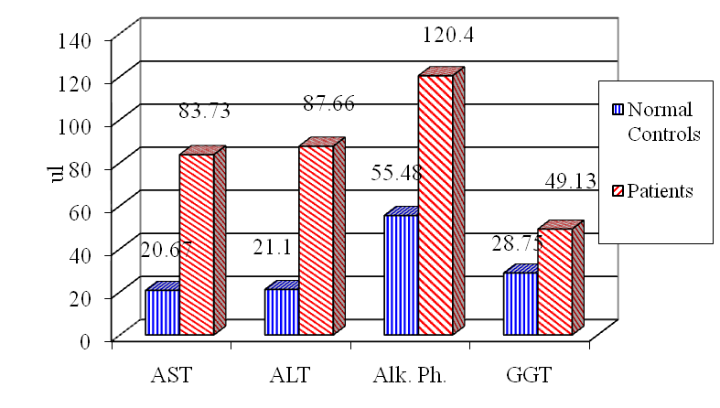  Figure 1: Liver Enzymes Parameters of Normal Controls and Patients. | 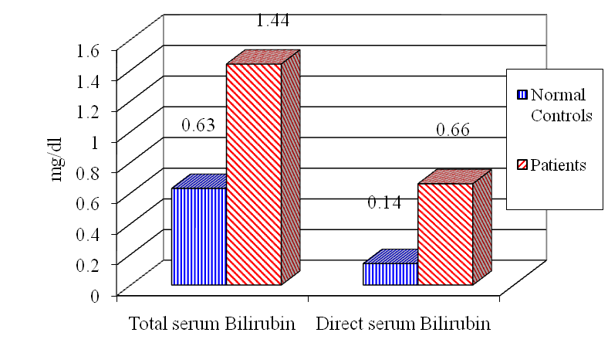  Figure 2: Serum Bilirubin of Normal Controls and Patient
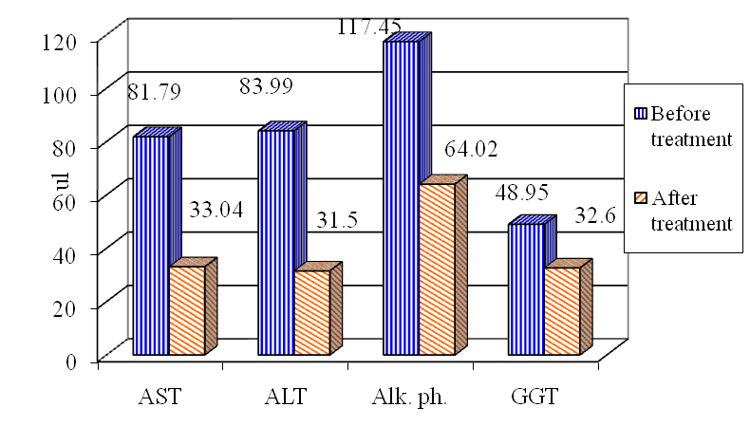  Figure 5: Effect of DDB on Liver Enzymes | 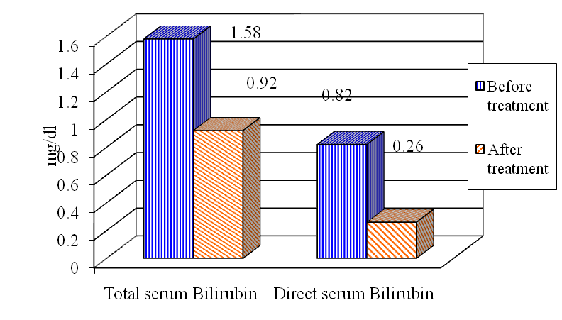  Figure 6: Effect of DBB on Serum Bilirubin.
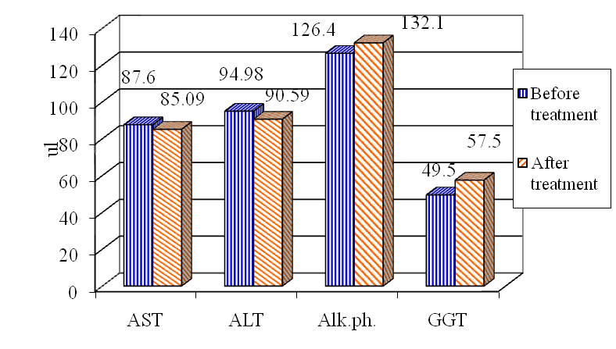 | 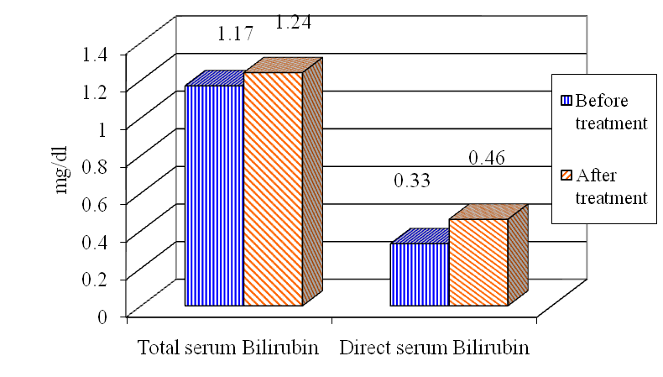
Figure 3: Effect of Silymarin on Liver Enzymes | Figure 4: Effect of Silymarin on Serum Bilirubin

AST = Aspartate aminotransaminase (u/l). ALT = Alanine aminotransaminase (u/l).
Alk.ph. = Alkaline phosphatase (u/l). GGT = Gamma glutamic transaminase (u/l).

Rats
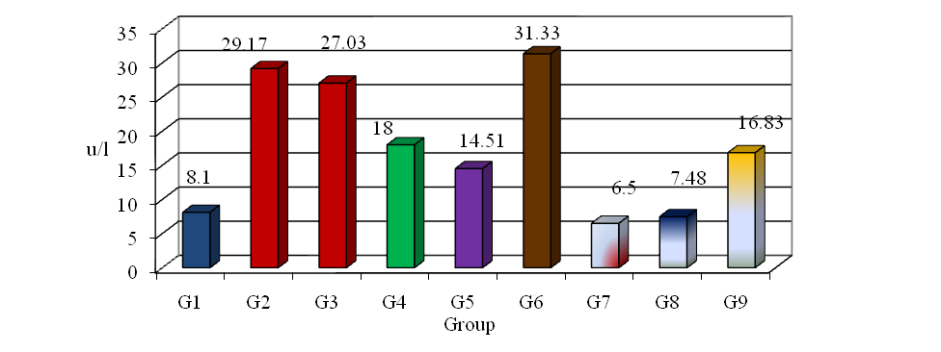
Figure 7: Comparative Effects of Silymarin and DDB on hepatitis induced by Carbon Tetrachloride in Rats for AST u/l.

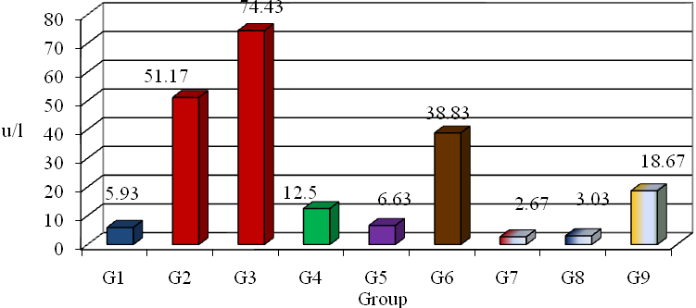

Figure 8: Comparative Effects of Silymarin and DDB on hepatitis Induced by Carbon Tetrachloride in Rats for ALT u/l.

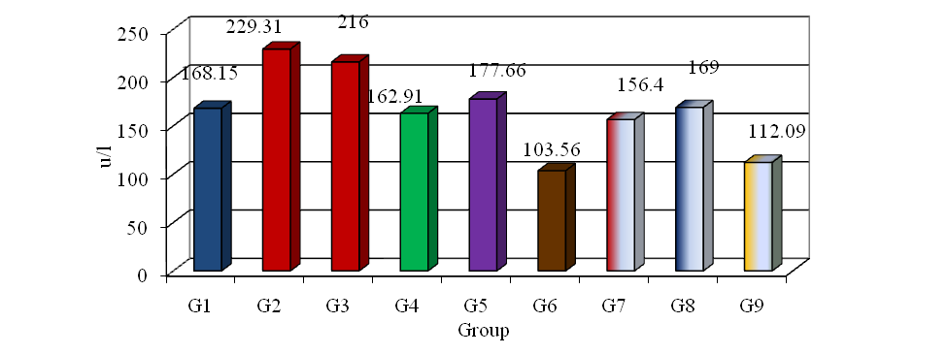
Figure 9: Comparative Effects of Silymarin and DDB on hepatitis induced by Carbon Tetrachloride in Rats for Alk.ph. u/l.
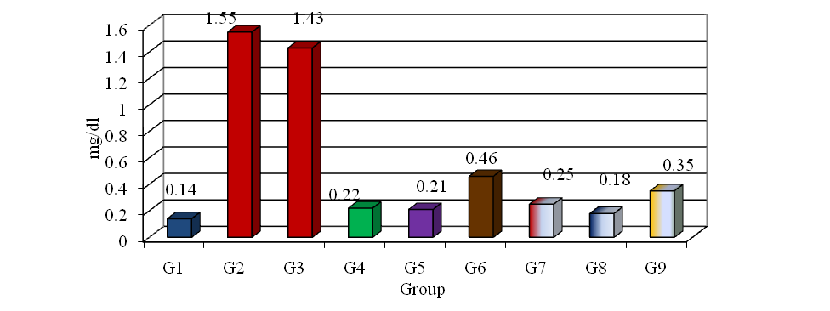

Figure 10: Comparative Effects of Silymarin and DDB on Hepatitis induced by Carbon Tetrachloride in Rats for Serum Bilirubin (mg/dl).

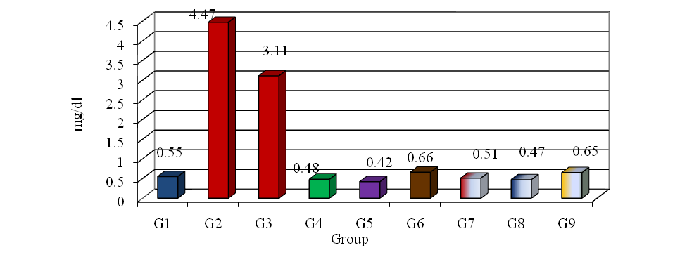

Figure 11: Comparative Effects of Silymarin and DDB on Hepatitis induced by Carbon Tetrachloride in Rats for Serum Creatinine (mg/dl).

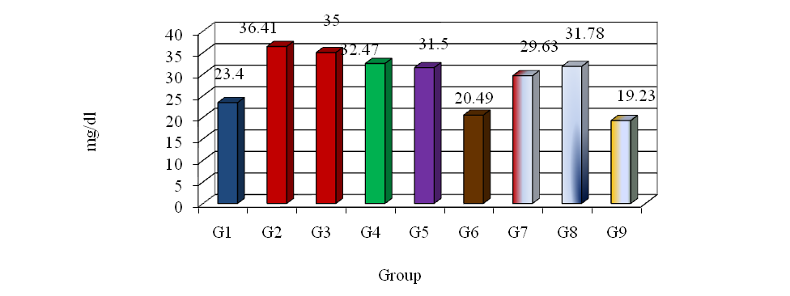
Figure 12: Comparative Effects of Silymarin and DDB on Hepatitis induced by Carbon Tetrachloride in Rats for Serum Urea (mg/dl).

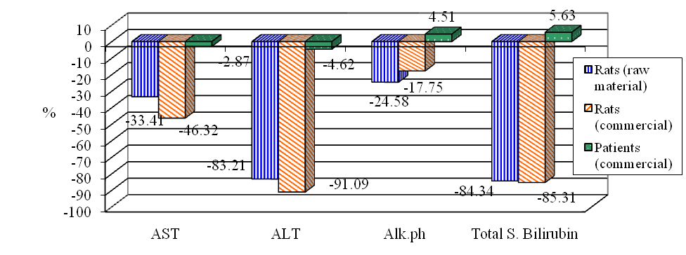

Figure 13: Impact of Treatment with Silymarin on the Measured Liver Parameters in Rats and Patients.
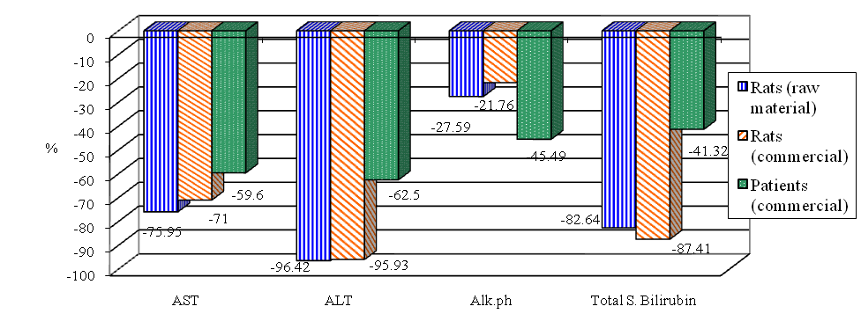

Figure 14: Impact of Treatment with DDB on the Measured Liver Parameters in Rats and Patients.

Liver

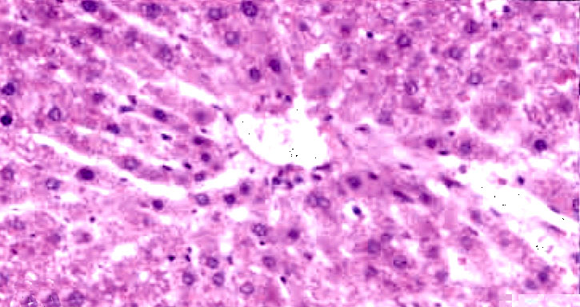  Figure (15): control group (grade 0) (H&E X200).  15 | 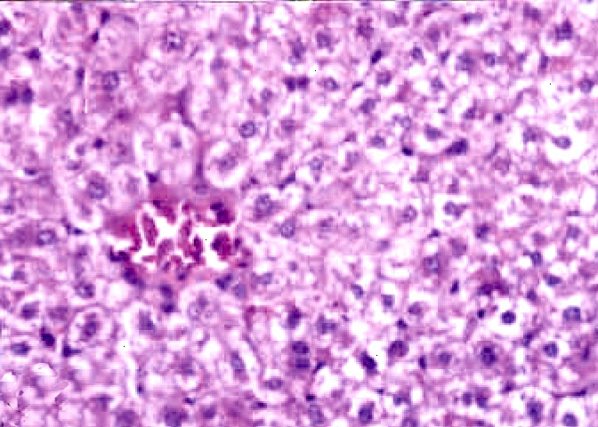  16  Figure (16): CCL₄ group (grade IV) (H&E X200).
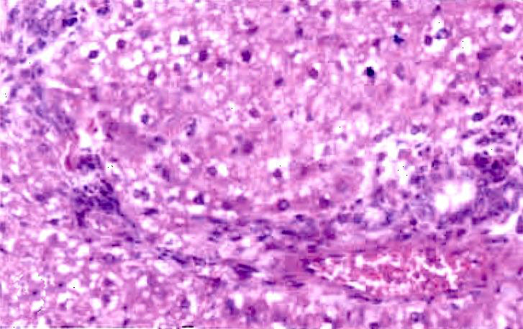  Figure (17): Group four (raw material of Silymarin) after exposed to CCL₄) (grade II) (H&E X200). | 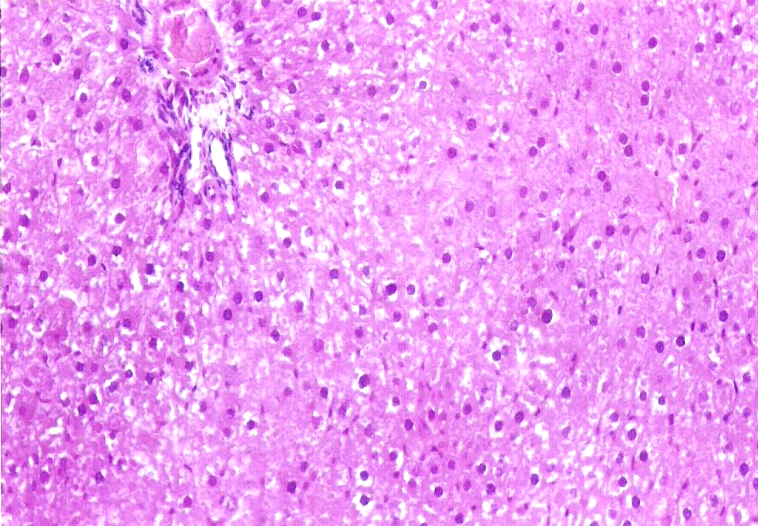  18  Figure (18): Group five (commercial product of Silymarin) after exposed to CCL₄ (grade III) (H&E X200).
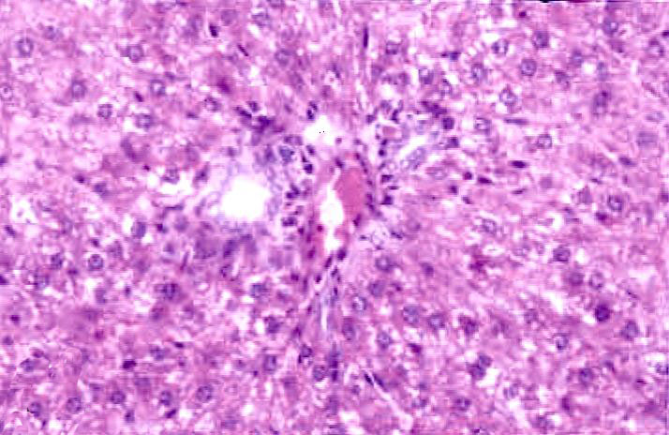  19 | 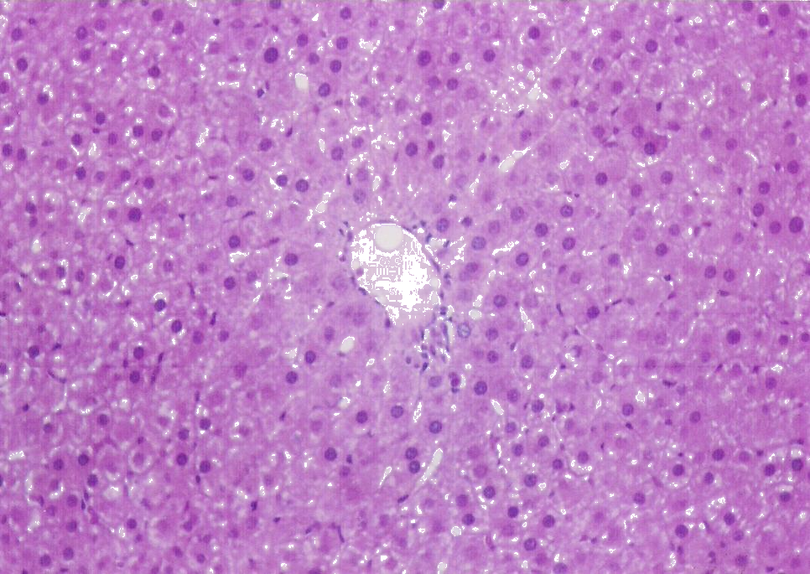  20
Figure (19): Group seven (raw material of DDB) after exposed to CCL₄ (grade I) (H&E X200). | Figure (20): Group eight (commercial product of DDB) after exposed to CCL₄ (grade II) (H&E X200).

Kidney

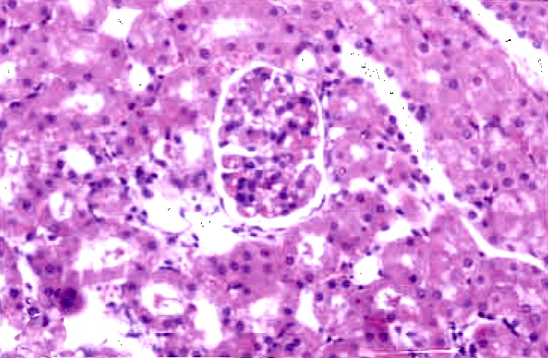  21  Figure (21): Control group, normal histological structure of it is parenchyma (H&E X200). | 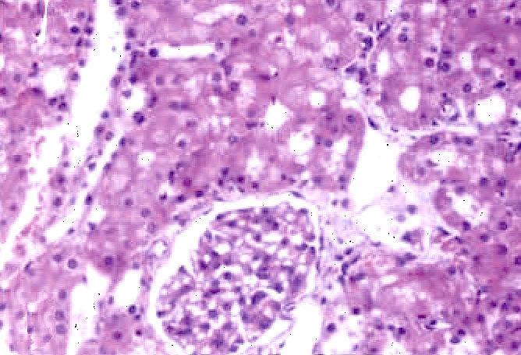  22  Figure (22): CCL₄ group, swelling of tubular epithelial lining (H&E X200).
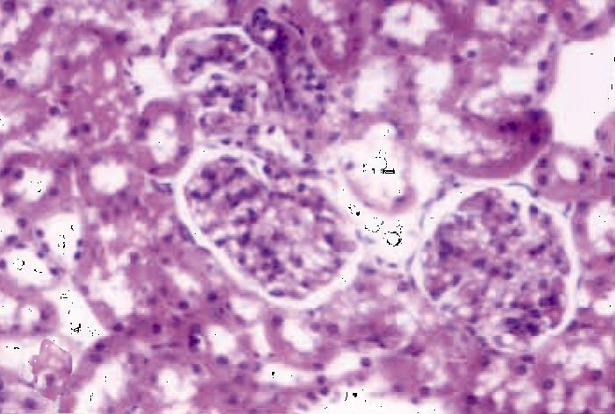  23 | 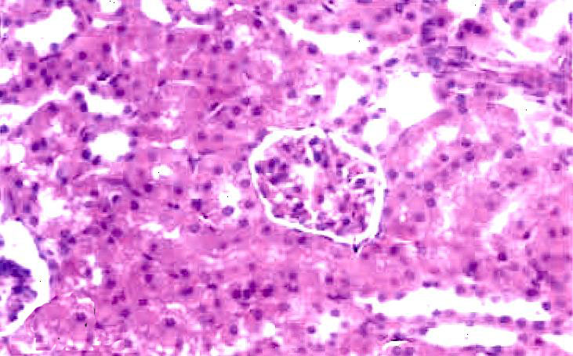  24
Figure (23): Group four (raw material of Silymarin) after exposed to CCL₄, mild swelling of tubular epithelial lining (H&E X200). | Figure 24: Group seven (raw material of DDB) after exposed CCL₄, normal histological structure (H&E X200).

4. Conclusion:
- DDB was improved liver functions as regards to AST, ALT, ALP., serum bilirubin and GGT in patients suffering from HCV infection.
- Silymarin has insignificant effect on the liver enzymes and serum bilirubin in patients suffering from HCV infection.
- The raw and commercial materials of Silymarin and DDB were significantly treated the liver and kidneys after CCL₄ induced toxic hepatitis in rats.
- Raw material of DDB and Silymarin is better than their commercial product in their action on treatment of CCL₄ induced hepatitis in rats.
- Commercial product of DDB is better than commercial product of Silymarin as regard the action on liver enzymes and creatinine in rats.
- Raw material and commercial products of DDB and Silymarin were improved the histo-pathological changes in CCL₄ induced hepatitis in rats.
- The rats might be considered as a good representative model for humans in researches tackling liver infections.

Corresponding author
S. M. Kandil
New Kassr El Aini Teaching Hospital, Cairo, Egypt.
kandil.2009@hotmail.com*
5. References:
- Kim S.N., Kim S.Y., Yim H.K., Lee W.Y., Ham K.S., Kim S.K., Yoon M.Y., (1999): Effect of dimethyl-4, 4’-dimethoxy-5, 6, 5’, 6’-dimethylenedioxybiphenyl-2, 2’- dicarboxylate (DDB) on chemical-induced liver injury. Biol Pharm Bull; 22:93-95.
- Xu Q., Lu J., Wang R., Cao J., and Chen X. (1997): Liver injury model induced in mice by a cellular immunologic mechanism-study for use in immunopharmcological evaluations. Pharmacol-Res.; 35, 4:273-278.
- Kim J. H., Mun Y.J., Chun H. J., Jeon K. S., Kim Y.O. and Woo W. H. (2000): Effect of biphenyl dimethyl dicarboxylate on the humoral immunosuppression by ethanol. Int-J-Immunopharmacol.; 22, 11: 905-913.
- El-Sawy S. A., El-Shafey A. M. and el-Bahrawy H. A. (2002): Effect of dimethyl diphenyl bicarboxylate on normal and chemically-injured liver. East-Mediterr-Health-J. 8, 95-104.
- Joanne Barnes Linda A. Anderson and J. David Phillipson (2007): Herbal Medicines, 3rd Edition, Pharmaceutical Press Publication.
- Jeong D.H., Lee G.P., Jeong W.I., Do S.H., Yang H.J., Yuan D.W., Park H.Y., Kim K.J. and Jeong K.S. (2005): Alterations of mast cells and TGF-betal on the Silymarin treatment for CCI ₄-induced hepatic fibrosis. World. J. Gastroenteral., 11: 1141-8.
- Rumi M., Aghemo N.A. and Prati G.M. (2010): Randomized Study of Peginterferon-alpha2a Plus Ribavirin vs Peginterferon-alpha2b Plus Ribavirin in Chronic Hepatitis C. Gastroenterology 138(1): 108-115.
- Berenguer J. and Carrasco D. (1977): double blind trial of Silymarin versus placebo in the treatment of chronic hepatitis. Munch Med wochenschr; 119:240-260.
- Albrecht M. and Freick H. (1992): Therapy of Toxic liver pathologies with legalon. Z Klin Med.; 47:87-92.
- Liu K.T., and Lesca P. (1982): Pharmacological properties of Dibenzo [a,c] cyclooctene derivatives isolated from Fructus Schizandrae Chinensis III. Inhibitory effects on carbon tetrachloride-induced lipid peroxidation, metabolism and covalent binding of carbon tetrachloride to lipids. Chem-Biol-Interact.15; 41: 39-47.
- Li X. Y. (1991): Bioactivity of neolignans from Fructas shizandrae. Mem. Inst. Oswaldo. Cruz; 86 Suppl. 2:31-37.
- Mayer K. E., Myers R.P., and Lee S.S. (2005): Silymarin treatment of viral hepatitis: a systematic review. J. viral.,Hepat. 12: 559-567.
- Rogers, AE. (1979): Nutrition, in “The Laboratory Rat’ (Eds. Baker, H.J.; Linsey, J.R. and Weisbroth, S.H) Academic press, New York: 1: 123-152.
- Paget G.E. and Barnes J.M. (1964): Toxicity tests. Chapt. 6, p.135-166. evaluation of drug activities: Pharmacometrics, vol. I. edited by Laurence, D.R. and Bacharach, A.L. academic press, London and New York.
- Janakat S., and Al-Merie H. (2002): Optimization of the dose and route of injection, and characterization of the time course of carbon tetrachloride-induced hepatotoxicity in the rat. J. Phrmacol. Toxicol. Methods, 48, 41-44.
- Siham M. El-Shenawy. (2003): The protective effect of melatonin, Silymarin and their combination in experiment induced acute hepatotoxicity. J. Egypt. Soc. Pharmacol. Exp. Ther., 23:229-245.
- Qing W. and Liu G. (1992): Protective effect of dimethyl-4,4'-dimethoxy-5,6,5', 6'-dimethylene dioxybiphenyl-2,2'-dicarboxylate (DDB) against carcinogen-induced rat liver nuclear DNA damage. Biomed-Environ-Sci. 5, 3: 201-207.
- Reitman S. and Frankel S. (1957): Determination of serum age and sex on 19 blood variables in healthy glutanic-oxalacetic and glutamic pyruvic subjects. Z. Gerontol., 25:339-345.
- Belfield A. and Goldberg, D.M. (1971): Hydrolysis of adenosine monophosphates by acids phosphatases as measured by a continuous spectrophotometric assay. Biochem Med.; 4(2): 135-148.
- Walter M. and Gerade H. (1970): Bilirubin assay Microchem. J., 15, 231-236.
- Henry J.B., Todd S. D (1974): Clinical Diagnosis and Measurement by Laboratory Methods. 16th ed., W.B. Saunders and Co. Philadelphia PA. p260.
- Bartles H., Bohmer M.and Heirli C. (1972): Serum creatinine determination without protein precipitation Clin, Chem, Acta, 37:193.
- Shaw M., Stromme H., London L. and Theodorsen L. (1983): Part 4 IFCC method for γ-glutamyltransferase. Clin Chem Clin Biochem; 21:633-646.
- Bancroft J.D., Stevans A., and Turnes D.R. (1996): Theory and Practice of Histological Techniques. 4th Ed. Churchil livingstone, Edinburgh, London, Melbourne, New York.
- Plaa G.L., and Charbonneau M. (1994): Detection and evaluation of chemically induced liver injury:InHayes,A,W.(ed.) Principles and methods of toxicology.3rdEd.,Raven press, New York.
- SPSS 14 (2006): “Statistical Package for Social Science, SPSS for windows Release 14.0.0, 12 June, 2006.” Standard Version, Copyright SPSS Inc., 1989-2006, All Rights Reserved, Copyright ® SPSS Inc.
- Strader D.B., Wright T., Thomas D.L. and Seeff L.B. (2004): "Diagnosis, management, and treatment of hepatitis "C.", Hepatology; 39: 1147–1171.
- Wellington K. and Jarvis B. (2001): Silymarin: a review of its clinical properties in the management of hepatic disorders. BioDrugs. 15: 465-489.
- Huber R., Futter I., and Ludtke R. (2005): Oral Silymarn for chronic hepatitis C – a retrospective analysis comparing three dose regimens. Eur- Med- Res.:10:68-70.
- Gordon A., Hobbs D.A., Bowden D.S., Bailey M.J., Mitchell J., Francis A.J.and Roberts S.K. (2006): The effects of Silybum marianum on serum hepatitis C virus RNA and ALT levels and well-being in patients with chronic hepatitis. J Gastroenterol Hepatol. Jan; 21 (1 Pt2): 275-280.
- Liu G.T. (1989): Pharmacological actions and clinical use of Fructus schizandrae. Chin Med J., 102:740-749.
- Li X.Y. (1991): Bioactivity of neolignans from Fructas shizandrae. Mem. Inst. Oswaldo. Cruz; 86 Suppl. 2:31-37.
- Shimabukuro K. (1997): Therapeutic effects of DDB on chronic hepatitis C Japan Medical Journal No.3841, 6.
- Akbar N., Tahir R.A.and Santoso W.D. (1998): Effectiveness of the analogue of natural schisandrin C (HpPro) in treatment of liver diseases: an experience in Indonesian patients. Chinese Medical Journal; 111(3): 248-251.
- Huber R., Hockenjos B. and Blum H.E. (2004): "DDB treatment of patients with chronic hepatitis." Hepatology; 39: 1732-1733.
- Li, X.J., Zhao B.L., Liu G.T. and Xin W.J. (1990): "Scavenging effects on active oxygen radicals by schizandrins with different structures and configurations." Free Radic. Biol. Med., 9: 99-104.
- Montasser M.F. (2001).Clinical and laboratory studies of DDB in treatment of chronic hepatitis C: 4-Combintion therapy with amintadine hydrochloride, a pilot study in Egypt. Ain. Shams. Med. J., 52:125-142.
- Mourelle M., Favari L. and Amezcua J, L. (1988): Protection against thallium hepatotoxicity by Silymarin. J-Appl.Toxicol.; 8: 351-354.
- Feher J., Cornides A., Pal J., Lang, I. and Csomos G. (1989): Liver cell protection in toxic liver lesion. Acta-Physiol.Hung.; 73: 285-291.
- Palanisamy D., Kannan S.E. and Bhojraj S. (2007): "Protective and Therapeutic Effects of the Indian Medicinal Plant Pterocarpus santalinus on D-Galactosamine-induced Liver Damage." Asian Journal of Traditional Medicines, 2 (2): 51-57.
- Shaarawy S.M., Tohamy A.A., Elgendy S.M., Abd Elmageed Z.Y., Bahnasy A., Mohamed M.S., Kandil E. and Matrougui K. (2009): "Protective Effects of Garlic and Silymarin on NDEA-Induced Rats Hepatotoxicity." Int J Biol Sci.; 5: 549-557.
- Letteron P., Labbe G., Degott C., Berson A., Fromenty B., Delaforge M., Larrey D., and Pessayre D. (1990): Mechanism for the protective effects of Silymarin against carbon tetrachloride-induced lipid peroxidation and hepatotoxicity in mice. Evidence that Silymarin acts both as an inhibitor of metabolic activation and as a chain-breaking antioxidant. Biochem. Pharmacol.; 39: 2027-2034.
- Fu T. and Liu G (1990): Protective effects of biphenyl dimethyl dicarboxylate on damage in isolated rat hepatocytes induced by carbon tetrachloride and D-galactosamine. Zhonghua-Yi-Xue-Za-Zhi.70, 4, 201-4, 16.
- El-Beshbishy H.A. (2005): "The Effect of Dimethyl Dimethoxy Biphenyl Dicarboxylate (DDB) against Tamoxifen-induced Liver Injury in Rats: DDB Use Is Curative or Protective." Journal of Biochemistry and Molecular Biology, 38(3): 300-306.
- Mohamed S.F., Koratum K.M., Salem R.M. and Hassan M.A. (2008): "The efficiency of dimethyl 4, 4- dimethoxy 5, 6, 5, 6- dimethylene dioxy-biphenyl- dicarboxylate (D.D.B.) and acetylsalicylic acid singly and in combination in control of aflatoxicosis." Egypt. J. Comp. Path. & Clinic. Path., 21: 76- 93.
- Oh S.Y., Lee C.H., and Ku Y. S. (2000): Pharmacokinetics and hepatoprotective effects of 2-methylaminoethyl-4, 4, - dimethoxy- 5, 6, 5, 6, dimethylenedioxy-biphenyl-2-carboxylic acid-2, - carboxylate monohydrochloride in rats with CC14-induced acute hepatic failure. J-Pharm-Pharmacol.; 52, 9:1099-1103.
- Ip S.P., Che C.T. and Ko K.M. (1998): "Structure-activity relationship of schisandrins in enhancing liver mitochondrial glutathione status in CCl₄-poisoned mice." Zhongguo-Yao-Li-Xue-Bao., 19: 313-316.
- Ip S. P., Yiu H. Y., and Ko K. M. (2000): Differential effect of schisandrin B and dimethyl diphenyl bicarboxylate (DDB) on hepatic mitochondrial glutathione redox status in carbon tetrachloride intoxicated mice. Mol-Cell-Biochem. ; 205, 1-2: 111-114.
- Pascoe G.A. and Reed D.J. (1989): "Cell calcium, vitamin E, and the thiol redox system in cytotoxicity." Free Radic Biol Med.; 6: 209-224.
- Kim S.C., Cho M.K. and Kim S.G. (2003): "Cadmium-induced non-apoptotic cell death mediated by oxidative stress under the condition of sulfhydryl deficiency." Toxicol. Lett.; 144: 325-336.
- Das G., Sarm G. and Barman S. (2008): Hepatoprotective Activity Of Aqueous Extract Of Fruit Pulp Of Cassia Fistula (AFCF) Against Carbon Tetrachloride (CCL4) Induced Liver Damage In Albino Rats, MD (Pharmacology).
- Johnson D. E. and Kroening C. (1998): Mechanism of early carbon Tetrachloride toxicity in cultured rat hepatocytes pharmacol. Toxicol.; 83: 231-39.
- Recknagel R. O. (1983): A new direction in the study of carbon tetrachloride hepatotoxicity. Life Sciences, 33:401-408.
- DeGroot H. and Noll T. (1986): The crucial role of low steady state oxygen partial pressures in haloalkane free-radical-mediated lipid peroxidation. Biochemical Pharmacology, 35: 15-19.
- Azri S., Mata H. P., Reid L.L., Gandlofi A. J. and Brendel K. (1992): Further examination of the selective toxicity of CCL4 rat liver slices. Toxicology and Applied Pharmacology, 112: 81-86.
- Barbarino F., Suciu A., Cotutiu C., and Ban A. (1977): The action of Silymarin on Galactosamine-induced hepatitis in the rat. Wien-Klin-Wochenschr. 4; 89: 90-95.
- Mishra G., Sinha R., Verma N., Khosa R.L., Garg V. K. and Singh P. (2009): Hepatoprotective activity of alcoholic and aqueous extracts of Wedelia chinensis. Pharmacology online, 1:345-356.
- Muriel P. (1990): Prevention by Silymarin of membrane alterations in acute CCl4 liver damage. J Appl. Toxicol., 10:275-279.

12/8/2010

