Surface Morphology of the Tongue of the Hoopoe (Upupa Epops)

Neveen E.R. El-Bakary

Department of Zoology, Faculty of Science, Damietta Branch, Mansoura University, New Damietta, Egypt. elbakaryneveen@yahoo.com

Abstract: The tongue of birds fills the oral cavity and has a beak- like shape. The hoopoe’s beak is long, slender and slightly down curved, however, the hoopoe’s tongue is reduced in the buccal cavity. Several studies have shown morphological differences among the tongue of bird species. The aims of this study was to examine the dorsal lingual surface of hoopoe’s tongue using scanning electron microscopy and to compare the present results with those reported in other avian species. The Hoopoe’s tongue occupy 2/3 length of the beak. The morphological features observed in the lingual surface are follows; the epithelium of the apex is thickly keratinized, large conical papillae are located at the border between lingual apex and body, small conical papillae are located between lingual body and root and numerous lingual glands are located in the anterior part of the lingual body and in the clefts of the lingual root. The observations of the three dimensional structure of the subepithetial connective tissue revealed the presence of a system of laminae or smaller interconnected ridges, depending on the area of the tongue. We have indicated the possibility that the differences in the structures of the avian tongue related to the differences in the feeding habits.
[Neveen E.R. El-Bakary. Surface Morphology of the Tongue of the Hoopoe (Upupa Epops). Journal of American Science 2011;7(1):394-399]. (ISSN: 1545-1003). http://www.americanscience.org.

Keywords: tongue, birds, hoopoe, scanning electron microscopy

1. Introduction:
Morphological studies on the structure of the tongue in birds have been conducted in various species, such as chickens, parrot, geese, eagle, cormorant, owl, peregrine falcon, common kestrel and oriental scops owl (Homberger and Brush, 1986; Iwasaki and Kobayashi, 1986; Iwasaki et al., 1997; Jackowiak and Godynicki, 2005; Jackowiak et al., 2006; Emura and Chen, 2008; Emura et al., 2008; Emura et al., 2009).
The previous studies indicates that the avian tongue is a triangular organ, which is filled in the whole lower part of the bill, and is divided into the apex, the body and the root. Morphological and functional studies of various avian species indicated a close correlation of the lingual form, the histological structure of the lingual epithelium and the lingual skeletal apparatus with their feeding habits (Campbell and Lack, 1985; McLelland, 1990; Vollmerhaus and Sinowatz, 1992; Koening and Liebig, 2001; Emura et al., 2008, 2009).
This study has carried out to clarify the relationship between the morphological features of the tongue by scanning electron microscopy and the life style in the hoopoe, and it was compared with the results reported by Homberger and Brush (1986) on the African grey parrot, studies by Kobayashi et al. (1998) describing the morphology of the tongue in penguins and a study by Jackowiak and Godynicki (2005) on the white tailed eagle.

2. Materials and methods
The tongues of the hoopoe (Upupa epops) of the family upupidae (Hoopoes) were used in this study. The tongues were fixed in 10% formalin, post fixed with 1% osmium tetroxide in 0.1M sodium cacodylate buffer at pH 7.2 for 1h at 4°C. Thereafter, the specimens were dehydrated through graded series of ethanol and critical point dried. To show the three dimensional connective tissue structure of the lamina propria of the mucosa, some samples were washed in distilled water after fixation and macerated in 10% NaOH at room temperature for 4 days. After maceration tissues were washed in several changes of the distilled water and post fixed in 1% buffered osmium tetroxide for 1h at 4°C and once again washed three times in distilled water, dehydrated in a series of ethanol and critical point dried. All specimens were mounted on aluminum stubs covered with carbon tabs, and then were sputtered with gold and observed under scanning electron microscopy (JSM-5300) at an accelerating voltage of 15kV.

3. Results
The tongue of the hoopoe is about 2 cm long and occupy 2/ 3 length of the beak. The tip of the tongue is pointed. Three parts are distinguished in the dorsal surface of the tongue: the apex, the body and the root of the tongue (Fig.1 ).
The surface of the lingual apex is rough and has a thickly keratinized epithelium (Figs. 2a, b). Large conical papillae are located at the rear end of the lingual apex in the form of letter "w" (Fig.2c,d). The body of the tongue has less keratinized epithelium than the apex. The apices of the lingual papillae are pointed towards the posterior part of the tongue. (Figs. 2c, d). There are numerous orifices of the lingual glands at the anterior border of the lingual body (Fig. 2e). The surface of the lingual body was smooth than that of the lingual apex (Fig. 2f, g).
The border between the body and root is clearly distinguished, and small and large conical papillae are located in this border area (Figs. 3a-c). Large number of wide opening of the lingual glands, which are included in many clefts, in the lingual root, and the number of the openings of the lingual glands in the root is larger than that in the anterior part of the tongue (Figs. 3c-g).
Morphological features of the connective tissue structure of subepithelial papillae was exposed after the removal of the epithelium (Figs.2b, d, g; Figs.3d, e, g). The SEM images of the connective tissue of tissue after macerations indicate that the subepithelial papillae are in fact laminae and ridges of varying height and shape. Fig.2b presents a three dimensional structure of the lamina propria of the lingual apex. The fibers of the connective tissue form thin parallel laminae. On the surface of the conical papillae mucosa, a pattern of connective tissue processes directed backward are located (Fig.2d). In the posterior part of the lingual body, the connective tissue ridges increase and join with each other (Fig.2g). The structure of the lamina propria of the mucosa on the surface of the lingual root is presented in Figs.3d,e,g. Several processes are located and directed backward (Fig.3d). The lingual clefts are deep and contain numerous lingual glands (Fig. 3e). Connective tissue ridges are arranged circularly, forming sheaths around the orifices of the lingual glands (Fig.3g).

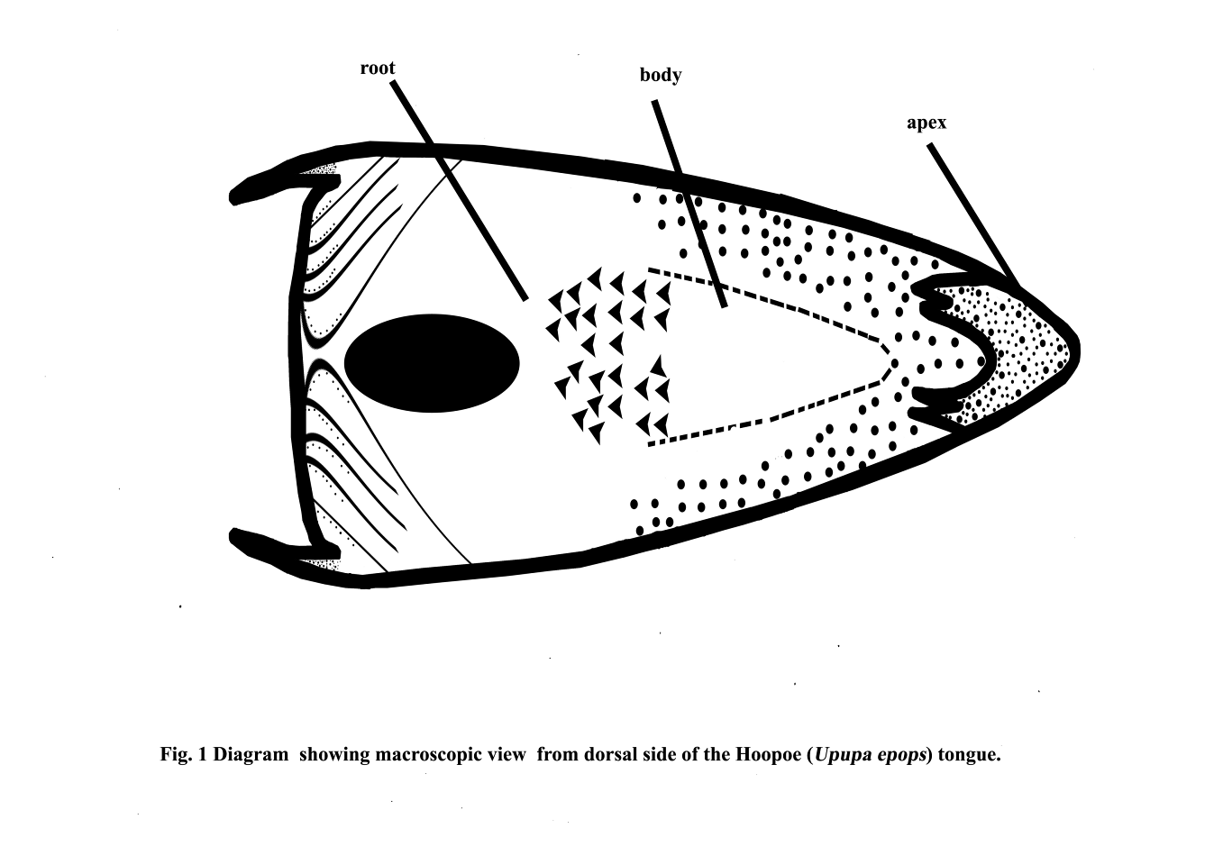

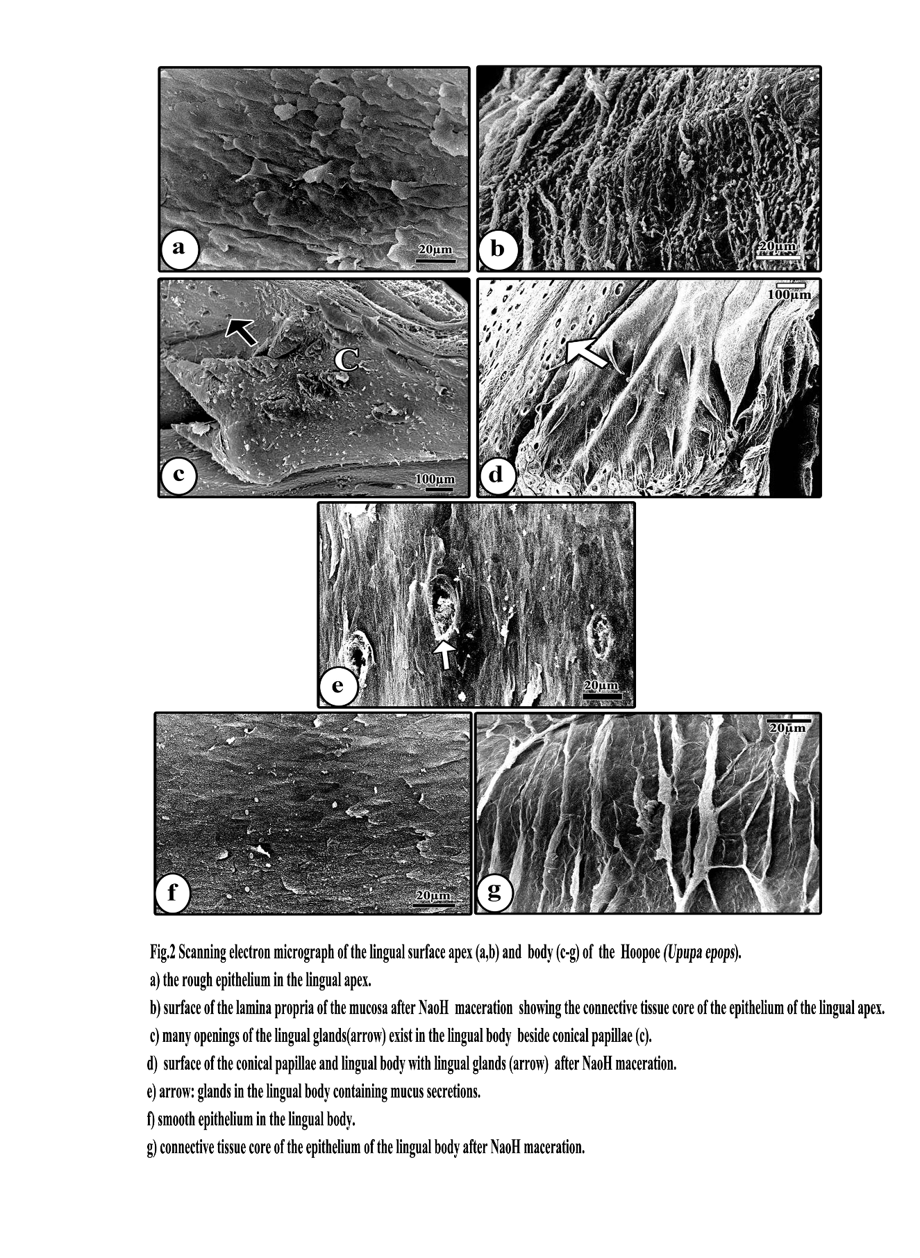

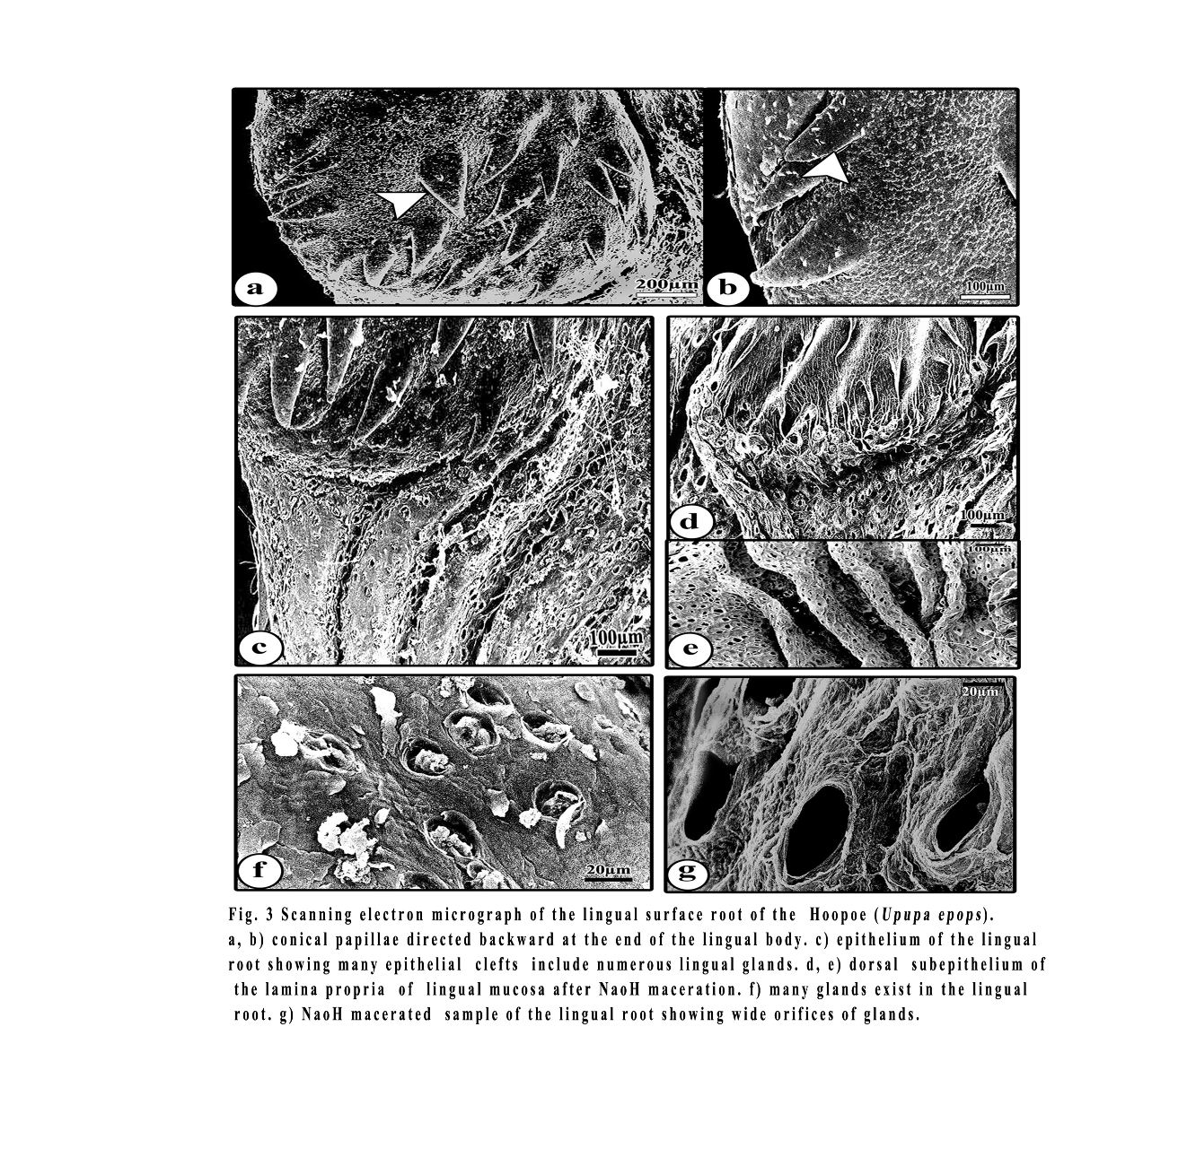

4. Discussion:
All birds are adapted to their habitats; in the air, on land and on and around fresh water and sea water with respect to food sources. Birds have different feeding habits, with corresponding differences in the structure of their bills and tongues. The structure of the tongue of birds frequently gives some clue to the principal diet and manner of feeding in each species, for example probe or spear in woodpeckers, sieve in ducks, capillary tube in sunbirds, brush in Trichglossidae, rasp in vulture and barbet in penguin.
Hoopoes hunt for prey primarily on the ground in short grasses and on bare soil by walking short distances, stopping Hoopoes eat mainly insects. Hoopoes usually search for the prey on the ground, but may sometimes make a short flight to catch their prey to insert its long slender bill into the ground with the hope of finding food, and then walking off in a different direction. They sometimes probe under and between bark on trees; and other times dig small holes and turn over leaf litter, dry animal droppings, and other material on the ground in search of prey. Hoopoes also make short flights in the air to catch prey. The feeding behaviour of hoopoes is peculiar. It captures its insect food by "gaping". During this operation the bill is first kept closed, then it is driven into the ground. Later the bill is opened against the resistance of earth and the insect food is captured (Kristin, 2001).
In the marginal region between the anterior and posterior parts of the tongue of the chicken, a close array of giant conical papillae was observed, arranged transversely in a row (Iwasaki and Kobayashi, 1986). On the tongue of the goose, giant conical papillae were located in a transverse row between the lingual body and the lingual radix (Iwasaki et al., 1997). Large conical papillae, the apices of which were pointed towards the posterior part of the tongue, were located between the body and the root at approximately two thirds of the tongue of the white tailed eagle (Jackowiak and Godynicki, 2005). In the dorsal surface of the hoopoe’s tongue, a large conical papillae are found at the posterior border of the lingual apex, and small conical papillae are found between the body and the root of the tongue. The presence of papillae in this region facilitates pushing food towards the posterior region of the conical papillae in which the lingual glands are located.
The main element of the mucosal connective tissue in the lingual body are regular high laminae, arranged parallel to one another. These single or sporadically ramified collagen laminae undoubtedly contribute to the increased area of attachment of the stratified parakeratinized epithelium. Moreover, they could make considerably expanding the boundary surface between the connective tissue and the epithelium for the nutrient exchange between the subepithelial capillary rete and the cells of the desquamate epithelium, which undergoes very intensive renewal. Such an organization of the mucosa may be related to the forces acting on the tongue during the passage of food to the esophagus (Jackowiak and Godynicki, 2005).
In the areas of the tongue covered by the keratinized epithelium connective tissue laminae are low and have the form of ridges. Depending on the segment of the tongue, these ridges are arranged parallel to one another or are joined forming polygonal depressions.
Structures similar to the ridges were observed in the lingual papillae covered by a keratinized epithelium in penguins and chickens (Kobayashi et al., 1998; Jackowiak and Godynicki, 2005). The pattern of connective tissue ridges on conical papillae in the penguin resembles parallel striae.
In a few species of birds, it was reported that the anterior and posterior lingual glands were distinguishable based on their location (McLelland, 1975, 1979; Homberger and Meyers, 1989; Vollmerhaus and Sinowatz, 1992). The orifices of the anterior lingual glands are located on the edges of the lingual body or occasionally on the lateral surfaces of the tongue, whereas the orifices of the posterior lingual glands are located on the dorsal surface of the root of the tongue. However, the present study indicated that, in the hoopoe, the anterior lingual glands were located on the entire part of the body and the posterior lingual glands were located on the entire part of the root, and that the number of posterior ones was larger than that of the anterior ones. It postulated that these glands might play a role in lubrication of foods before transporting them to the esophagus. Gargiulo et al. (1991) indicated that the secretion of these lingual glands was collected in the subepithelial chamber with the wide orifices, and then was effectively evacuated to the surface of the tongue, and that one of the main components of the secretion was the glutinous mucus which might act as an inhibitors of some bacterial enzymes.
In mammals, some openings of the glandular ducts at the dorsal surfaces of the conical papillae of the lingual radix were observed in the tiger (Emura et al., 2004), fox (Jackowiak and Godynicki, 2004) and mole (Jackowiak, 2006). However, the openings of the lingual glands in mammals are a small number than that of the eagle, owl and hoopoe.
The white tailed eagle feeds mostly on fish and the peregrine falcon and common kestrel feeds on small animal. The hoopoe feeds on large insects, their larvae and pupae, and small vertebrates: lizards and geckos. Furthermore, in the white tailed eagle, the crest of the conical papillae found in the lingual body was sites aiding in the transfer of the swallowed food towards the esophagus and at the same time preventing its regurgitatioin (Jackowiak and Godynicki, 2005). In the peregrine falcon and common kestrel (Emura et al., 2008), there were observed not only the crest but also the many conical papillae on the lingual body. In hoopoe, large conical papillae are found at the border between apex and body and many conical papillae are found at the posterior part of the body. Therefore, it seems that the differences in the structures of the tongues in the white tailed eagles, peregrine falcons, common kestrels and hoopoes might reflect the differences in their feeding habits.

Corresponding author
Neveen E.R. El-Bakary
Department of Zoology, Faculty of Science, Damietta Branch, Mansoura University, New Damietta, Egypt.
elbakaryneveen@yahoo.com

5. References:
- Campbell, B. and Lack, E. (1985): A Dictionary of Birds. Calton T. AD. Poyser.
- Emura, S. and Chen, H. (2008): Scanning electron microscopic study of the tongue in the owl (Strix uralensis). Anat. Histol. Embryol., 37: 475-478.
- Emura, S. Hayakawa, D. Chen, H. and Shoumura, S. (2004): Morphology of the lingual papillae in the tiger. Okajimas Folia Anat. Jpn. 81: 39-44.
- Emura, S. Okumura, T. and Chen, H. (2008): Scanning electron microscopic study of the tongue in the peregrine falcon and common kestrel. Okajimas Folia Anat. Jpn., 85(1): 11-15.
- Emura, S. Okumura, T. and Chen, H. (2009): Scanning electron microscopic study of the tongue in the Japanese pygmy woodpecker (Dendrocopes kizuki). Okajimas Folia Anat. Jpn. 86(1): 31-35.
- Gargiulo, A.M., Lorvik, S. Ceccarelli, P. and Pedini, V. (1991): Histological and histochemical studies on the chicken lingual glands. Br. Poult. Sci. 32: 693-702.
- Homberger, D.G. and Brush, A.H. (1986): Functional morphological and biochemical correlations of the keratinized structure in the African Grey parrot, Psittaccus erithacus (aves). Zoomorphol., 106: 103-114.
- Homberger, D.G. and Meyers, R. (1989): Morphology of the lingual apparatus of the domestic chicken Gallus gallus, with special attention to the structure of the fasciae. Amer. J. Anat., 186: 217-257.
- Iwasaki, S. and Kobayashi, K. (1986): Scanning and transmission electron microscopical studies on the lingual dorsal epithelium of chickens. Acta Anat Nippon. 61: 83-96.
- Iwasaki, S. Asami, T. and Chiba, (1997): Ultrastructural study of the keratinisation of the dorsal epithelium of the tongue of Middendorff s bean goose, Anser fabalis middedorfii (Anseres, Antidae). Anat. Rec. 247, 147-163.
- Jackowiak, H. (2006): Scanning electron microscopic study of the lingual papillae in the European mole (Talpa europea, L., Talpidae). Anat. Histol. Embryol. 35: 190- 195.
- Jackowiak, H., Andrzejewski, W. and Godynicki, S. (2006): Light and scanning electron microscopic study of the tongue in the cormorant Phalacrocorax carbo (Phalacrocoracidae, Aves). Zoology. Sci. 23, 161-167.
- Jackowiak, H. and Godynicki, S. (2004): The scanning electron microscopic study of lingual papillae in the silver fox (Vulpes Vulpes fulva, Desmarest, 1820). Ann. Anat. 186: 179-183.
- Jackowiak, H. and Godynicki, S. (2005): Light and scanning electron microscopic study of the tongue in the white tailed eagle (Haliaeetus allbicilla, Accipitridae, Aves). Ann. Anat. 187: 197-205.
- Kobayashi, K., Kumakura, M., Yoshimura, K., Inatomi, M. and Asami, T. (1998): Fine structure of the tongue and lingual papillae of the penguin. Arch Histol Cytol., 61: 37-46.
- Koeing, H.E. and Liebig, H.G. (2001): Anatomie und Propadeutik des Geflugels. Lehrbuch and Farbatlas fur Studium und Praxis. Schattauer Stuttgart, New York.
- Kristin, A. 2001. Family Upupidae (Hoopoes). In: Josep, del Hoyo; Andrew, Elliott; Sargatal, Jordi. Handbook of the Birds of the World. Vol. 6.Barcelona: Lynx Edicions. pp. 396-411.
- McLelland, J. (1975): Aves digestive system. In: Getty, R. (Ed.) Sisson and Grossmans. The anatomy of the domestic animals, fifth ed. Vol.2 Saunders Company, Philadelphia, London, Toronto, pp. 1857-1882.
- McLelland, J. (1979): Systema digestorium. In:"Nomina Anatomica Avium" Ed by J.J. Baumel, A.S. King, A.M. Lucas, J.E., Breazile, H.E., Evans, Academic Press, London, pp 19-51.
- McLelland, J. (1990): A colour atlas of avian anatomy, Wolfe Publishing Ltd.
- Vollmerhaus, B. and Sinowatz, F. (1992):Verdauungsapparat. In: Nickel, R., Schummer, E. Seiferle, E. (Eds.) Anatomie der Vogel Bd. 5. Lehrbuch der Anatomie der Haustiere, Parey, Berlin.

12/12/2010

