Well Logs Application in Determining the Impact of Mineral Types and Proportions on the Reservoir Performance of Bahariya Formation of Bassel-1x Well, Western Desert, Egypt.

Tarek F. Shazly and Mohamed A. M. Ramadan*

Egyptian Petroleum Research Institute, Cairo, Egypt.
moh_ramadan2222@yahoo.com *

Abstract: The present work dealt with the computerized well log analysis of Bassel – 1X well in the Sherouk Field in the Northern Western Desert of Egypt to determine the mineralogical composition of Lower and Upper Bahariya Formation and to estimate the influence of these minerals on the different petrophysical parameters of Lower and Upper Bahariya Formation. The lithologic and mineralogical compositions were identified qualitatively through the utilizing of crossplots which were established by using the different petrophysical parameters. Also the lithologic and mineralogical compositions were established quantitatively by using the mathematic equations. The matrix components of Lower Bahariya Formation included few percentage of clay minerals (illite and montmorillonite) and high quantity of quartz, calcite and dolomite, while in Upper Bahariya Formation it involves high percentage of clay minerals (illite and montmorillonite) and low quantity of quartz, calcite and dolomite. These minerals were plotted against the different petrophysical parameters to show the effect of these minerals on the effective porosity and the saturation of hydrocarbon.
[Tarek F. Shazly and Mohamed A. M. Ramadan. Well Logs Application in Determining the Impact of Mineral Types and Proportions on the Reservoir Performance of Bahariya Formation of Bassel-1x Well, Western Desert, Egypt. Journal of American Science 2011;7(1):498-505]. (ISSN: 1545-1003). http://www.americanscience.org.

Keywords: Logs; Mineral Type; Reservoir; Bahariya; Western Desert; Egypt

Introduction:
The way of analysis of open – hole well log data is an important technique for studying the rock characteristics such as matrix identification, from which the mineralogical composition can be detected (Ramadan, 1997). The mixed lithology possesses a particular problem for the log analyst because the difficulties arise from the mineralogical complexity reflected from varying rock associations, facies and depositional environments. By this way, the demand for appropriate method and techniques to evolve the lithologic problem is advisable (Said et al. 2003). So the crossplots are important for establishing the lithology and mineralogy for the rock units qualitatively.
First the lithology is identified through M – N and ρ_{b} - Φ_{N} plots and then the minerals are defined through Th – K, M lith and mid plots. Secondly, the mineral compositions are established by using the mathematical modeling (Mats, et al. 2004).
The different petrophysical parameters such as the effective porosity and the hydrocarbon saturation (movable and residual) are greatly affected by the presence of clay minerals. In this study the mineral composition will be evaluated and will show its effect on the petrophysical characteristic for Lower and Upper Bahariya Formation in Bassel – 1x well. This well is located at latitude 30˚ 35\ 10.1\\ N and Longitude 26˚ 56\ 36.9\\ E in the Sherouk Field in the northern western Desert of Egypt (Fig. 1).

Crossplots Application:
The well log data extracted for the studied rock units are presented in the form of crossplots which, assist in the selection of the interpretation parameters and the identification of the trend and problems of the mineralogical models.
On all types of crossplots, it is of prime importance to locate the position of the most probable presented minerals. The following is a detailed presentation for the various crossplots constructed for the evaluated rock units (Lower and Upper Bahariya Formation) in the studied well.

- ρ_{b} vs.Φ_{N} – GR. Z plot and M – N plot:
These plots (Figs. 2 and 3) represent the relation between ρ_{b} and Φ_{N} with taking the GR as a third component.
The first glance reveals the chemical nature of these rock units. The majority of the presented points in this plot lie between the Limestone, Dolomite and the sand line with high and medium GR intensity for the Upper Bahariya Formation, indicating the presence of shale but Low GR intensity in the Lower Bahariya Formation. Some points are located around illite, kaolinite and montmorillonite.
Figures (4 and 5) show nearly the same lithologic composition as in the previous figures, the calculation of M and N will be shown in M-N lith plot.

- Mid plot:
It is a relation between the apparent matrix parameters (ρ_{ma})_{a} and (Δt_{ma})_{a}, which are computed (Wyllie, 1963) as the following:

  - For clean zones:
ρ_{b} _{log} = Φρ_{f} + (1 – Φ) ρ_{ma} or ρ_{ma} = (ρ_{b} _{log} - Φρ_{f}) / (1 - Φ)…..(1)
∆t_{log} = Φ∆t_{f} + (1 – Φ) ∆t_{ma} or ∆t_{ma} = (∆t_{log} - Φ∆t_{f}) / (1 - Φ)….. (2)

  - For shaly zones:
ρ_{b} _{log} = Φρ_{f} + V_{sh} ρ_{sh} + (1 – Φ - V_{sh})ρ_{ma} or
ρ_{ma} = (ρ_{b} _{log} - Φρ_{f} - V_{sh} ρ_{sh}) / (1 – Φ - V_{sh})…..(3)
∆t_{log} = Φ∆t_{f} + V_{sh} ∆t_{sh} + (1 – Φ - V_{sh}) ∆t_{ma} or
∆t_{ma} = (∆t_{log} - Φ∆t_{f} - V_{sh}∆t_{sh}) / (1 – Φ - V_{sh})….. (4)
Clavier and Rust (1976) proposed this crossplot which shows the separation of the different matrix contents. Figures (6 and 7) are plots for Lower and Upper Bahariya Formation in the studied well. In the Lower Bahariya Formation, Figure (6) shows a group of points lying between the Quartz, K-feldspars and carbonate in the form of calcite and dolomite, while the plot of the Upper Bahariya Formation (Fig. 7) exhibits that the majority of the points around the clay minerals (illite and montmorillonite).

- M lith – N lith crossplot:
The advantage of is this plot that, it depends on the three porosity logs (ρ_{b}, ∆t, and Φ_{N}), from these values, two parameters (M and N) are calculated (Burke et al. 1969). These parameters are calculated by the following formulae:
M lith = ((∆t_{f} - ∆t_{log}) / (ρ_{b} _{log} - ρ_{f})) * 0.01….. (5)
N lith = (Φ_{Nf} – Φ_{N} _{log}) / (ρ_{b} _{log} - ρ_{f})….. (6)
Figure (8) reflects that calcite; Quartz and K-feldspars are presented in this crossplot while the clay minerals (montmorillonite, kaolinite) are shown in the crossplot of Upper Bahariya Formation (Fig. 9).

- Th – K crossplot:
It is one of the best crossplots which identify the presence of clay minerals where, the NGS (U, Th and K content) tool is the best logs for discriminating the clay minerals.
The analyzed crossplots (Figs. 10 and 11) reveal the presence of some illite in the Lower Bahariya Formation while, existence of mixed layer clay, illite and montmorillonite can be observed in the Upper Bahariya Formation.

Mathematical Modeling:
Based on the mineralogical modeling obtained from the previous technique, the mathematical modeling was established. Through this modeling process, one has to select the equations, which will enable to relate the log data to the desired computed parameters, like mineral constituents and porosity (Abu El-Ata et al., 1985). The response equations of the minerals, present in each model, are performed and a statistical analysis is carried out on each mineral, in a probabilistic test, for establishing the mineralogical composition that frequently occurred in each studied zone (Delfiner et al., 1984).
Based on the mineralogical model of the Lower and Upper Bahariya Formation in Bassel -1x well, the two units are composed of Qz, calcite, dolomite, illite and montmorillonite with different percentages. The following equations (7-10) are used for Lower Bahariya Formation while, the equations (11-14) represent the Upper Bahariya Formation.
ρ_{b}=2.65qz+2.71cal+2.88dol+2.52ill+2.12 mont+1.0Φ…..(7)
Φ_{N}=-0.02qz–0.01cal+0.01dol+0.30ill+0.44 mont+1.0Φ….. (8)
∆T=55.5qz+48cal+43.5dol+120ill+140mont+189Φ….. (9)
1=Vqz+Vcal+Vdol+Vill+Vmont+Φ….. (10)
ρ_{b}=2.65qz+2.71cal+2.88dol+2.52ill+2.12 mont+1.0Φ…..(11)
Φ_{N}=-0.02qz–0.01cal+0.01dol+0.30ill+0.44 mont+1.0Φ….. (12)
∆T=55.5qz+48cal+43.5dol+120ill+140mont+189Φ….. (13)
1=Vqz+Vcal+Vdol+Vill+Vmont+Φ….. (14)
Where:
ρ_{b} is the reading of density log.
∆t is the interval transit time in μsec/feet.
V is the volume of mineral to be computed (fraction).
Vqz, Vcal, Vdol, Vill and Vmont are the volumes of quartz, calcite, dolomite, illite and montmorillonite
Φ is the porosity value in fraction.
Accordingly, the previous concluded mineralogical models concerning the types of mineral constituents and their volumes, as well as the pore volumes could be helpful in the final lithologic-geologic modeling of the evaluated rock units in the studied well.

Minerologic Quantification:
The determination and calculation of the mineralogical composition and porosity of Bahariya Formation in the studied well is done by using the simultaneous equations as follow;
a₁ V₁ + a₂ V₂ + a₃ V₃ = Φ_{D}
b₁ V₁ + b₂ V₂ + b₃ V₃ = Φ_{N}
V₁ + V₂ + V₃ = 1.0 (15)
Where : a₁, a₂ and a₃ are the density log readings and b₁, b₂ and b₃ are the neutron log porosity readings of the three rock components; in which their volumes are V₁, V₂ and V₃.
Equation (15) is known as the identity equation and it defines the fact that, these components add up to 1.0. The first component could be the porosity and the other two could be illite and calcite or quartz and montmorillonite (Abu El-Ata and Ismail, 1985).
In the matrix form, these equations should be reduced to:
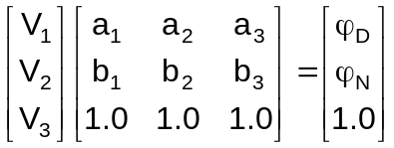 (16)
To solve this matrix for the values of V₁, V₂ and V₃, the matrix inverse should be obtained (Delfiner et al., 1984) as;
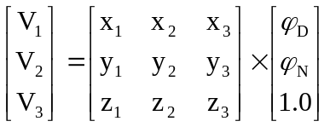 (17)
This concept can be extended to as many equations as; there are independent log readings available for a well. For example, a full suite of logs may consist of the following:
Spectral Gamma-Ray Log: SGR, uranium, thorium and potassium. Usual Porosity Logs: density, neutron and sonic. Litho-Density Logs: PEF. Usual Resistivity Logs: shallow, medium and deep. Electro-Magnetic Propagation Time Log: EPT.
These logs together with the identity equation give a possibility of 13 equations in 13 unknowns. It is unlikely that, the three resistivity logs are truly dependent equations, so they may not assist in the solution.
The possibility of a ridiculous solution can be reduced by taking all combinations, but five or six equations from the possible unknowns are better for checking the results of each solution for reasonableness. Reasonableness might be performed by reaching a solution, in which the deduced volumes are all within the range of −0.05 to 1.05 (i.e., no material can be presented in large negative quantities or be greater than the volume of rock). However, the method for selecting the desired solution from the various possible ones is to scan the rock types found in all reasonable solutions and to pick a set of rocks that occur most frequently (Szendro, 1983). Moreover, if more log types (known data) are available than the unknowns (mineral volumes), the case is called over - determined. In this situation, the number of equations provided by the logs exceeds the number of components.
An appropriate estimate for the zone composition can be drawn from a least-squares model, in which the error is minimized between the log responses and their corresponding values predicted by the solution, thus the matrix solution of the least-squares model becomes:
V = (C^{T} C) ⁻¹ C^{T} L….. (18)
where each letter signifies an array of numbers or unknowns, rather than a single number of unknowns, as in the conventional algebra. The “known” are C (vector of log readings), L (vector of log response), the symbol C^{T} signifies as the transpose of the C matrix, which simply means a matrix in which the rows and columns have been interchanged and the “unknown” is V (vector of the volume of minerals), as shown by Doveton (1996).
On the other hand, if the log types (known data) are less than the unknowns (mineral volumes), the case is called underdetermined, and then the matrix solution for the least-squares model becomes:
V = CT (C C^{T}) ⁻¹ L….. (19)
The different computer programs were established by Reda (1997) for facilitating the complexities arisen in the solution of the simultaneous equations in this study. By this way, the correct values of the mineralogical constituents (quartz, calcite, dolomite, illite and montmorillonite) were derived for Bahariya Formation in the studied well.

Impact of Mineral Types and Proportions on the Reservoir Performance:
As long as production is concerned for any study, the well log data analysis provides a continuous record for the petrophysical parameters. The reservoir porosity (Φ), permeability, water saturation (Sw) and hydrocarbon saturation (Sh) are the most important properties that define and control qualitatively and quantitatively the reservoir performance. The minerals present in the reservoir especially the clay mineral (Moll, 2001) can play the utmost role, which affect both the reservoir capacity and production because the grain size of clay minerals is generally very small and result in very low effective porosity and permeability, thus any presence of clay in a reservoir may have direct consequences on the reservoir properties (Said et al. 2003). However the type of clay minerals must be taken into account in reservoir evaluation. Their influence has been studied by Nesham (1977) which cause pore filling, pore lining or pore bridging. The following discussion represents an attempt to relate the mineralogic suit for each formation to reservoir characteristics.
The lithologic and clay minerals identification of the Upper Bahariya Formation in Bassel – 1x well reveals the majority of shale followed by sandstone and limestone in decreasing occurrence. The clay minerals are represented by illite and montmorillonite. The calculated reservoir parameters responding for these mineral contents are shown in Fig. (12), it reveals that the high percentage of illite and montmorillonite affected on the reservoir performance of Upper Bahariya Formation, these fine grains of clay minerals reduced the total porosity into small effective porosity this gives rise to varying total hydrocarbon saturation which behaves by analogous way, in which the movable hydrocarbon saturation became the least and residual hydrocarbon saturation became the largest. This reflects badly fair reservoir performance for the Upper Bahariya Formation.
The mineral contents of Lower Bahariya Formation (qz, calcite, dolomite, illite and montmorillonite) play another role for the reservoir performance (fig. 13), Mmontmorillonite and illite decrease in percentage in the Lower Bahariya Formation as compared to the Upper Bahariya Formation which increases the effective porosity and then the hydrocarbon saturation. Moreover, a part of the calcite is dolomitized, giving rise to more secondary porosity. These variations of the mineral types and their contents enhanced the reservoir performance of Lower Bahariya Formation as compared to that of the Upper Bahariya Formation.

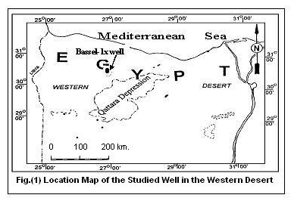

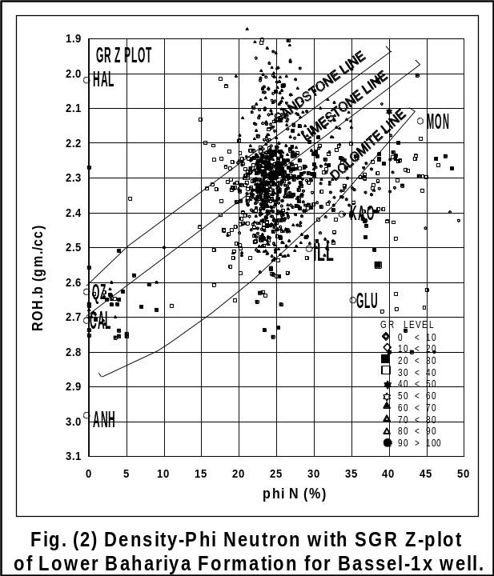

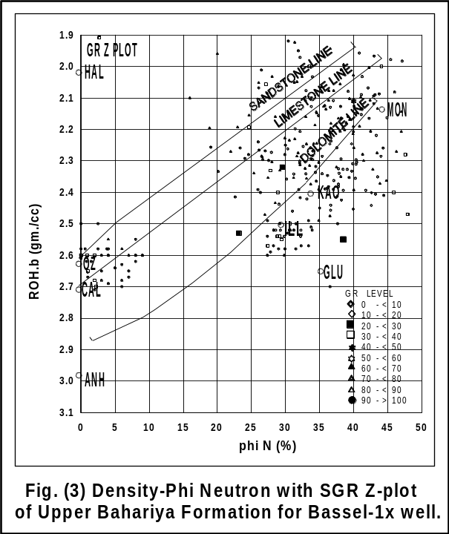

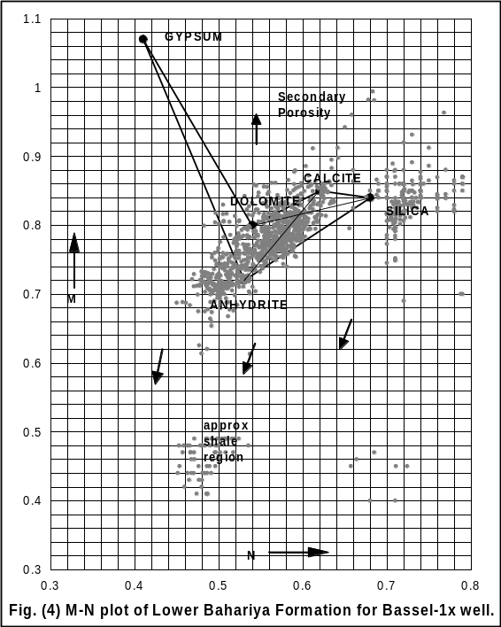

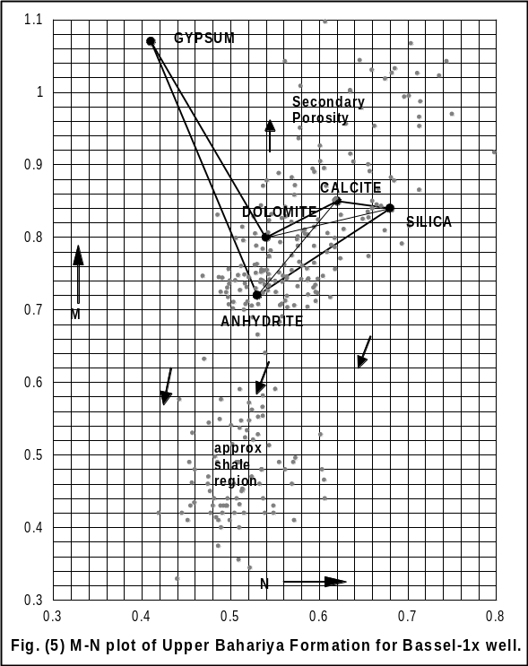

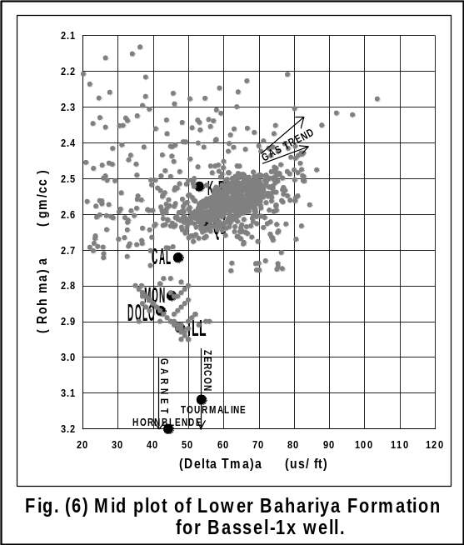

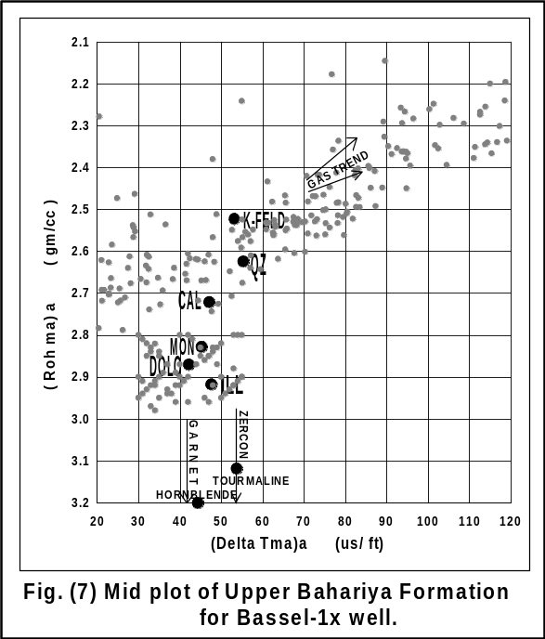

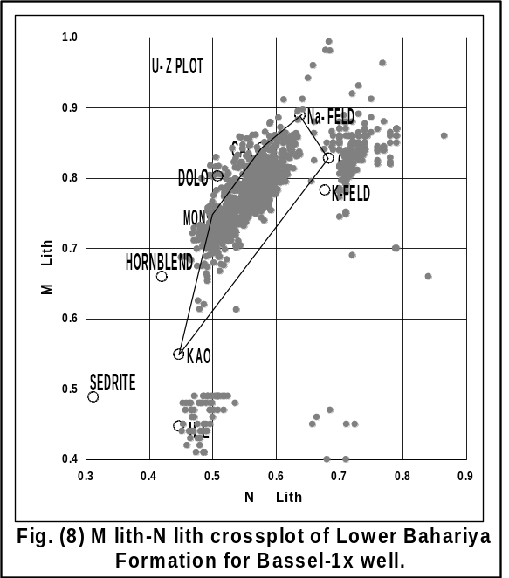

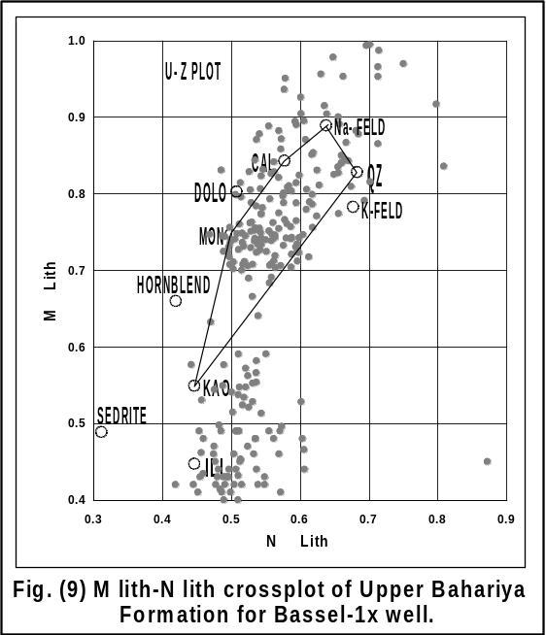

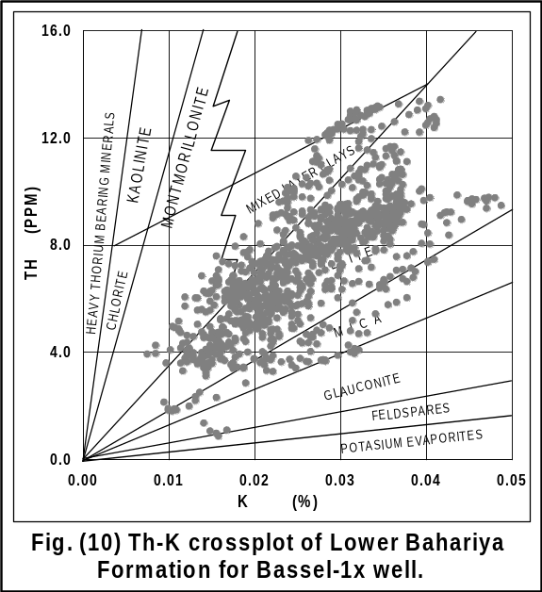

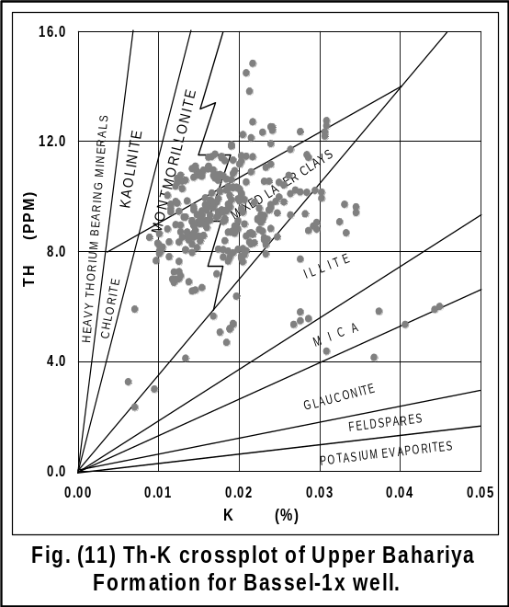

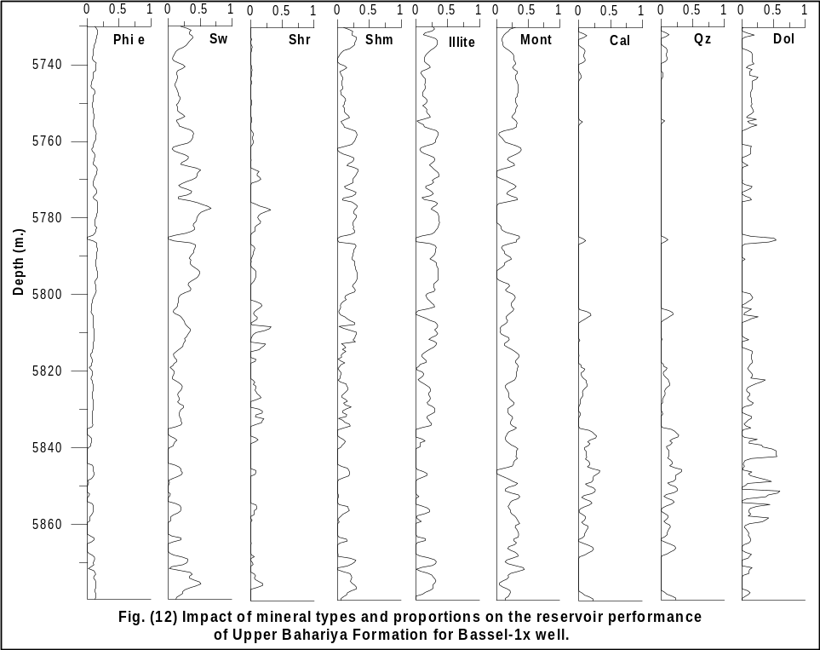

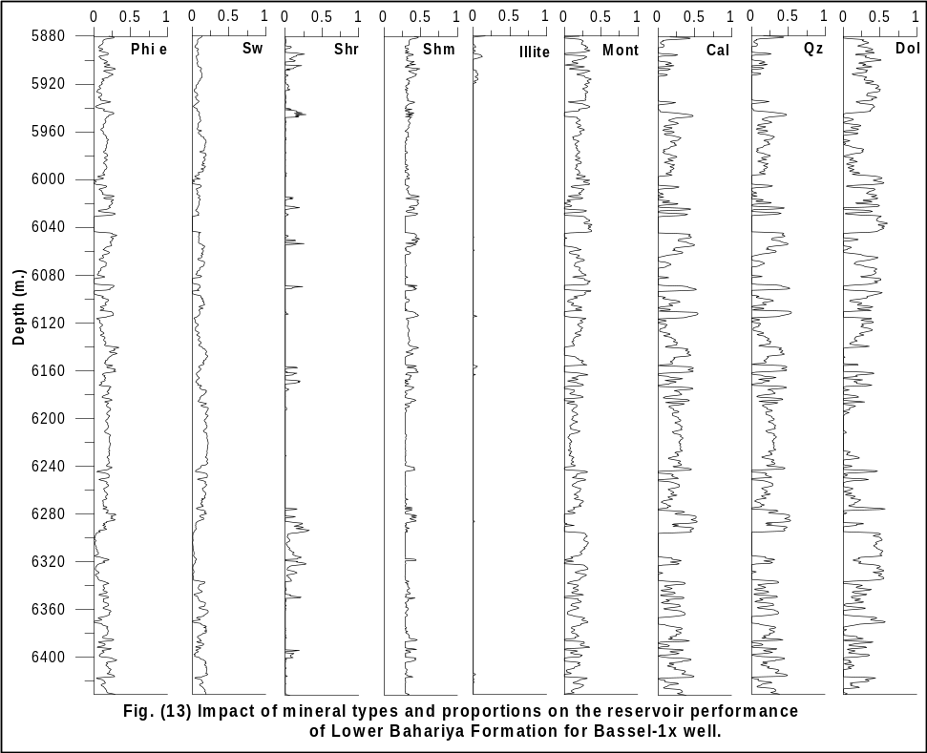

Summary and Conclusion
The present work deals with the computerized well - log analysis for Bassel-1x well in the North Western Desert of Egypt. Such an analysis was carried out on Lower and Upper Bahariya Formation where these rock units are very important for petroleum exploration.
The integrated analysis of the available open hole log data is in the form of porosity tool (density, sonic and neutron), gamma ray, natural gamma ray spectroscopy and resistivity logs for invaded and uninvaded zones, these analysis helped in identifying and determining the lithologic and mineralogic components of the rock units of the studied well.
Well log technique started by representing these data in the form of crossplots to facilitate the qualitative and quantitative interpretation for the mineralogical composition of the studied rock units. However, the mineralogical constituents were deduced from these crossplots.
For the Lower and Upper Bahariya Formations, the following minerals are indicated: quartz, calcite, dolomite, illite and montmorillonite. After establishing the mineralogical models of the studied formation, the mathematical equation was applied on the estimated minerals from the crossplot to determine the percentage of each mineral. It was found that the clay minerals (illite and montmorillonite) are found with high percentage in the upper unit while with low ratios in the lower unit of Bahariya Formation.
The effect of these minerals on the different petrophysical parameters of the two rock units is shown by plotting the percentages of these minerals against the different petrophysical properties. From these plots, it was found that the montmorillonite and illite which are found with high ratio in the Upper unit rather than the lower unit caused a major reduction in the effective porosity and then in the hydrocarbon saturation in the Upper Bahariya Formation, while the effective porosity and the hydrocarbon saturation are high in the Lower unit where, these clay minerals didn't have an affect on it. This variation of mineral contents enhanced that the lower rock unit can perform as a reservoir rather than the upper rock unit.

Corresponding author
Mohamed A. M. Ramadan*
Egyptian Petroleum Research Institute, Cairo, Egypt.
moh_ramadan2222@yahoo.com

References:
- Abu El-Ata, A.S.A. and Ismail, A.A.; 1985 : A computerized solution for the simultaneous equations to identify the rock matrices of Abu Madi and Sidi Salem Formations in the central part of the Nile Delta, Egypt, E.G.S. Proc. of 4th Ann. Meet., pp. 376,397.
- Burke, J.A., Compbell, Jr.R.L. and Schmidt, A.W.; 1969: The litho-porosity crossplot; SPWLA, 10th Ann. Log. Sump. Trans., Paper Y.
- Clavier, C. and Rust, D.H.; 1976 : Mid-plot, a new lithology technique, The Log Analyst, V. 17, No. 6, pp. 16,31.
- Delfiner, P., Peyret, O. and Serra, O.; 1984: Automatic determination of lithology from well logs, 59th Ann. Tech. Conf. of SPE of Aime, Houston, USA, Paper 13290.
- Doveton, H.J.; 1996: Log analysis of subsurface geology, concepts and computer methods, John Wiley, New York.
- Mats, V.D., Lomonosova, T.K., Vorobyova, G.A., and Granina, L.Z.; 2004: Upper Cretaceous-Cenozoic clay minerals of the Baikal region (eastern Siberia), Applied Clay Science, V. 24, pp. 327-336.
- Moll, W.F., Jr.; 2001: Baseline studies of the clay minerals society source clays: Geological origin. Clays and Clay Minerals, V. 49, pp. 374–380.
- Neasham, J.W.; 1977: The Morphology of dispersed clays in sandstone and its effect on sandstone shaliness, pore space and fluids properties; 52 nd. Ann Fall. Meet, SPE of AIME, Paper No. 6858.
- Ramadan, M.; 1997: Lithofacies analysis of the Miocene clastic rock units in Ras Ghara Area, Gulf of Suez, Egypt, using open hole logging data, Ph.D. Thesis, Ain Shams University, Cairo, Egypt. pp. 293.
- Reda, M.A.; 1997: The role of well logging analysis in delineating the mixed lithology models of the Miocene rock units in the area west of Feiran field, Gulf of Suez province, Egypt. Ph.D. Thesis, Ain Shams University, Cairo, Egypt. pp. 293.
- Said, A., Abdallah, M. and Alaa E.; 2003: Application of well logs to assess the effect of clay minerals on the petrophysical parameters of Lower Cretaceous Reservoirs, North Sinai, Egypt. EGS Journal, V. 1, No. 1, pp. 117-127.
- Szendro, D.; 1983: A statistical method for lithologic interpretation from well logs, The Log Analysts, V. 34, pp. 16, 23.
- Wyllie, M.R.J.; 1963: The fundamentals of well log interpretation, New York, Academic Press.

12/2/2010

