Utility Mapping with Ground Penetrating Radar: an Innovative Approach

Bello. Y. Idiª and Md. N. Kamarudin^{b}

ªDepartment of Geomatic Engineering, FKSG, Universiti Teknologi Malaysia.
belyus2000@gmail.com
^{b}Institute of Geospatial Science and Technology, (INSTEG), Universiti Teknologi Malaysia.
mdnorkamarudin@utm.my

Abstract: A new approach for the fitting of hyperbolic signatures due to point or cylindrical reflector in a GPR radargram is proposed. The technique is based on the least square error minimization of hyperbolic function derived from the general equation of hyperbola leading to the determination of the optimal values of the fitting parameters at the minimal level of sum of squared error function. The parameters are used to determine the radar velocity and the radius of cylindrical reflector. A test for the effectiveness of the proposed technique was conducted using a GPR radargram obtained at a road side where subsurface utilities are anticipated. A unique hyperbolic signature obtained in the radar image was digitized and interpreted using the developed algorism in MATLAB environment. Hyperbolic fitting parameters a and b were numerically obtained as 49.6444ns and 4.3182m respectively. The parameters were used to obtain the media velocity, dielectric constant and depth of the reflector as 0.174m/ns, 2.973 and 2.61m respectively. The technique therefore seems promising and a new approach to utility mapping.

[Bello. Y. Idi and Md. N. Kamarudin. Utility Mapping with Ground Penetrating Radar: an Innovative Approach. Journal of American Science 2011;7(1):644-649]. (ISSN: 1545-1003). http://www.americanscience.org.

Keywords: Ground penetrating radar, least square fitting, radar velocity, hyperbolic reflection, utility mapping

1. Introduction
Electromagnetic method of geophysical prospecting is widely applicable in mineral exploration and environmental studies. There are different techniques of the method but the most commonly used in engineering and environmental studies is the Ground Penetrating Radar (GPR). The term Ground Penetrating Radar or ground probing radar refers to a range of electromagnetic techniques designed primarily for the location of objects or interfaces buried beneath the earth surfaces or located within a visually opaque structure (Daniels, 2004). Ground-Penetrating Radar (GPR) has become a useful and efficient instrument for gathering information about subsurface geologic formations and detection of buried objects. GPR records continuous graphic profiles of the subsurface interfaces with high degree of accuracy. It is particularly found to be successful in detecting subsurface geologic formations, buried archeological remains, geologic subsurface fracture zones and cavities etc.
The range of application of GPR has been expanding steadily with the development of more sophisticated computing devices. The technique is successfully found to be applicable in stratigraphic studies of sedimentary formation (Bristow & Jol, 2003), outlining the foundation of building and other engineering structures, (Abbas, et al, 2009), archeological investigation (Negri, Leucci & Mazzone, 2008), location of water table, and characterization of subsurface contamination (Hamzah, Ismail & Samsudin 2009), geomorphic controls of flood-plain and surface subsidence (Poole et al, 2002), road inspection (Loizos & Plati, 2007), mine detection (Bruschini et al, 1998) etc.
One of the most usedful application of GPR in urban infrastructural engineering is mapping and detection of buried pipes. This unique application becomes imperative due to the ever growing urbanization in both developed and developing nations with its attendant demand for buried utilities. The construction, development and management of subsurface infrastructures has become a very viable business that attracts the attention of scientists and engineers over the past few years. Various utilities such as telecommunication and electric power cables,water and gas supply cables etc are delivered through underground pipes of varius sized buried at different depths. In many cases, maintainance of these infrastructures require digging operation which leads to unintentional damage to some of the facilities. Since most of these pipes are distinguishable from their depths and sizes, geophysical methods can be used to reduce the cost and effect of these damages. Various geophysical methods are known for their ability to determine the overburden thickness and map subsurface conditions prior to excarvation and construction (Lukumon, Festus & Bolaji, 2010). GPR is relatively a new geophysical utility location tool for accurate mapping of various underground utilities. The technique provides a rapid, high resolution and non-inverssive means of identifying and characterizing underground pipes of different sizes at different depths.
Mapping underground utility requires the knowledge of the electromagnetic properties of the subsurface soil. The fundamental electromagnetic property of the subsurface soil is the radar propagation velocity across the soil medium. A radar pulse transmitted through a homogeneous medium propagates with a unique characteristic velocity that defines the medium. Radar velocity v is related to the relative dielectric permittivity of the medium by the equation
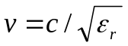 1
where c is the velocity of light in free space.
The propagation of radar signal in ground therefore depends on the dielectric permittivity of the soil. The dielectric permittivity of a material is a frequency-dependent response of the material to electromagnetic waves (Chu, et al, 2006) and it can be used to distinguish it from other materials. Velocity information with respect to a particular subsurface structure can therefore be used to detect variation or discontinuity within the media of different dielectric property.
Techniques of GPR radar velocity estimation are related to data collection modes. There are two types of data collection modes: the Common Offset (CO) mode in which distance between transmitting and receiving antennas is fixed and the entire system is pushed on a cart vehicle along a survey line. This mode has the advantage of being faster in data recording process and produce high resolution image of the subsurface. It is however difficult to estimate velocity from the data obtained using the mode (Nakashima, Zhou & Sato, 2001). The common mid-point (CMP) is the method commonly used in estimating the radar velocity. In this mode, commonly known as bistatic, the transmitter–receiver offset is increased in steps at either site along the profile beginning with the smallest offset. In the CMP gather, all the receiver traces are reflections from the same depth point which is directly beneath the centre of the spread. Tillard & Dubois (1995) reviewed the propagation equation for a two-way bistatic travel time of the reflected waves from a CMP gather, leading to a hyperbolic travel-time curve.
Most of the available GPR equipment are monostatic in which the two antennas are housed in a single casing with a fixed separation. A CMP survey cannot be conducted with such instrument. The most practicable technique for radar velocity estimation in this case is fitting the hyperbolic signature pattern due to a point or cylindrical reflector (Aitken & Steward, 2004). This involves the fitting of the hyperbolic spread due to the reflector with a mathematical model to determine the model parameters. The parameter model that minimizes error criterion can be used to simultaneously estimate the radar propagation velocity of the medium and the radius of the reflector (Ristic, Petrovacki & Govedarica, 2009).
It is however observed that the degree of accuracy with which the velocity can be determined from the model parameter is a subject of concern to many near surface geophysicists. This is mainly due to the fact that the position of the centre of the hyperbola for point reflector is different from that of a cylindrical reflector of finite radius R (Ristic et al, 2009). Point reflector is actually a special case of cylindrical reflector with radius R=0. The variation in the shape of the hyperbola would lead to the false assumption that the spread of the hyperbola is caused by higher magnitude of velocity and can consequently lead to an incorrect velocity value. Thus a polynomial fitting of the hyperbola do not adequately characterized the hyperbola in terms of the model parameters and therefore failed to provide the necessary information for target identification. In other word, second order least square polynomial fitting of the hyperbolic signatures cannot be used to accurately estimate the radar velocity especially if the hyperbolic reflection signature is due to a cylindrical object of finite non zero radius. In most engineering applications especially in urban areas, the reflection is due to buried utility pipes of none zero radius. The specific position, depth and the dielectric constant of the surrounding medium are vital information that cannot be compromised.
In an attempt to overcome this limitation, Shihab & Al-Nuaimy (2005) developed and presented a direct least square method that is specifically adopted for conic section in which the constraints on the parameter vectors were modified to match the properties of a hyperbolic conic section. The method, which is based on quadratic constrained least square fitting, is an extension of an efficient technique for fitting ellipse to scattered data points developed by Fitzgibbon, Pitu & Fisher (1999). They consider the ellipse specific property constrain into the normalization factor by minimizing the algebraic distance based on the following specific properties of conic sections:
parabolic ,
hyperbolic ,
ellipse.
where a, b, and c are the fitting parameters of the conic sections. Detail description of the technique was presented by O’Leary & Zsombor-Murray (2004). The technique was recently utilized by Ristic et al (2009) to directly estimate radar propagation velocity and cylindrical object radius with an optimality criterion that minimizes the sum of squares of the residuals. They estimated the velocity iteratively by varying its magnitude from minimum to maximum possible values in constant steps. The value closest to satisfying the optimality criterion which minimized the sum of squared residuals is accepted as the estimated velocity and used to determine the depth of the reflector.
In this work, a similar but more direct approach for determination of the radar velocity and depth of reflector is proposed. The algorithm for the proposed technique was derived from the general equation of an ideal vertical transverse axis hyperbola in line with the appearance of the hyperbolic signature due to point or cylindrical reflector in a GPR radargram. The proposed technique also fits the hyperbola using the least-square minimization of error function that is directly executable leading to the optimal values of the hyperbolic parameters. The technique was a modification of the fitting procedure developed by Chaudhuri (2010) for fitting circles and ellipses in target detection using the boundary points of the image region. The hyperbola–constrained least square fitting algorithm was proposed and tested on field trial data. The theoretical frame work is discussed below.
2. Model geometry
Consider a simple geometry like a horizontal cylinder buried in a homogeneous medium on a plane perpendicular to the direction of motion of the antennas (Fig. 1). It could be observed from the figure that
2

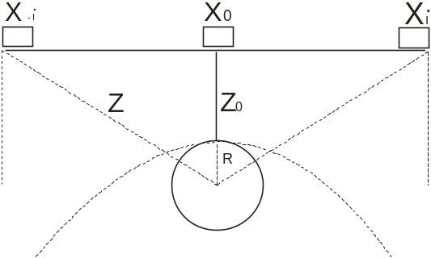

Fig. 1, hyperbolic signature spread due to buried cylinder

Obviously the depth to the top of the cylinder Z is given by

and the apparent depth Z when the antennas are at X_{i} (or X_{-i}) is
Substituting the above in equation 2 and rearranging, we have
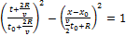 3
Equation 3 defines a hyperbola of semi axes a and b given by
4
where
5
6
Eliminating v in 5 and 6, we have
7
Thus it is possible to estimate the velocity and hence the depth of the reflector from the hyperbola parameters a and b. These parameters can be obtained using the least square polynomial curve fitting of the hyperbolic signatures due to the cylindrical reflector. It could be observed from equation 3 that for a point reflector (R=0),
8
This implies variation in the position of the centre of the hyperbola. The hyperbola, which was centered around 2R/v for R>0 is now shifted to (x_{o},0). This leads to the false assumption that the spread of the hyperbola is affected by a higher value of propagation velocity while in actual sense, velocity is only a function of material dielectric and independent of the radius of the reflector.
Consider an ideal vertical transverse axis hyperbola of coefficients a and b centered at the origin. The equation for this hyperbola is
9
where (x_{i}, y_{i}), i =1, 2, 3,…n are the n-point coordinates of the points along the curve. If the curve is a perfect hyperbola, then all the points (x_{i}, y_{i}) satisfy equation 9 and thus the error due to fitting of the hyperbola is zero. For real field hyperbolic signatures in a radargram, the coordinates of the

curve may not perfectly lie on the fitting hyperbola. For any point (x_{i}, y_{i}) on the curve, the error generated e is given by the difference between the left and the right hand sides of equation 9. That is
10
The error due to n points is therefore the sum of all the n point errors given by
The square error for all the n-points e² is
11
The above equation is a function of the parameters a and b. The parameters are to be determined such that the square error e² (same as the sum of squared residuals SS_{residual}) is minimized. The optimal values of a and b are obtainable by differentiating e² with respect to the parameters and equating the differentials to zero. That is by solving the equations
leading to

12
and
leading to
13

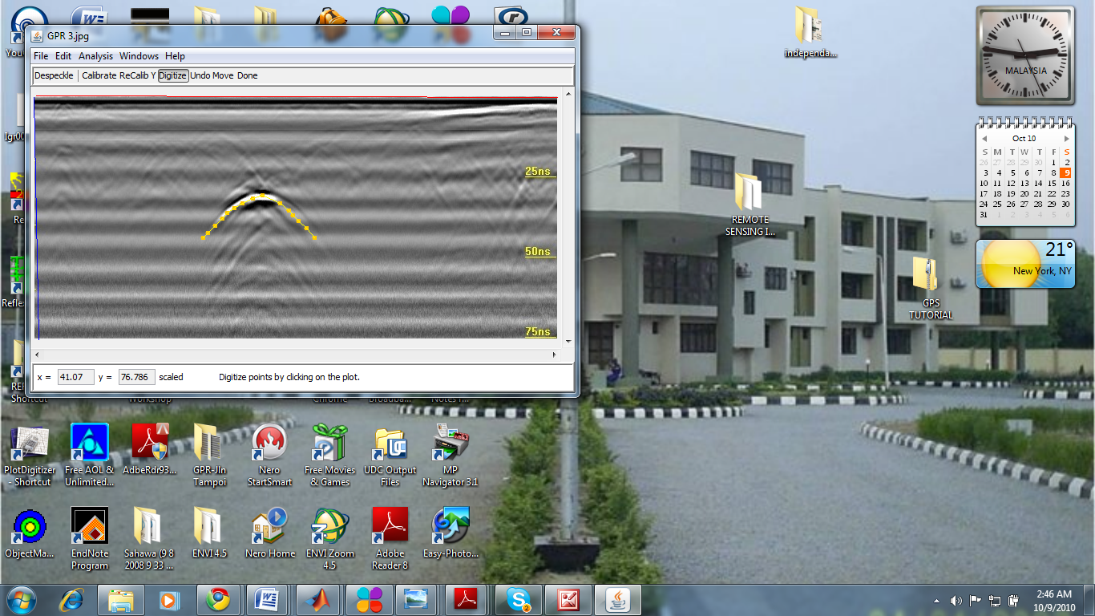

Fig. 3, digitized radar scan

Equations 12 and 13 can be solve for a and b leading to the following equations
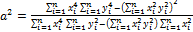 14
and
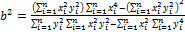 15
Thus the optimum values of the parameters can easily be computed with the coordinates (x_{i}, y_{i}) as inputs.
3. Method and materials
A GPR cross section was obtained on a trial field over a buried pipe along Jalan Tampoi road site in Johor Bahru using a multichannel IDS DAD fast wave radar acquisition unit. The acquired data is preprocessed with GRED IDS 3D software. The processed radargram was used as a sample data for the assessment of the performance of the above algorithm.
The coordinates of the hyperbolic signatures were recorded with a plot digitizer 2.4.1, (Fig. 3), a Java program used to digitize scanned plots of functional data developed by Huwaldt (2005).The algorithm was executed in a MATLAB environment with the following implementation code.

function [a,b]=hypfit(x,t)
%Filename: hypfit.m
%Usage: [a,b]=hypfit(x,t)
%Input
% x horizontal distance coordinates (m)
% t vertical time coordinates (ns)
%Output
% a fitting coefficient (a)
% b fitting coefficient (b)
P=sum(x.^2);
Q=sum(t.^2);
R=sum(x.^4);
S=sum(t.^4);
T=sum((x.^2).*(t.^2));
a=sqrt((R.*S-T.^2)/(R.*Q-T.*P));
b=sqrt((T.*R-T.^2)/(Q.*T-P.*S));
end

4. Result and discussion
The results yield a numerical values of the fitting coefficients for the hyperbolic signature a and b as 49.6444ns and 4.3182m respectively. The parameters are used to estimate the velocity (equation 7) and a numerical value of 0.174m/ns is obtained. The dielectric permittivity of the soil is computed using equation 1 and a value of 2.973 is obtained. The velocity and the two-way travel time obtained from the radargram (Fig. 3) are used to compute the depth of the reflector and a value of 2.61m is obtained.
The study area is a site of a tarred road in a commercial area within the northern part of Johor Bahru, Malaysia. The site experienced series of sand filling and compaction over the years as a result of infrastructural development. Subsurface utilities are therefore likely to be found at various depths due to long time of human activities. Thus at a depth of 2.61m, the reflector is suspected to be an age long forgotten pipe buried before the development of the road to its presence state. Even though lateritic soil is clearly visible within the edge of the study area, the relatively small magnitude of the dielectric constant (2.973) suggests that the pipe is likely buried within a deeper soil horizon of relatively low dielectric constant, most likely dry clay or sand overplayed by a thin layer of lateritic soil cover. The lateritic soil cover appears as first strong reflection in the GPR cross section (Fig. 3).
5. Conclusion
A new approach for the fitting of hyperbolic signatures due to point or cylindrical reflector in GPR radargram is presented. The technique is a modification of the fitting procedure developed by Chaudhuri (2010) for fitting circles and ellipses based on the least square error minimization of hyperbolic function. With hyperbola-constrained fitting, the optimal values of the fitting parameters are determined at the minimal level of sum of squared error. The parameters are used to determine the radar velocity and dielectric constant of a soil medium as well as the depth of buried cylindrical pipe. The technique is used to detect a deeply buried utility at a depth of 2.61m within a subsurface soil of dielectric permittivity 2.973. Modeling and further testing of the technique will no doubt enhance the effectiveness of the application of GPR in underground utility mapping.

Acknowledgement
The authors acknowledged with thanks the contribution of Jurukur Abadi of No. 06-01, Jalan Padi Emas 4/5, Pusat Bandar Tampoi, 81200, Johor Bahru, Malaysia for the test data acquisition.

References

      - Abbas A. M ,. Kamei H,. Helal, A , Atya M. A., Shaaban F. A (2009) Contribution of geophysics to outlining the foundation structure of the Islamic Museum, Cairo, Egypt Archaeological Prospection, Volume 12 Issue 3, Pages 167-176.
      - Aitken, J. A. and Stewart, R. R. (2004) Shallow GPR and seismic surveying in a carbonate environment: Belize, Central America CREWES Research Report, Volume 16 (2004).
      - Bristow, C and Jol, H. M (2003). An introduction to ground penetrating radar (GPR) in sediment; Geological Society , London, special publication, 211, 1-7
      - Bruschini, C. et al (1998). Ground penetrating radar and imaging metal detector for antipersonnel mine detection. Journal of Applied Geophysics. 40, 59-71.
      - Chaudhuri, D. (2010). A simple least square method for fitting an ellipse and circles depends on border points of a two –tone image and their 3-D extensions. Pattern Recognition Letters, 3, 818-829.
      - Chu, C. C,. Li, Y. M,. Teng, H. C and Cherng, S (2006) The Permittivity Frequency-dependent Response of a Ceramic Material to ElectromagneticWaves at 2GHz Journal of American Science, 2(4)
      - Daniels, J D. (ed) (2004). Ground Penetrating Radar, 2nd edition Institute of Electrical Engineers, United Kingdom.
      - Fitzgibbon, A, Pitu, M. and Fisher, R. B. (1999). Direct least square fitting of ellipse. Tern Analysis and Machine Intelligence. Vol. 21, No. 5.
      - Hamzah, U, Ismail,M. A and Samsudin, A. R.(2009) Geoelectrical resistivity and ground penetrating radar techniques in the study of hydrocarbon-contaminated soil Sains Malaysiana 38(3): 305–311
      - Huwaldt, J. (2005). Plot Digitizer 2.4.1. Retrieved on 28. April, 2010 from http://plotdigitalzer.sourceforge.net
      - Loizos, A and Plati, C. (2007). Accuracy of pavement thickness using different ground penetrating radar analysis approaches. NDT & E International. 40, 147-157
      - Lukumon, A, Festus, O. K and Bolaji, A. R (2010). Subsurface Geophysical Estimation of Sand Volume in Ogudu Sandfilled area of Lagos, Lagos, Nigeria. Journal of American Science ;6(7)
      - Nakashima, Y, Zhou, H and Sato, M (2001). Estimation of ground level by GPR in an area with multiple ambiguous reflections. Journal of Applied Geophysics. 47, 241-249
      - Negri, S, Leucci, G and Mazzone, F (2008). High resolution 3D ERT to help GPR data interpretation for researching archaeological items in geologically complex surface; Journal of Applied Geophysics, 65, 111-120.
      - O’Leary, P. and Zsombor-Murray, P. (2004).Direct and specific least-square fitting of hyperbolae and ellipse. Journal of Electronic Imaging. 13 (3), 492-503
      - Poole,G. C, Stanford, J. A, Frissell C A Running, S. W (2002). Three-dimensional mapping of geomorphic controls on flood-plain hydrology and connectivity from aerial photos; Geomorphology 48, 329–347
      - Ristic, A. V, Petrovacki, D and Govedarica, M (2009). A new method to simultaneously estimate the radius of a cylindrical object and the wave propagation velocity from GPR data; Computers and Geosciences, 35, 1620-1630
      - Shihab, S and Al-Nuaimy, W. (2005). Radius estimation for cylindrical objects detected by Ground Penetrating Radar. Subsurface Sensing Technologies and Applications. Vol. 6, No. 2,
      - Tillard, S. and Dubois, J. C. (1995).Analysis of GPR data: wave propagation velocity determination. Journal of Applied Geophysics. 33, 77-91.

12/15/2010

