Simultaneous diffusion of Cr-Si on Ni-Base super alloy using pure Cr and Si by pack cementation method

A. Afsharª, A. Sabour^{b}, M. Saremi^{c} , D. Ghasemi^{a,*}

ª Islamic Azad University, Science and Research Branch, Tehran, Iran,
^{b} Tarbiyat Modarres University - Tehran – Iran,
^{c} Department of Materials Science and Engineering -Tehran University – Tehran – Iran.
* Corresponding Author: Davood Ghasemi, E-mail: Davoodghasemi@yahoo.com

Abstract: Pure Cr and Si powders were used to produce Cr-Si coatings by Simultaneously diffusion of these elements on Ni-base Super alloy. A mixture of elemental Cr and Si powders (as Cr, Si sources) was used with (NaCl-NaF) or (NaCl-NaF-NH₄Cl) mixed activators were applied. The results of this study indicated that for co diffusion of these elements, Si content must be 0.1 Cr content in the pack mixture. Using 95%NaCl-5%NaF mixed activator was produced porous Cr-Si coatings, but by addition of 1% NH₄Cl to pack mixture, porosity of Cr-Si coating was eliminated. Increasing of (NaCl-NaF) content was leaded to increase depth of Si diffusion into the surface.
[A. Afshar, A. Sabour, M. Saremi, D. Ghasemi. Simultaneous diffusion of Cr-Si on Ni-Base super alloy using pure Cr and Si by pack cementation method. Journal of American Science 2011;7(1):708-711]. (ISSN: 1545-1003). http://www.americanscience.org.

Key words: Simultaneous diffusion, pack cementation, pure elements, mixed activator, Super alloy.

1. Introduction
To protect the hot components in land-based gas turbines, used in power generation, a wide range of coatings are applied to these parts [1]. One of them is diffusion coating in which elements are diffused into the surface of components. A common way to produce diffusion coatings is through pack-cementation process due to its simple and cost effective advantages [2].
Alloying elements used in the diffusion coatings include Al, Cr, Si, or combinations of these elements [3-6]. Cr-Si diffusion coatings have been produced by following methods:
- Simultaneous diffusion of Cr and Si by pack-cementation [7-9]
- Two step pack-cementation process in which Cr, diffused in substrate prior to diffusion of Si
It would be technically and economically more efficient if Cr and Si could be deposited simultaneously in a single step [4]. Therefore, there is a strong technical incentive to further develop the pack-cementation process so that multiple elements such as Cr, Si and etc can be co-diffused to produce high temperature oxidation and corrosion protective coatings. For Simultaneous diffusion of Cr and Si, the vapor pressure of Cr and Si halides (generated in the pack mixture trough reactions between these elements with activators) should be comparable. Many researches have been made to identify suitable conditions for co-diffusion of Cr with Si using Si-Cr master alloys in the pack mixture [10].
In the present paper, studies on the feasibility of co-diffusion of Cr with Si, using pure Cr and Si. The cross section of produced coatings is evaluated by electron microscope (SEM) and distribution of elements determined by line-scan, mapping and quantitative analysis with energy dispersive x-ray spectroscopy (EDS).

2. Experimental Procedures
The substrate used in this investigation was Nickel- base super alloy INC738 in the ingot form with the composition, shown in Table 1.
Specimens in dimension of Ø15×20 mm were cut from ingot, and then grounded with 120-300-600 grit SiC paper, cleaned in acetone and dried. The samples were placed in a 10×10×10cm Coat box, made of stainless steel and filled with pack mixture, containing elemental Si and Cr, an activator salt(s) and inert alumina-filler. The composition of pack mixtures has been shown in Table 2.
Semi sealed coat boxes were placed into a retort, which set up in an electric furnace and retort purged with argon in a flow rate of 10 litmin⁻¹ from the onset of furnace heat up to provide an inert environment. After completion of coating time, coat boxes were allowed to furnace cool and were removed and discharged. Then, the coated samples were cleaned, mounted and polished. SEM with an EDS was used to determine the structure, thickness and concentration profiles across the coating cross-section.

Table 1 - chemical composition of IN738LC
Element Al TI Cr Co Mo Ta Nb Zr Ni
Wt% 3.5 3.42 15.8 8.5 1.6 1.81 0.86 0.05 bal

Table 2 - chemical composition of pack mixtures

pack | Composition
A  B  C | 23%Cr -10%Si-2 %(95%NaCl-5%NaF)-65%Al₂O₃(wt%)  23%Cr -5%Si -2% (95%NaCl-5%NaF)-70%Al₂O₃(wt%)  23%Cr-2.3%Si-2%(95%NaCl-5%NaF)- 72.7%Al₂O₃ (wt%)
D | 23%Cr-2.3%Si-2%(95%NaCl-5%NaF)-1.5%NH₄Cl-71.2% Al₂O₃ (wt%)

Semi sealed Coat boxes were placed into a retort, which set up in an electric furnace and retort purged with argon in a flow rate of 10 litmin⁻¹ from the onset of furnace heat up to provide an inert environment. After completion of coating time, coat boxes were allowed to furnace cool and were removed and discharged. Then, the coated samples were cleaned, mounted and polished. SEM with an EDS was used to determine the structure, thickness and concentration profiles across the coating cross-section.

3. Results and Discussions
According to thermo dynamical calculations, volatile halides of Si are more stable than those of Cr. Therefore, Cr-reach pack mixtures must be used to generate comparable Cr and Si halides partial vapor pressures to co-deposition and diffusion of these elements [10, 11].
Fig. 1 shows the microstructure and line-scan analysis of the specimen coated at 1100 ºC for 2 h in pack (A) with composition, listed in table 2.
According to Fig.1 a thick coating (with 325μm thickness) enriched with Si, is produced at mentioned condition. it means that, the volatile halides of Si , which generated in pack (A) , had higher vapor pressure than those for Cr. Fig.2 shows the microstructure and line-scan analysis of the specimen coated at1100 ºC for 2 h in pack (B) with composition, listed in table 2. This coating also consisted of Si and indicated that Cr did not co diffuse with Si.
Fig.3 shows the microstructure and line-scan analysis of the specimen coated at 1100 ºC for 2 h in pack (C) with composition, listed in table 2. Fig. 3 shows that co-deposition of Cr and Si, achieved in a pack mixture contained elemental Cr and Si (which the Cr content is tenfold of Si) and (95% NaCl-5% NaF) mixed activator at 1100 ˚C and 2 h. The thickness of coating is low (∼14μm) and has porosity.

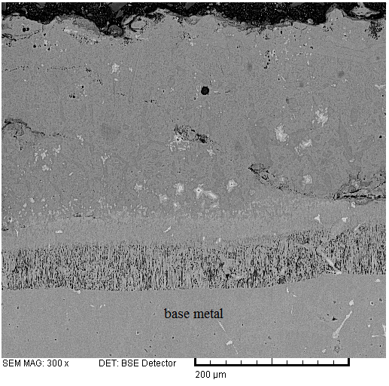
a
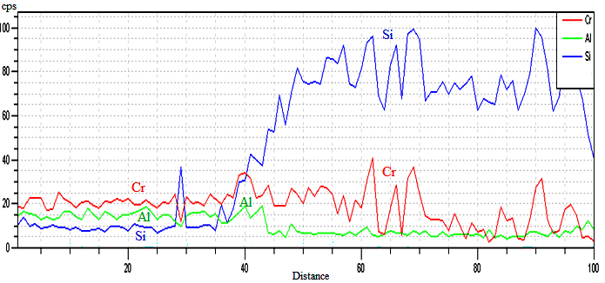
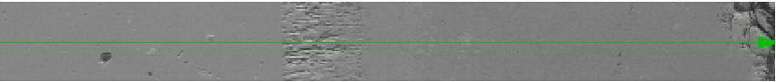
b

Fig.1 a) microstructure and b) line-scan analysis of the specimen coated at 1100 ºC for 2 h in pack (A)

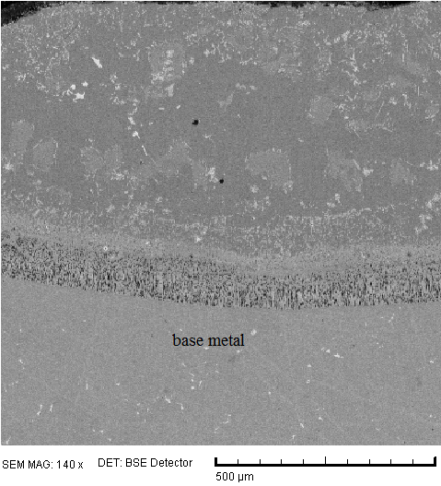
a
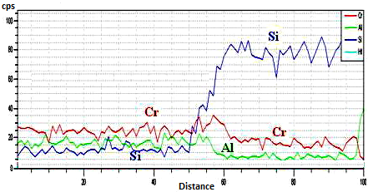
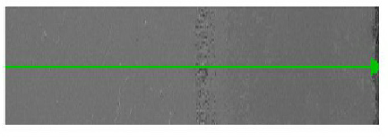
b

Fig.2 a) microstructure and b) line-scan analysis of the specimen coated at 1100 ºC for 2 h in pack (B)

Fig. 4 shows the microstructure and line-scan analysis of the specimen coated at 1100 ºC for 3 h, in pack (B) with composition, which is given in table 2. This figure also shows that the produced coating at this condition , is without any porosity and has a total thickness of a bout 40 µm. In consequence, the addition of NH4Cl to (NaCl-NaF) as an activator was leaded to increase of coating thickness and elimination of porosity.
NH₄Cl is an unstable activator and decomposed as follows [12]:
NH₄Cl _{(g)}→¹/₂N_{2(g)}+³/₂H_{2(g)}+HCl _{(g)} (1)

Dissociated HCl from NH₄Cl could increase the kinetic of volatile halides generation reactions (reactions of Cr and Si with activators) in the pack mixture. Also, dissociated H₂ could change the reactions of volatile halides in the substrate surface from displacement or dissociation to reduction type as follows [13]:
Cr_{x}Cl_{y(g)}+^{y}/₂H_{2(g)} → yHCl_{(g)}+xCr_{(s)} (2)
Si_{x}Cl_{y}+^{y}/₂H_{2 (g)}→yHCl(g)+xSi(s) (3)

Then Pack (B) was provided suitable condition for Cr and Si co-deposition as mentioned a bove. Effect of increasing (NaCl-NaF) content in the pack mixture, on the coating thickness is shown in fig 5. It is illustrated that in 3.5% (95%NaCl-5%NaF) the thickness of coating increases rapidly. It is due to increasing in vapor pressure of Si and Cr fluorides in the pack mixture, which leaded to more transportation of Si and Cr from the pack mixture to surface of the sample.

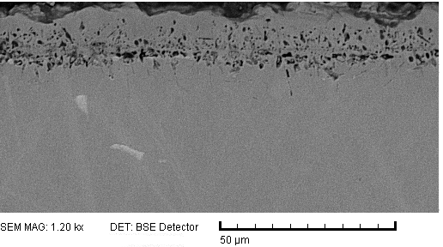
a

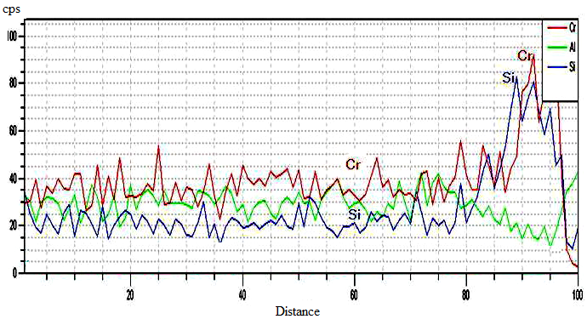

b
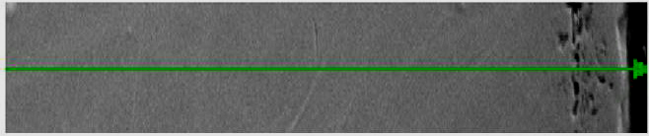

Fig.3 a) microstructure and b) line-scan analysis of the specimen coated at 1100 ºC for 2 h in pack (C)

4. Conclusions:
The evidences from experiments showed that pure Cr and Si can be applied to simultaneous diffusion of Cr, Si by pack-cementation process. Si content of pack mixture should be 0.1 Cr content for co diffusion of them. A mixture of 1%NH₄Cl –2% (95%NaCl-5%NaF) is the best activator to produce Cr-Si coating with enough thickness and without porosity. Increasing of (95%NaCl-5%NaF) content in the pack mixture was leaded to increase thickness of coating. In 3.5% (95%NaCl-5%NaF) thickness of coating rapidly increases.

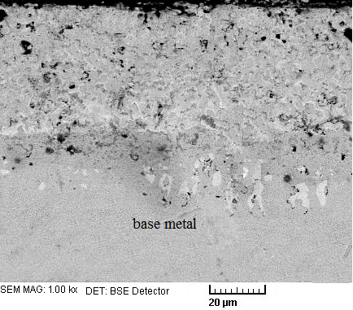
a
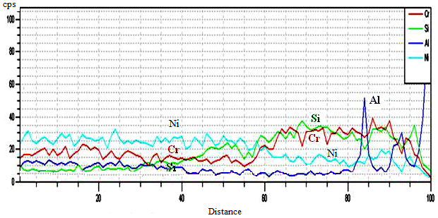

b
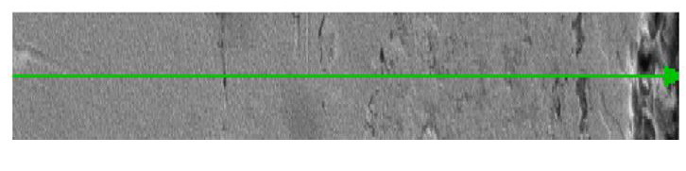

Fig.4 a) microstructure and b) line-scan analysis of the specimen coated at 1100 ºC for 2 h in pack (D)

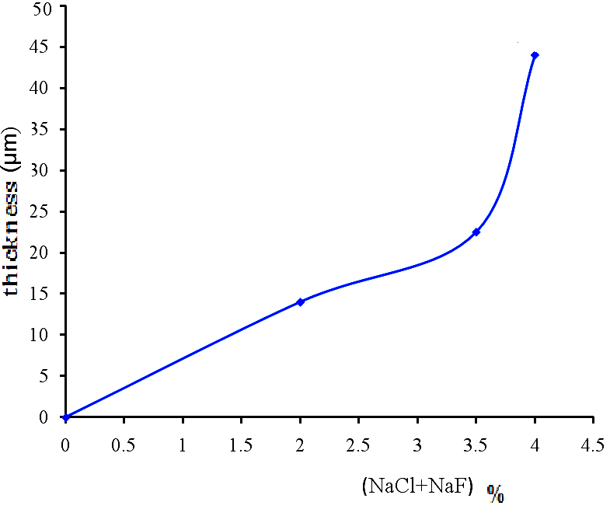

Fig.5. The effect of increasing (95% NaCl-5%NaF) content in the pack mixture on coating thickness.

References
[1] T. Sourmail "Coating for gas turbine blades "University of Cambridge 2008.
[2] Mit.kim,N.HHeo,J.H.Shin,C.Y.Kim, Surface and Coating technology 123 (2000)227-230.
[3] Z.D.Xiang, P.K.Datta Materials Science and Engineering A356(2003) 136-144.
[4] Z.D.Xiang,J.S.Burnell-Geray,andP.K.Datta, Surface Engineering 2001,vol17,no4.
[5] H.L Du, J. Kipkemoi,D.N. Tsipas,P.K. Datta, Surface and Coatings Technology 86-87 (1996) l-8.
[6] J. Kipkemoi, D. T.Siapas, Journal of Materials Science 31 (1996) 6247-6250.
[7] Z.D.Xiang,P.K.Datta Materiale Science and Engineering A363(2003)185-192.
[8].B. Gleeson,W.H.Cheung,W.DaCosta, and Dj.young, Oxidation of Metals, VoL 38,no5/6 .1992.
[9] Mit.kim,N.HHeo,J.H.Shin,C.Y.Kim Surface and Coating technology 123 (2000)227-230.
[10] P.A.Choquet, M.A. Harper and R.A.Rapp, Journal De Physique 50,1989.
[11] Robert Bianco,RobertA.Rapp,andNathanS.Jacobson, Oxidation of Metals, Vol 38, Nos. 1/2, 1992.
[12] Y.A.Tamarin.ASM,2008.
[13] Robert Bianco, Mark. A. Haperand Robert A. Rapp, Jom, vol 43, 1991.

Submission date: 15/12/2010
Submission Address: Marsland Press, P.O. Box 21126, Lansing, Michigan 48909, The United States, 347-321-7172.

