Protective Effect of Taurine and Bismuth Subnitrate against Cyclosporine and NSAID-induced Nephrotoxicity in Rats.

Suzan F.I. Elsisi¹, Salwa Kamal El –Nabarawy²

¹Physiology Department, National Organization for Drug Control and Research, Cairo, Egypt
²Zoology Department, Faculty of Science Al -Azhar University, Cairo, Egypt
drsal2006@hotmail.com suzanElsisi@yahoo.com

Abstract: The immunosuppressive drug cyclosporine (CSA) has been successfully used in several diseases with immunological basis and in transplant patients. Nephrotoxicity is the major limitation for CSA use. Recent evidence suggests that reactive oxygen species (ROS) play an important role in mediating CSA-induced nephrotoxicity. Co-administration of CSA and non steroidal anti-inflammatory drug (NSAID), sodium diclofenac (SD), increases the efficacy for pain relief in patients with rheumatoid arthritis. However, clinical studies showed enhancement of cyclosporine nephrotoxicity. To characterize biochemical parameters of nephrotoxicity, the study assessed the effect of CSA (10 mg/kg B.wt) alone or in combination with SD (10 mg/kg B.wt) for 6 weeks on serum creatinine (S.Cr), blood urea (BU), alkaline phosphatase (ALP), total protein (TP), albumin and gamma glutamyl transferase (GGT). Oxidative stress was also evaluated; lipid peroxide measured as malondialdehyde (MDA), lactate dehydrogenase (LDH), as well as oxidized and reduced glutathione (GSSG and GSH) in serum of adult albino rats. CSA alone caused significant rise in BU and S.Cr, serum ALP and GGT, while reduction of serum TP and albumin was observed. In addition CSA also alternated oxidative stress through increasing levels of serum MDA, LDH and GSSG and decreasing levels of GSH and GSH/GSSG ratio. When SD combined with CSA, it enhanced all biochemical parameters of CSA-induced nephrotoxicity. The study also extended to evaluate and compare the protective effect of taurine, (tau), which is a major intracellular free beta-amino acid and potent endogenous antioxidant with Bismuth subnitrate (BSN), an antiulcer drug and a specific inducer of renal metalothionine (MT), against nephrotoxicity induced by CSA and SD administration. The present investigation showed that co-administration of both BSN and taurine could antagonize most of CSA negative effects, by attenuating renal dysfunctions, reducing serum MDA and counteracting the deleterious effects of CSA on oxidative stress markers.
[Suzan F.I. Elsisi, Salwa Kamal El –Nabarawy. Protective Effect of Taurine and Bismuth Subnitrate against Cyclosporine and NSAID-induced Nephrotoxicity in Rats. Journal of American Science 2011;7(1):912-921]. (ISSN: 1545-1003). http://www.americanscience.org.

Key Words: Nephrotoxicity, drug interaction, reactive oxygen species.

1. Introduction:
Cyclosporine A (CSA), a cyclic undecapeptide of fungal origin, is the most widely immunosuppressive drug in organ transplantation and in the treatment of autoimmune disorders (Capasso et al., 2008; Shu et al., 2009). However, its clinical use has been hampered by frequent reports of nephrotoxicity. In fact, moderate to sever renal dysfunction has been documented in ~30% of CSA-treated patients (Galletti et al., 2005). Although the mechanisms of nephrotoxicity are not completely defined, there is evidence that suggests the role of ROS in its pathogenesis. It has been demonstrated in numerous in vivo and in vitro experiments that CSA induced renal failure and increased the synthesis of ROS and lipid peroxidation products in the kidney. These include: Upregulation of the cytochrome P450-dependent system in kidney (Buetler et al. 2000); perturbation of the balance between vasodilatation-vasoconstriction, which in turn is responsible for tubular hypoxia-reoxygenation (Burdmann et al. 2003); increased formation of renal thromboxane A2 and induction of nitric oxide production (Burdmann et al., 2003); direct interference of CSA with intracellular homeostasis of glutathione (Galletti et al., 2005). Oxidative stress is the main mechanism resulting in cyclosporine-induced nephrotoxicity because of its ability to stimulate endogenous melatonin production (Ghorbanihaghjo et al., 2008).
Although CSA has been shown in a series of controlled trails to be of benefit, patients continue to require NSAID, as SD, for relief of joint pain and stiffness. The adverse effects of SD include gastrointestinal complaints, liver damages, acute and chronic nephrotoxicity, heart attack, bone marrow depression. SD produces multiple undesirable renal effects. Most of these effects are attributed to inhibition of the synthesis of renal prostaglandin which influences cortical blood flow, glomerular filtration rate and salt and water excretion (Griffin et al., 2000). Long term treatment of NSAID leaded to ulceration and gastrointestinal bleeding. Hence most patients used to receive ulcer-protection drugs as bismuth subnitrate (BSN) during long term treatment with SD. BSN can also protect kidney against toxicity as it is a specific inducer of renal metalothionine (Kondo et al., 2004).
Taurine is a sulfur containing amino acid; it is the major intracellular free ß-amino acid that plays various important physiological roles including osmorgulation, bile acid conjugation, viability and prevention of oxidant-induced injury in many tissues (Erdem et al., 2000). The beneficial effects of taurine as an antioxidant in biological systems has been attributed to its ability to stabilize biomembranes, scavenge ROS and reduce the lipid peroxidation (Erdem et al., 2000).
The present study aimed to ascertain how often nephrotoxicity by CSA is associated with concurrent additive nephrotoxicity by SD as well as to investigate and compare the possible protective effect of BSN and taurine against nephrotoxicity induced by concurrent administration of CSA and SD.

2. Materials and methods:
Animals
56 Female Albino rats weighing 120 ± 20 g were used. The rats were obtained from animal breeding laboratory of National Organization of Drug Control and Research (NODCAR) Giza, Egypt. They were kept under strictly hygienic conditions. Rats were put on a standard basal diet and allowed free access to drinking water.
Handling and usage of animals was carried out according to guidelines of institual health care and usage committee of animal lab of NODCAR.

Materials
- Bismuth subnitrate and taurine were purchased from Sigma Co. USA.
- Cyclosporine A and Sodium Diclofenac, were purchased from Egyptian market pharmacy.
- Drug doses were freshly prepared before adminis-tration dissolved in water (except BSN which was dissolved in citrate solution) and given orally.
Experimental design
Rats were classified into 7 equal groups each comprises 8 rats and treated daily for 6 weeks, as follow:
G1; Negative (-ve) control group (CON), fed on basal diet.
G2; Taurine (+ve) control group (T), orally administrated 500 mg/kg B.wt of taurine.
G3; BSN (+ve) control group (B), orally administrated 15 mg/kg B.wt of BSN.
G4; Cyclosporine group (CSA), orally administrated 10 mg/kg B.wt of CSA.
G5; Combined-treated group (CSA+SD), orally administrated 10 mg/kg B.wt of CSA plus 10 mg/kg B.wt of diclofenac.
G6; Taurine-treated group (C +T), treated as in G5 and supplemented with 500 mg/kg B.wt of taurine.
G7; Bismuth -treated group (C +B), treated as in G5 and supplemented with 15 mg/kg B.wt of BSN.
At the end of the treatment schedule, blood samples were taken from each rat and let stand to get serum and then rats were sacrificed. Kidney tissue was removed; part of it was subjected to histopathological examinations as described by Bancrofet et al. (1996) and the other was homogenized in iced 10% KOH and centrifuged at 5000 rpm for 5 minutes. Supernatants were separated. Serum and supernatants of tissues were processed for the biochemical analyses; S.Cr determined by the method of Houot (1985), BU by Patton and Cruoch (1977), ALP by Roy (1970), TP by Henry (1964), albumin by Doumas et al. (1971) and GGT by Szasz (1974), oxidative stress lipid peroxides measured as MDA, GSSG and GSH were determined by HPLC methods of Karatepe (2004); Jayatilleke and Shaw (1993) respectively. LDH was determined by the commercial kits of Buhl and Jackson (1978).

Statistical analysis
Data were presented as mean ± SE. one way ANOVA followed by LSD test were used to evaluate significant differences from different treatments (It was done using SPSS, version 11.5)

3. Results and Discussion:
The nephrotoxicity of CSA remains the major limitation of this widely used immunosuppressive drug. Increased level of free oxygen radicals may play an important role in pathogenesis of its adverse effect. Immunosuppressive action of CSA is mediated by formation of a complex with cyclophilin, which in turn inhibits the activity of protein phosphatase 2B calcineurin. Hence, CSA is also known as calciuneurin inhibitor (Naesens, et al., 2009).

The effect of CSA on kidney function and oxidative stress
Treatment of rats with CSA for a period of 6 weeks resulted in a significant (P<0.05) increase in BU and S.Cr levels (Table 1 &Fig. 1), suggesting the occurrence of renal dysfunction. These results were in agreement with the earlier investigators, who reported significant alteration in BU, S.Cr in patients and experimental animals after CSA treatment (Mason, 1990; Tariq et al. 1999; Khan et al., 2006).
In order to investigate the role of ROS of CSA induced-toxicity, data depicted in table (2) show that CSA produced a marked significant (P<0.05) increase in lipid peroxides measured as MDA,

Table (1): The effect of taurine and bismuth subnitrate on blood urea (mg/dl), serum creatinine (mg/dl), total protein (g/dl), Albumin (g/dl), alkaline phosphatase (U/L) and gamma glutamyltransferase (U/L) against cyclosporine and Sodium diclofenac- induced nephrotoxicity in ♀ rats after 6 weeks of treatment.
Animal group |  | CON | B | T | CSA | CSA+SD | C+B | C+T
Tested Parameters | BU | 36.30 | 38.76 | 39.51 | 52.78 | 60.49 | 43.88 | 41.55
Tested Parameters |  | ± 1.6 | ± 1.31 | ± 1.53 | ± 2.41* | ± 1.2* ª | ± 1.91 ^{b} | ± 1.75 ^{b}
Tested Parameters | S.Cr | 0.70 | 0.69 | 0.77 | 1.46 | 1.80 | 0.89 | 1.02
Tested Parameters |  | ± 0.04 | ± 0.04 | ± 0.03 | ± 0.05* | ± 0.06*ª | ± 0.05^{*b} | ± 0.03^{*b}
Tested Parameters | TP | 6.06 | 6.07 | 6.04 | 5.14 | 4.82 | 5.44 | 5.50
Tested Parameters |  | ± 0.02 | ±0.03 | ± 0.02 | ± 0.04* | ± 0.11*ª | ± 0.02^{*b} | ± 0.03^{*b}
Tested Parameters | Albumin | 3.36 | 3.32 | 3.34 | 2.70 | 2.20 | 3.13 | 3.11
Tested Parameters |  | ± 0.03 | ± 0.03 | ± 0.04 | ± 0.04* | ± 0.05*ª | ± 0.04 ^{b} | ± 0.03 ^{b}
Tested Parameters | ALP | 60.73 | 64.96 | 61.00 | 84.8 | 100.40 | 74.50 | 73.20
Tested Parameters |  | ± 1.28 | ± 1.9 | ± 2.06 | ± 2.1* | ± 2.00*ª | ± 2.6 ^{b} | ± 1.96 ^{b}
Tested Parameters | GGT | 5.42 | 5.87 | 5.67 | 9.32 | 13.42 | 7.08 | 7.18
Tested Parameters |  | ± 0.61 | ± 0.53 | ± 0.59 | ± 0.44* | ± 0.69*ª | ± 0.61^{b} | ± 0.56 ^{b}
Significant difference vs. CON group: *P<0.05. Significant difference vs. CSA group: ªP<0.05.
Significant difference vs. CSA +SD group: ^{b}P<0.05.

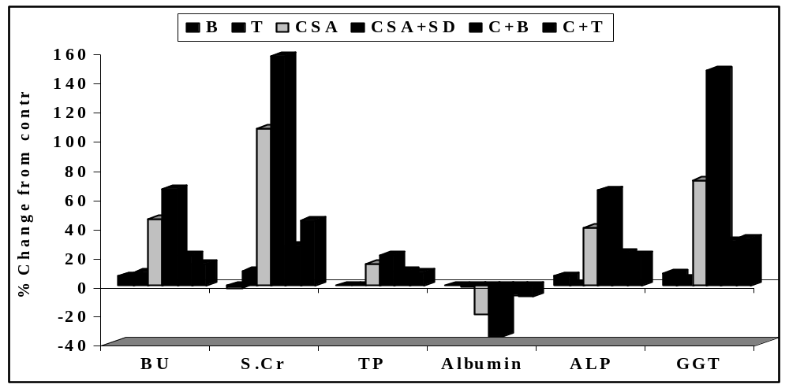

Fig. (1): % Changes from control to show the effect of taurine and bismuth subnitrate on blood urea (mg/dl), serum creatinine (mg/dl), total protein (g/dl), Albumin (g/dl), alkaline phosphatase (U/L) and gamma glutamyltransferase (U/L) against cyclosporine and Sodium diclofenac -induced nephrotoxicity in ♀ rats after 6 weeks of treatment.

marked significant (P<0.05) increase in cell injury LDH release as well as significant (P<0.05) increase of the level of GSSG and reduction in the GSH/GSSG ratio (0.69% of control). These data suggest the role of oxidative stress in CSA nephrotoxicity. Treatment with CSA showed an increase in O^{.-}₂, H₂O ₂ and OH– radicals production as described by Tariq et al. (1999) and Hagar (2004).
Lipid peroxidation begins as a result of oxygen derived free radicals (ODFR)-induced abstraction of hydrogen from a polyunsaturated fatty acid of cellular membrane forming a lipid radical, which is accompanied by cellular degeneration. Oxygen radicals are considered as important modulators of renal blood flow and glomerular filtration rate (Tariq et al., 1999 and Capasso et al., 2008). An efficient endogenous antioxidant defense system operates to compact free radicals. The main detoxifying system for lipid peroxides is GSH. The decrease in GSH following CSA observed in this study greatly supported this hypothesis (Tariq et al., 1999 and Galletti et al.. 2005).

The effect of CSA on total protein, albumin, GGT and ALP
Accompanied to CSA- induced oxidative stress, a hepatotoxicity was implicated secondary to nephrotoxicity that was assessed by reduced serum total protein level and albumen, increased serum level of GGT and ALP, as depicted in table (1) and fig. (1). The present results are in agreement with the study of Hagar (2004). Also Briner et al. (2008) found that CSA induced transient rise in plasma ALP in kidney transplant patients.

The effect of CSA on kidney tissue
Confirming the biochemical results, the histopathological examination made on the kidney of CSA-treated rats, showed structural abnormalities in the kidney including swelling and degeneration in the epithelial cell lining the tubules (Fig. K2) and focal fibrosis in corticomedullary junction (Fig. K3). Atrophy was observed in some glomeruli while the others showed hypertrophy (Fig. K4) vs to the normal structure of CON (-ve control) and in T & B groups (+ve controls) (Fig. K1). Histopathological changes of kidney structure were recorded with earlier investigators who reported that CSA induced tubular vacuolation and necrosis, interstitial fibrosis (Tariq et al., 1999 and Lim et al. 2004). Sanchez-pozos et al., (2010) declared that CSA produced renal dysfunction and induced the development of arteriolopathy, TI-fibrosis and tubular apoptosis. Both acute and chronic administrations of CSA have been shown to increase renal vascular resistance (Mason 1990). Many substances such as angiotensin and nitric oxide are regarded as possible mediators of CSA-induced vasoconstriction (Tariq et al., 1999). However, recent studies suggest an important role of endothelin in CSA-induced increase in vascular resistance (Bobadilla and Gamba, 2007). Endothelin has also been shown to affect rennin-angiotensin system and inhibit NO and prostaglandin production leading to vasoconstriction (Shihab et al., 2003).

The effect of co-administration of CSA and SD on nephrotoxicity
Co-administration of CSA and SD increases the pain relieving efficacy in patients with rheumatoid arthritis. However, clinical studies showed that combined administration exaggerated cyclosporine nephrotoxicity. So, the first aim of this study is to visualize the possible extra nephrotoxicity by CSA in combined treatment.
Data in the tables (1,2) and figs. (1, 2) showed that SD induced an additive effect in all biochemical parameters of CSA-induced nephrotoxicity. The data recorded in the combined treated group (CSA+SD) showed significant (P<0.05) difference in both renal function and the oxidative stress parameters in comparison to CSA-treated group alone. Consistently, Kim et al. (1999) reported that administration of SD alone did not result in significant renal dysfunction, but combination of gentamicin, an inducer of nephrotoxicity, became deleterious to renal function.
On the other hand, it was observed that SD alone is a powerful nephrotoxicant and a strong oxidative stress (Hickey et al., 2001). They added also that SD-induced nephrotoxicity may involve production of ROS leading to oxidative stress and massive genomic DNA fragmentation and apoptotic cell death. Secondary to oxidative stress an increment (p<0.05) in the levels of ALP, serum albumen, LDH release reported in combined treatment vs CSA alone were in agreement with the earlier studies of Masubuchi et al. (1998) and Okbi et al. (2002).
Confirming the biochemical results, histopathological studies made in kidney tissue of combined treatment showed severe structural changes in kidney more than observed in CSA alone, the combined group showed tubular necrobiosis in corticomedullary portion (Fig. K5), sever congestion, swelling and proliferation in the endothelial cells of glomerular tuft (Figs. K6&K7) in comparison to structural changes in kidney observed in CSA alone .In conform, marked histopathological changes were also recorded in the combined treatment with SD and gentamicin (a powerful nephrotoxicant) characterized by tubular atrophy, interstitial fibrosis and progressive renal impairment (Kim et al., 1999; Yazawa et al. 2004). Inhibition of renal prostaglandin

Table (2): The effect of taurine and BSN on serum MDA (umol/ml), LDH (U/L), GSH (mmol/100 mL), GSSG (mmol/100ml) and GSH/GSSH ratio, against cyclosporine and Sodium diclofenac-induced nephrotoxicity in ♀ rats after 6 weeks of treatment.
Significant difference vs. CON group: *P <0.05. Significant difference vs. CSA group: ªP <0.05.
Animal group |  | CON | B | T | CSA | CSA+SD | C+B | C+T
Tested Parameters | MDA | 0.73 | 0.68 | 0.76 | 1.33 | 1.62 | 1.13 | 0.97
Tested Parameters |  | ±0.02 | ±0.03 | ±0.02 | ±0.04* | ±0.02*ª | ±0.06*^{b} | ±0.05*^{b}
Tested Parameters | LDH | 168.25 | 170.88 | 171.33 | 243.88 | 335.88 | 214.13 | 212.13
Tested Parameters |  | ±15.4 | ±16.9 | ±17.9 | ±17.3* | ±18.7* | ±17.6*^{b} | ±15.6* ^{b}
Tested Parameters | GSSG | 2.74 | 2.76 | 2.75 | 3.40 | 4.60 | 2.95 | 2.88
Tested Parameters |  | ±0.07 | ±0.06 | ±0.03 | ±0.08* | ±0.05*ª | ±0.06* ^{b} | ±0.04* ^{b}
Tested Parameters | GSH | 85.50 | 84.18 | 85.87 | 73.87 | 64.99 | 77.01 | 79.18
Tested Parameters |  | ± 3.42 | ±2.20 | ±2.04 | ± 4.41* | ±2.41*ª | ±4.54^{b} | ± 2.77^{b}
Tested Parameters | GSH/GSSH | 31.2 | 30.5 | 31.2 | 21.7 | 14.13 | 26.1 | 27.5
Tested Parameters |  | ± 1.3 | ± 1.6 | ± 1.2 | ± 2.1* | ± 2.1*ª | ± 2.5 ^{b} | ± 1.4 ^{b}
Significant difference vs. CSA +SD group: ^{b}P <0.05.

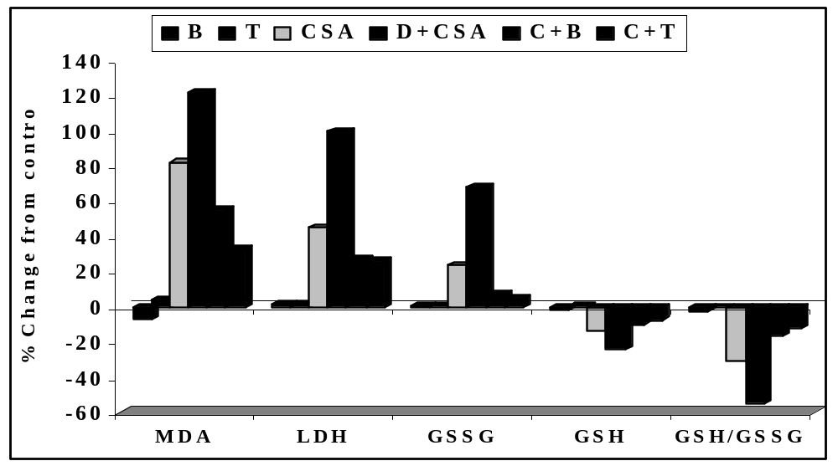

Fig. (2): % Changes from control to show the effect of taurine and BSN on serum MDA (umol/ml), LDH (U/L), GSH (mmol/100 mL), GSSG (mmol/100ml) and GSH/GSSH ratio, against cyclosporine and Sodium diclofenac-induced nephrotoxicity in ♀ rats after 6 weeks of treatment.

synthesis by SD can lead to renal dysfunction which influence cortical blood flow, glomerular filtration rate and salt and water excretion (Griffin et al., 2000). Also inhibition of cyclooxygenases after NSAIDs treatment may have a role in renal effects (Kim et al., 1999). Considering this finding, the data strongly explored potential drug interactions when CSA co-administered with SD that cause deleterious effects to renal function and structure. The possible pharmacokinetic/dynamic study contributing to drug interactions reported in rheumatoid arthritis patients receiving CSA and NSAIDs, showed a negative relationship by CSA and SD co-administration and renal function (Mueller et al., 1997). To interpret the latter observations it was mentioned that CSA induced nephrotoxicity through decreasing intrarenal PGE2 production mainly by decreasing COX2 expressing, i.e. minims the effect produced by SD. For that a prescription of NSAIDs, even COX2 inhibitor, should be very cautious in patients taking CSA (Chang et al. 2005). The data have strongly revealed that ROS mediate CSA-induced nephrotoxicity through increasing vascular resistance by inhibition of PGE2, leading to vasoconstriction and promotes fibrotic process that is characterized by tubular atrophy, interstitial fibrosis and progressive renal impairment (Shihab et al. 2003; Bobadilla and Gamba. 2007).
The 2nd target of this study was to investigate and compare the possible protective effects of taurine and BSN against nephrotoxicity induced by concurrent administration of CSA and SD. Concomitant oral administration of rats with either Tau or BSN attenuated the CSA and SD induced structure and functional changes in kidney.
As shown in table (1) and fig. (1) a significant (P<0.05) reduction in BU, S.Cr, serum ALP, GGT, TP and albumin under Tau and BSN treatments. In addition, the treatment antagonized deleterious effects of CSA and SD on oxidative stress markers, where it significantly (P<0.05) reduced the levels of serum MDA, serum LDH release and significantly (P<0.05) increase the level of serum GSH and GSH/GSSG ratio.

Protective effect of taurine
Reinforcing the biochemical results, histopathological examination of the kidney tissues of rats treated with taurine showed marked attenuation in all the CSA + SD-induced structural changes in kidney except some congestion in the cortical blood vessels (Fig. K8). In agreement, it was found that taurine administration (1% in the drinking water) reduced deteriorated renal function induced by CSA, as assessed by decreased serum creatinine, proteinurea levels and ameliorated CSA-induced morphological changes (Hagar et al., 2006). The same authors also indicated that taurine in the same dose could decrease GGT level, increase serum TP, decrease hepatic MDA and increase level of GSH against CSA-induced hepatotoxicity. Taurine has been shown to decrease vascular resistance. It increased serum levels of nitric oxide and nitric oxide synthesis (Fennessy et al. 2003 and Hager et al. 2006), interfered with the activity of the renin-angiotensin-aldosterone system and minimized the elevation in serum cytokine, endothelin, thromboxane B₂ taurine also reduced oxygen derived free radical generation, up regulated the antioxidant defenses and inhibited the proliferation of vascular smooth muscle cells (Hu et al.,2009) which all lead to inhibit vasoconstriction and thus may decrease CSA-induced vascular resistance. Furthermore it was found that taurine can inhibit the hypoxia-induced expression of Entrolikin-1 mRNA and reduce the release of entrolikuin1and angiotensin II (Yu et al. 1997) that all may be contributing to ameliorate CSA-induced vascular resistance. CSA-induced nephrotoxicity is associated with accumulation of cellular calcium (Croft et al., 1997), Taurine also can modulate calcium transport and has sulfhydryl group that have been shown to block calcium channels and maintain calcium homeostasis (Ruggenenti et al., 1993). On the other hand taurine is a potent antioxidant and may attenuate tissue lipid peroxication either by scavenging a wide variety of ODFR including O^{.-}₂, H₂O₂ and OH. – radicals or by binding Fe²⁺ like a chelator, with HOCl and HOCl-metalloproteins, or by binding to or complexing the sulfonic acid group (SO₃-) to free metal ion species such as Fe²⁺, Cu⁺ or oxidant metalloprotein (Erdem et al., 2000). Treatment of rats with taurine attenuated CSA-induced depletion of GSH. GSH-dependent mechanisms play a vital role in protection of cells against oxidative stress and detoxification of xenobiotes including CSA (Inselman et al., 1994). The major disadvantage is that GSH does not pass through the cell membrane and its action may be a function of its extracellular level only, on the other hand taurine readily passes through the cell membrane thereby resulting in quick replenishment of intracellular GSH. Finally, the data presented here suggest that concomitant use of antioxidant such as taurine might be useful in reducing CSA-mediated nephrotoxicity.

Protective effect of BSN
BSN is used as an antigastric ulcer and antidiarrhitic agent. It is suitable for inducing metalothionine (MT) in the kidney in cancer patients (Kondo et al., 2004). However, due to the low absorption rate of Bismuth (Bi) from the

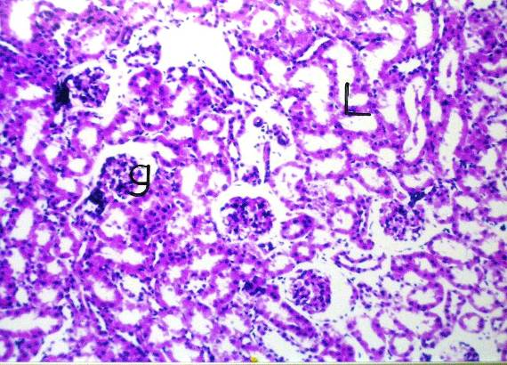  Fig . ( K1) Kidney section of CON gp, showing the normal histological structure of the gloeruli (g) and tubules (L) in the cortex. (H&E X 40). | 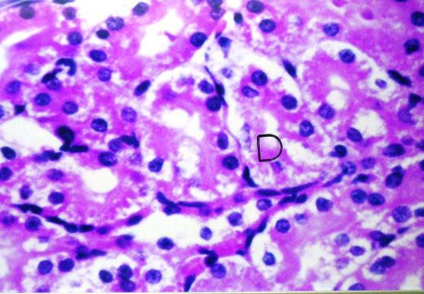  Fig. ( K.2) Kidney of CSA gp, showing swelling and degeneration in the epithelial cells lining the tubules (D).  (H&E X 160).
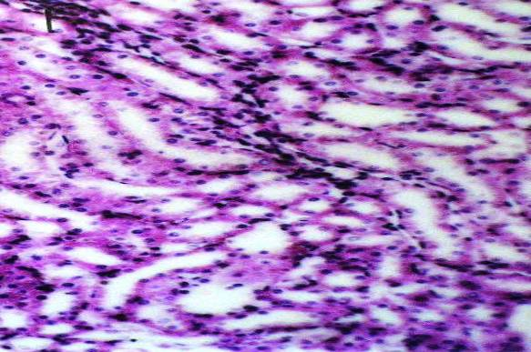  Fig . (K3) Kidney section of CSA gp, showing focal fibrosis in cortico-medullary junction (f). (H&E X 160). | 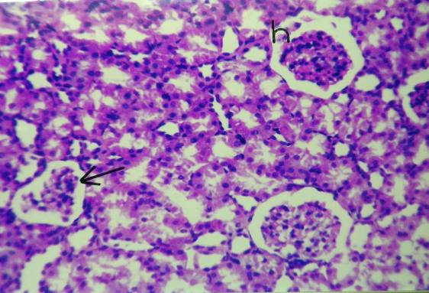  Fig. (K4) Kidney of CSA gp, showing atrophy in some glomeruli (arrow) and hypertrophy in others (h).  (H&E X 64).
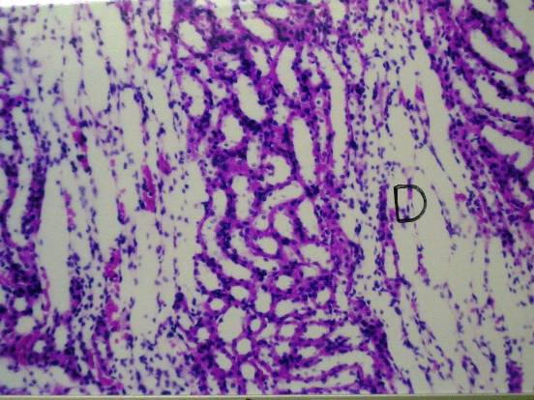  Fig. (K5) Kidney of CSA+SD gp, showing necrobiosis in the tubules at the corticomedullary (D). (H&E X 40). | 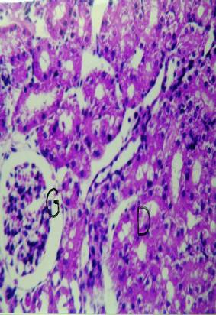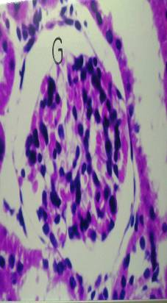  Fig (6K&7K) Kidney of CSA+SD gp, showing sever congestion of glomerular tuft (G) with degeneration and swelling in the lining epithelium of the renal tubules (D).  (H&E X64) & (H&E X160).
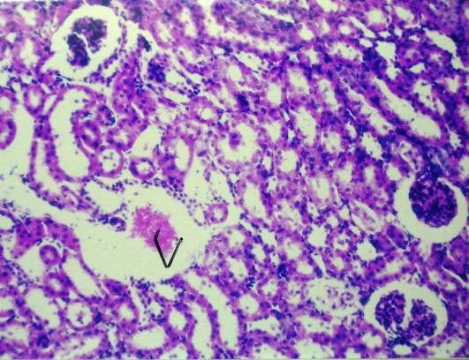  Fig. ( K8) Kidney of C+T gp, showing congestion in cortical blood vessels (V). (H&E X 40). | 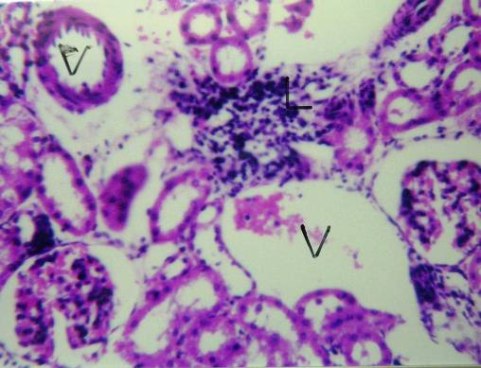  Fig. ( K9) Kidney of C+B gp, showing congestion in the glomerular tuft (G) focal inflammatory cells infiltration (L) in between the tubules and congested and dilated blood vessels (V). (H&E X 40).

gastrointestinal tract, we used citrate as a vehicle for oral administration of BSN that increase the tissue distribution of Bi and enhance induction of MT in the kidney (Kondo et al., 2004). MT is known to reduce the toxic effects of heavy metals, alkylating agents, inducers of ROS and γ- irradiation by virtue of its high content of sulfhydryl groups. Since CSA is an ROS inducer, the toxic effect of CSA could be greatly affected by MT and can be prevented by treatment with BSN. In agreement, it was shown that renal toxicity by CDDP can be prevented by MT induction in the target organ by administration of BSN in mice that reduced the elevated level of BU caused by CFFP treatment (Kondo et al. 2004). Moreover, BSN has been demonstrated to reduce cisplatin-induced renal cell death in clinical setting and during in vivo and in vitro animal experiment (Baelde et al., 2003). Confirming the previous studies, the histopatological study on kidney of BSN- treated group showed mild improvement in kidney structure changes, where focal mononuclear leucocytes inflammatory cells infiltration was observed inbetween the tubules and congested blood vessels (Fig. K9).
The results demonstrated that bismuth subnitrate has a dual benefit effect as an ulcer-protection drugs and reno protective agent, which are considered the most common side effects for patients used to Co-administrate CSA and SD for long term treatment. It was found that BSN can bind and induce MT, as seen by the extended X-ray absorption fine structure spectrum of Bi₇MT is very similar to that for the glutathione and N-acetyl-L-Cystein complexes MT [Bi(GS₃)] and [Bi(NAC)₃] (Sun et al., 1999). To interpret the latter observations, the result showed that BSN markedly increase the lower level of GSH induced by CSA. GSH is an efficient endogenous antioxidant defense system operates to compact free radicals and plays a vital role in protection of cells against oxidative stress and detoxification of xenobiotes including CSA. Thus induction of renal MT and GSH by BSN might be the major role of BSN in protecting renal function and tissue in CSA-induced oxidative damage and nephrotoxicity.

4. Conclusion:
These results indicate that; 1) there is a negative relationship when CSA co-administered with SD and a positive one when the combined treatment co-administered with either tau or BSN. 2) ROS play the key role in mediating the negative effects of CSA. 3). Histopathological examination done on kidney sections reinforce the results obtained. 4) The potent effect of both Tau and BSN are somewhat similar but taurine appears more potent than BSN, in regaining the normal architecture of kidney tissue, and suggests a significant contribution of its antioxidant property to this benefit effect.

Acknowledgements
Thanks to Dr. Adel Bakeer Kholoussy, professor of pathology, Cairo University, for histopathological part.

Corresponding author
Suzan F.I. Elsisi¹, Salwa Kamal El –Nabarawy²
¹Physiology Department, National Organization for Drug Control and Research, Cairo, Egypt
²Zoology Department, Faculty of Science Al -Azhar University, Cairo, Egypt
drsal2006@hotmail.com; suzanElsisi@yahoo.com

5. References:
- Baelde H.J., Broekhuizen-Van den Berg T.M. and Emil de Heer (2003): Renal epithelial gene expression profile and bismuth-induced resistance against cisplatin nephrotoxicity. Human and Experimental Toxicology. 22 (10), 535-540.
- Bancrofet J.D., Stevens A.andTurner D.R. (1996): Theory and Practice of Histological Techniques 4th eds Churchil Livingstone New York, London, San Francisco, Tokyo.
- Bobadilla N.A.and Gamba G. (2007): New insights into the pathophysiology of cyclosporine nephrotoxicity: a role of aldosterone. American Journal Physiol Renal Physiol. 293, F2-F9.
- Briner V.A., Landmann J., Brunner F.P.and Thiel G. (2008): Cyclosporine A-induced transient rise in plasma alkaline phosphatase in kidney transplant patients Transplantation International journal. 6, 99-107.
- Buetler T.M., Cottet-Maire F., Krauskopf A. (2000): Does cyclosporine A generate free radicals? Trends in pharmacological sciences 21, 288-290.
- Buhl S.N.and Jackson K.Y. (1978): Optimal conditions and comparison of lactate dehydrogenase catalysis of the lactate-to- pyruvate and pyruvate-to-lactate reactions in human serum at 25, 30, 37 degrees C. Clinical chemistry. 824-828.
- Burdmann E.A., Andoh T.F., Yu L.andBennett W.M. (2003): Cyclosporine nephrotoxicity. Seminars in nephrology. 23, 465-476.
- Capasso G., Iolanda Di., Gennaro C., Ragione F.D., Manna C., Ciarcia R., Florio S., Perna A., Pollastro R.M., Damiano S., Mazzoni O., Galletti P.and Zappia V. (2008):In vivo effect of the natural antioxidant hydroxytyrosol on cyclosporine nephrotoxicity in rats. Nephrology, dialysis, transplantation. 23 (4), 1186-1196.
- Chang C.T., Hung C.C., Yang C.W., Vandewalle A.and Wu M.S. (2005): Cyclosporine decreases prostaglandin E2 production in mouse modularly thick ascending limb cultured cells. Transplant international. 18 (7), 871-878.
- Croft C.B., Mozaffari M.S., Azuma J.and Schaffer S. (1997): Interaction between taurine and angiotensin II: Modulation of calcium transport and myocardial contractile function Amino Acids, Springer Wien, Biomedical and Life Sciences. 13 (2), 105-114.
- Doumas B.T., Watson W.A.and Biggs H.G. (1971): Albumin standards and the measurement of serum albumin with bromcresol green. Clinica chimica acta. 31 (1), 87-96.
- Erdem A., Gundogan N.U., Usubutun A., Kilinc K., Erdem R., Kara A.and Bozkurt A.(2000):The protective effect of taurine against gentamicin-induced acute tubular necrosis in rats. Nephrology, dialysis, transplantation. 15, 1175-1182.
- Fennessy F.M., Moneley D.S., Wang J.H., Kelly C.J.and Bouchier-Hayes D.J. (2003): Taurine and Vitamin C Modify Monocyte and Endothelial Dysfunction in Young Smokers. Circulation. 107 (3), 410-415.
- Galletti G., Iolanda C., Migliardi V., Indaco S., Ragione F.D., Mana C., Chiodini P., Capasso G.and Zippia V. (2005): Diverse effect of natural antioxidants on cyclosporine cytotoxicity in rats renal tubular cells. Nephrology Dialysis Transplantation. 20 (8), 1551-1558.
- Ghorbanihaghjo A., Argani H., Foroughimoghaddam H., Safa J., Rashtchizadeh N.and Mesgari M. (2008): Effect of isoproterenol on cyclosporine-induced nephrotoxicity in rat Transplantation proceedings. 40 (10), 3737- 3741.
- Griffin M.R., Yared A.and Ray W.A. (2000); Non steroidal anti-inflammatory drugs and acute renal failure in elderly persons. American Journal of Epidemiology. 151 (5), 488-496.
- Hagar H.H. (2004): The protective effect of taurine against cyclosporine A - induced oxidative stress and hepatotoxicity in rats. Toxicology. 151 (2), 335-343.
- Hager H.H., El Etter and Arafa M. (2006) ;Taurine attenuates hypertension and renal dysfunction induced by cyclosporine A in rats, Clinical and Experimental Pharmacology. 33, 189-196.
- HenryR. J.(1964): Clinical chemistry,Harper and Row Publishers. New York.181-184.
- Hickey E.J., Raje R.R., Reid V.E., Gross S.M.and Ray S.D. (2001): Diclofenac induced in vivo nephrotoxicity may involve oxidative stress-mediated massive genomic DNA fragmentation and apoptotic cell death, Free Radical Biology and medicine. 31, 139-152.
- Houot O. (1985): Interpretation of Clinical Laboratory Tests, Edited by Siest G, Henny J, Schiele F, Young D.S, Biomedical Publication. 220-234.
- Hu J., Xu X., Yang J., Wu G., Sun C.and Lv QA. (2009): Antihypertensive Effect of Taurine in Rat Advances in Experimental Medicine and Biology, 643, Taurine 7, Biomedical and Life Sciences, Springer New York, Part I pages 75-84.
- Inselman G., Lawerenz H.U., Nellessen U.and Hieddemann H.T. (1994): Enhancement of cyclosporine A induced hepato- and nephrotoxicity by glutathione depletion. European journal of clinical investigation. 24, 355-359.
- Jayatilleke E.and Shaw S. (1993): A high-performance liquid chromatographic assay for reduced and oxidized glutathione in biological samples. Analytical biochemistry. 214 (2), 452-457.
- Karatepe M. (2004): Simultaneous Determination of Ascorbic Acid and Free Malondialdehyde in Human Serum by HPLC–UV LCGC, North America. 22 (4), 362-365.
- Khan M., Shobha J.C., Mohan I.K., Naidu M.R., Prayag A.and Kutala V.R. (2006).: Spirulina attenuates cyclosporine-induced nephrotoxicity in rats. Journal of applied toxicology. 26 (5), 444-451.
- Kim H., Xu M., Lin Y., Cousins M.J., Eckstein R.P., Jordan V., Power J.and Mather L.E. (1999): Renal Dysfunction associated with the perioperative use of diclofenac. Anesthesia and analgesia. 989-999.
- Kondo Y., Himeno S., Satoh M., Naganuma A., Nishimura T.and Imura N. (2004): Citrate enhances the protective effect of orally administered bismuth subnitrate against the nephrotoxicity of cis-diamminedichloroplatinum,. Cancer chemotherapy and pharmacology. 53, 33-38.
- Lim S.W., Li C., Sun B.K., Han K.H., Kim W.Y., Oh Y.W., Lee J.U., Kador P.F., Kenepper M.A., Sands J.M., Kim J.andYang C.W. (2004): Long-term treatment with cyclosporine decreases aquaporins and urea transporters in the rat kidney. American journal of physiology. Renal physiology 287, F139-F151.
- Mason J. (1990): The pathophysiology of Sandimmum (cyclosporine) in man and animals. Pediatric nephrology. 4, 554-574.
- Masubuchi Y., Haruka S.and Toshiharu H. (1998):Structural Requirements for the Hepatotoxicity of Nonsteroidal Anti-inflammatory Drugs in Isolated Rat Hepatocytes. The American Society for Pharmacology and Experimental Therapeutics. 287, 208–213.
- Mueller E.A., Kovarik J.M., Koelle E.U., Merdjan H., Johnston A.and Hitzenberger G. (1997):Cyclosporine and non steroidal anti inflammatory drugs: exploring potential drug interactions and their implications for the treatment of rheumatoid arthritis. The Journal of Clinical Pharmacology. 37, 336-343.
- Naesens M., Dirk R. J. Kuypers, and Minnie S. (2009): Calcineurin Inhibitor Nephrotoxicity. Clin J Am Soc Nephrol. 4, 481–508.
- Okbi S.A., Sayed E.E., Ammar N.M., Sayed N.and Abou-ElKasem L.T. (2002): Effect of Ruta graeolens L. and Euphorbia Peplus L. anti-inflammatory extracts on nutritional status of rats and the safety of their use. Indian journal of experimental biology. 40 (2), 45-48.
- Patton C. and Cruoch S. (1977): Spectrophotometric and kinetics investigation of the Bethelot Reaction for determination of ammonia. Analytical chemistry. 49, 464-469.
- Roy A.V. (1970): Rapid method for determination of alkaline phosphatase activity in serum with thymolphthlein monophosphate, Clinical chemistry 16 (5), 409- 431.
- Ruggenenti P., Perico N., Mosconi L., Gaspari F., Benigni A., Amuchastegui C.S., Bruzzi I.and Remuzzi G. (1993): Calcium channel blockers protect transplant patients from cyclosporine-induced daily renal hypoperfusion. Kidney international 43, 706 -711.
- Sanchez-Pozos K., Lee-Montiel F., Perez-Villalva R., Uribe N., Gamba G., Bazan-Perkins B., and Bobadilla N.A. (2010):Polymerized type I collagen reduces chronic cyclosporine nephrotoxicity. Nephrol. Dial. Transplant. 25(7), 2150 – 2158.
- Shihab F.S., Bennett W.M., Isaac J., Yi H.:Andoh T.F. (2003): Nitric oxide modulates vascular endothelial growth factor and receptors in chronic cyclosporine nephrotoxicity. Kidney international. 63, 522-533.
- Shu Z., Pu X., Xiong X., Li Q., Wang Y.and Zhai S. (2009): Differential expression of plasma proteins in cyclosporine A-induced rat acute nephrotoxicity Bioscience, biotechnology, and biochemistry 73 (3), 592-598.
- Sun H., Li H., Harvey I.and Sadler P.J.(1999): Interaction of Bismuth complexes with metallothionin (II). The Journal of biological chemistry 274 (41), 29094-29101.
- Szasz G. (1974): New substrates for measuring gamma-glutamyl transpeptidase activity. Zeitschrift für klinische Chemie und klinische Biochemie. 12 (5), 228.
- Tariq M., Morais C., Sobki S., Al Sulaiman M.and Al Kader A. (1999): N-acetylcysteine attenuates cyclosporine-induced nephrotoxicity in rats. Nephrology Dialysis Transplantation. 14, 923-929.
- Yazawa K., Isaka Y., Takahara S., Imai E., Ichimaru N., Shi Y. M., Namba Y.and Okuyama A. (2004): Direct transfer of hepatocyte growth factor gene into kidney suppresses cyclosporine A in rats. Nephrology Dialysis Transplantation. 19, 812-816.
- Yu Z., Li J.and Sun B. (1997): Effect of hypoxia and taurine on vasoconstriction peptides from cultured bovine pulmonary arterial endothelial cells. Zhonghua jie he he hu xi za zhi. 20 (1), 25-29.

12/1/2010

