Study of Sub-basal and Anterior Stromal Nerves of Corneal Flap with Modified Gold Chloride Stain
Sherif H Emerah MD, Hany M Labib MD, Ehab EL Zakzouk MD, Ahmed A Zaki MD
Cornea and ocular surface unit, Research Institute of Ophthalmology, Cairo, Egypt
Corresponding author: sherifemera@yahoo.com
Abstract: The aim was to study the regeneration of corneal nerve fibers following creation of corneal flap. MATERIALS AND METHODS: Nine white rabbits underwent creation of corneal flap only without the subsequent excimer laser photoablation, rabbits were scarified at 3 days, one week, two weeks and one month after the procedure. Demonstration of the corneal innervation was carried out with a modified gold chloride procedure. The tissue was dissected into 4-6 lamellae before dehydration and mounted on slides for observation and photography. RESULTS: At the 1stweek, both superficial , basal epithelial and sub-epithelial nerves were found at the hinge of the flap but the rest of the flap showed a major loss of epithelial, basal subepithelial and superficial stromal nerves. At 1st month, A few new regenerating thin nerve fibres were found to emerge from the cut stromal nerve trunks. In addition,the anterior stromal nerve were thin with gradual restoration to its normal condition over time. At 6th month, The Sub-basal plexi returns to its pre-operative shape. The nerves of flap stroma become well developed. CONCLUSION: The number of sub-basal and stromal nerve fiber bundles almost completely disappeared after creation of flap. Sub-basal and anterior stromal nerves were still less than normal after 6 months.
Key words: gold chloride, corneal nerves.
[Sherif H Emerah, Hany M Labib, Ehab EL Zakzouk, Ahmed A Zaki. Study of Sub-basal and Anterior Stromal Nerves of Corneal Flap with Modified Gold Chloride Stain. Journal of American Science 2011;7(1):932-936]. (ISSN: 1545-1003). http://www.americanscience.org.
Keywords: Sub-basal; Anterior; Stromal; Nerve; Corneal; Flap; Gold Chloride Stain

1. Introduction
The sensory innervation of the cornea is derived from the ophthalmic and maxillary branches of the trigeminal nerve. These nerve fibers are mylinated until they penetrate the limbus and form thick nerve bundles surrounded by the Schwann cells in the anterior third of the stroma (Zander and Weddell, 1951a).
Each stromal bundle gave rise through repetitive branching to a moderately dense midstromal plexus and a dense subepithelial plexus (SEP). The SEP was comprised of modest numbers of straight and curvilinear nerves, most of which penetrated Bowman's membrane to supply the corneal epithelium, and a more abundant and anatomically complex population of tortuous, highly anastomotic nerves that remained largely confined in their distribution to the SEP. SEP density and anatomical complexity varied considerably among corneas and was less dense and patchier in the central cornea. A mean of 204 +/- 58.5 stromal nerves penetrated Bowman's membrane to supply the central 10 mm of corneal epithelium (2.60 nerves/mm²). The density of Bowman's membrane penetrations was greater peripherally than centrally (Marfurt et al 2010).
After entering the epithelium, stromal nerves branched into groups of up to twenty subbasal nerve fibers known as epithelial leashes. Leashes in the central and intermediate cornea anastomosed extensively to form a dense, continuous subbasal nerve plexus, while leashes in the peripheral cornea demonstrated fewer anastomoses and were less complex anatomically. Viewed in its entirety, the subbasal nerve plexus formed a gentle, whorl-like assemblage of long curvilinear subbasal fibers, 1.0-8.0 mm in length, that converged on an imaginary seam or gentle spiral (vortex) approximately 2.51 +/- 0.23 mm inferonasal to the corneal apex. Mean subbasal nerve fiber density near the corneal apex was 45.94 +/- 5.20 mm/mm² and mean sub-basal and interconnecting nerve fiber diameters in the same region were 1.51 +/- 0.74 microm and 0.69 +/- 0.26 microm, respectively (Marfurt et al 2010).
Intraepithelial terminals originated exclusively as branches of subbasal nerves and terminated in all epithelial layers. Nerve terminals in the wing and squamous cell layers were morphologically diverse and ranged in total length from 9 to 780 microm. The suprabasal layers of the central corneal epithelium contained approximately 605.8 terminals/mm (Marfurt et al 2010).
In rabbits corneas the penetration of nerve bundles from the limbal area resembles that in human corneas. The rabbit corneas also exhibit stromal nerves that penetrate the uppermost a cellular stromal layer and gain access into the epithelium (Linna et al 1998).
The gold chloride procedure was first used by Ranvier in late 1800’s to visualize the structure of peripheral nerves. It was with this procedure that he observed the change in the continuity of myelin that he called the Node of Ranvier. This anatomically identified area of peripheral nerve is known by this name today. Ranvier's method of staining tissue whole mounts with gold chloride to visualize nerve fibers was modified by lengthening the incubation time in gold chloride and reducing the time in acidulated water. These simple modifications of an old technique give consistent impregnation of nerve fibers with light background staining in whole mounts of cornea and dura (Silverberg et al 1989).

2. Materials and Methods:
2.1. Materials:
2.1.1. Experimental animals:
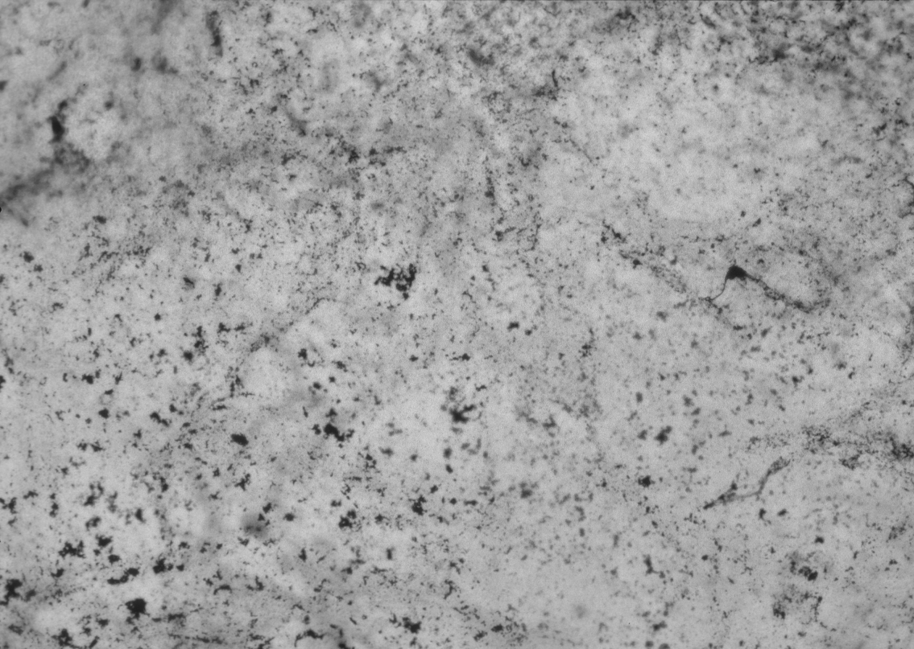
Nine white rabbits underwent creation of corneal flap only without the subsequent excimer laser photoablation.

2.1.2. Drugs:
Each animal received adequate anesthesia with intramuscular Ketamine (35 mg/ kg) and xylazine (5mg/kg) in addition to topical proparacaine HCL 0.5%.

2.2. Experimental design and methods:
Initially, nectatic membrane was cut before the procedure to prevent it from disturbing the flap. Eye lid speculum was placed between the lids and the eye was rinsed with 0.9% saline. A pararadial linear mark was dawn with a gentian violet pencil on the corneal surface. After placement of the suction ring, a superior hinge, 180µm, and 8.5 mm corneal flap was created, using Hansatome® microkeratome (B&L). Subsequently, the keratome was removed from the eye and the flap was lifted, using a cannula, rinsed well using 0.9% saline and repositioned without suturing. A suture was used to keep the lids closed for the first 24 hours. Antibiotic eye drops were administered 2 times daily for the first 3 days.
At the designated post-operative intervals, animals were sacrificed; the cornea was removed and stained with gold chloride.
Demonstration of the corneal innervation was carried out with a modified gold chloride procedure. We removed the cornea posterior to the limbus. We put the cornea into 5% formalin for 2 minutes. At the end of 2 minutes we drain off the solution and then section the cornea into 4 quadrants. With a sharp forceps we pick up each piece by the edge and put into the lemon juice for 10 minutes. We put each section of cornea into a bottle with about 5ml of 1% gold chloride. After 12 minutes we remove the cornea and put it in acidulated water for 16 hours. We remove the acidulated water and replace with 70% alcohol. The tissue was dissected into 4-6 lamellae before dehydration and mounting on slides for observation and photography.

3. Results:
3.1 Sub-basal nerves:
3.1. 1. After one week:
Nearly complete absence of the sub-basal nerve plexus in the basal cell layer was observed. (Figure 1).

3.1.2. After one month:
The starting regenerating sub basal nerves appeared short with few beads (Figure 2).

Figure 1: Complete absence of sub-basal nerve fibers at one week

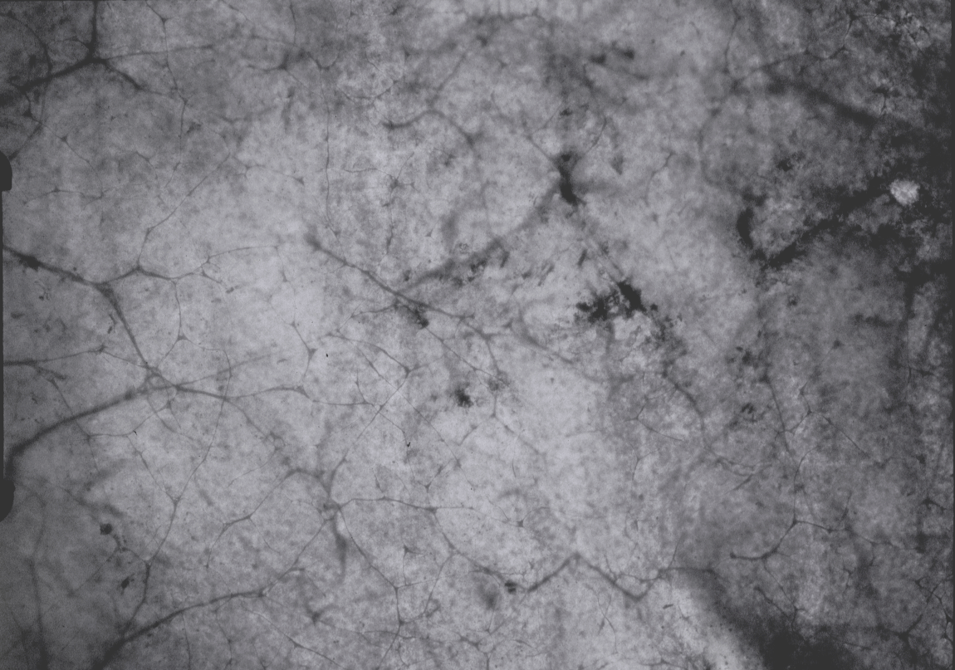

Figure 2: Starting regenerating sub basal nerves appeared short with few beads one month post surgery.

3.1.3. With further follow up:
The newly generated sub-basal nerves were slightly better constituted, especially in the centre of the flap. The Sub-basal plexus nearly returns to its pre-operative corneas in shape but not in density (Figure 3).

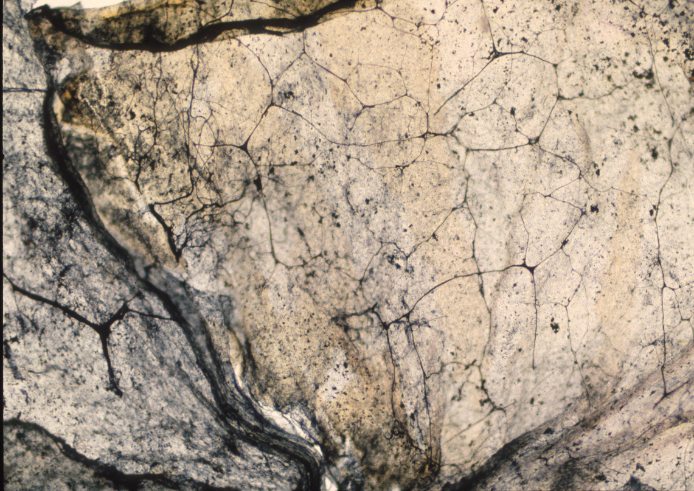
Figure 3: The Sub-basal plexus still less than its pre-operative shape at 6 month

Because most of the corneal stromal nerves lie within the anterior two thirds of the cornea, only the deepest stromal nerves avoid the microkeratome cut at the flap margin.
Only in the hinge area are spared as well developed epithelial and anterior stromal nerves are shown extending from the hinge to the flap (Figure 4).

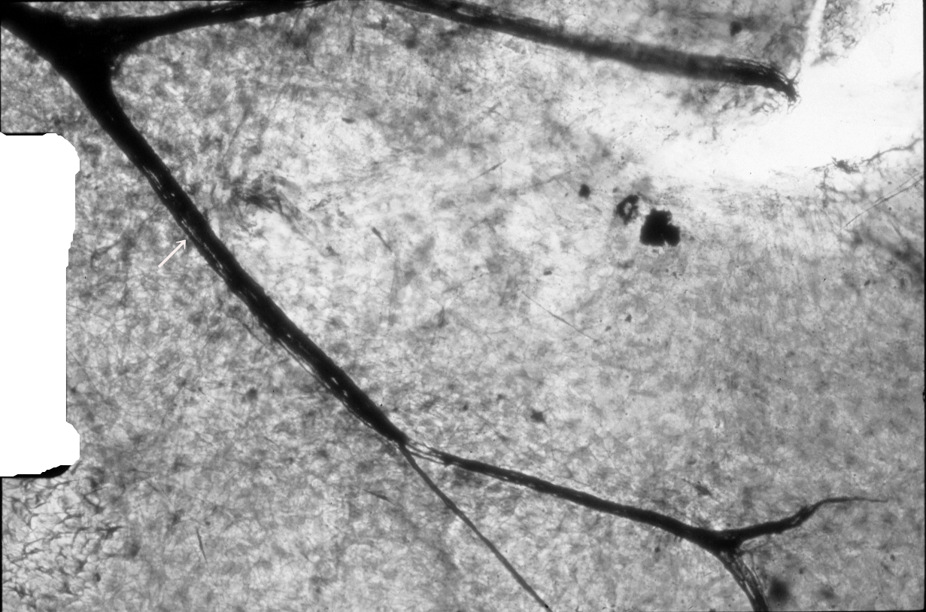

Figure 4: Superficial stromal nerves are seen at the hinge area

3.2. Aanterior stromal nerves:
3.2.1. At one week after the procedure
Some degenerated anterior stromal nerves in flap stroma were observed which appeared as very faint thin nerves (Figure 5).

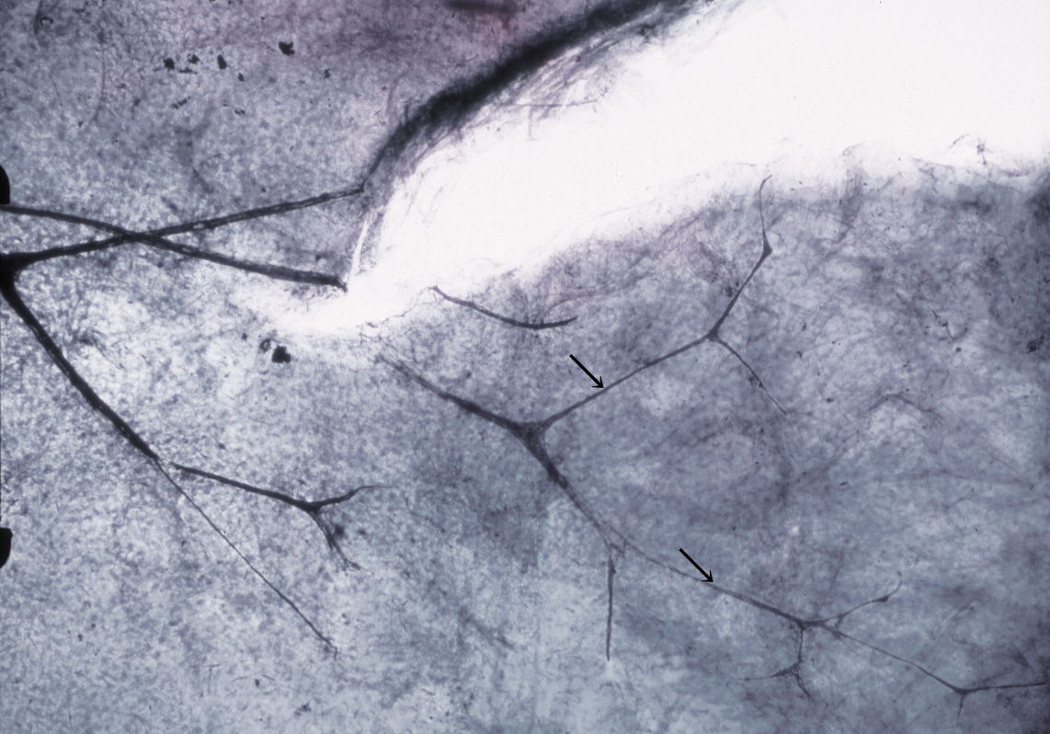

Figure 5: After superficial stromal nerves were cut at the nerve edges, the degenerated anterior stromal nerves were seen in flap stroma which appeared as very faint thin nerves (arrows)

3.2. 2. After one month of the procedure:
Numerous regenerating nerve fibers were observed to emerge from the cut stromal nerve trunks (Figure6).
Well-developed branched nerves start to appear in the anterior stroma of the corneal flap at six months.
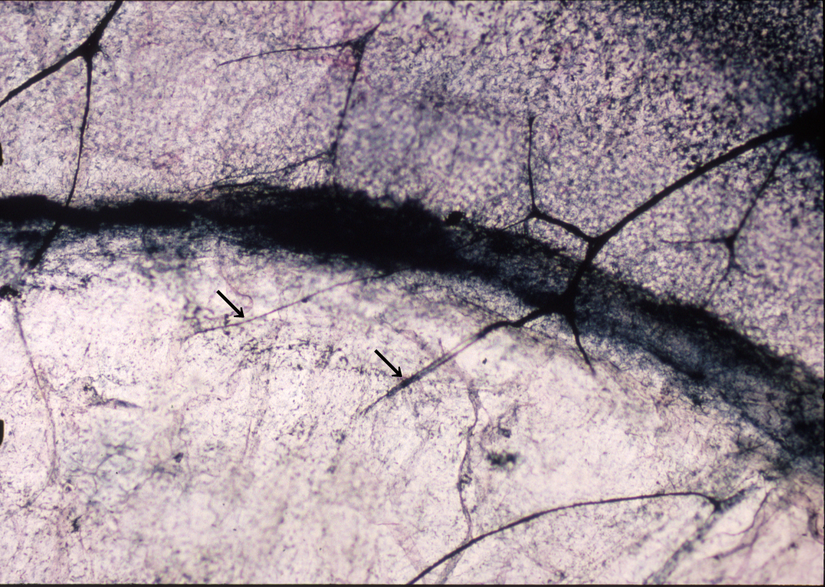
Figure 6: Thin single nerves started to appear in the flap stroma (arrows)

4. Discussion:
The rabbit and primate corneas shared relatively similar pattern of sensory innervation (Rozsa et al 1983) with some differences revealed by (Muller et al 1996). While Bowman’s layer is well developed in human corneas, this anterior a cellular stromal region is a less recognized structure in rabbits. The wound healing response of rabbit corneas is also considered to be more vigorous than in human.
The regeneration of stromal and epithelial innervations after LASIK has been studied using acetylcholinesterase histochemistry. Initially, in a rabbit study, only the hinge area was shown to preserve some of its stromal and epithelial innervation. In addition, occasional deep stromal nerve fibre bundles (NFBs) were observed to survive the micro-keratome cut under the flap. The cut stromal NFBs were found to send thin regenerating nerve fibers sometimes anastomosing with the neighboring stromal NFBs. These regenerating NFBs sometimes penetrated the most anterior a cellular stromal layer and sent subbasal NFBs forming the nerve terminals between the epithelial cells. By 2.5 months the anterior stromal, subbasal, and intraepithelial innervations was restored to near normal. The architecture of the deep stromal NFBs, however, remained abnormal even at 5 months. (Linna et al, 1998).
Linna and co-workers, found that sub-basal nerve morphology seemed to degenerate from 1 week to 6 months after LASIK and corneal sensitivity returned to normal. All their patients had visible subepithelial nerve fiber bundles in their corneas. (Linna et al 2000).
However, Lee and his associates reported significantly lower numbers of sub-basal nerve fiber bundles even 12 months after LASIK compared with the preoperative values with a superior hinge. Their findings were more consistent with the findings of Linna et al. The reason for the difference between results might be explained by the hinge position, since most nerves appear to enter the cornea at the nasal and temporal limbus. In their study, the regeneration of the nerves in the flap stroma was not complete up to 6 moths after LASIK, as reported earlier. They did not find any effect of LASIK on posterior stromal nerve fiber bundles, as expected (Lee et al 2002).
In the sub-basal region, the number of nerve fiber bundles decreased by more than 90% 1 week after LASIK and was significantly lower at all times after surgery than it was before surgery. It increased 6 and 12 months after LASIK, but remained less than half of the preoperative value. In the stromal flap, the number of nerves at all times after surgery was also significantly less than before surgery and did not increase significantly by 1 year. In the stromal bed, there were no significant differences among any of the nerve measurements before and after LASIK (Lee et al 2002).
It is found that corneal sub-basal nerve density does not recover to near preoperative densities until 5 years after LASIK, as compared with 2 years after PRK (Erie et al 2005).
In other study, sub-basal nerve density decreased 82% in 5 days after LASIK. A gradual increase was observed from 2 weeks postoperatively, but even 2 years after the operation the nerve density was only 64% from the preoperative values (Moilanen et al 2008). Mean (SD) nerve density was decreased at 1 month compared with the preoperative examination and remained decreased through 12 months (Patel et al 2010).
Corneal sub-basal nerve fiber density, nerve branch density, nerve fiber length, and nerve fiber width decreased significantly 1 month after LASIK and had not returned to the preoperative levels by 6 months. Nerve fiber tortuosity decreased significantly 1 month after LASEK and returned to the preoperative levels 3 months after surgery (Stachs et al 2010).

5. References:

Erie JC, McLaren JW, Hodge DO, Bourne WM. Recovery of corneal subbasal nerve density after PRK and LASIK.Am J Ophthalmol. 2005 Dec;140(6):1059-1064.

Exp. Eye Res. (1998) 66.775-763. Invest Ophthalmol Vis Sci. (1983) 24:1033–51.
- Lee BH, McLaren JW, Erie JC, Hodge DO, Bourne WM. Reinnervation in the cornea after LASIK. Invest Ophthalmol Vis Sci. 2002 Dec;43(12):3660-4.
- Linna TU, Perez-Santonja JJ, Tervo KM, Sakla HF, Alio JL and Tervo TMT. Recovery of corneal nerves morphology following laser in situ keratomileusis. Exp Eye Res. 1998 Jun;66(6):755-63.
- Linna TU, Vesaluoma MH, Perez-Santonja JJ, Petroll WM, Alio JL and Tervo TMT. Effect of myopic LASIK on corneal sensitivity and morphology of subbasal nerves. Invest Ophthalmol Vis Sci. (2000) 41:393–397.
- Marfurt CF, Cox J, Deek S, Dvorscak L. Anatomy of the human corneal innervation.Exp Eye Res. 2010 Apr;90(4):478-92.
- Moilanen JA, Holopainen JM, Vesaluoma MH, Tervo TM. Corneal recovery after lasik for high myopia: a 2-year prospective confocal microscopic study.B r J Ophthalmol. 2008 Oct;92(10):1397-402
- Muller L, Pels L and Vernsen G F. Ultra-structural organization of human corneal nerves.Invest Ophthalmol Vis Sci. (1996) 37:476–88.

Patel SV, McLaren JW, Kittleson KM, Bourne WM. Sub-basal nerve density and corneal sensitivity after laser in situ keratomileusis: femtosecond laser vs mechanical microkeratome.Arch Ophthalmol. 2010 Nov;128(11):1413-9.
- Rozsa AJ,Guess RB and Beuerman RW. Neural regeneration following experimental surgery of the rabbit cornea. Invest Ophthalmol Vis Sci. (1983) 24:1033–51.
- Silverberg KR, Ogilvy CS, Borges LF. A modified gold chloride technique for optimal impregnation of nerves within corneal whole mounts and dura of the albino rat. J Histochem Cytochem. 1989 Feb;37(2):269-71.

Stachs O, Zhivov A, Kraak R, Hovakimyan M, Wree A, Guthoff R. Structural-functional correlations of corneal innervation after LASIK and penetrating keratoplasty.J Refract Surg. 2010 Mar;26(3):159-67.
- Zander E and Weddell G. Reaction of corneal nerve fibres to injury. Br.J.ophthalmol. (1951a) 35,61-97.

12/21/2010

