Effects of Prenatal Phenytoin Toxicity on the Expression of Glial Fibrillary Acidic Protein (GFAP) in the Developing Rat Cerebellum

*Sahar Youssef ; Olfat A. Abd-El- Aty ; Halla H. M. Mossalam and Amina M. A. Tolba

Anatomy Department, Faculty of Medicine for Girls, Al-Azhar University, Cairo, Egypt
*sahar_sayed @ yahoo.com

Abstract The Cerebellum is a highly organized structure and its postnatal development was characterized by cell proliferation, migration and differentiation. Phenytoin is a primary antiepileptic drug used for all types of epilepsy except absence seizures. Even with the newer antiepileptic drugs, phenytoin continues to serve as a reference point and many epileptic women received phenytoin during pregnancy. The mechanism of teratogenicity by phenytoin is still under investigation. So, the present study was designed to clarify the effect of prenatal phenytoin on the cerebellar development in rat offspring using the immunohistochemical distribution of glial marker. The pregnant rats were received phenytoin 35mg/ kg body weight once a day from gestational days E5 to E20. In H and E stained sections, the Purkinje cells in the treated group (PD7) had poor and immature arbors and partially showed an irregular arrangement. There is dispersal of the internal granular cell layer and the white matter with the presence of vacuolations, dilated capillaries and extracellular oedema. The marker of radial glia, glial fibrillary acidic protein (GFAP) has been used to describe phenytoin induced alteration in the morphology and reactivity of Bergman glial cells and their fibres that are the guide substrate of granule cells. The feature of these fibres gives information on the proper granule cell migration. GFAP positive immunoreactivity was first detected at postnatal day one (PD1). Thin glial positive fibers had a regular feature running in parallel in the molecular layer and in the external granular layer of controls at postnatal day seven (PD7). In contrast, in the treated rats, the glial fibers appeared twisted, thickened with an uneven course and strongly labeled end feet. GFAP immunoreactivity in the white matter astrocytes was highly detected in both the control and the treated PD7. From the previous findings, it could be concluded that phenytoin has degenerative changes on the cerebellar development. These changes can lead to extensive neurological poor health effects later in life.
[Sahar Youssef; Olfat A. Abd-El- Aty; Halla H. M. Mossalam and Amina M. A. Tolba. Effects of Prenatal Phenytoin Toxicity on the Expression of Glial Fibrillary Acidic Protein (GFAP) in the Developing Rat Cerebellum. Journal of American Science 2011;7(8) 139-152](ISSN: 1545-1003). http://www.americanscience.org.

Keywords: Cerebellum; Phenytoin; Purkinje cells; Bergman glial fibers; Astrocytes; GFAP

Abbreviations: E5, E20, embryonic day 5, 20; GFAP, glial fibrillary acidic protein; PD1, PD7; postnatal day 1, 7

1. Introduction:
The cerebellum is a highly organized structure in which the Purkinje cells are the sole output of the cerebellar cortex (Altman, 1969; 1972a-c). Significantly, the cerebellum is one of the first structures to differentiate however; it achieves its mature configuration after birth (Bouet et al., 2005). Therefore, the cerebellum is especially vulnerable to developmental irregularities (Kern et al., 2006).
During postnatal development of rat cerebellum, the external granule cell layer represents the matrix area in which two discrete zones can be clearly recognized, the proliferative and the premigratory zones (Altman, 1972a-c). The postmitotic cells of external granular layer migrate to their final destination in the internal granule cell layer (Rakic, 1971 and Altman, 1972a). Definitely, the precise positioning of the cells is important for the final cytoarchitecture and in particular for the pattern of synaptic connections in laminated brain regions such as cerebellum (Rakic et al., 1994).
Maternal treatment with antiepileptic drugs can lead to cognitive dysfunction in later life of offspring and probably increasing the risk of central nervous system disorder. Several investigations demonstrated that the children of epileptic women who received antiepileptic drugs during pregnancy might have mild mental retardation (Scolnik et al., 1994). Phenytoin is a primary anti-epileptic drug used for all types of epilepsy except absence seizures (McNamara, 2001). Significantly, many epileptic women received phenytoin during pregnancy (Kelly et al., 1984; Lander and Eadie, 1991). There is some evidence that phenytoin causes brain damage. Gestational administration of phenytoin in rats can reduce whole brain weight (Tachibana et al., 1996), delay maturation of reflexes (Dam, 1972), and change postnatal behaviors such as increased spontaneous locomotion as well as learning impairments (Vorhees, 1987; Adams et al., 1990 and Pizzi and Jersey, 1992).
The purpose of this study is to clarify the effect of prenatal phenytoin administration on the cerebellar development in rat offspring. The present work was carried out in rat offspring on PD1 and PD7 born from mothers treated by phenytoin during the gestation period. In this study, the immuno-histochemical marker of glial polypeptides was used. A marker of radial glia, glial fibrillary acidic protein (GFAP) has been analysed here to describe phenytoin induced alteration in the morphology and reactivity of radial glial fibers. GFAP was discovered by Eng et al. in 1971 during an analysis of multiple sclerosis plaques (Eng et al., 1971). GFAP was found to be an intermediate filament protein expressed almost exclusively in astrocytes, leading to its adoption as an astrocytic marker for both clinical and basic studies (Eng and Ghirnikar, 1994; McLendon and Bigner, 1994).

2. Materials and Methods:
Experimental animals
40 adult albino rats (33 female and 7 male) were used. The rats were housed in animal care centre of faculty of Medicine for Girls, AL-Azhar University. They were kept under similar conditions of wire-floored cages, adequate ventilation and temperature with free access to water and food.

Experimental treatment & groups
The rats were mated overnight, and the day on which a vaginal plug was found was selected as gestational day 0. The pregnant rats were housed separately in a plastic cage. The pregnant rats (270-300g) were treated with phenytoin orally. Phenytoin (Phenytin) produced by the (The Nile for Pharmaceuticals and Chemical Industries- CO. Cairo- A.R.E.). Phenytin was in the form of tablets, which were freshly dissolved in distilled water and given orally by gastric tube to the rats. Rats were received phenytoin at a dose of 35mg/ kg body weight (Ohmori et al., 1999) once a day from gestational days E5 to E20. The day of birth was designated as postnatal day 0. In the postnatal period, the male rat’s offspring cerebellum of both the treated and the control groups were selected at the following ages: postnatal day one (PD1) and postnatal day seven (PD7). 40 male rats' offspring were used. In the postnatal period, rat pups were grouped as follows:
Group 1: Control male rat pups (PD1) born from the control pregnant rats.
Group 2: Treated male rat pups (PD1) born from the pregnant rats treated by phenytoin.
Group 3: Control male rat pups (PD7) born from the control pregnant rats.
Group 4: Treated male rat pups (PD7) born from the pregnant rats treated by phenytoin.

Histopathological analysis
Each offspring Rat was anaesthetized with diethyl ether. The brains were removed and immersed in Bouin,s fixative for 24 hours. The brains were then dehydrated in ascending grades of ethanol, embedded in paraffin and serially sectioned in median sagittal plane at a thickness of 4-5μm. Sections were stained with Haematoxylin and Eosin for histological examination according to the method of (Drury and Wallington, 1980).

GFAP immunohistochemistry
The tissue blocks were cut at 4μm thickness, deparaffinized and rehydrated to buffer (water). The sections were incubated with optimally diluted GFAP, mouse monoclonal antibody (Dako N-series Ready- to use primary antibody). The immunostaining was amplified and completed by Hoarseradish Peroxidase complex (Dako REALTM EnVision TM / HRP, Mouse ENV). Sections were developed and visualized using 3,3diaminobenzidine (Dako REAL TM DAB+ Chromogen). The substrate system produces a crisp brown end product at the site of the target antigen. Sections were counterstained with or without haematoxylin. The sections were then dehydrated in alcohol, cleared in xylene and coverslipped with Permount. The Sections were examined under light microscopy.

3. Results:

Group 1: Control postnatal day one (PD1) rats
In H& E stained sections, the cerebellum was present in the dorsal part of the hindbrain. The cerebellum consisted of normal lobules and fissures (Fig.1A). The cerebellar cortex is built up of, from outside inwards, the external granular layer, the molecular layer and the internal granular layer. The external granular layer consisted of 3-5 cell layers. The cells of the external granular were oval or rounded in shape with darkly stained nuclei. They are densely aggregated superficial zone and less packed deep zone. The molecular layer is a pale narrow zone with loose aggregation of cells. The Purkinje cells could barely be seen. The Purkinje cells could be observed mixed together among cells of the internal granular layer or as an indistinct layer superficial to the cells of the internal granular layer. The internal granular layer is relatively a thick layer with deeply stained cells of different shape and size. The white matter is observed beneath the internal granular layer and it is stuffed with a great number of less packed fusiform or oval cells (Fig.1B).

GFAP immunoreactivity: GFAP positive immunostaining was detected in the external granular layer and in the molecular layer (Fig.1 C& D).

Group 2: Treated postnatal day one (PD1) rats
In H& E stained sections, the cerebella revealed slightly decrease in its size as compared with the control. The fissures became shallow and poorly developed in comparison with the control one. There is obvious decreased in the depth of the fissures. Moreover, there is slightly delayed appearance of some cerebellar fissures (Fig.2A). The cerebellar cortex showed that there is slightly dispersion of cerebellar cortical layers with the presence of cavitations and extracellular oedema. The external granular layer was thin in comparison to the control. The cells of the external granular layer were small rounded or oval in shape with deeply stained nuclei. The molecular layer could hardly be recognized. It appeared very thin and weakly developed as compared with the control. The Purkinje cell layers could not be seen similar to the control one. The internal granular layer consisted of small rounded or oval cells with deeply stained nuclei. The cells of the internal granular layer were dissociated from each other and some of them had vacuolated cytoplasm (Fig.2B).

GFAP immunoreactivity: GFAP positive immunoreactivity was observed in the external granular layer and in the molecular layer (Fig. 2 C&D).

Group 3: Control postnatal day seven (PD7) rats
In H& E stained sections, the cerebellar cortex became more developed. The cerebellum is obviously increased in size and its fissures are increased in depth as compared with the previous control age. In addition, the development and differentiation of the new fissures were also observed (Fig.3 A). The cerebellar cortex is built up, from outside inside, the external granular layer, the molecular layer, the Purkinje cell layer and the white matter. The external granular layer showed marked increase in thickness in comparison to the PD1. The molecular layer showed marked development and apparantly increased in thickness (Fig.3 B, C& D). The Purkinje cell layer is arranged in one row. The Purkinje cells were typically oval or fusiform in shape with their long axes vertical to the surface. The elongated dendrites of Purkinje cells in the molecular layer are visible. Dendritic arbors are also clearly observed. Most of the Purkinje cells are aligned in a regular pattern (Fig.3 B, C& D). The internal granular layer is thicker than that of the control of the previous age. The cells of the internal granular layer are rounded or oval with deeply stained nuclei. The white matter is well developed and clearly detected underneath the internal granular layer (Fig.3 B& C).

GFAP immunoreactivity: the GFAP positive fibers were thin and had a regular feature running in parallel in the molecular and in the external granular layers (Fig.4 A-D). The GFAP is highly expressed in the astrocytes in the white matter (Fig. 4 E-F).

Group 4: Treated postnatal day seven (PD7) rats
In H& E stained sections the cerebellum was slightly less developed (Fig.5A) in comparison to the control of the same age (Fig.3.A). The cerebellar cortex consists of from outside inwards, the external granular layer, the molecular layer, the Purkinje cell layer and the internal granular layer. Significantly, extensive hemorrhage along the cerebellar cortical layers was also observed (Fig.5B). The external granular layer was to some extent less developed than that of the control group. In addition, the cells in the external granular layer appeared small in size with deeply stained or pyknotic nuclei. Apparently, the width of molecular layer (Fig.5B, C&D) was relatively decreased in comparison to the control. The molecular layer cells were loosely packed. The Purkinje cells were disarranged in one row with less stained cytoplasm and less diverse nuclei. In addition, focal loss of Purkinje cells is observable (Fig. 5B, C&D). Dendritic arbors appeared poorly developed and immature. Some of Purkinje cells are aligned irregularly (Fig.5D). There is dispersion of the internal granular cell layer and the white matter with the presence of vacuolations, dilated capillaries and extracellular oedema (Fig.5 C& D).

GFAP immunoreactivity: Importantly, the glial fibers emerged twisted with an uneven course and sometimes they navigated the molecular layer at different angles. Sometimes, the fibers appeared disrupted. Then, few GFAP positive fibers (Fig. 6 A- D) frequently had thickened and intensely stained end-feet in the pial surface of the external granular layer (Fig.6 C). The GFAP is highly detected in astrocytes in the cerebellar white matter (Fig.6.E-F).

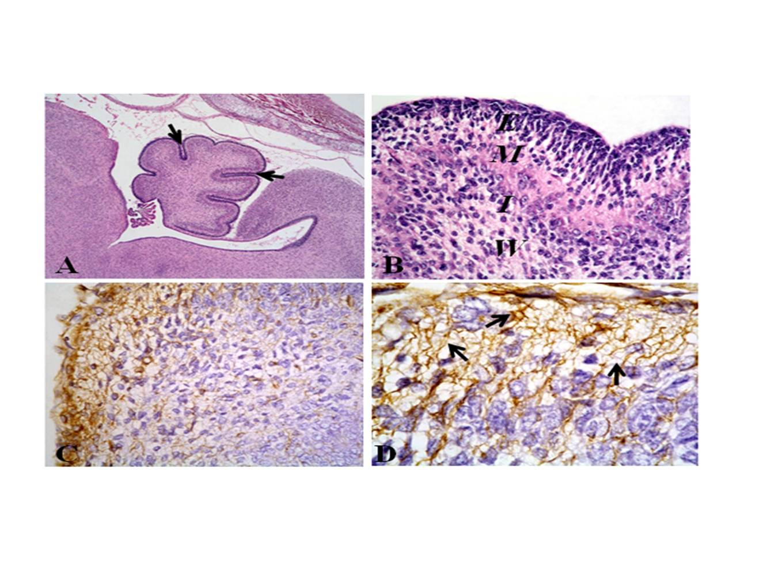

Fig.1. Photomicrographs of the median sagittal sections of cerebellum of the control postnatal day one (PD1) rats (A- D). (Group 1)
(A) Showing the normal architecture of the cerebellum with many fissures
(arrows) and lobules.
(H and E x40)
(B) Showing the layers of the cerebellar cortex namely; the external granular layer (E), the molecular layer (M) and the internal granular layer (I). The white matter (W) is observed beneath the internal granular layer.
(H and E x400)
(C) Showing distribution of GFAP positive immunoreactivity in the external granular layer and in the molecular layer.
(x400)
(D) High magnification of C to show the intense GFAP staining pattern in the glial positive fibers in the external granular layer and in the molecular layer (arrows). (x1000)

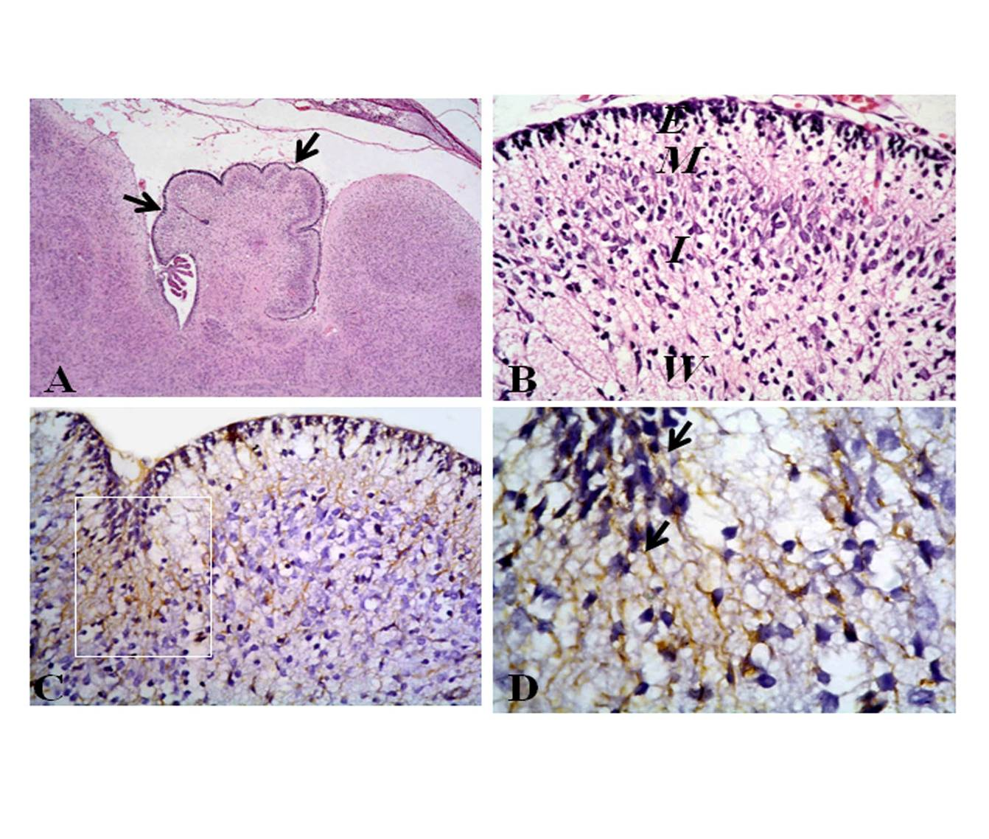
Fig.2. Photomicrographs of the median sagittal sections of cerebellum of postnatal day one (PD1) rats of treated mothers (A- D). (Group 2)
(A) Showing that the cerebellum was less developed. Marked reduction of the depth of the fissures (arrows) is observed.
(H and E x 40)
(B) Showing the poorly developed of the external granular layer (E). The molecular layer (M) appeared as a very thin narrow zone and the internal granular layer (I) are of low density with small size of cells and some of them have vacuolated cytoplasm.
(H and E x400)
(C) Showing distribution of GFAP immunoreactivity in the external granular layer and in the molecular layer.
(x400)
(D) The figure D are the high magnification of the white frame in (C) to show the positive brown immunostaining pattern of GFAP in the external granular and molecular layers (arrows).
(x1000)

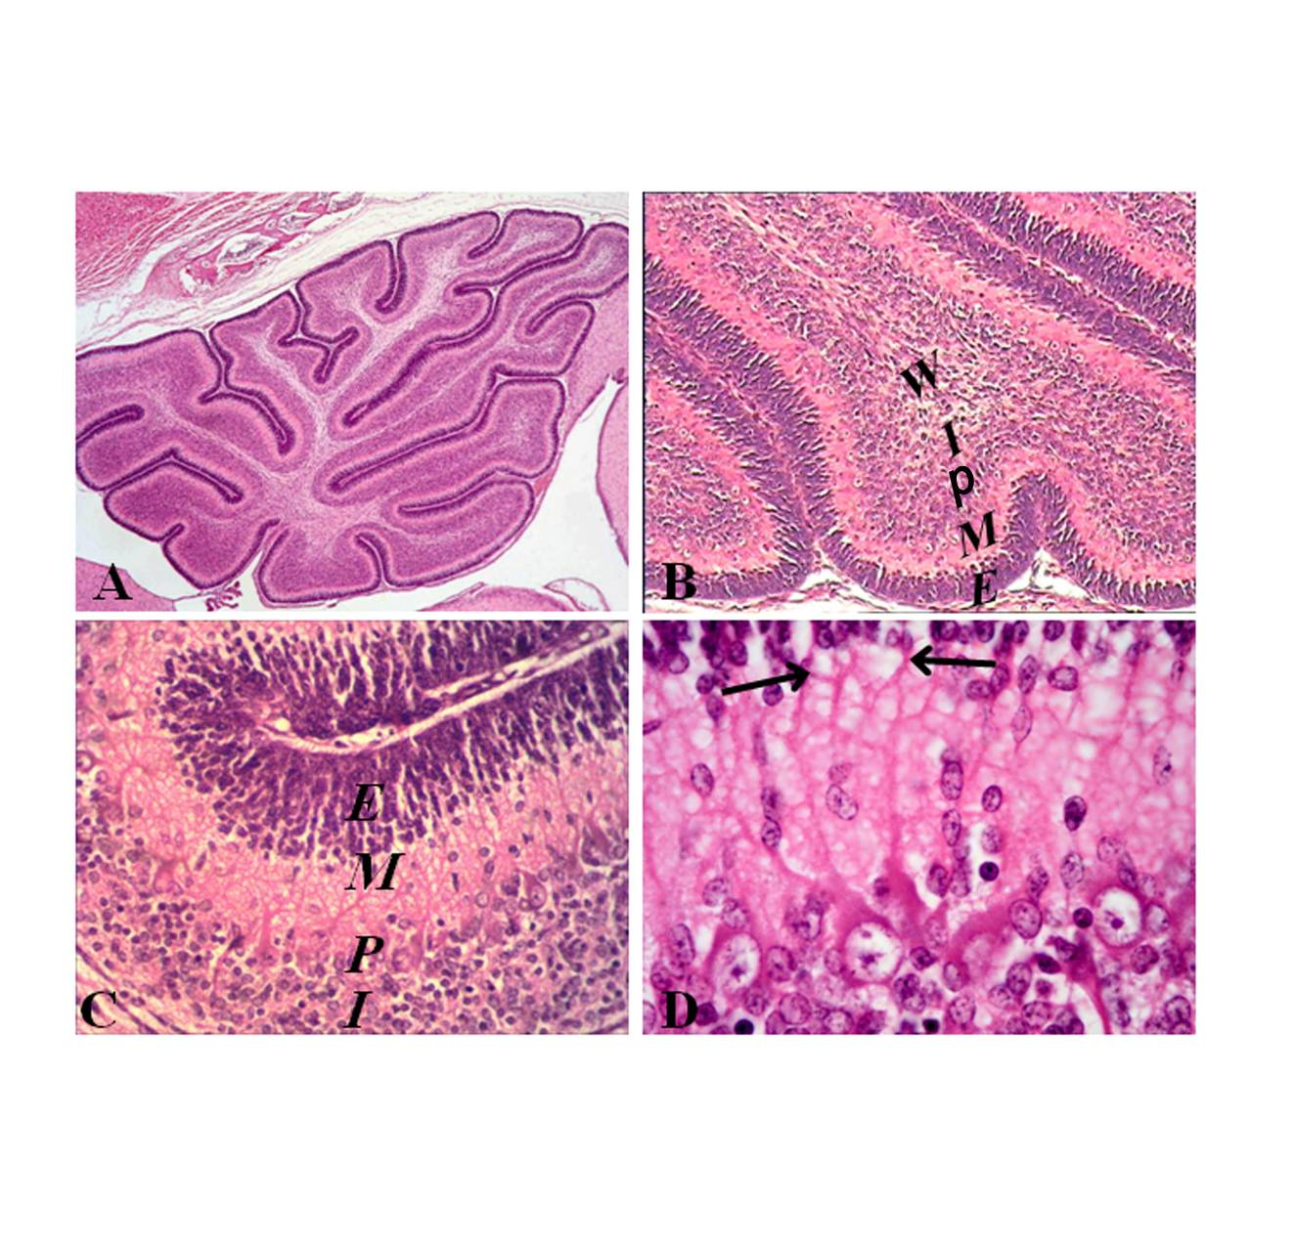
Fig.3. Photomicrographs of the median sagittal sections of cerebellum of the
control postnatal day seven (PD7) rats (A- D). (Group 3)
- Showing that the cerebellum is markedly increased in size. The development and the differentiation of the new fissures are clearly observed.
(H and E x40)
(B) Showing the well developed of the cerebellar cortical layers namely from outside inwards, the external granular layer (E), the molecular layer (M), the Purkinje cell layer (P) and the internal granular layer. The white matter (W) is clearly distinguished.
(H and E x100)
(C) Showing the well demarcated of the cerebellar cortical layers.
(H and E x400)
(D) Showing the Purkinje cells are well developed and stuffed in one raw. The elongated dendrites of Purkinje cells in the molecular layer are evident. Importantly, dendritic arbors are also clearly observed (arrows). In addition, most of the Purkinje cells are aligned in a regular pattern.
(H and E x1000)
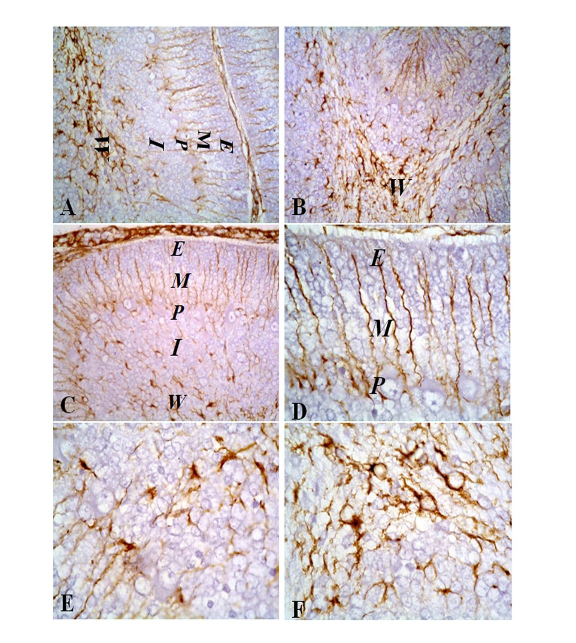
Fig.4. Photomicrographs of the median sagittal sections of cerebellum of the control postnatal day seven (PD7) rats (A- F). (Group 3)
(A-D) Showing the GFAP positive radial glial fibers appear thin and regular in the external granular layer (E) and in the molecular layer (M).
(E-F) The strong GFAP positive immunostaining in the astrocytes in white matter is observed.
(A-B-C x 400) (D- E-F x1000)

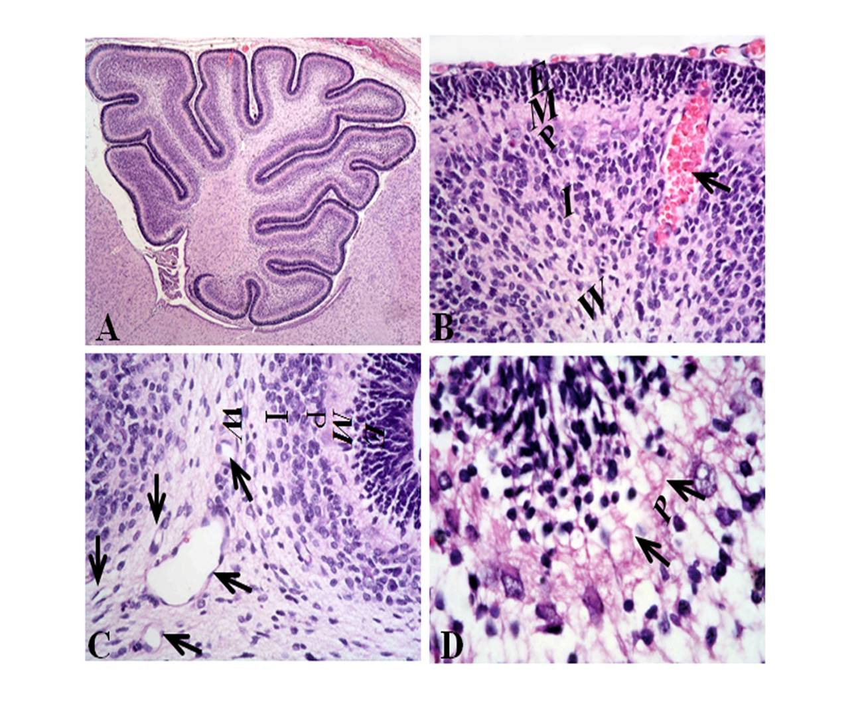
Fig. 5. Photomicrographs of the median sagittal sections of cerebellum of
the postnatal day seven (PD7) rats of treated mothers (A- D). (Group 4)
(A) Showing that the size of the cerebellum is slightly decreased.
(H and E x40)
(B) Showing the external granular layer (E) and the molecular layer (M) are poorly developed. Diffusion of the internal granular layer (I) and extensive hemorrhage (arrow) along the cerebellar cortical layers are clearly noticed.
(H and E x400)
(C) Showing dispersion of the white matter with the presence of dilated capillary of blood vessels and cavitations (arrows).
(H and E x400)
(D) Showing moderately focal loss (P) of Purkinje cells. Significantly, the Purkinje cells had poor and immature arbors (arrows) and partially showed an uneven arrangement.
(H and E x1000)

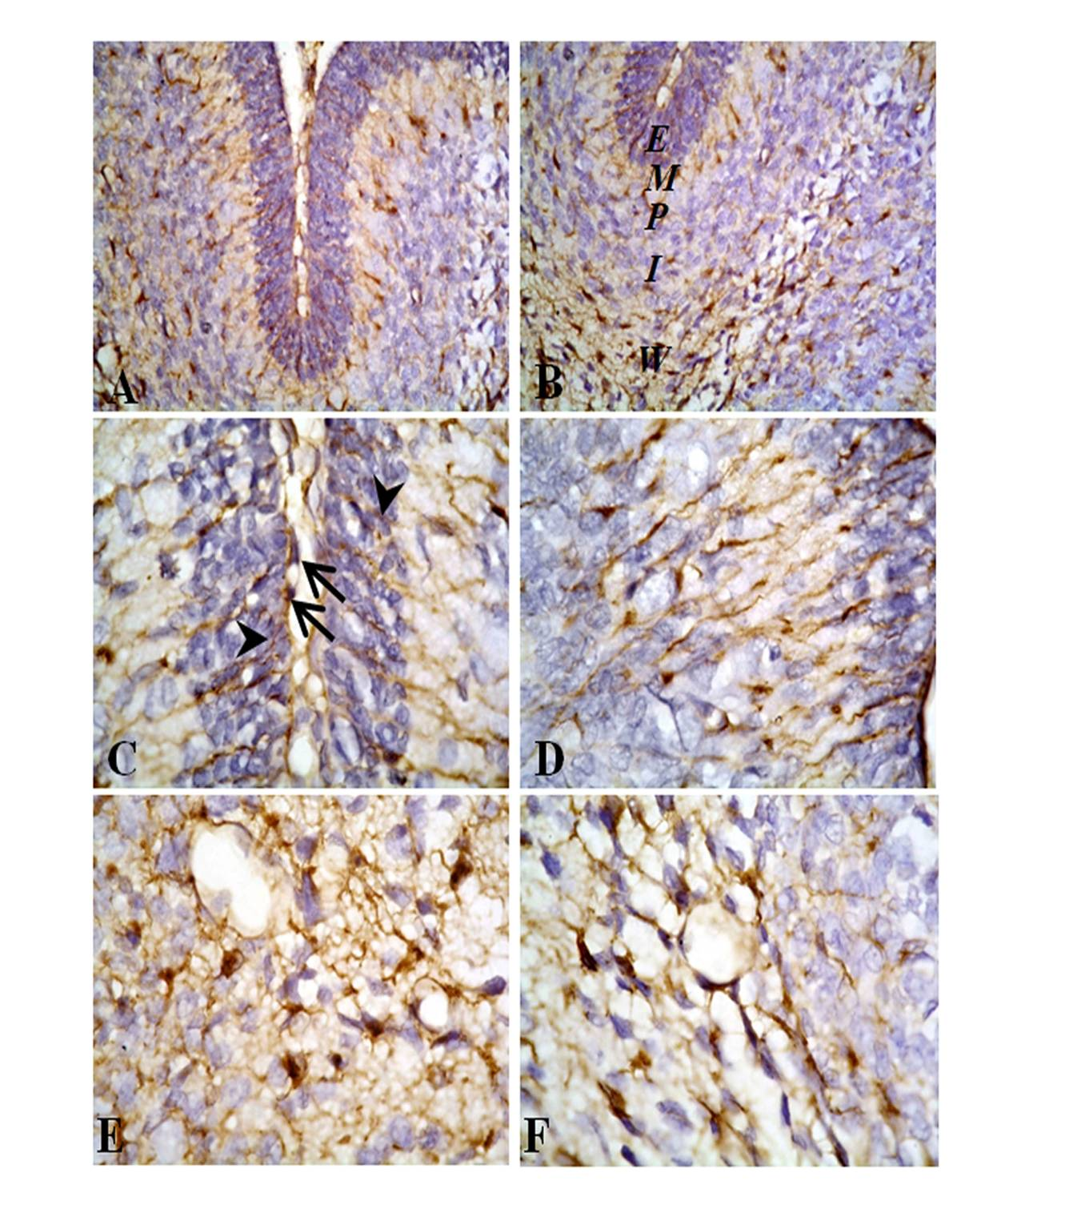
Fig.6. Photomicrographs of the median sagittal sections of cerebellum of the postnatal day seven (PD7) rats of treated mothers (A- F). (Group 4)
(A-D) Showing the GFAP positive radial glial fibers are twisted, thickened, interrupted (arrowheads), and loose their parallel course. Moreover in (C) some of these fibers have intensely stained thickening (end- feet) at the pial surface of the external granular layer (arrows).
(E-F) Showing the GFAP positive imunostaining in the astrocytes in white matter are noticed.
(A- B x 400) (C- D-E -F x1000)

4. Discussion
Phenytoin is one of the most effective antiepileptic drugs that it is widely used in most forms of epilepsy except absence seizures (McNamara, 2001). The neurotoxicity of phenytoin has been investigated. Clinico-epidemiologic studies suggested an approximated two to three-fold increase in malformations in neonates exposed to phenytoin during the prenatal period (Janz, 1982 and Kaneko et al., 1988).
The mechanism of teratogenicity by phenytoin is still under analysis. The present study was carried out, in a trial to elucidate the cause of cerebellar injury with special reference to its effect with both histological and immunohistochemical studies following maternal administration of phenytoin during the gestation period. The current study evidenced that administration of phenytoin to the pregnant rats extensively influenced the cerebellum of offspring on PD1 and on PD7 groups. These results could be attributed to the findings of (Vorhees et al., 1988; Adams et al., 1990; Pizzi and Jersey, 1992).
In the present study, phenytoin diminished the rate of growth of the cerebellum. The cerebella of treated groups at PD1 and PD7 were less developed as compared with the control. These results were in harmony with Gadisseaux et al. (1984) who stated a novel cases of ponto-neocerebellar hypoplasia in children born to mothers treated with phenytoin during pregnancy. Moreover, Squier et al. (1990) have demonstrated no Purkinje cells in any part of the cerebellar hemispheres and cerebellar hypoplasia accompanied by extensive gliosis. Furthermore, total brain weight was lower following neonatal administration of phenytoin in mice than the control group and the reduction of brain weight was more remarkable in comparison to body weight (Ogura et al., 2002). The same result was obtained in the chick cerebellum. Allam et al. (1987) had explained that phenytoin (epanutin) produced reduction of the activity of the cells in the external granular layer leading to shrinking of the size of the cerebellum.
The present work showed that the cerebellar fissures became shallow and poorly developed in the treated group on PD1 than that of the control group. Significantly an apparent reduction in the depth of the fissures was also observed. Indeed, cerebellar malformations have been reported following intrauterine exposure to anticonvulsants drugs including phenytoin (Gadisseaux et al. 1984; Squier et al. 1990).
The present study showed that the external granular layer of the control group on PD7 is more developed than that of the control group on PD1. These observations receive a marked support from the reports issued by Noor-El-Din et al. (1977) who reported that the thickness of the external granular layer increased gradually to reach its maximum at the age of 7days.
In this study, the external granular layer apparently is thinner of the treated group on PD1 than that of the control group. In addition, the cells of the external granular layer are deeply stained. The possible explanation of the reduction of the thickness of the external granular layer principally as a result of the high number of apoptotic cells in the cerebellum. Two anticonvulsants, carbamazepine and phenytoin have been shown to induce apoptosis of cerebellar granule cells at doses higher than their therapeutic levels (Yan et al., 1995). The changes of the external granular layer in the previous literatures were outstanding compared with those of other cerebellar cells. Ohmori et al. (1992) reported that, oral administration of phenytoin in the neonatal period induces neurotoxic effects on the developing mouse cerebellum. The cells of the external granular layer were pyknotic cells and the external granular layer was thicker than that of the control. These changes were observed in high (50mg/Kg) or low doses (25-35mg/Kg) of phenytoin. These results suggested that phenytoin induces cell death of the external granule cells and inhibits proliferation and migration of granule cells in newborn mouse cerebella (Ohmori et al., 1992; 1997 and 1999). In addition, neonatal administration of phenytoin (35 mg/Kg) daily during postnatal days 5-14 revealed that the layer of the mature granule cells in the dentate gyrus was thinner in the phenytoin treated mice (Ogura et al., 2002). Their results demonstrated that neonatal administration of phenytoin interferes with the development of granule cells in the hippocampus and the cerebellum and causes spatial learning deficits in later life. The same results were obtained in the chick cerebellum. Previously, Allam et al. (1987) reported that phenytoin (epanutin) inhibited the migration of the cells of the external granular layer. Definitely, agents acting in the perinatal or early postnatal periods are thus liable to interfere with the development of cerebellar granule cells and other cerebellar cells may be affected as a result of loss granule cells (Altman et al., 1969; Ohmori et al., 1999). Moreover, the relationship among proliferation, death and migration in the development of cerebellar lobules was largely supported by findings obtained after the cisplatin treatment. Significantly, evident changes of the whole external granular layer were found on postnatal days 11, one day after cisplatin treatment when reduction of the thickness of this layer was found in treated rats, mainly in consequence of the high number of apoptotic cells in all the cerebellar lobules (Pisu et al., 2005).
The present study showed that the molecular layer of the control group is thin on PD1. The molecular layer of the control group is markedly developed and increased in thickness on PD7. The same results were obtained in the rabbit cerebellum. In the rabbit, the molecular layer was observed as a very thin zone on the 19th prenatal days and gradually increased in thickness between 1st and 5th postnatal days (Noor- El-Din et al., 1985).
The present study suggested the retardation of the growth of the molecular layer in the treated rats in both PD1 and PD7 as compared to the control. These findings were in agreement with (Ohmori et al., 1999) who stated that the molecular layer in the vermis in the treated group was thinner than that of the control group on postnatal days 14 in mouse cerebellum. Similarly, in chick cerebellum, phenytoin reduced the thickness of the molecular layer (Allam et al., 1987).
In the present work, the most impressive alterations in the cerebellum of treated rats on PD7 were delayed the maturation of Purkinje cells. These changes were in the form of immature dendritic development and partially an irregular arrangement of Purkinje cells. These results are in accordance with Blank et al. (1982) who applied phenytoin to the developing neonatal mouse cerebellar cultures. Their observations revealed that phenytoin induce Purkinje cell degeneration. Similar changes of the immature dendritic development of the Purkinje cells following phenytoin administration to the newborn mouse once a day during postnatal days 2-4 was also reported (Ohmori et al., 1999). The possible interpretation of the result of the deleterious changes of the Purkinje cells in the present study could be attributed to the toxicity effects of phenytoin. This interpretation received a good support by Ohmori et al. (1999) in which they explained that delayed migration of granule cells to the internal granule layer may deteriorate the synaptic connection of parallel fibers with dendrites of Purkinje cells; or phenytoin may directly damage Purkinje cells and their dendritic extensions. Indeed, altered migration of granule cells influences the growth of Purkinje cell dendrites because the granule cells represent trophic factors for Purkinje cell differentiation (Altman, 1982). The alterations in the growth and remodeling of Purkinje cell dendrites are an apparent proof of brain plasticity as revealed during postnatal histogenesis after X –ray irradiation or treatment with cytotoxic substances (Avella et al., 2006; Li et al., 2006).
Although several literatures of toxicities in animals and side effects in human induced by phenytoin have been published, however, there is not clear evidence to describe phenytoin induced changes in the morphology of Bergmann radial glial fibers and the astrocytes in the white matter. In this concern, the immunoreactivity of the astrocytic marker (GFAP) is evaluated. GFAP is believed to play an important role in the long-term maintenance of brain cytoarchitecture, proper functioning of the blood brain barrier and modulation of neuronal functions (Liedtke et al., 1996; Shibuki et al., 1996 and Penky et al., 1998).
The immunohistochemical findings reported in the present study offer significant evidence that GFAP is highly expressed in the cerebellum in all developmental ages of the control and the treated rats. These results coincide with those of (Pisu et al., 2005; Cerri et al., 2010).
The immunohistochemical results reported in this study provide significant proof that phenytoin induces neurotoxic damage. At PD7 of the treated group, the GFAP- positive radial glial fibers in the external granular layer were interrupted and in the molecular layer, the radial glial fibers were asymmetrical and distorted in comparison with the typical parallel running features of normal fibres at the same age of the control group. These results are in agreement with Pisu et al. (2005) who applied a single injection of cisplatin to the developing rat cerebellum. GFAP immuno-fluorescence showed that cisplatin altered the pattern of radial glia in the neocerebellar lobules VI- VIII; in these lobules fibers were lacking or thick and intensely labeled, also in the end feet. Furthermore, injured radial glia fibers were persisted twenty days after cisplatin treatment possibly leading to the presence of ectopic granule cells in the molecular layer (Pisu et al., 2004).
Alterations of Bergmann glia processes was reported two days after a single injection of cytotoxic agent, methylazoxymethanol (MAM) which produces extensive cell death in the external granular layer and over-expression of GFAP in the distal half of Bergman fibers, including the end feet at the pial surface (Lafarga et al., 1998). These results have been explained as a reactive response, in which changes in the interactions between Bergmann glia and granule cell precursors have a role (Lafarga et al., 1998).
Faults of Bergmann glia from loss to relatively slight alterations in their localization or in the organization, length and end feet contacts of their processes are reported to affect the cerebellar architecture (Delaney et al., 1996; Kaartinen et al., 2001).
Astrocytes are the main cell types that principally express GFAP, as these cells are known to play a critical role in neuromodulation and axon guidance control during development. In addition, these cells are essential in homeostasis preservation (Ridet et al., 1997). In the present research, the expression of GFAP immunostaining in the cerebellar white matter was observed in the control and in the treated PD7. As previously reported, prenatal exposure to carbon monoxide, there is an upregulation of GFAP astroglia in the granular layer and in the Bergman glial cells located in the Purkinje cell and molecular layer (Yamada and Watanabe, 2002). Moreover, exposure to nicotine leads to persistently elevated expression of GFAP in the cerebellar white matter rat offspring on PD60 (Abdel- Rahman et al., 2004).

5. Conclusion
In the present work the subsequent reduction of the thickness of the external granular layer, the altered expression of GFAP and the deformed morphology in the radial glial system could early affect the differentiation of Purkinje cells arbour. Changes in this relationship after the phenytoin treatment may result in the disturbed cerebellar cytoarchitecture. These changes can lead to extensive neurological poor health effects later in life.

Corresponding author:
Sahar Youssef
Anatomy Department, Faculty of Medicine for Girls, Al-Azhar University, Cairo, Egypt
sahar_sayed @ yahoo.com

References
Abdel- Rahman, A.; Dechkovskaia, A.; Mehta- Simmons, H.; Sutton, J.M.;Guan, X.; et al (2004): Maternal exposure to nicotine and chlorpyrifos, alone and in combination, leads to persistently elevated expression of glial fibrillary acidic protein in the cerebellum of the offspring in late puberty. Developmental Toxicology. 78: 467-76.
Adams, J.; Vorhees, C.V., and Middaugh, L. D. (1990): Develpomental neurotoxicity of anticonvulsants: Human and animal evidence on phenytoin. Neurotoxicol. Teratol. 12: 203-14.
Allam, H.N.; Sadek, S. A. and El- Falaky, M. M. (1987): Effect of phenytoin (Epanutin) on the development of the cerebellum of the chick embryo. Sc. J. Az. Med. Fac. (Girls). 5(1): 195-208.
Altman, J. (1969): Autoradiographic and histological studies of postnatal neurogenesis III. Dating the time of production and onset of differentiation of cerebellar microneurons in rats. J. Comp. Neurol. 136:269-93.
Altman, J. (1972a): Postnatal development of the cerebellar cortex in the rat: I. The external germinal layer and the transitional molecular layer. J. Comp. Neurol. 145: 353–97.
Altman, J. (1972b): Postnatal development of the cerebellar cortex in the rat. II. Phases in the maturation of Purkinje cells and of the molecular layer. J. Comp. Neurol. 145:399-464.
Altman, J. (1972c): Postnatal development of the cerebellar cortex in the rat. III. Maturation of the components of the granular layer. J. Comp. Neurol. 145:465-513.
Altman, J. (1982): Morphological development of the rat cerebellum and some of its mechanisms. Exp. Brain Res. 6: 8-46.
Avella, D.; Pisu, M.B.; Roda, E.; Gravati, M. and Bernocchi, G. (2006): Reorganization of rat cerebellar cortex during postnatal development following cisplatin treatment. Exp. Neurol. 201:131-43.
Blank, N.K.; Nishimura, R.N.; Seil, F.J. (1982): Phenytoin neurotoxicity in developing mouse cerebellum in tissue culture. J. Neurol. Sci. 55: 91-97.
Bouet, V.; Dijk, F.; Ijkema-Paassen, J.; Wubbles, R.J. and Want, J.J. (2005): Early hypergravity exposure effects calbindin-D28K and inosito-3-phosphate expression in Purkinje cells. Neurosci. Letters. 382:10-15.
Cerri, S.; Piccolini, V. M. and Bernocchi, G. (2010): Postnatal development of the central nervous system: anomalies in the formation of cerebellum fissures. Ana. Re. 293: 492-501.
Delaney, C.L.; Brenner, M.; Messing, A. (1996): Conditional ablation of cerebellar astrocytes in postnatal transgenic mice. J. Neurosci. 16: 6908-18.
Dam, M. (1972): The density and ultrastructure of the Purkinje cells following diphenylhydantoin treatment in animals and man. Neurol. Scand: 48:13-51.
Drury, R.A.V. and Wallington, E.A. (1980): Carltons histological techniques, fifth ed. Oxford University Press, New York: P.206.
Eng, L.F., Vanderhaeghen, J. J., Bignami, A., and Gerstl, B. (1971): An acidic protein isolated from fibrous astrocytes. Brain Res.28: 351-54.
Eng, L.F. and Ghirnikar, R.S. (1994): GFAP and astrogiosis. Brain Pathol. 4:229-37.
Gadisseaux, J.F.; Rodrigues, J.; and Lyon, J. (1984): Pontoneocerebellar hpoplasia- a probable consequence of prenatal destruction of the pontine nuclei and a possible role of phenytoin intoxication. Clin. Neuropathol. 3: 160-70.
Janz, D. (1982): On major malformations and minor anomalies in the offspring of parents with epilepsy, in Epilepsy, Pregnancy and the Child. Plenium Press, New York. pp 211-22.
Kaartinen, V.; Gonzalez-Gomez, I.; Voncken, J.W.; Haataja, L.; et al., (2001): Abnormal function of astroglia lacking Abr and Bcr RacGAPs. Development. 128: 4217-27.
Kaneko, S.; Otani, K.; Fukushima, Y.; Ogawa, Y.; Nomura, Y. (1988): Teratogenicity of antiepileptic drugs: analysis of possible risk factors. Epilepsia. 29: 459-67.
Kelly, T.E; Edwards, P.; Rein, M.; Miller, J.; and Dreifuss, F. (1984): Teratogenicity of anticonvulsant drugs. II. A prospective study. Arm. J. Med. Genet. 19: 435-43.
Kern, J.K.; Jones, A.M. (2006): Evidence of toxicity, oxidative stress, and neuronal insult in autism. J. Toxicol. Environ. Health B Crit. Rev. 9:485-99.
Lafarga, M.; Andres, M.A.; Calle, E.; Berciano, M.T. (1998): Reactive gliosis of immature Bergman glia and microglial activation in response to cell death of granule cell precursors induced by methylazoxymethanol treatment in the developing rat cerebellum. Anat. Embryol. 198: 111-22.
Lander, C. M. and Eadie, M. J. (1991): Plasma antiepileptic drug concentrations during pregnancy. Epilepsia. 32: 257-66.
Li, H.P.; Miki, T.; Yokoyama, T.; Lee, K. Y.; Gu, H. et al. (2006): Regional differences in vulnerability of the cerebellar foliations of rats exposed to neonatal X-irradiation. Neurosci. Lett. 402: 86-91.
Liedtke, W.; Edelman, W.; Bieri, P.L.; Chin, F.C. and Cowen, N.J. (1996): GFAP is necessary for the integrity of CNs white matter architecture and long term maintenance of myelination. Neuron. 17: 607-15.
McLendon, R. E. and Bigner, D.D. (1994): Immunohistochemistry of the glial fibrillary acidic protein: basic and applied considerations. Brain Pathol. 4:221-28.
McNamara, J.O. (2001): Drugs effective in the therapy of the epilepsies. In Hardman J.G.; Limbird, L.E.; Gilman, A.G. eds. Goodman and Gilman’s the pharmacological basis of therapeutics 10th ed. New Yourk: pergamon Press. 521-47.
Noor - El-Din, M.A.; Abd-El-Rehim, M.M. and Ibrahim, M.W. (1977): Fate of the external granular layer of the cerebellar cortex in the white rat. Al-Azhar Med. J. 6(2): 181-86.
Noor - El-Din, M.A.; Abd-El-Rehim, M.M.; Ebada, M.M.; El- Sayed, A.O. and Zaher, F. I. (1985): Development of the fissures and lobules in the cerebellum of rabbit. Al- Azhar Med. J. 14 (1): 45-56.
Ogura, H.; Yasuda, M.; NaKamura, S. (2002): Neurotoxic damage of granule cells in the dentate gyrus and the cerebellum and cognitive deficit following neonatal administration of phenytoin in mice. Journal of Neuropathology and Experimental Neurology. 61 (11): 956-67.
Ohmori, H.; Kobayashi,T.; and Yasuda, M. (1992): Neurotoxicity of phenytoin administered to newborn mice on developing cerebellum. Neurotoxicol. Teratol. 14: 159-65.
Ohmori, H.; Yamashita, K.; Hatta, T.; Yamasaki, S. and Kawamura, M. (1997): Effects of low dose phenytoin administered to newborn mice on developing cerebellum. Neurotoxicol. Teratol. 19: 205-11.
Ohmori, H.; Ogura, H.; Yasuda, M.; Nakamura, S.; Hatta, T.; et al. (1999): Developmental neurotoxicity of phenytoin on granule cells and purkinje cells in mouse cerebellum. J. Neurochem. 72(4): 1497- 1506.
Penky, M.; Stannes, K.; Eliasson, C.; Betsholtz,C.; and Jaigro, D. (1998): Impaired induction of blood brain barrier properties in aortic endothelial cells by astrocytes from GFAP- deficient mice. Glia. 22:390-400.
Pisu, M.B.; Roda, E.; Avella, D. and Bernocchi, G. (2004): Developmental plasticity of rat cerebellar cortex after cisplatin injury: inhibitory synapses and differentiating Purkinje neuron. Neuroscience. 129: 655-64.
Pisu, M.B.; Roda, E.; Guioli, S.; Avella,D.; Bottone, M.G. and Bernocchi, G. (2005): Proliferation and migration of granule cells in the developing rat cerebellum: cisplatin effects. Anat. Rec. A. 287: 1226-35.
Pizzi, W.J and Jersey, R. M. (1992): Effects of prenatal diphenylhydantoin treatment on reproductive outcome, development, and behavior in rats. 14: 114-17.
Rakic, P. (1971): Neuron- glia relationship during granule cell migration in developing cerebellar cortex. A Golgi and electron microscopic study in Macacus rhesus. J. Comp. Neurol. 141(3): 283-312.
Rakic, P., Cameron, R.S.; Komuro, H. (1994): Recognition, adhesion, trans-membrane signaling and cell motility in guided neuronal migration. Curr. Opin. Neurobiol. 4: 63–69.
Ridet, J.L.; Malhotra, S. K.; Privat, A. and Gage, F.H. (1997): Reactive astrocytes: cellular and molecular cues to biological functions. Trends Neurosci. 20:570-77.
Scolnik, D.; Nulman, I.; Rovet, J.; et al. (1994): Neurodevelopment of children exposed in utero to phenytoin and carbamazepine monotherapy. J. Amer. Med.assoc. 271: 767-70.
Shibuki, K.; Gomi, H.; Chen, L.; Bao, S. and Kim, J.J. (1996): Deficient cerebellar long-term depression, impaired eyeblink conditioning and normal motor coordinationin GFAP mutant mice. Neuron.16:587-99.
Squier, W.; Hope, P.; and Lindenbaum, R.H. (1990): Neocerebellar hypoplasia in a neonate following intra-uterine exposure to anticonvulsants. Dev. Med. Child Neurol. 32: 737- 42.
Tachibana, T.; Terada, Y.; Fukunishi, K.; and Tanimura, T. (1996): Estimated magnitude of behavioural effects of phenytoin in rats and its reproducibility: Acollaborative behavioural teratology study in Japan. Physiol Behav. 60: 941-51.
Vorhees, C.V. (1987): Maze learning in rats. A comparison of performance in two water mazes in progeny prenatally exposed to different doses of phenytoin. Neurotoxicol. Teratol. 9:235-41.
Vorhees, C. V.; Minck, D. R. and Berry, H. K. (1988): Anticonvulsants and brain development. Prog. Brain Res. 73:229-44.
Yamada, K.; Watanabe, M. (2002): Cyto-differentiation of Bergmann glia and its relationship with Purkinje cells. Anat. Sci. Int. 77:94-108.
Yan, G.M.; Irwin, R.P.; Lin, S.Z; Weller, M. and Wood, K.A. (1995): Diphenylhydantoin induces apoptotic cell death of cultured rat cerebellar granule neurons. J. Pharmacol. Exp. Ther. 274 (2): 983: 90.

7/2/2011

