Stability Measurement Of Immediate Dental Implants During Healing Process Using Resonance Frequency Analysis

Gamal M. Moutamed

∗ Lecturer, Department of Oral and Maxillofacial Surgery, Faculty of Oral and Dental Medicine, Cairo University.
Corresponding author: gamalmoutamed@yahoo.com

Abstract: Primary implant stability has been identified as a prerequisite to achieve osseointegration. Recently, Resonance Frequency Analysis (RFA) has been introduced to provide an objective measurement of implant primary stability and implant stability over the healing period. It was hypothesized that determination of a primary stability threshold, provided in terms of a defined Implant Stability Quotient (ISQ) value, might be relevant to predict the osseointegration of a given implant. The purpose of the current study was directed to evaluate the Osstell ™mentor (Integration Diagnostics AB, Gothenburg, Sweden) as a diagnostic tool capable of discriminating between stable and mobile implants and to evaluate cut-off threshold ISQ value at implant placement that might be a predictive of osseointegration and up to 6 months post placement. Moreover, a correlation between ISQ values and the implants-mesial and distal bone density was carried out. Ten patients (8 men and 2 women) required extraction of maxillary anterior or premolar teeth and planned for immediate dental implants were accepted. A total of 12 Implant Direct's Screw Plant ™ implants (www.implantdirect.com) were placed immediately after extraction of teeth in the selected patients (one implant for each patient and only one patient received three implants). All implants were placed using a non-submerged technique.Immediately after placement of the implant, the Osstell ™ mentor was used for direct measurement of implant stability. Then RFA measurements were recorded at one, two, four and six months postoperative. Periapical digital radiographs were taken postoperatively at the predetermined time intervals. The ISQ values over time intervals, as well as, bone density in the mesial and distal sides of the implants were presented as means and standard deviation (SD) values. Paired t-test was used to study the changes by time. Pearson’s correlation coefficient was used to determine significant correlations between ISQ values and the implants bone density %. The means ± SD of the ISQ at implant placement was 52.2 ± 5.2. The means of ISQ values at 1, 2, and 4 months after implants insertion were 58.3, 66.3, and 75.2 respectively, and at 6 months was 86.7. There was a statistically significant increase in the mean ISQ values through all periods (P<0.001). The lowest ISQ obtained at implant placement that might be predictive of osseointegration was 49. The results showed a positive correlation between ISQ values and mesial and distal bone density percentage. In conclusion, RFA with the Osstell monitor has been claimed to be useful for monitoring implant stability and osseointegration during the healing phase. The RFA method, as a diagnostic tool, was reliable in identifying implant stability and successful osseointegration for implants with an ISQ ≥ 49. The ISQ values increased gradually with time in correlation with the increased mesial and distal bone density percentage.
[Gamal M. Moutamed. Stability Measurement Of Immediate Dental Implants During Healing Process Using Resonance Frequency Analysis. Journal of American Science 2011;7(8) 153-164](ISSN: 1545-1003). http://www.americanscience.org.

Key words: Clinical study, immediate dental implants, ISQ, implant primary stability, Resonance-frequency analysis

1. INTRODUCTION
Maintaining bone quality and quantity in the alveolar ridge during and after tooth extraction is critical for assuring good aesthetic and functional results and minimizing the need for grafting procedures prior to implant placement. Following tooth extraction, bone remodelling usually takes place with the final outcome of alveolar bone reduction in both height and width, Meredith(1998). The placement of immediate implants prevents bone resorption and preserves the alveolar crest at the extraction site. Single-rooted teeth, predominately incisors and premolars, have been the most frequent sites for immediate implants, Fonseca (2000); Ekfeldt et al., (1994).
Primary implant stability has been identified as a prerequisite to achieve osseointegration. The term osseointegration was defined as “the direct structural and functional connection between ordered living bone and the surface of a load-carrying implant.” Osseointegration has also been defined in clinical terms as “a process in which clinically asymptomatic rigid fixation of alloplastic materials is achieved and maintained in bone during functional loading”, Albrektsson et al.,(2000).Primary stability occurs at the time of implant placement and is related to the level of primary bone contact, Cochran et al.,(1998). It is influenced by the length, geometry, and surface area of the implantand by the bone-to-implant contact area, Meredith (1998).Other factors include the ratio of cortical to trabecular bone and the placement technique. Secondary stability is the result of the formation of secondary bone contact of woven and then lamellar bone. During healing, as primary bone contact decreases, secondary bone contact increases, Cochran et al.,(1998). Primary and secondary stability in healed bone has typically been clinically assessed via tapping the implant in a lateral direction with 2 opposing mirror handles, Cochran et al.,(2002) .Although this is a widely practiced clinical technique, there is little evidence in the literature to suggest that this method is valid. A clearly perceived need for a quantitative method to measure implant stability exists, Meredith (1998).
Periotest or the Dental Fine Tester as objective measurements of primary stability has been proposed. However, their lack of resolution, poor sensitivity and susceptibility to operator variables has been criticized, Meredith (1998); Friberg et al.,(1993). Radiographs, in spite of their relatively good diagnostic accuracy in detecting bone level changes, are not sensitive enough to predict clinical implant instability with any certainty, Sunden et al.,(1995). Therefore, Resonance Frequency Analysis (RFA) has been introduced to provide an objective measurement of implant primary stability and to monitor implant stability over the healing period Meredith et al.,(1997a); Meredith et al.,(1997b); Friberg et al.,(1999b); Bischof et al.,(2004). Implant primary stability plays a key-role in achieving osseointegration. Distinct ranges of implant primary stability have been distinguished by the resonance frequency method, Jaffin, and Berman(1991); Meredith et al.,(1996); Meredith et al.,(1997c); Balleri et al.,(2002).Resonance frequency analysis is a method that involves the use of a small transducer attached to the implant abutment. This transducer acts as an electronic fork that vibrates and sends out a frequency to the jaw bone, Sullivan et al.,(1996); Young et al.,(2001); Dario et al.,(2002); Huang et al.,(2002); Huang et al.,(2003) . The resulting resonance frequency is translated into an index called Implant Stability Quotient (ISQ) and the appliance is known commercially as Osstell (www.osstell.com).
Therefore, it was hypothesized that determination of a primary stability threshold, provided in terms of a defined threshold ISQ value, might be relevant to predict the osseointegration prognosis of a given implant, Jaffin, and Berman(1991); Lazzaraet al.,(1996); Sennerby and Meredith(1998); Nkenke et al.,(2003) .
The feasibility of the RFA technique for implant stability measurement in human application has been proved in vivo animal models by Meredith et al.,(1996); Meredith et al.,(1997b); Meredith et al.,(1997c); Huang et al.,(2000); Bischof et al.,(2004), Glauser et al.,(2004) and in vitro studies by Huang et al.,(2003); Huang et al.,(2005). Nedir et al (2004) conducted a study to evaluate the Osstell as a diagnostic tool capable of differentiating between stable and mobile ITI implants, and to evaluate a cut-off threshold ISQ value obtained at implant placement (ISQ itv) that might be predictive of osseointegration. They concluded that implant stability could be reliably determined for implants with an ISQ itv ≤ 47 and all implants with ISQ itv ≤ 54 osseointegrated when immediately loaded. Lachmann et al.,(2006) conducted a study to evaluate reliability of the Osstell and Periotest devices in the assessment of implant stability and to perform a method comparison. Commercial dental implants were inserted into bovine rib segments of different anatomical origins and densities. The results showed that both RFA and Periotest were comparable and showed a strong association to each other and recommended for clinical use in the assessment of implant stability.
Therefore, the purpose of the current study was directed to evaluate the Osstell ™mentor (integration diagnostics AB, Gothenburg, Sweden. www.Osstell.com) as a diagnostic tool capable of discriminating between stable and mobile implants and to evaluate cut-off threshold ISQ value obtained at implant placement that might be a predictive of osseointegration. Also to evaluate the correlation between ISQ values and the implants mesial and distal bone density percentage (%).

2. MATERIALS AND METHODS
This study was designed to measure stability of immediate implants with RFA (Integration Diagnostics AB, Gothenburg, Sweden. www.Osstell.com) at the time of implant placement and up to the sixth postoperative month.
2.1. Materials:
2.1.1. Subjects:
Ten Patients (8 men and 2 women) were selected from the Outpatient Clinic, Department of Oral and Maxillofacial Surgery, Faculty of Oral and Dental Medicine, Cairo University.

Patients' ages ranged from 25 to 40 years. At the initial screening appointments, the subjects’ medical and dental histories were reviewed and inclusion/exclusion criteria (Figure 1) were confirmed, Barewal et al.,(2003).

1- Patient inclusion criteria
a. Age 18 years or older
b. Ability to understand and sign the informed consent prior to starting the study
c. Ability and willingness to comply with all study requirements
d. Adequate oral hygiene (defined as an average Modified Sulcus Bleeding Index of 1 or less and an average Modified Plaque index of 1 or less
e. Adequate bone volume to accommodate the planned endosseous dental implants (e.g., sufficient height such that the implant would not encroach on vital structures such as sinuses and sufficient width that the implant could be placed within the confines of the existing bone
f. If the patient was of childbearing potential, a negative pregnancy test within 1 week prior to surgery
g. Accepted teeth to be replaced with immediate implants are fractured teeth following trauma, teeth with vertical or horizontal root fracture and badly broken non restorable tooth. Those teeth should be free from periapical pathological lesions, free from any alveolar bone damage due to trauma and should have at least 3mm of sound bone present beyond the socket apices.
2. Patient exclusion criteria
a. Moderate or heavy smoking (more than 10 cigarettes per day) or tobacco chewing
b. History of alcoholism or drug abuse within the past 5 years
c. Severe bruxing or clenching habits
d. Untreated periodontitis
e. At risk for a surgical procedure
f. Presence of local inflammation
g. Uncontrolled diabetes
h. Current hematologic disorder or coumadin (or similar) therapy
i. History of leukocyte dysfunction and deficiencies
j. Metabolic bone disorders
k. History of renal failure
l. History of liver disease
m. Immunocompromised status, including HIV and herpes virus
n. Current steroid treatment, i.e., any person who within the last 2 years had received for 2 weeks a dose equivalent to 20 mg hydrocortisone
o. Current chemotherapy
p. History of radiation treatment to the head or neck
q. Physical limitations that would have interfered with patient's ability to exercise good oral hygiene on a regular basis
r. A need for grafting of bone or soft tissue at the time of implant placement
s. A need for submersion of implants for esthetic reasons
Figure 1: Inclusion and exclusion criteria for the present study.

Only patients requiring extraction of maxillary anterior or premolar teeth and planned for having immediate dental implants were accepted. Clinical and radiographic screening was used to limit the study to patients with sufficient bone quantity (Figure 2-4).

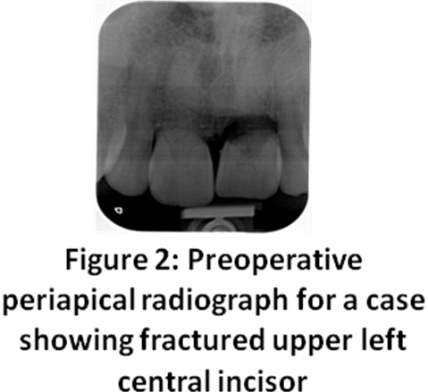

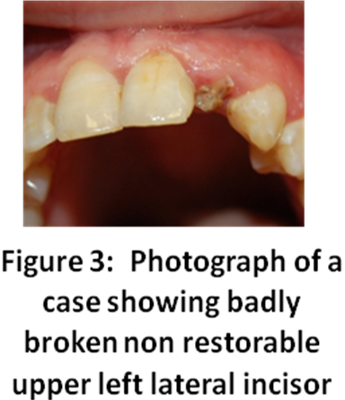

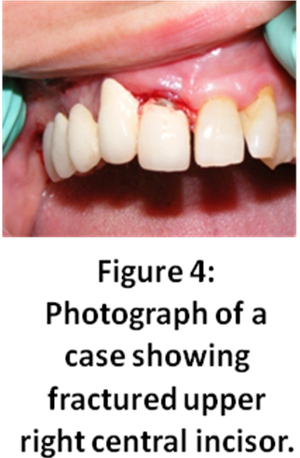

2.1.2. Implants:
A total of 12 Implant Direct's Screw Plant ™ implants (www.implantdirect.com) were used.

2.2. Methods:
2.2.1. Surgical Design:
12 Implant Direct's Screw Plant ™ implants were placed immediately after extraction of teeth in the selected patients (one implant for each patient and only one patient received three implants). Mesiodistal socket width and length were measured to help in selection of appropriate implant diameter and length with the aid of transparency guide template, provided by the implant manufactures. All implants were placed using a non-submerged technique, according to a strict surgical protocol following the manufacturer’s instructions.Immediately after the implant was placed, the Osstell ™ mentor for RFA measurements was used for direct measurement of implant stability. Then RFA measurements were recorded at one, two and four months after implants insertion and six months postoperative at time of loading of the implants. The implants were restored with ceramic crowns 6 months after insertion.
Two hours prior to surgery, 1gm Augmentin (875mg amoxicillin and 125 mg clavulanate potassium, GlaxoSmithKline S.A.E, El Salam city, Cairo, A.R.E.) was given orally to the patient as a prophylaxis against infection. The patient was anesthetized using a standard solution of 2% mepivacaine hydrochloride (The Alexandria Co. for Pharmaceuticals, Alexandria, Egypt) with 1: 20 000 levonordefrin. Infiltration or nerve block anaesthetic techniques were used. The oral cavity was rinsed with 0.2% chlorahexidine gluconate (Hexitol mouth wash, The Arab drug Co. Cairo, Egypt) for 30 seconds immediately before extraction to obtain aseptic environment.
A traumatic extraction was accomplished in order to protect and preserve the alveolar bone plates. In all cases, no bone or tooth fracture has been occurred during extraction (Figure 5).

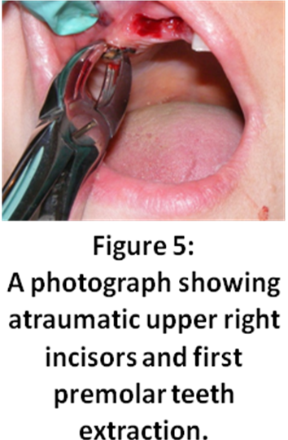

Following tooth extraction, the socket was debrided by small sized curette to remove any remnants of the periodontal tissue. Then copious irrigation of the socket with sterile solution was done. The socket was then dried and carefully inspected. The extracted root length as well as the socket depth and width was measured to estimate appropriately implant diameter and length. The implant diameter was selected according to the estimated mesiodistal and bucco-lingual dimensions of the empty socket. The implant length was selected according to the estimated root length of the extracted tooth. During selection of the implant length we took into consideration that, the implant length should be 3-4 mm longer than the root length of the extracted tooth to engage the apical 3-4 mm bone in the extraction socket whenever possible to obtain primary stability.
The extraction sockets were prepared to receive Implant Direct's Screw Plant ™ implants of 13mm length and 3.7, 4.7 and 5.7 mm diameter. All drilling procedures were completed using a high torque low-speed (800 rpm) surgical motor with an internal irrigation device using sterile saline solution. Internally irrigated stepped standard drills in different lengths and diameters were used until the desired implant diameter was reached. Then prepared sites were irrigated with normal saline to remove bone fragments. The implant was then threaded in place using the ratchet in a clockwise direction. The cover screw was screwed into the implant body to cover it. All implants were placed using a non-submerged technique. Implant Direct's Screw Plant ™ implants have 2mm extender retained by cover screw for use as a healing collar in that non-submerged technique. Therefore the healing collar was left exposed intra-orally to allow the commercially available transducer adapted to the Direct's Screw Plant ™ implants to hand-screwed into the implant as recommended by the manufacturer during RFA measurements. Augmentin 1gm orally every 12 hours to guard against infection and Oflam 50mg (Oflam lactab, Medical Union Pharm Co., Ismailia, Egypt) orally three times a day as analgesic were given to the patients for the following five days postoperative. Chlorahexidine 0.2% mouth rinse was used three times a day for the next 14 days postoperative. Removable prostheses were used for esthetic and social reasons but these prostheses were not pressing on the implant site and were out of occlusion.
Implant primary stability was first assessed clinically by finger pressure exerted on the implant-mount. If stable, the cut-off threshold ISQ value immediately after the implant placement; referring as the resonance frequency of the implant-bone complex, was measured with Osstell apparatus (Figures 6-8) using a commercially available transducer adapted to the Implant Direct's Screw Plant ™ implants.

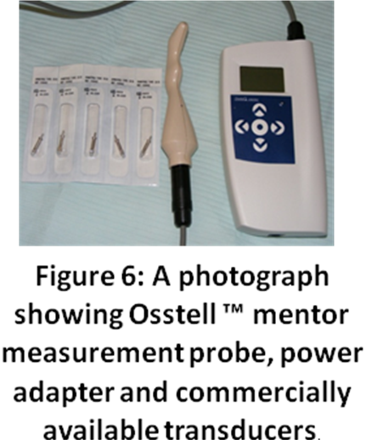

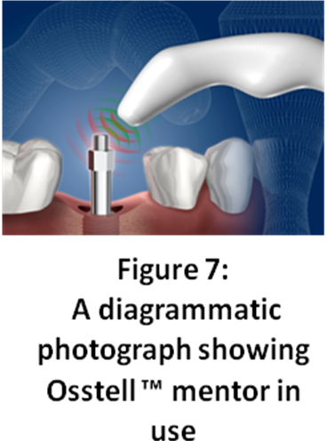
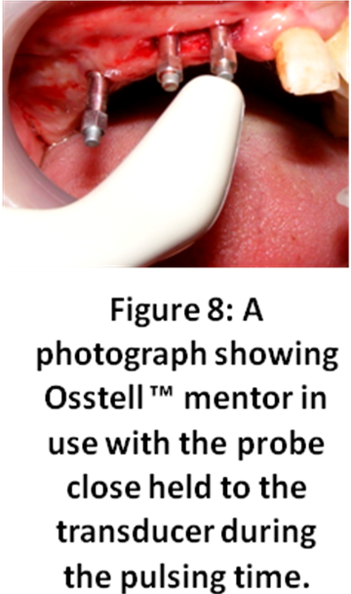

To perform the measurements, the cover screw was removed at each time interval and then the transducer was attached to the implant fixture and tightened directly onto the implant neck. Hold the probe of the Osstell ™ mentor device close to the transducer during the pulsing time (three short beeps). After that the probe can be taken away from the transducer. After the processing time the instrument beeps again (once), the small blue light turns on and the ISQ value was presented in the display. Repeat the measurement at a different rotational angle (45⁰ – 90⁰). To be able to measure both the lowest and the highest stability it is recommended to make a second measurement at a different rotational angle (45⁰ – 90⁰) degrees from the first. Readings were obtained 2 times to ensure repeatability of the instrument. Therefore, the cut-off threshold ISQ at implant placement was recorded that might be predictive of osseointegration. The cover screws were then replaced (Figures 9 and 10).

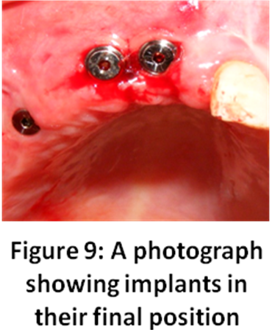
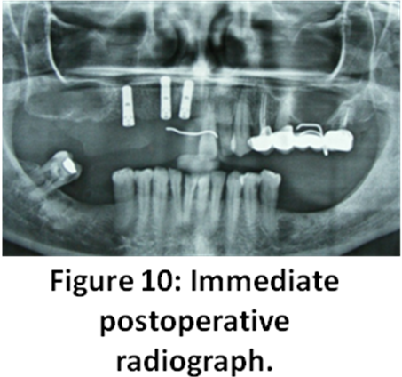
The ISQ value at each time point was further measured at 1, 2, and 4 months after implants insertion and 6 months; at time of loading of the implants. The RFA values, calculated from the peak amplitude, were represented in a quantitative unit called ISQ on a scale from 1 to 100. ISQ values were derived from the stiffness (N/μm) of the transducer/implant/ bone system and the calibration parameters of the transducer, Nedir et al.,(2004); Lachmann et al.,(2006). Classically, an increased ISQ value indicates increased stability, whereas decreased values indicate a decrease in implant stability according to previous studies by Nedir et al.,(2004); Lachmann et al.,(2006) .

2.2.2. Postoperative

Postoperative periapical digital radiographs were taken by x-ray machine (Orix 70 dental intraoral x-ray unit, Italy) at the predetermined time intervals, using long cone paralleling technique to obtain reproducible radiographs at each follow-up interval. Customized bite acrylic template was fabricated for each patient and was used in conjunction with radiographic film holder system (Rinn's XCP film holder to hold the Photo-Stimuable Phosphor plate (PSP) or sensor in a fixed relation to the area to be examined). The sensor was held parallel to the implant long axis, and the x-ray beam was directed perpendicular to the long axis of the implant. The exposure parameters were standardized for all patients (70 KVp, 8 mA, and 0.20 seconds). Bone density measurements were carried out using the specially designed Digora software (SPSS , Inc., Chicago, IL, USA) for Windows version 1.51, where 3 lines were drawn parallel and 1 mm apart from each other on both mesial and distal sides of the implant. The first line was drawn starting from the flute of the implant tangential to it till the base of the implant. The mean gray values (Pixels) of each line were collected and the means of the 3 line on each side were calculated for statistical analysis (Figure 11).

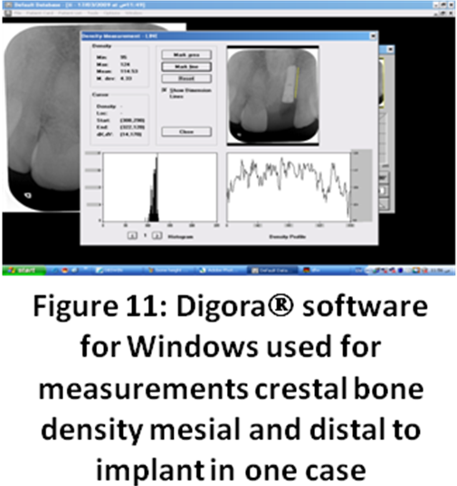

Data of the implants ISQ values over time intervals as well as bone density values of the mesial and distal sides of the implants were presented as means and standard deviation (SD) values. Paired t-test was used to study the changes by time. Pearson’s correlation coefficient was used to determine correlations between ISQ values and the implants mesial and distal bone density percentage (%). The significance level was set at P ≤ 0.05. Statistical analysis was performed with SPSS 16.0 (Statistical Package for Scientific Studies; SPSS, Inc., Chicago, IL, USA) for Windows.

3. RESULTS
Postoperative healing was uneventful in all patients. There was no inflammation, no pain or suppuration around the implants. The means and standard deviation (SD) values for bone density % in the mesial and distal sides of the implants, as well as, ISQ values recorded immediately, 1,2,4, and 6 months postoperatively were shown in (Table 1) and (Figures12 and 13).

Table (1): Descriptive table showing the means and standard deviation (SD) values for bone density % in the mesial and distal sides as well as ISQ values
Period | Mesial bone density % |  | Distal bone density % |  | ISQ
Period | Mean | SD | Mean | SD | Mean | SD
Immediate | 87.8 | 0.5 | 87.9 | 0.6 | 52.2 | 5.2
1 month | 88.5 | 0.5 | 88.6 | 0.4 | 58.3 | 7.3
2 months | 88.9 | 0.5 | 89.1 | 0.5 | 66.3 | 5.8
4 months | 90.7 | 0.6 | 91 | 0.6 | 75.2 | 3.7
6 months | 94.1 | 0.5 | 94.5 | 0.6 | 86.7 | 1.7

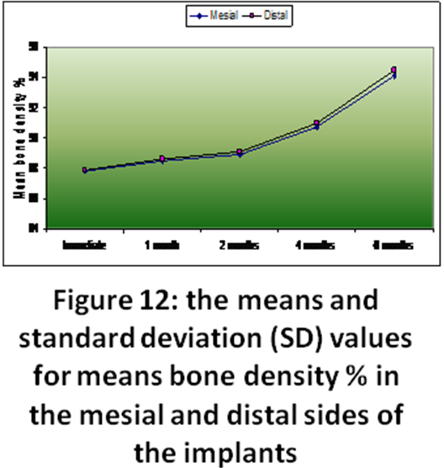

The means of the cut-off threshold ISQ at implant placement was 52.2 and SD was 5.2. The means of ISQ values at 1, 2, and 4 months after implants insertion were 58.3, 66.3, and 75.2 respectively, and at 6 months was 86.7, as shown in (Table 1).

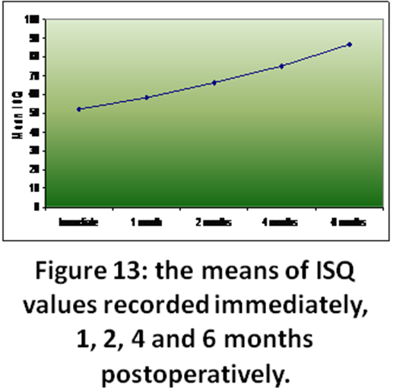
The mean differences, standard deviation (SD) values and results of paired t-test for the comparison between mean ISQ values at different periods were shown in (Table 2). There was a statistically significant increase in mean ISQ values through all periods (P<0.001). The mean differences in the ISQ values in (immediate −1month) was -6.2, (immediate − 2months) was -14.1, (immediate − 4months) was -23, and the mean differences between the final ISQ and that of implant placement (immediate − 6 months) was -34.5. The lowest ISQ obtained at implant placement that might be predictive of osseointegration was 49.

Table (2): The mean differences, standard deviation (SD) values and results of paired t-test for the comparison between mean ISQ values at different periods

Period | Mean difference | SD | P-value
Immediate – 1 month | -6.2 | 3.6 | <0.001*
Immediate – 2 months | -14.1 | 3.9 | <0.001*
Immediate – 4 months | -23 | 3.3 | <0.001*
Immediate – 6 months | -34.5 | 4.4 | <0.001*
1 month – 2 months | -7.9 | 2.7 | <0.001*
1 month – 4 months | -16.8 | 4.3 | <0.001*
1 month – 6 months | -28.3 | 6.2 | <0.001*
2 months – 4 months | -8.9 | 2.6 | <0.001*
2 months – 6 months | -20.4 | 4.8 | <0.001*
4 months – 6 months | -11.5 | 2.8 | <0.001*
*: Significant at P ≤ 0.05

Mesial and distal bone density % in all implants at each time point was calculated as a percentage from the mean density of the native bone. The density in general increased gradually with time stating from 87.8% and 87.9% on the mesial and distal sides respectively immediately at implant insertion, till reaching 94.1% and 94.5% on the mesial and distal sides respectively after 6 months of implant insertion (Table 1 and Figure 5). The mean differences, standard deviation (SD) values and results of paired t-test for the comparison between mean mesial bone density % to the mean density of the native bone at different periods were shown in (Table 3).

Table (3): The mean differences, standard deviation (SD) values and results of paired t-test for the comparison between mean mesial bone density % at different periods
Period | Mean difference | SD | P-value
Immediate –  1month | -0.6 | 0.3 | <0.001*
Immediate –  2 months | -1.1 | 0.3 | <0.001*
Immediate –  4 months | -2.9 | 0.4 | <0.001*
Immediate –  6 months | -6.3 | 0.5 | <0.001*
1 month –  2 months | -0.5 | 0.1 | <0.001*
1 month –  4 months | -2.3 | 0.3 | <0.001*
1 month –  6 months | -5.7 | 0.4 | <0.001*
2 months –  4 months | -1.8 | 0.2 | <0.001*
2 months –  6 months | -5.2 | 0.4 | <0.001*
4 months –  6 months | -3.4 | 0.4 | <0.001*
*: Significant at P ≤ 0.05

There was a statistically significant increase in mean mesial bone density % through all periods. Moreover, the mean differences, standard deviation (SD) values and results of paired t-test for the comparison between mean distal bone density % to the mean density of the native bone at different periods were shown in (Table 4). There was a statistically significant increase in mean mesial bone density % through all periods.
The correlation between ISQ values and mesial and distal bone density % was done. The results of Pearson’s correlation coefficient for the correlation between ISQ values and mesial and distal bone density % were shown in (Table 5). There was a positive correlation between ISQ, mesial and distal bone density %. However, this correlation was not statistically significant through all periods.

Table (4): The mean differences, standard deviation (SD) values and results of paired t-test for the comparison between mean distal bone density % at different periods

Period | Mean difference | SD | P-value
Immediate – 1 month | -0.7 | 0.4 | <0.001*
Immediate –2 months | -1.2 | 0.4 | <0.001*
Immediate – 4 months | -3.1 | 0.5 | <0.001*
Immediate –6 months | -6.6 | 0.5 | <0.001*
1 month –2 months | -0.5 | 0.2 | <0.001*
1 month – 4 months | -2.4 | 0.3 | <0.001*
1 month – 6 months | -5.9 | 0.3 | <0.001*
2 months – 4 months | -1.9 | 0.2 | <0.001*
2 months – 6 months | -5.4 | 0.3 | <0.001*
4 months – 6 months | -3.5 | 0.4 | <0.001*
*: Significant at P ≤ 0.05
Table (5): Results of Pearson’s correlation coefficient for the correlation between ISQ values and mesial and distal bone density %

Period | Mesial bone density % |  | Distal bone  density %
Period | Correlation coefficient (r) | P-value | Correlation coefficient (r) | P-value
Immediate | 0.275 | 0.386 | 0.250 | 0.434
1 month | 0.007 | 0.984 | 0.052 | 0.872
2 months | 0.263 | 0.408 | 0.239 | 0.454
4 months | 0.107 | 0.740 | 0.081 | 0.802
6 months | 0.242 | 0.48 | 0.145 | 0.652

4. DISCUSSION
The overall objective of this study was to quantify the early stability patterns of immediate implants. The Osstell device, which is essentially identical to the RFA developed by Meredith (1998) was able in the current study to measure the overall stiffness of the transducer/ implant/tissue system. The current study was in accordance with Friberg et al.,(1999a); and Friberg et al.,(1999b),who found that the Osstell device served as a sensitive tool for clinically monitoring implant stability during healing phase and up to 6 months postoperative. In RFA, the stiffness of the bone/implant interface was calculated from a resonance frequency as a reaction to oscillations exerted onto the implant/bone system. The implant was excited with an oscillating transducer screwed onto the implant and the resonance specific to the resonance system ‘implant/ bone’ captured electronically over a range of five to 15 kHz. The implant’s own oscillation under a given transducer frequency was mainly dependent on the character of the implant’s bony fixation. The unit of measurement in this approach was the ISQ that was calculated from the resonance frequency and ranged with increasing stiffness of the interface from 0 to 100 units, Sunden et al.,(1998); Meredith et al.,(1998).
Meredith et al.,(1997b); Bischof,et al.,(2004) found that determination of a primary stability threshold, provided in terms of a defined threshold ISQ value, might be relevant to predict the osseointegration prognosis of a given implant. Friberg et al.,(1999b) found that ISQ may vary between 40 and 80 and that the higher the ISQ, the higher the implant stability. A substantial increase or decrease in implant stability could be detected. In agreement with Friberg et al.,(1999b), the mean ISQ in the current study ranged from 52.2 (at time of implant insertion) to 86.7 (at the sixth postoperative month) and the lowest ISQ obtained at implant placement that might be predictive of osseointegration was 49. Moreover, there was a statistically significant increase in mean ISQ values through time intervals (P<0.001).
Olive and Aparicio(1990); Saadoun and LeGal (1992) reported that implants placed in softer bone failed more often than implants placed in denser bone. Moreover, Friberg et al.,(1999b) also reported that implants located in the posterior maxilla failed more often than implants placed in the anterior mandible. In contradiction to these reports, all implants in the current study that placed in the maxillary premolars area showed high success rate with increased ISQ values with increased implant- mesial and distal bone density percentage.
The implicit assumption is that implants undergoing osseointegration are supposed to increase their stability with time or at least maintain it. The effect of time in the current study on implant stability and osseointegration comes in agreement with Meredith et al.,(1997c); Meredith(1998); Friberg et al (1999 b); Friberg et al.,(1999a); they found that the stability of the implant was affected by healing time and the stiffness of the tissue adjacent to and surrounding the implant. Our findings showed that the time factor on ISQ value was significant (P ≤ 0.05). From baseline to 6 months postoperative, the stability patterns were noticeably different, especially at the fourth month (mean ISQ difference = -23; SD=3.3; P <0.001) and at the sixth month (mean ISQ difference = -34.5; SD= 4.4; P <0.001).
Barewal, et al.,(2003) reported that the dynamic nature of bone during healing resulted in a change around the implant over time. Stability was required in this healing period and later during function to allow regeneration of bone to occur around the implant, rather than fibrous repair. In addition,Cochran et al.,(1998) found that primary stability occurred at the time of implant placement might be largely the result of the slightly larger diameter of the implant against the cut native bone surface, referred to as primary bone contact. Moreover, they found that secondary stability was the result of bony modelling. During this healing process, woven bone became lamellar bone, and secondary bone contact increased while primary bone contact decreased. In agreement with the findings of Cochran et al.,(1998) the current study examined the transition in levels of stability from the time of primary bone contact to the development of early secondary bone contact during the first two months of healing. The mean second month ISQ values (66.3) was higher than the mean baseline values (52.2). The mean ± SD mesial and distal bone density % at the second month postoperatively (88.9±0.5 for mesial side and 89.1±0.5) was higher than the mean baseline values.
No defined cut-off ISQ value has been validated until now through documented studies to determine the threshold value that discriminates between a mobile and a stable implant. Nedir et al.,(2004) designed a study to evaluate the Osstell as a diagnostic tool capable of differentiating between stable and mobile ITI implants and to evaluate a cut-off threshold implant ISQ value obtained at implant placement that might be predictive of osseointegration. They concluded that implants with an immediate ISQ ≥ 49 should reliably osseointegrated when they are left to heal for 3 months in the mandible and in the maxilla. These implants should require only minimal routine follow-up. On the other hand, less stable implants with an ISQ < 49 might still osseointegrated. Implants with an ISQ ≥ 70 seemed not to require scrutiny when implant stability decreases but then remained stable. Implants with an ISQ in the 60–65 range might remain stable or slightly decrease. Stability of the implants that have an ISQ > 60 should increase. A decrease of the ISQ value after 6 weeks of healing should warn the practitioner to put these implants under tighter scrutiny and decide on the relevance of unloading until regaining stability. In agreement with this findings ,the current study found that RFA as a diagnostic tool was reliable in identifying implant stability and predicting a successful osseointegration for implants with mean ISQ ≥ 52.2. In addition, we found that the highest ISQ obtained at implant placement that might be predictive of osseointegration was 54 and the lowest ISQ was 49. All implants in our study showed a statistically significant increase in mean ISQ values through all periods. Moreover, there was a statistical significant increase in mean mesial and distal bone density % to the mean density of the native bone through all periods. Failure of osseointegration was not recorded spite of the lowest recorded ISQ value was 49.
Szmukler-Moncler et al.,(2000) found that implants showing high primary stability with increased ISQ values over time and an earlier loading protocol may be indicated. However, it is difficult to advocate possible earlier loading protocols when stability levels and ISQ values were fluctuating in the first two months of healing. In agreement with these finding, only two implants in the current study showed a relative decrease in ISQ values at the fourth month and this decrease might be related to the minimal marginal bone loss that observed on radiographs. Possible earlier loading was advocated for these two implants until ISQ value increased at the sixth month postoperative.
In the present study, there was a positive correlation with time between mean ISQ values and mean mesial and distal bone density % indicating that the higher ISQ value with time was a result of the increased crestal bone density % to the mean density of the native bone. Our finding was in agreement with Cornelinil et al.,(2000) and Harmely et al., (2001) who found that increased bone density around dental implants gradually with time resulting in more osseointegration and increased ISQ values.
In summary, this study permitted an evaluation of the stability of the immediate implant using RFA during healing. The monthly visits allowed for regular and proper observation of the changes in bone density on periapical digital radiograph following implant placement and up to the sixth postoperative month.
In conclusion, RFA with the Osstell monitor has been claimed to be useful for monitoring implant osseointegration during the healing phase. The RFA method, as a diagnostic tool, was reliable in identifying implant stability, predicting and monitoring osseointegration with time for immediate implants with an ISQ ≥ 49 recorded immediately after implant insertion. The ISQ values increased gradually with time in correlation with the increased bone density around implant.

5. References

- Albrektsson TO, Johansson CB, Sennerby L. Biological aspects of implant dentistry: Osseointegration. Periodontology; 2:58–73, 2000.

- Bschof, M., Nedir, R., Szmukler-Moncler, S., Bernard, J., and Samson, J.: Implant stability measurement of delayed and immediately loaded implants during healing. A clinical RFA study with SLA ITI implants (Part II). Clinical Oral Implants Research, 4 :168, 2004.

- Balleri, P., Cozzolino, A., Ghelli, L., Momicchioli, G. and Varriale, A.: Stability measurements of Osseo integrated implants using Osstell in partially edentulous jaws after1 year of loading; a pilot study. Clinical Imp Dent and Related Research, 4: 128, 2002.

- Barewal, RM, Oates,TW Meredith, N, Cochran, DL,: Resonance Frequency Measurement of Implant Stability In Vivo on Implants with a Sandblasted and Acid-Etched Surface. Int J Oral Maxillofac implants; 18:641–651, 2003.

- Cochran DL, Schenk R, Lussi A, Higginbottom FL, Buser D. Bone response to unloaded and loaded titanium implants with a sandblasted and acid-etched surface: A histometric study in the canine mandible. J Biomed Mater Res; 40: 1–11, 1998.

- Cochran DL, Buser D, Bruggenkate C: The use of reduced healing times on ITI implants with a sandblasted and acid-etched (SLA) surface: Early results from clinical trials on ITI SLA implants. Clin Oral Implants Res; 13:144–153, 2002.

- Cornelini R, Scarano A, and Piatteli A: immediate one-stage post extraction implant. Int J Oral Maxillofac Implants. 15; 432, 2000.

- Dario L, Cucchiaro P and Deluzio A: Electronic Monitoring of Dental Implant Osseointegration J Am Dent Assoc, 133(4): 483-490, 2002
- Ekfeldt A, Carlsson GE, Borjesson G: clinical evaluation of single-tooth restorations supported by osseointegrated implants: a retrospective study. Int J Oral Maxillofac Implants; 9:179-183, 1994

- Fonseca R: Oral and Maxillofacial Surgery Principles for the Surgical Placement of Endosseous Implants W.B. Saunders Company. Philadelphia: 105-114, 2000.

- Friberg, B., Sennerhy, L., Linden, B., Grondahl, K. and Lekholm, U.: Stability measurements of one-stage Branemark implants during healing in mandibles. A clinical resonance frequency analysis study. International J of Oral a) Maxillofacial Surgery 28: 266, 1993.

- Friberg, B., Sennerby, L., Meredith, N. & Lekholm, U. A comparison between cutting torque and resonance frequency measurements of maxillary implants. A 2o-month clinical study. I J Oral Maxillofac Surg 28: 297, 1999 b.

- Friberg B, Sennerby L, Meredith N, Lekholm U. A comparison between cutting torque and resonance frequency measurements of maxillary implants. A 20-month clinical study. Int J Oral Maxillofac Implants; 28:297–303,1999a.

- Glauser, R., Sennerby, L., Meredith, N., Ree, A., Lundgren, A., Gottlow, J., Hammerle, C.F.: Resonance frequency analysis of implants subjected to immediate or early functional occlusal loading. Clinical Oral Implants Research 15, 428, 2004.

- Hammerly C, and Lang N: Single stage surgery combining transmucosal implant placement with GBR and bio-resorbable materials. Clin Oral Impl Res; 12:9,2001

- Huang HM, Lee SY, Yeh CY and Lin CT: Resonance Frequency Assessment of Dental Implant Stability with Various Bone Qualities: A Numerical Approach Clin Oral Implants Res, 13(1): 65-74, 2002

- Huang HM, Chiu CL, Yeh CY, Lin CT, Lin LH and Lee SY: Early Detection of Implant Healing Process Using Resonance Frequency Analysis Clin Oral Implants Res, 14(4): 437-443, 2003

- Huang, H.M., Pan, L.C., Lee, S.Y., Chiu, C.L., Fan, K.H., Ho, K.N: Assessing the implant/bone interface by using natural frequency analysis. Oral Surgery, Oral Medicine, Oral Pathology, Oral Radiology, and Endodontics 90, 285, 2000.

- Huang, H.M., Cheng, K.Y., Chen, C.H., Lin, C.T., Lee, S.Y: Design of a stability-detecting device for dental implants. Proceedings of the Institution of Mechanical Engineering—Part H—Journal of Engineering in Medicine 219, 203, 2005.

- Jaffin, R.A. &. Berman, C.L: The excessive loss of Branemark fixtures in type IV bone: a 5-year analysis. Journal of Periodontol61: 2-4, 1991.

- Lachmann S, Jager B, Axmann D., and weber H: Resonance frequency analysis and damping capacity assessment. Part I: an in vitro study. Clin Oral Impl Res 17, 75, 2006.

- Lazzara, R., Siddiqui, A., Binon, P., Feldman, S.A., Weiner, R., Philipps, R. and Gonshor, A.: Retrospective multi-center analysis of endosseous dental implants placed over a 5 year period. Clinical Oral Implants Research 7: 73, 1996.

- Lachmann S, Jager B, Axmann D., and weber H: Resonance frequency analysis and damping capacity assessment. Part II : an in vitro study with Periotest and Osstell instruments. Clin Oral Impl Res 17, 80, 2006

- Meredith, N., Book, K., Friberg, B., Jemt, T. and Sennerby, L.: Resonance frequency measurements of implant stability in vivo. A cross-sectional and longitudinal study of resonance frequency measurements on implants in the edentulous and partially dentate maxilla. Clinical Oral Implants Research 8: 226, 1997a.

- Meredith, N., Shagaldi, P., Alleyne, D., Sennerby, L. & Cawley, P. The application of resonance frequency measurements to study the stability of titanium implants during healing in the rabbit tibia. Clinical Oral Implants Research8: 234, 1997b.

- Meredith, N.: Assessment of implant stability as a prognostic determinant. International Journal of Prosthodontics ΙΙ : 491- 501, 1998.

- Meredith N, Alleyne D, and Cawley P: Quantitative determination of the stability of the implant- tissue interface using RFA. Clin Oral Implants Res, 7:261, 1996.
- Meredith N, Book K, Friberg B, Jemt T and Sennerby L: Resonance Frequency Measurements of Implant Stability in vivo. A Cross-sectional and longitudinal Study of Resonance Frequency Measurements on Implants in the Edentulous and Partially Dentate Maxilla Clin Oral Implants Res, 8(3): 226-233, 1997 c.

- Nkenke E, Hahn M, Weinzierl K, Radespiel-Troger M, Neukam FW and Engelke K: Implant Stability and Histomorphometry: A Correlation Study in Human Cadavers Using Stepped Cylinder Implants. Clin Oral Implants Res, 14(5): 601-609, 2003

- Nedir R, Bischof M., Szmulker S, and Samson J,: Predicting ossiointegration by means of implant primary stability. A RFA study. Clin Oral Impl Res 15, 520, 2004

- Olive´, J., Aparicio, C.: Periotest method as a measure of osseointegrated oral implant stability. Int J Oral Maxillofac Implants ; 5: 390–400, 1990.

- Saadoun, A.P., LeGall, M.L: Clinical results and guidelines on Steri-Oss endosseous implants. International J of Periodontics &Restorative Dentistry 12: 487–499, 1992

- Sennerby L and Meredith N: Resonance Frequency Analysis: Measuring Implant Stability and Osseointegration Compend Contin Educ Dent, 19(5): 493-498, 1998

- Sullivan D, Sherwood R, Collins T and Krogh P: The Reverse-Torque Test: A Clinical Report Int J Oral Maxillofac Implants, 11(2): 179-185, 1996

- Sunden S, Grandahl k, Grandahl HG: Accuracy and precision in the radiographic diagnosis of clinical instability in Branemark dental implant. Clin Oral Implants Res, 6:220, 1995.

- Szmukler-Moncler S, Piattelli A, Favero GA, Dubruille JH. Considerations preliminary to the application of early and immediate loading protocols in dental implantology. Clin Oral Implants Res;11:12–25, 2000.

- Young M, Quayle A, Sloan P and Carter D: A Survey of Clinical Members of the Association of Dental Implantology in the United Kingdom. Part III. The Use of Augmentation Techniques in Dental Implant Surgery Implant Dent, 10(4): -298, 2001

7/12/2011

