Technology of earthquake resistant solar systems used in solar earthquake parks

Akbar Toloeeyan
Department of civil engineering, Tabriz University, Tabriz, Iran
a.toloeeyan@gmail.com
Akbar Toloian
Member of Iranian Solar Energy Society & The Responsible Expert of Technical Council of East Azarbaijan Province.
akbar_toloian@yahoo.com

Abstract: Earthquake is among the natural destructive catastrophes whose incidence imposes serious social and economical damages to human societies. The only way to save people is to pay attention to safety issues, providing the required facilities and equipments prior to earthquake occurrence. The first step is hence smoothing the way for establishing and equipping parks and places supplying the essential needs of people wherein the natural, permanent, and reusable energy is used for the purpose of providing light, air conditioning, cooking, and telecommunication requirements. Regarding such an approach, carrying out the project of solar park for earthquake in all regions of Iran with high probability of earthquake occurrence is of critical importance. The next step will be to use the technology of anti-earthquake solar systems in these parks, which paves the way for reaching the first objective. In order to supply the required energy for light, air conditioning, and also for preparing hot water for bath and washing in these earthquake solar parks, it is needed to install photovoltaic (PV) panels with essential equipments on floor or under the ceiling of the buildings which have been recognized to be resistant against earthquake in critical times. Accordingly, making use of the technology of solar systems and designing and making the buildings with maximum use from solar energy are of great significance.
[Akbar Toloeeyan. Akbar Toloeeyan. Akbar Toloian. Akbar Toloian Journal of American Science 2011;7(8):277-284]. (ISSN: 1545-1003). http://www.americanscience.org.

Keywords: Solar Park; Reproducible energies; Earthquake; Natural catastrophes; solar systems; Photovoltaic

1. Introduction
According to equilibrium theory, after earthquake occurrence in a country, the critical condition is initiated due to the generated imbalance in the society. Why do we always observe the loss of thousands of our compatriots and then managing these conditions and eventually be proud by presenting the statistics relating to rescuing some people, burying the died ones, and reconstruction of damaged regions? So, the real crisis management should be started now [1].
The anti-earthquake solar systems technology should be used in earthquake solar parks, cities, locations susceptible to earthquake, rural regions, large parks, and open sport places. Inspiring from the technology of mentioned systems, it is possible to make anti-earthquake solar packages from steel. Since the electricity is off by earthquake occurrence and makes trouble for agitated people, it is crucial to consider the batteries saving the solar or reusable energy in these packages for light use in environment, charging of the cell phones, communication and telecommunication systems, radio and television, and chillers in garners and places wherein drugs and vaccines are kept [2]. Concerning the mentioned information, geographical location of our country, the possibility of using solar energy in all seasons, and high occurrence probability of earthquake in most of Iran's cities and rural regions, making use of such packages is of considerable importance.

2. General characteristics of the scheme
Making use of the anti-earthquake solar systems technology in earthquake solar parks is a scheme which was suggested in 2008 by me (constant member of Iranian solar energy society) for the first time in Iran, which was then patented in the bureau for discovery patent and the main bureau for company registration and industrial ownership, after confirmation of respective organizations. It is noteworthy that by applying this scheme, mass production of anti-earthquake solar packages in all earthquake-susceptible regions of Iran will be possible and it can save people up to several days by the installed equipments in the case of earthquake. Technical characteristics of this anti-earthquake solar package keep it approximately 80% intact even if the buildings are collapsed through the earthquake. Also, it should be mentioned about the recyclability and effective life of this packages that, the average operational life of these solar modules is 25 years and many of components and raw materials of these modules are reusable and recyclable. As was mentioned above, the portion of energy release reaching the earth, which is caused by sun's mass decrease, is 35,000 times the energy consumption of earth habitants and there would be no need to consume any fuel if we can absorb one unit of these 35,000 units of energy. Thus, in order to supply the required energy for light, air conditioning, and also for preparing hot water for bath and washing in these earthquake solar parks, it is required to install these earthquake-resistant solar packages with essential equipments on floor or in buildings which have been recognized to be resistant against earthquake in critical times. In general, the advantages of the scheme of "using anti-earthquake solar systems in earthquake solar parks", which has gained the approval of respective organizations (including the Iranian national center of strengthening, the bureau for discovery patent and the main bureau for company registration and industrial ownership, ministry of industry and mine, and a faculty member of an Iranian university) are as following:
- preventing the sudden collapse of the buildings and providing the time needed for escape
- optimal use of energy resources
- saving the transportation costs
- saving people's lives and health
- making mental security for habitants of the earthquake-susceptible region
- low cost of production process
- transportation possibility in least time
- being resistant against the earthquake
- offering the possibility to be used in cities and earthquake-susceptible regions, rural regions, large parks and open sport places, and the buildings which have been recognized as resistant against earthquake and in critical times
- possibility of mobile installation and being used in critical conditions
- Higher safety and no preventing factor regarding air and environmental pollution is one of the characteristics of these systems. For instance, it is possible to cook the required food for 20 persons in one hour by each of solar ovens without the danger of firing or environmental problems.
- possibility of centralized control of the complex
- ease of installation, control, and operation
- no need to daily, weekly, and monthly services
- frugality in required space up to 70 percent
Meanwhile, the target places for this scheme are as following:
- cities and earthquake-susceptible regions
- rural regions
- large parks and open sport places
- the buildings which have been recognized as resistant against earthquake and in critical times
Damages due to earthquake are specific and experienced ones which have been witnessed in past in Iran and throughout the world. Building relatively high buildings exactly on fault line and also the expansion of towns in earthquake-susceptible cities indicates a programmed progress of such towns and the hypothesis is rejected that this expansion is carried out by people neglecting the rules of urban development. So, the responsible person is the one who permits building in these regions [3]. Fortunately, man in present world has come to the conclusion that, it is essential to transform reusable energies to other usable energy types via the technology of solar systems, which belongs to present era. Regarding this, a suitable method for using reusable resources is the application of photovoltaic systems. These systems are based upon direct transformation of solar energy into electrical energy, which will be discussed later.

Table 1- Properties of PU-5KW/48 and PU- 15KW/48 system
Number | Description | Characteristics | Number in PU- 5KW/48 system | Number in PU-15KW/48 system
1 | Solar electricity panel | 45 W, 2.76 A | 112 | 352
2 | Controller charger | 48 W, 30 A | 7 | 7
3 | Battery | 600 Ah | 120 | 400
4 | Holder system | Metallic/installed on floor | 7 | 22
5 | Inverter | 48.220 KW, A | 1 | 2
6 | Wiring of the system | ------------------ | ------------- | -----------------
7 | Electronic equipments and control panels | ------------------- | ------------- | ----------------

Table 2- capability of photovoltaic systems in some regions of Iran
Region | Sun's emission KWh/m²/day | Regions | Application
1 | 5.2 – 5.4 | South parts of Iran and some parts of the central regions (Kerman and Fars) | ------------------------------
2 | 4.8 – 5.2 | Central regions and coastal parts near Persian Gulf and Oman Sea (Tehran, Semnan, Isfahan, Khorasan, Yazd, Sistan and Baluchestan, Bandar Abbas) | Hot water generation systems, heat and cold generation systems, systems for desiccating agricultural products, production of distilled water, freshwater Cannes, and solar powerhouses
3 | 3.8 – 4.5 | Mountainous regions (East and West Azarbaijan) | Solar heat system (in summer, water produced with low temperature)
4 | 2.8 – 3.8 | Coastal regions of the Caspian Sea (Gilan and Mazandaran) | Solar heat system

3. Development steps of photovoltaic systems
Photovoltaic systems are energizer systems which generate electricity from solar light without making use of moving mechanisms or chemical ones. In other words, these systems produce clean and reliable energy without consuming fossil fuels. Research relating to photovoltaic technology has been initiated from a hundred years ago. In 1873, the British scientist Willogbi Smith found out that selenium is sensitive to light. He resulted from his experiments that Selenium's ability in conducting the electricity has a direct relationship with the light emitted to it. In 1880, Charles Fritz accomplished in manufacturing the first electrical solar cell. This product could generate electricity without consuming raw materials and created no heat or noise. The research was however inert until 1905, when Albert Einstein presented his theory on photovoltaic effect. His theory caused a revolution in electricity generation; nevertheless little progress was made in the field due to high costs and low efficiency in production. In the early 1950s, during their studies on systems of remote communication and discovery of novel sources of energy, researchers at Bell laboratories found out the sensitivity of Silicon, the second abundant element on earth, to sun's light. They realized that when this element is used with a specific level of impurity, it will generate energy with considerable voltage. These researches led to production of the first silicon solar cell in 1954 with 60% of efficiency. Afterward, this technology was first utilized in rural telecommunication station in Georgia State. In early 1960s, the scientist in NASA installed a system of 108 solar cells on Vanguard satellite in order to generate abundant, light, reliable, and suitable energy out of earth's atmosphere. Till then, photovoltaic systems have been applied on most satellites and aerospaces. Nowadays, more than 200,000 houses in America use such a technology and these systems are utilized worldwide in a wide range. This method of energy generation is used in different kinds of communication, irrigation, filtering water, providing light, space and sea navigation, etc [4].
The process of electricity generation in photovoltaic system is simpler and less harmful to environment, compared to other common energy resources. In this process, the light particles which are called photons penetrate the cells and generate electrical current via release of electrons from silicon atoms. Electricity is generated until the light is emitted into the cell. These cells do not consume electrons like the batteries, since they are transformers which transform solar energy into electricity. It should be mentioned that electricity generation by modules is completely without danger [5].

4. Durability of photovoltaic components
Operational life of solar modules was considered in previous years to be 10 years on average, but it has reached 25 years due to technical advances. Meanwhile, many of the components and raw materials of these modules are reusable and recyclable. For instance, the glasses, plastic boxes, and metallic hanks are reusable; however some parts such as semiconductors cannot be recycled [6].

5. Components of photovoltaic systems
a) Photovoltaic cells
These cells are thin squares, discs, or semiconductor films which generate sufficient voltage and current when they are under the emission of sun's light.
b) Module and panel
Module is a set of photovoltaic cells which are placed layer by layer in a glass container. A set of several modules is called a panel.
c) Array and charger controller
Several panels connected to each other through wiring with specific voltage are called an array. Charger controllers are equipments which regulate and control the voltage of batteries and prevent from probable damages to batteries.
d) Battery storage (battery bank)
It is a device which stores the produced DC electrical energy in itself.
e) Transformer
It is a device which transforms DC current to AC current for use.
f) DC loads
These are tools, motors, and equipments which use DC current.
g) AC loads
These are tools, motors, and equipments which use AC current.

6. Types of photovoltaic systems
Photovoltaic systems have different types. The simplest form of them provides the required energy of watches and calculators. More complex systems provide the needed electricity of houses, factories, and other places by connecting to consumption network. Generally, these systems are utilized in different forms. For example, some home systems are equipped with energy storage batteries for use in night. Some systems use DC equipments and there is no need to transformers. Some other systems make use of transformers and use both AC and DC currents. Different types of photovoltaic transformers are mentioned in following.
Solar lamps and photovoltaic chargers used in radio batteries are of this kind and have a good market. In this system, all parts are integrated and rechargeable batteries are utilized instead of normal batteries.
The simplest and cheapest photovoltaic systems are designed for daily use. An example of these systems is illustrated in Fig. 2. These systems usually include modules which have no storage components and generate electricity by direct sun emission. Instances of this type are some fans, blowers, propellers for heat energy distribution in water heating systems, and the devices which use solar energy, like calculators and watches.
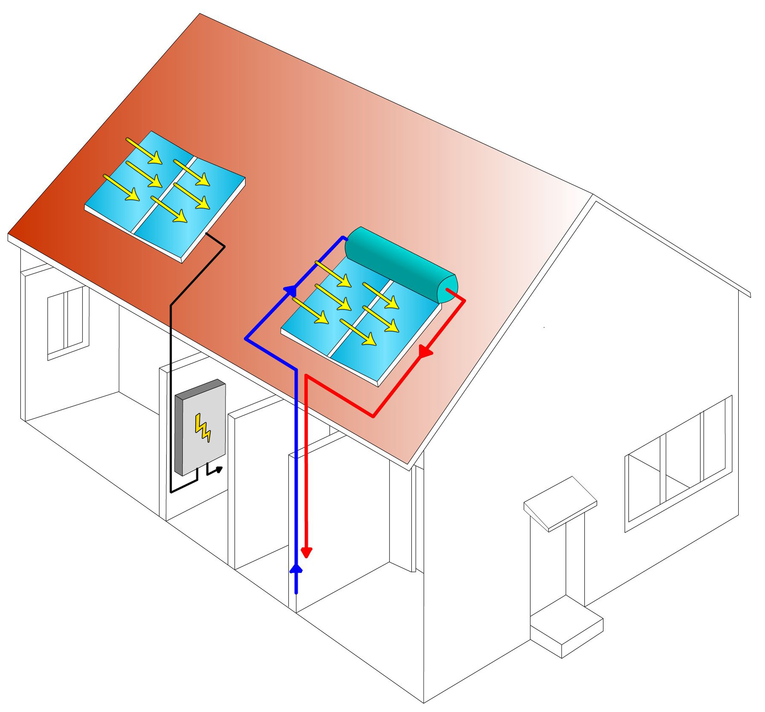

Fig 1- Thermal and electrical systems in the solar house
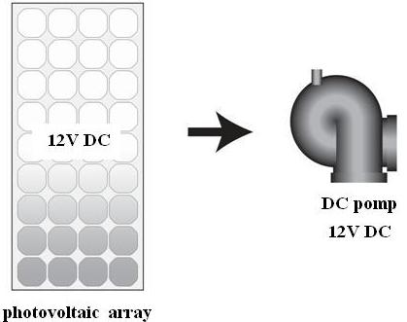

Fig 2- Daily-use systems

In order to use photovoltaic systems in night or cloudy air, the systems with storage batteries are used. Fig. 3 shows an example of such a system. These systems may include small devices, such as flashlight with one battery, and large machinery with numerous industrial batteries. The significant point about rechargeable batteries is that they should be charged after being completely discharged for more durability. Size and shape of battery source should be designed consistent with operation o system's voltage, amount of use in night, and weather condition, etc. In some types of these systems, a charge controller has also been designed which prevents the batteries from being over-charged or being abnormally discharged when the module is disconnected from battery source. This is effective in quality maintenance and durability of the battery.
Photovoltaic modules generate DC electrical energy by sun's emission; however most electrical devices need AC energy. Therefore, the photovoltaic systems must have a transformer for converting DC energy to AC. These transformers increase the flexibility of the system and offer facilities, but they results in cost increase.
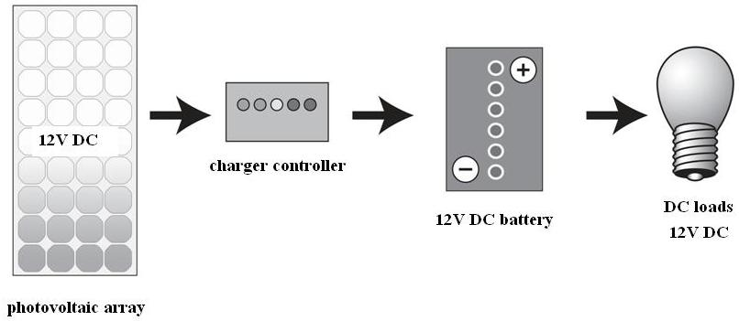

Fig 3- DC system with storage battery
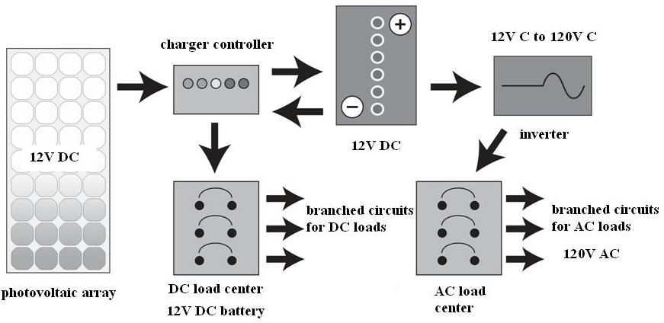
Fig 4- A system with DC and AC loads
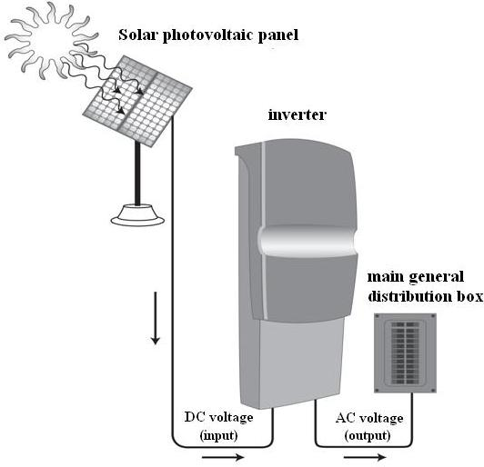
Fig 5- Systems connected to urban electricity network
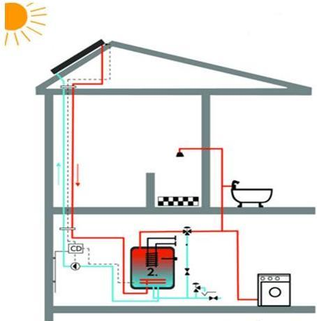
Fig 6- The system providing hot water for consumption in the solar package

These systems require no storage battery since the electricity network stores the energy itself. The system owner sells the excess generated energy to urban network and receives from this network in case of need. Subsequently, the conditions should be prepared such that energy exchange between the owner and urban network is possible. For this reason, some companies of urban electricity network give counters to their customers which determine the amount of electricity exchange [6].
Most people do not gain all of their required electrical energy only from photovoltaic system and they use some other types of energy. In hybrid systems, a diesel or gas motor generates energy which can be effective in reducing the initial costs. Preparations should be made in photovoltaic systems for unsuitable weather conditions. For this purpose, the batteries used should be large enough and be capable of providing the essential energy when needed. An advantage of hybrid systems is that they have at least two independent charging systems. As an example of these systems, the photovoltaic modules with wind turbines have mentioned property and possess the third battery charging resource, other than the advantages of photovoltaic and generating systems.

7. Solar system of water heater
Solar water heater with polymer collector has high efficiency, can be easily installed by low investment cost, and can provide up to 330 days hot water for consumption. In general, the required hot water can be obtained by receiving the sun's heat by flat solar collectors. In a solar water heater, water is heated in a flat thin black vessel. The heated water circulates in spiral pipes by a thermosiphon. These pipes are located spirally in the tank where water heats there; so thermal exchange takes place.
The solar water heater is utilized for heating the water which circulates through its pipes. In direct heating system, water is heated during its pass through flat and glass plates (solar collectors) which are located on the ramp roof toward south by slope angle of 15 to 50 degrees, whose position is less than 45 degrees toward southeast or southwest. The heated water is then stored in a tank above the collector. In most solar water heaters, there is also an auxiliary heating system which increases the water temperature in days that solar energy is not enough for providing heat to obtain hot water. Natural gas, liquid gas, or solid fuel is used in the source of the auxiliary system. Common solar water heaters in world market are closed-cycle system (main pressure), thermosiphon system with separate tank (low constant pressure), and compulsory circulating system (pumping by the main pressure) [7].
The solar water heater system appended to the solar package includes a set of two-layer source, collector, and the connecting pipes. In some types, a pump and a simple thermostat is utilized. Solar emissions are absorbed via the collector and transfer heat to the liquid in connecting pipe, which is then stored there in a source. The collector is usually installed on the mentioned package with a suitable angle and the optimum value of collector's deviation angle for heating is the geographical latitude plus 15 degrees toward south. Furthermore, computer predictions about collectors show that each 10m2 collectors can yearly collect 10,000 kW to 12,000 kW of energy, which is beyond the total heat needed for mentioned packages.
Auxiliary heater (electrical or gas); storage tank; hot water to house; input cold water; hot water from collector to tank; transparent cover; depletion tap; framework; collector; absorbing plate.
The tank isolated from top; auxiliary heater; hot water to house; input cold water; collectors placed in the ceiling.
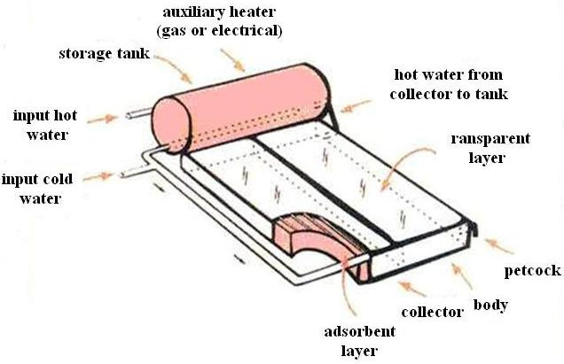
Fig 7- Closed-cycle thermo siphon system
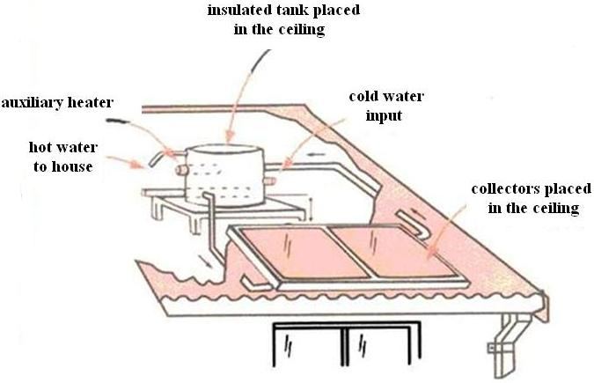
Fig 8- Thermo siphon system with separate tank

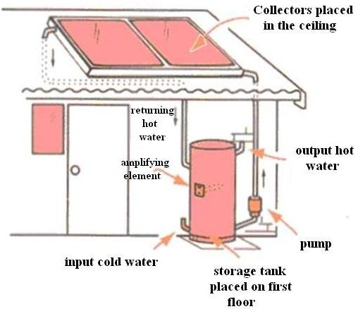
Fig 9- Compulsory circulating system

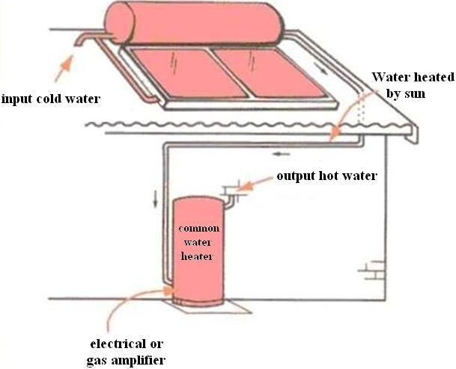
Fig 10- Pre-heater with a closed-cycle solar system

8. Vision of using photovoltaic systems
Common fuel resources which are non-reproducible have caused numerous environmental problems such as increase in earth temperature, acidic rains, water pollution, rapid increase of garbage, corruption of environment, and waste of natural resources. The photovoltaic systems however cause none of these negative environmental problems. The raw material for making the photovoltaic modules is silicon, which is abundantly available. During its lifetime, silicon cells obtained from one ton of sand can generate electricity equal to burning 500,000 tons of coal. Also, photovoltaic technology can create many jobs. Some of these occupations are directly related to manufacturing these systems, while numerous other jobs are indirectly related to it, e.g. in making glass, metal, wiring, electric activities, building accessory equipments, and architecture [6].
In a general evaluation, each 100 million dollars selling of photovoltaic products creates 3800 occupations. It is predicted that until 2010 use of solar energy doubles and till 2030 the market of its products reaches 100 billion dollars. What guaranties the development of this system in future is its being clean, reproducibility, and reliability. Moreover, the advantages of novel and reproducible energies are of great importance and some of these advantages are mentioned in following.
a) Compatibility with environment
The first and most obvious characteristic of these energy resources is that these types of energies are compatible with the environment. The heat energy caused by fossil fuels and nuclear energy make its specific environmental problems. It should be noted that the viewpoint of societies toward the energy resources compatible with the environment gets increasingly pore positive. For example, subsequent to increase in earth's temperature and after the activities following Kyoto protocol, some countries like India decided to perform wide range of activities in order to minimize the amount of greenhouse gases produced in these countries.
b) Environmental advantages
- Reproducible energies never produce CO2 or other gases which are polluting and harmful to atmosphere.
- Reproducible energies do not produce garbage and harmful remains.
- We never run out of these energies.
c) Strategic advantages
- Reproducible energy can be produced locally.
- These energies lead to energy independency.
d) Social and economical advantages
- Reproducible energies promote the level of small societies since their equipments are often installed in rural regions.
- These kinds of energies provide the opportunity of creation and development of national technologies for nations.
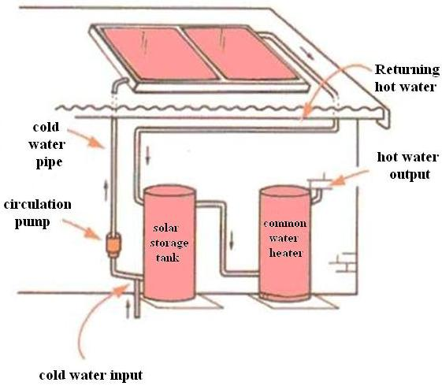
Fig 11- Pre-heater with solar storage tank on the ground
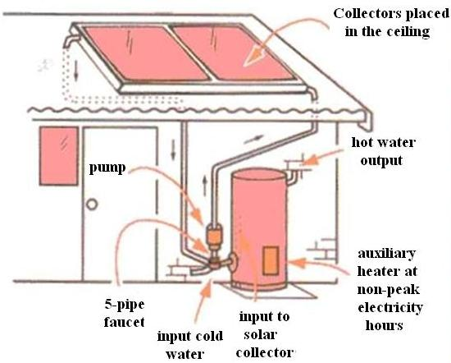
Fig 12- retrofits (electricity at non-peak hours)

9. Conclusion and suggestions
1- Clean and reproducible energies, including solar energy, have attracted all countries, both developing and developed ones, due to their numerous advantages regarding energy providing and decrease in air pollution. We hope that more attention will be paid to application of reproducible energies which results in stable development, saving people's lives, and service to human society, so that we will observe less victims during earthquake occurrence.
2- When earthquake happens and urban electricity transfer is not possible, we can make use of photovoltaic systems because they generate electricity independently and require no electricity transfer line and continuous maintenance. Considering the built-in modules in these systems, electricity can be generated in different scales. For instance, if we utilize this system as small individual modules, it satisfies our small needs. On the other hand, if a set of wide photovoltaic arrangements is used, we have established an enormous power plant for operation.
3- One of the most significant challenges is that the largest portion of society has little knowledge of the solar energy applications and no favorite cultural activities have been performed.
4- Suggestions have been offered to all of municipality regarding the establishment of earthquake solar parks and if these suggestions are applied, people will experience the application of these energies in a concrete way.
5- Establishment of solar cities is another suggestion which can solve lots of problems in this field and if this suggestion is implemented, we will observe a considerable transition in urbanism. As an example, Saudi Arabia has now three solar cities and all of the required energy of these cities is provided via solar energy.
6- In a system of non-reproducible resources, the costs of material transportation and labor are very high, but no such costs are present in production cycle of photovoltaic systems. Furthermore, through programming and executing short-term and long-term plans in the field of using solar energy, the opportunity is offered to make use of oil, this valuable black gold which is considered to provide the development and promotion of nations, in production of thousands of petrochemical products.
7- Without any doubt, one of the most important activities of advanced countries in the field of decreasing the consumption of non-clean energies is to help develop the technologies through which, utilization of reproducible and unlimited energy resources will be possible. Reaching this objective and accomplishing this goal will have a great influence on environment and economics of the countries. In photovoltaic systems, there is no need to resources of fossil fuel, so the environmental disadvantages caused by these resources and also cost of transportation and storekeeping are removed. In addition, photovoltaic systems are immobile and soundless and produce no audio noise.

Corresponding Author:
Akbar Toloeeyan
Department of civil engineering
Tabriz University
Akbar Toloian
Member of Iranian Solar Energy Society & The Responsible Expert of Technical Council of East Azarbaijan Province.
Tabriz, Iran
E-mail: a.toloeeyan@gmail.com
E-mail:akbar_toloian@yahoo.com

References
1. Reduction of Iran earthquake dangers population, Introduction to crises after earth quake in Iran, Tehran, 2004.
2. Http://www.Temev.org.tr.
3. M. Zare, Danger of earthquake and constructions in north Tabriz and Iran rift valley zones, Journal of identification of earthquake and earthquake engineering, Vol. 4, Issues 2-3, 2001.
4. Haj-Saqati, Bases and application of solar energies, Tehran, 2001.
5. M. Haratiyan, Energy management and applications of renewable energies, Isfahan, 2003.
6. Http://www.Pvresources.com.
7. H. Nazar-Poor, Using solar energy in buildings, Proceeding of 2nd conference on optimization of fuel consumption in buildings, Optimization of fuel consumption organization of Iran, Tehran, 2002.

3/5/2011

