**Geochemical Systematic Exploration of Stream Sediments in Shurchah Area (SE Zahedan)**

Mohammad G. Kahrazeh 1, Hamidoddin Yousefi 2

1. Department of Geology, Science and Research branch, Islamic Azad University, Tehran, Iran

m.kahrazeh@srbiu.ac.ir

2. Sistan and Baluchistan Mining Engineering Organization, Daneshgah St. Zahedan, Iran

hamidoddiny@gmail.com

**Abstract:** Shurchah area is located 60 kilometers to the southeast of Zahedan. Zahedan granitoides and dioritic dykes have intruded in flysches of Eocene age. According to factors such as stratigraphy, lithology, tectonics and topological gravity of drainage patterns, 82 stream sediment samples have been taken from streams. Samples were analyzed using ICP-MS and AAS analytical methods. For eight elements Au, Ag, Cu, Pb, Zn, As, Sb and Hg factors such as error, frequency distribution, amount of sensored, background, threshold, anomaly, mean, mode and standard deviation, calculated individually. Among these elements, Sb with an average value of 10 ppm has been considered as anomaly regarding the spatial situation of the anomaly; it was determined to be in the central part of the study area. In addition, strong positive correlation was observed between gold- arsenic and gold- antimony.

**[**Mohammad G. Kahrazeh, Hamidoddin Yousefi. **Geochemical Systematic Exploration of Stream Sediments in Shurchah Area (SE Zahedan).** Journal of American Science 2011;7(8):441-449]. (ISSN: 1545-1003). <http://www.americanscience.org>.

**Key words**: frequency distribution, antimony, anomaly, positive correlation

**1. Introduction**

The primary exploration for stream sediments study carried out in such drainage basins under different climate especially with few rains. Each sample can include chemical component of its upstream. Covering of vast area, ease of sampling, preparation and exist of wide aureole distribution are the advantages of method.

High probable pollution, river geomorphology changes, data interpretation difficulty and their relation to anomaly source are the disadvantages of method. (Hasani Pak &sharafoddin 2002).

The environment and effective process of ore deposition can be determined by geochemical studies of stream sediments. (Yazdi 2003). The sedimentary basin of study area has been divided into small parts due to separating stream sediment related to probable mineralization and those are not related to such mineralization which caused weakening of the anomaly.

The geochemical explorations method for stream sediments has been selected due to significance of geochemical studies of stream sediment which can help to determine environment, effective process in mineral explorations, concentration, distribution of elements in sediments and also use of tracer elements for promising area (Hasani Pak &sharafoddin 2002).

In stream sediments study method, many of minerals especially sulphide types was unstable and they decomposed because of oxidation and other chemical reaction. Such fact takes an important place in distribution of more minerals. Transportation and distribution of elements depends on their mobility in geochemical environment.

According to above reasons concentration changes of some elements such as Au, Ag, Cu, Pb, Zn, As, Hg, Sb in sediments and also relation and distribution of different element in sediment distribution, trace elements identification, exploration and accessibility to expected area are the objectives of this research.

The study area located in East Iran Flysch zone (Nehbandan –Khash Zone) (Stocklin 1972). This study covers Zahedan Granite, its age and genesis identification (Camp & Griffis 1981) (sadeghiyan 2007) also has been studied the granite rocks of Zahedan.

The geological location and access roads to Shurchah area falls 60Km SE of Zahedan city (Longitude 52 ́54 ˚60E, Latitude ˚29 ́10 ˝33N), The region is hot and arid. The weather is tolerable and the days are mostly sunny, it rains with few stormy periods, each lasting for several days (Fig.1).

**2. Study methods**

**2.1 Sampling and their analyses**

The design of sampling grid of this research covers 82 samples for sefid sang sheet with scale 1:50000 and map No. (8148-2) which introduce us the gravity center method. Factors such as stratigraphy, lithology and tectonics controlled the degree of gravity centre. According to definition, gravity centre of drainages are streams in which topologically can divided the drainage basin in two equal parts.

If stream itself is not gravity centre, amount (outermost) of streams (with number 1) located in both side are equals therefore, by using gravity centre method design on the map some points with high sampling density should be available. These points are: intrusive mass and its contacts, fault surrounding area in their intersection, alteration zones and areas which are located in upper part of hypabyssal intrusive mass (Hasani Pak & sharafoddin 2002).

To provide optimize design of sampling, drainages in a basin should be numbering.

The numbering procedure follows as each division of grid stream attributed to digit one out of the total upstream drainage, therefore digit one is belong to outer drainage and any division that derived from digit one marked as digit two, with continue numbering procedure will reach to the main stream in the outlet of Basin. If numbering is correct the obtained digit number for main stream at the outlet of basin will be equal to the total outer drainages of basin. (Hasani Pak & sharafoddin 2002).

Then, the outer streams should be divided to such samples which will take from stream sediment.

The obtained answer explains the number of drainages that should be consider for one sample. Thus

M=N/n

Where: N = the outer drainage, n = the number of samples have to be taken (Hasani Pak & Sharafoddin 2001).

During sampling process after selecting a suitable position with the help of topography maps and GPS through middle of streams, we have been taken the newest stream sediment deposits so that the new deviated drainage not connected to main stream (Fig2).

In this research 500 gram stream sediment samples with -80 meshes have taken and pulverized to -200 meshes. Due to wideness of area and frequency of elements only eight important elements including (Au, Ag, Cu, Pb, Zn, As, Hg, Sb), has been selected for geochemical processing.

The main factors in analyze method are to determine the sensored limit.

Basically, sensor amount in an element caused disturbance of data analyzing. (Goncalves 1998). In Geochemical explorations the importance and use of numerical values, related to elements is on account of relative comparison of them to each other.

To find out anomaly values, numerical values for each element related to its background value obtained, in which these values should be less than anomaly. (wellmer1998). Thus the different elements background value assigned and the suitable analyzing method will be select.

In this research owning to sensored limit elements, Gold element has been analyzed by ICP-MS method and other elements by AAS method analyzed which there were no sensored data in these eight selective elements.

**2.3** **Analyzing Error**

In order to analytical machines accuracy control usually out of 10-15 samples, one repetitive sample (about 10-15%) has been selected and sent with secret codes to laboratory. Repetitive samples for eight mentioned selective element with rate of 35% has been chosen. Table1 shows the primary and repetitive data results.

With a repetitious analysis of geochemical samples the accuracy process has been studied. At the first steps Microsoft Excel and Thompson diagram used for measuring accuracy consideration (Fig. 3 to 9).

These charts are logarithmic which mean of values in x-axis and different of values in y-axis has been shown. After plotting the values if 90 % of data are below equivalent line of 10% and 99% of data are below equivalent line of 1%, will have about 10% errors.

As we can see in the diagrams all the plotted points are below two curves which shows the errors are less than 10%. (Silver data are less than one impossible to plot in this diagram).

**3. Discussion**

**3.1 Outlier Value Test**

In statistical discussion such values are significant different to other values are known as outlier value. For calculating the above values subtraction of large number to one value before it method was used. As data are not so extended, therefore this simple correction gives a reasonable result. (Hasani Pak & Sharafoddin 2001).

For example antimony element with a value of 52262 ppm from 80 taken samples is unusual and should be replace with nearest small value means 38293for its correction.

Thus, the maximum Antimony grade decreases from 52262 ppm to 52089.5 ppm therefore outlier values of other elements also calculated as shown in Table 2.



**3.2 Determination of background, threshold limit, anomaly values**

Sometimes, exploration data are asymmetrical with positive skewness, it means samples with low value ( i.e. low grad) are abundance as compare to samples with high values( high grad). Therefore data distributions have been transformed, symmetric, and will be close to normal distribution often by using transformed logarithmic function method. (Hasani Pak & Sharafoddin 2001). In data transformation logarithm the base 10 selected and the transformed values was used to calculated mean, variance, and other statistical factors.

For calculation and determination of background, threshold, anomaly values there is variety of methods which supposed all the data are normal. These values are obtained with the help of mean and standard deviation as follow: (Table.3).

<Mean + Sd = Background

Mean + 2Sd = Threshold limit

> Mean + 2Sd = Anomaly

**3.3 Determining raw data stream sediment of elements**

In geochemical data, the existence of abnormal value plays an importance role in selecting of promising area. Therefore, separation of anomal area and background is very important.

Exploration data in an ore deposit scale the Sturge’s rule for estimating of class ranges used and has shown as follows:



Where:

(Xmax) and (Xmin) are the maximum and minimum values of data

N is No. of data

Due to determining raw data stream sediment of elements, statistic factors, frequency histograms and concentration distribute in statistic population for eight raw selective elements have been prepared in fig. 10 to 15.

As we can see from the above histograms all of them follow (L) distribution and maximum frequency is belongs to few values (Reimam 2005). In the samples, frequency distribution between low to middle values is dispersion, as in Cu element middle values shown more frequency.

The Au histogram more than 50 samples have less than 700 ppb values, 25 samples more than 1ppm and 5 samples have values near background or less than it. 74 samples had shown the anomaly grade.

The Antimony element, 13 samples are near threshold except for 2 samples from other samples (66 samples) are near anomaly. Stream sediment normal curve of antimony shows that middle frequency is about 300ppm. Frequency of AS element according to positive and strong correlation with Au is similar to gold frequency distribution curve and reasonably it can be antimony frequency and middle frequency of AS is related to about 35 ppm values.

**3.4 Determining of correlation coefficient of elements**

Owing to find out the relation between gold and its associated elements around mineralization and also to indentify process of different elements enrichment toward gold anomaly, we have chosen some of elements which their nature and frequency have been important in mineralization mechanism therefore their correlation coefficient calculated with gold element.

Spearman and Pearson methods were used for determining correlation coefficient between variables. Spearman method use when data frequency are not normal but for calculating of correlation coefficient through Pearson’s method the data frequency should be normal (wellmer 1998). Elements correlation coefficient values of both spearman and Pearson’s have been shown in Tables 5 & 6 respectively.

According to result of raw data, maximum correlation coefficient had shown between Gold and Antimony elements with 0.728 values and Arsenic with value of 0.641. In normal data maximum correlation is belong to Gold while Arsenic has a 0.995 value, it means Arsenic element is a good tracer for Gold and Antimony elements, as with the help of Antimony and Arsenic assemblies estimation can figure out reasonable Gold assembly. (Carranza 2008). figures16&17 indicated the regression curve of these elements.

**3.4 Cluster Analysis**

The linkage method used for data clustering on account of good connection of samples and variables as compare to return method. All cluster methods are base on resemblances matrix (Davis 2002). At the first step two samples or variables which are more similar to each other connected and at each repetition similar even cluster will connected together. (Fig. 18).

To identify paragenesis between eight selective elements in dendrogram cluster analysis of Shurchah samples, there is two important paragenesis groups as follow:

1. Zinc – Arsenic – Gold
2. Copper – Antimony – Mercury – Silver

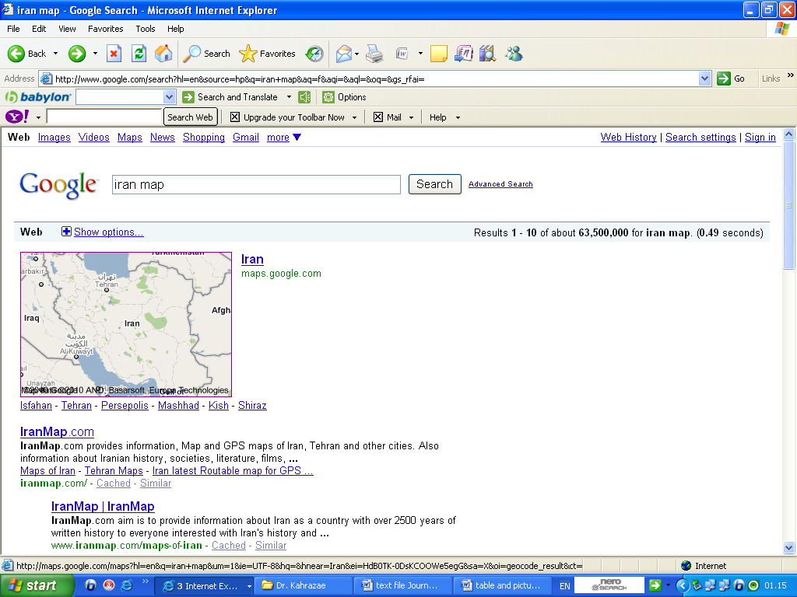 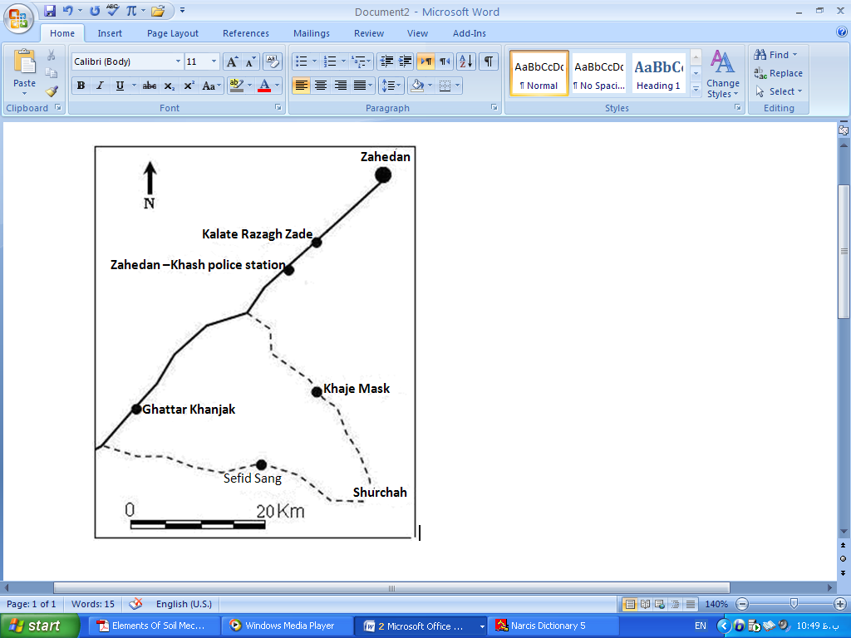

FIG.1. Geological location and the access roads to study area

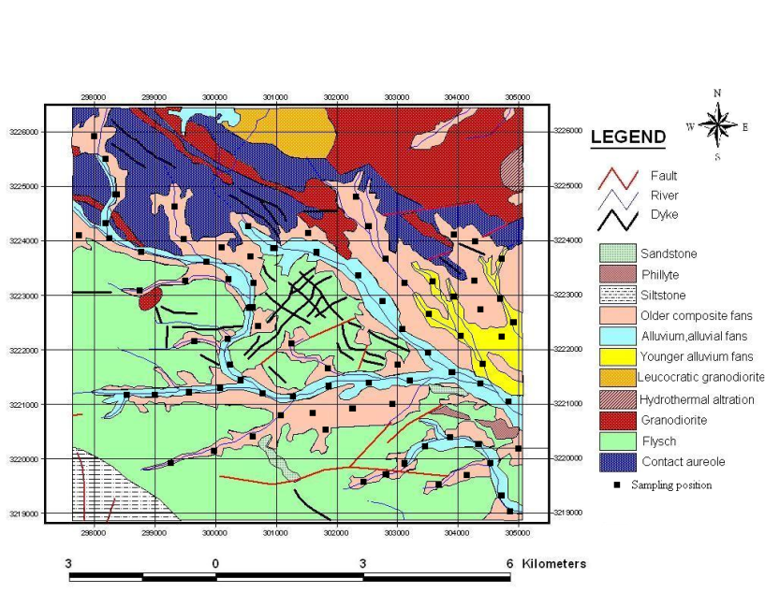

Table 1. Shows the primary (X1) and repetitive(X2) analyses results.

|  |  |  |  |  |  |  |  |
| --- | --- | --- | --- | --- | --- | --- | --- |
| Hg (ppm) | Sb  (ppm) | As  (ppm) | Zn  (ppm) | Pb  (ppm) | Cu  (ppm) | Ag  (ppm) | Au  (ppb) |
| N27=30 | N27=2 | N27=58 | N27=288 | N27=20 | N27=29 | N27=0.1 | N27=13.3 | X1 |
| N54=15 | N54=2389 | N54=846 | N54=6 | N54=9 | N54=4 | N54=0.1 | N54=1332 |
| N81=5 | N81=3 | N81=2 | N81=5 | N81=35 | N81=10 | N81=0.2 | N81=0.5 |
| N27=28 | N27=3 | N27=57 | N27=287 | N27=21 | N27=28 | N27=0.1 | N27=12 | X2 |
| N54=15 | N54=2393 | N54=844 | N54=6 | N54=10 | N54=3 | N54=0.1 | N54=1335 |
| N81=5 | N81=4 | N81=2 | N81=5 | N81=35 | N81=9 | N81=0.2 | N81=0.5 |















Table2. Outlier Value and their correction

|  |  |  |  |
| --- | --- | --- | --- |
| After of correction | next Value | Anomaly value | Element |
| 10534.5 | 7900.2 | 10567.5 | Au |
| 272.7 | 149.9 | 274.2 | Ag |
| 14144.2 | 1770 | 14299 | Cu |
| 33379.4 | 23730 | 33500 | Pb |
| 79574.6 | 42709 | 80008 | Zn |
| 60315.7 | 51170 | 60430 | As |
| 52089.5 | 38293 | 52262 | Sb |
| 2244.5 | 1798 | 2250 | Hg |

Table.3 Determination of background, threshold, and anomaly limits of elements

|  |  |  |  |  |  |  |  |  |
| --- | --- | --- | --- | --- | --- | --- | --- | --- |
| Hg  (ppm) | Sb  (ppm) | As  (ppm) | Zn  (ppm) | Pb  (ppm) | Cu  (ppm) | Ag  (ppm) | Au  (ppb) | Elements |
| <5.08 | <11.15 | 12.7> | 4.68> | 9.1> | 4.83> | <18.53 | <2.9 | Background |
| 9.68 | 19.58 | 21.96 | 5.77 | 15.62 | 6.43 | 22.46 | 4.71 | Threshold |
| >9.68 | >19.58 | >21.96 | >5.77 | >15.62 | >6.43 | >22.46 | >4.71 | Anomaly |

Table.4 Statistic factors calculated of raw data

|  |  |  |  |  |  |  |  |  |
| --- | --- | --- | --- | --- | --- | --- | --- | --- |
| Hg | Sb | As | Zn | Pb | Cu | Ag | Au | Elements  Factors |
| 82 | 82 | 82 | 82 | 82 | 82 | 82 | 82 | N |
| 3.4110 | .3243 | 26.0739 | 31.3263 | 70.2976 | 35.3854 | 2.9462 | 9.3171 | Mean |
| .53489 | .02426 | 1.09507 | 6.60107 | 7.45702 | 5.15960 | .21049 | .66392 | Std. E. M |
| 2.0000 | .3000 | 26.0000 | 20.0000 | 59.3000 | 20.0000 | 2.5600 | 8.0000 | Median |
| 1.00 | .20 | 22.00 | 24.00 | 47.00 | 15.00 | 1.00 | 10.00 | Mode |
| 4.84363 | .21964 | 9.91630 | 5.97752E1 | 6.75262E1 | 4.67222E1 | 1.90609 | 6.01208 | Std. Dev. |
| 23.461 | .048 | 98.333 | 3.573E3 | 4.560E3 | 2.183E3 | 3.633 | 36.145 | Variance |
| 3.903 | 1.880 | .172 | 5.619 | 4.785 | 3.244 | 1.242 | 1.197 | Skewness |
| .266 | .266 | .266 | .266 | .266 | .266 | .266 | .266 | Std. E. of Skw. |
| 20.572 | 5.495 | -.640 | 32.743 | 22.815 | 11.651 | 1.776 | 1.219 | Kurtosis |
| .526 | .526 | .526 | .526 | .526 | .526 | .526 | .526 | Std. E. of Kurt. |
| 33.80 | 1.29 | 45.00 | 426.00 | 416.00 | 265.80 | 9.00 | 28.00 | Range |
| .50 | .01 | 8.00 | 7.00 | 27.00 | 2.00 | 1.00 | 2.00 | Minimum |
| 34.30 | 1.30 | 53.00 | 433.00 | 443.00 | 267.80 | 10.00 | 30.00 | Maximum |
| 279.70 | 26.59 | 2138.06 | 2568.76 | 5764.40 | 2901.60 | 241.59 | 764.00 | Sum |













Table5. Calculation of elements correlation coefficient using spearman method

|  |  |  |  |  |  |  |  |  |
| --- | --- | --- | --- | --- | --- | --- | --- | --- |
| Hg | Sb | As | Zn | Pb | Cu | Ag | Au | Element |
| 1.00 | .164 | -.218 | .126 | -.006 | .641** | .728** | .219 | Au |
| .164 | 1.00 | .270* | .458** | .437** | .292** | .069 | .117 | Ag |
| -.218 | .270* | 1.00 | .506** | .656** | .176 | -.331* | -.053 | Cu |
| .126 | .458** | .506** | 1.00 | .705** | .581** | -.053 | -.065 | Pb |
| -.006 | .437** | .656** | .705** | 1.00 | .422** | -.162 | .023 | Zn |
| .641** | .292** | .176 | .581** | .422** | 1.00 | .449** | -.029 | As |
| .728** | .069 | -.331* | -.053 | -.162 | .449** | 1.00 | .216 | Sb |
| .219 | .117 | -.053 | -.065 | .023 | -.029 | .216 | 1.00 | Hg |

Table6. Calculation of elements correlation coefficient using Pearson’s method

|  |  |  |  |  |  |  |  |  |
| --- | --- | --- | --- | --- | --- | --- | --- | --- |
| Hg | Sb | As | Zn | Pb | Cu | Ag | Au | Element |
| .566** | -.004 | .995** | -.027 | .240* | -.036 | .018 | 1 | Au |
| .058 | .167 | .007 | -.161 | -.139 | -.163 | 1 | .018 | Ag |
| -.020 | -.034 | -.033 | .792** | .557** | 1 | -.163 | -.036 | Cu |
| -.033 | -.029 | .194 | .448** | 1 | .557** | -.139 | .240* | Pb |
| -.015 | -.025 | -.025 | 1 | .448** | .792** | -.161 | -.027 | Zn |
| .570** | -.002 | 1 | -.025 | .194 | -.033 | .007 | .995** | As |
| .036 | 1 | -.002 | -.025 | -.029 | -.034 | .167 | -.004 | Sb |
| 1 | .036 | .570** | -.015 | -.033 | -.020 | .058 | .566** | Hg |

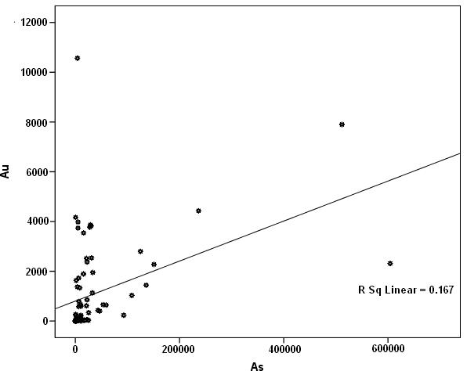

FIG.16. Shows dispersion of Gold with Arsenic elements along with regression curve

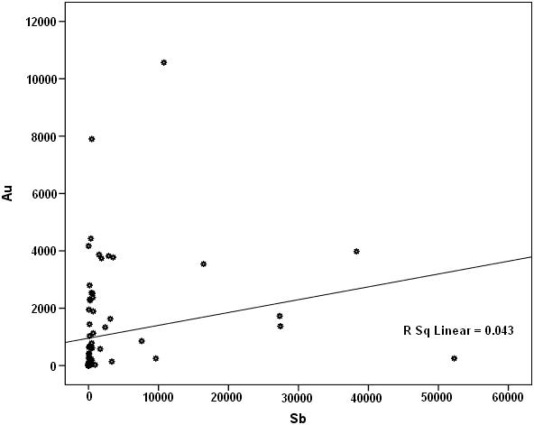

FIG.17. Shows dispersion of Gold with Antimony elements along with regression curve

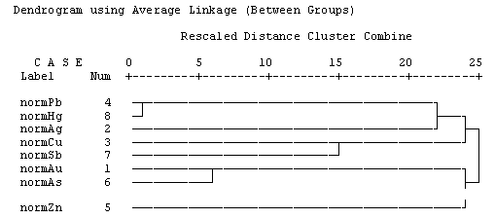

FIG.18. Shows Dendrogram related to stream sediments

**Conclusion**

1. In the raw data more correlation coefficient is a value of 0.827 between Gold and Antimony element and in normal data more correlation coefficient is a value of 0.995 between Gold and Arsenic.

2.Studies of elements correlation show in spite of strong and positive correlation between Gold, Arsenic and Antimony, Arsenic element can be introduce as Gold and antimony tracer and the estimation of Antimony and Arsenic piles can give reasonable information of Gold pile.

3.The elements such Copper, Silver and Mercury because of their strong chemical affinity with sulphide have fewer solvencies in water and in compare to other studied elements they are mostly in upstream.

4. Antimony element with a value of 10 ppm located in latitude ˝46 ´17 °29 and longitude ˝51 ´00 °61 has been selected as anomaly limit out of eight selective elements.

5. According to cluster analysis there are two important group as follow:

1. Zinc – Arsenic – Gold

2. Copper – Antimony – Mercury – Silver

Therefore chemical and paragenesis behavior elements of each group are similar.

**Correspondence to**

Mohammad G. Kahrazeh

Department of Geology, Science and Research branch, Islamic Azad University, Tehran, Iran

Tel:989155492551

m.kahrazeh@srbiu.ac.ir

Hamidoddin Yousefi

Sistan and Baluchistan Mining Engineering Organization, Daneshgah St. Zahedan, Iran

Tel:989155410619

hamidoddiny@gmail.com

**References**

**[1] A.Hasani Pak, 2001**, exploration dada analysis, Tehran university publication, Islamic Republic of Iran, p. 987.

**[2] A.Hasani Pak, 1999**, Geostatics, Tehran University Publication, Islamic Republic of Iran, p. 3143

**[3] A.Sadeghiyan and M.Valizadeh**, 2007, replacement of north part zahedan massive granitoide mechanism, twenty sixth earth science association.

**[4] M.Yazdi, 1381**, Conventional methods in Geochemical exploration, Shahid Beheshti university Publication, Islamic Republic of Iran, p.180

**[5] Camp, V. E. & Griffis, R. J., 1981,** "Character, genesis and tectonic setting of igneous in the Sistan suture zone, eastern Iran", *Lithos, Vol. 15(3): 221-239.*

**[6] Carranza, E.J.M.,** 2008, "Geochemical anomaly and mineral prospectively mapping in GIS, 11". *Hardbound, 368 pages.*

**[7] Davis, John C.,** 2002. "Statistics and data analysis in geology", *3therd, john Wiley & Sons Inc, New York.*

**[8] Goncalves, M.A., Vairinho, M., Oliveira, V.,** 1998, "Study of geochemical anomalies in Mombeja area using a multifractal methodology and geostatistics", *In: Buccianti, A., Nardi, G., Potenza, R. (Eds.), IV IAMG 98. De Fred, Ischia Island, Italy, PP. 590-595.*

**[9] Reimam, c., Filzmoser, P., and Garrent, R.G.,** 2005, "Background and threshold: critical comparison of methods of determination".*Science of Total Evironment, 346, 1-16.*

**[10] Stoecklin, J., Eftekharnezhad, J. & Hushmand Zadeh, A.,** 1972, "Central lut reconnaissance east Iran"*, Geol. Surv. Iran, Rept. pp. 22-62.*

**[11] Wellmer, F.W.,** 1998, "Statistical evaluations in exploration for mineral deposits", *Article, Springer New York, pp. 350-379.*

7/15/2011