Oriented Indium Doped Zinc Oxide Thin Films by Spray Pyrolysis Technique

M.O. Abou-Helal

Solid State Physics Dept., National Research Center, El-Behoos str., 12311Dokki, Cairo, Egypt
osamah4@hotmail.com, osamah4@tedata.net.eg, mabouhelal@mailer.scu.eun.eg

Abstract: Spray pyrolysis technique has been proved to be an effective tool to produce well oriented undoped and indium doped zinc oxide thin films onto glass substrates. The correlation between the main preparation parameters such as: substrate temperature (673-873 K), spraying time (10-50 min.) and doping concentration (0-3%) and the structural and optical properties of the films, have been discussed. The alignment of the crystals has been investigated by X-ray diffraction, atomic force microscopy and transmission electron microscopy. The prepared ZnO:In films are generally homogeneous, have smooth surfaces and low sheet resistance values R_{s} in kΩ range. The doping with Indium decreased the sheet resistance of ZnO films by about two orders of magnitude.
[M.O. Abou-Helal, Oriented Indium Doped Zinc Oxide Thin Films by Spray Pyrolysis Technique]. Journal of American Science 2011; 7(8): 583-587]. (ISSN: 1545-1003). http://www.americanscience.org.

Keywords: Zinc oxide, Indium, Spray Pyrolysis, Mono-crystals, Single-crystals.

1. Introduction
Zinc oxide (ZnO) is a good candidate for different opto-electronic devices; gas sensors, ultrasonic oscillators and transducers. Additionally, in solar cell related applications, for instance, as a window material, or in a heterojunction solar cell ZnO/CdTe, ZnO can be used due to its mix of properties like stability in hydrogenated atmosphere and non-toxicity [1-5]. ZnO films have been prepared by different techniques such as: sputtering [6], chemical vapor deposition [7], and spray pyrolysis technique [8-10]. Spray pyrolysis may have several advantages compared with the other techniques such as: simplicity and possibility to produce non-expensive large area films.
In this paper, it was attempted to establish an idea that spray pyrolysis technique could be an effective tool to prepare well-oriented mono crystals. That is why the structural characteristics of undoped and Indium doped ZnO films prepared by spray pyrolysis are investigated.

2. Experimental
The ZnO:In films were deposited on glass substrates with dimensions 11x22 mm (Menzel-Gläser, Germany) by the spray pyrolysis set up which had been already described in an earlier publication [11]. Zinc acetate (Merck, 99%) was dissolved in a mixture of three quarters water (HPLC grade) and one-quarter methanol (Laborchemie Apolda, p.a., Germany). The deposition parameters were: 0.2 molarity of the starting solution, 1.1 bar air pressure, 0.3 ml/min solution rate, (673-873 K) substrate temperature range and (10-50 min.) spray time range. The doping is achieved by adding Indium trichloride to the solution with percentages 1-3% and at the same Zn molarity (0.2 M).
X-ray diffractometery (SIEMENS D5000) and transmission electron microscopy TEM in conjunction with energy dispersive X-ray spectroscopy EDX were used to get a more detailed view of the microstructure and composition of the prepared films. For TEM imaging, a HITACHI H-8100 II electron microscope was used at an operation voltage of 200 kV (point to point resolution 0.23 nm), with attached EDX detector (Oxford Instruments, Link ISIS). Atomic force microscope AFM (JENAVAL, Carl Zeiss, equipped with a SIS-Ultra objective) was used to get information about the surface topography of the films. The UV/VIS/NIR-transmission spectra of the samples were recorded by a spectrophotometer (UV-3101PC Shimadzu, Japan) to investigate the optical properties of the prepared films.

3. Results
X-ray diffraction pattern XRD of undoped and 1% Indium doped ZnO films at two substrate temperatures T_{s}, namely 773 & 873 K, at the same deposition time t_{d} = 30 min., besides the ZnO JCPDS data file 36-1451 for comparison, are shown in Fig.1, which indicates that the films are polycrystalline and well oriented in [002] direction of the hexagonal Wurzite ZnO.
A TEM image of ZnO: 1%In film prepared at substrate temperature T_{s} = 873 K and deposition time t_{d} = 30 min. is presented in Fig. 2, which shows well oriented large crystals.
Fig.3 shows the transmission T in percent, against the wavelength λ in nm, at different substrate temperatures T_{s} and at the same deposition time t_{d} = 30 min. for undoped and 2% Indium doped ZnO films. The films are transparent ( ≈ 70-90%) in the visible region.
The T - λ curve of undoped and indium doped ZnO at substrate temperature T_{s} = 873 K, deposition time t_{d} = 30 min. and different doping concentrations, can be seen in Fig.4, the doping with Indium (1-3%) lower the transparency of ZnO films from almost 90% to 70%. The thickness of the films and related optical constants have been estimated using a software package (APAS Program, Ver.1.3, J.K. Kühn, Otto-Schott-Institut, Germany) on the basis of experimental optical transmission spectra.
The atomic force microscopic image AFM of ZnO: 1%In, at substrate temperature T_{s} = 873 K and deposition time t_{d} = 30 min. is shown in Fig.5, which shows the topography and homogeneity of the film.

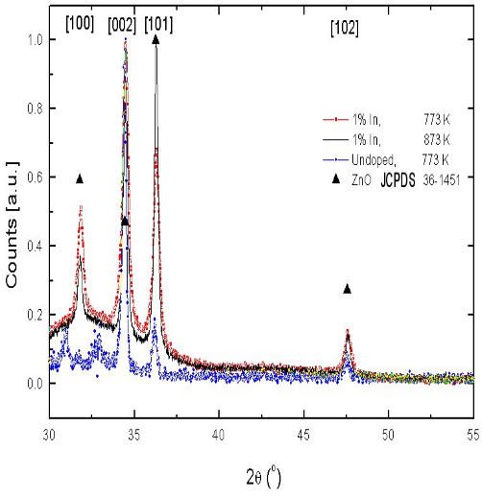
Fig.1. XRD of undoped and 1%In doped ZnO at different substrate temperatures T_{s} and the same deposition time t_{d} = 30 min.

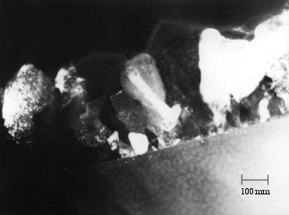
Fig.2. TEM of ZnO:1%In at substrate temperature T_{s} = 873 K and deposition time t_{d} = 30min.
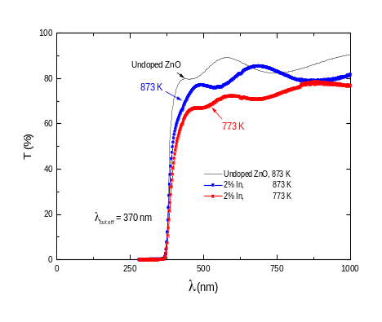
Fig.3. T-λ Curve of undoped ZnO and 2%In doped at different substrate temperatures T_{s} and the same deposition time t_{d} = 30 min.
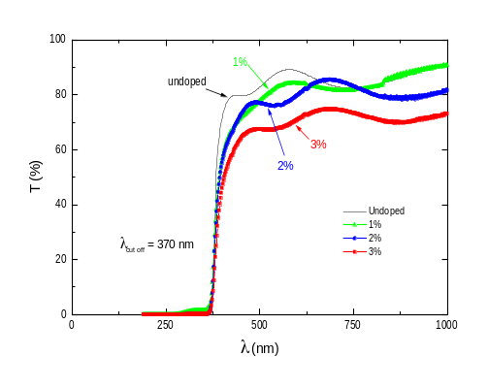
Fig.4. T-λ Curve of undoped ZnO and Indium doped at substrate temperature T_{s} = 873 K, deposition time t_{d} = 30min. and different dopant concentrations.
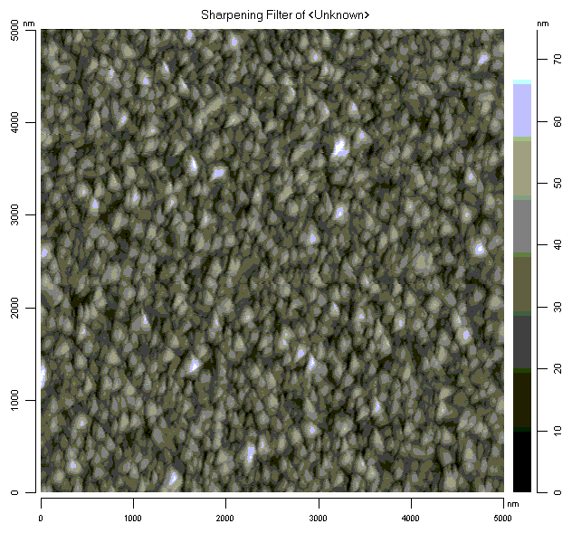
Fig.5. AFM of ZnO:1%In at substrate temperature T_{s} = 873 K and Deposition time t_{d} = 30min.

4. Discussion
General examination of XRD patterns of the ZnO:In films, shows that the principal lines [100], [002] and [101] of the hexagonal Wurzite ZnO are the strongest in the whole spectrum (Fig. 1), and correspond very well with the standard patterns of ZnO powder (JCPDS data file 36-1451). No additional peaks could be observed due to the doping with Indium up to 3% in the starting spraying solution. This is due to the low concentration of the dopant (In).
The segregation of Indium at the grain boundary (GB) and the formation of other phases mainly depend on its concentration. In this work, the actual Indium concentration in for example ZnO:1%In was ≈ 0.6% as given by EDX measurements, therefore, the probability for Indium to form other phases or to segregate at grain boundaries is much smaller than to be as interstitial or substituted in ZnO lattice. The appearance of only the characteristic peaks of pure ZnO in XRD patterns supports the conclusion that no other phases are present.
The average size of the micro crystallites can be calculated from the full width at half maximum (FWHM), using the Scherrer formula for crystallite size broadening of diffraction peaks [12]:

D = 0.94 λ / Δ (2θ) cos (θ) | (1)
Where Δ(2θ) is the full peak width at half maximum of the diffraction line in radians, θ is the diffraction angle and λ is the wavelength of X-rays in Angstrom (Cu K_{α}, λ = 1.5406 Å).
The texture coefficient TC (hkl) is used as a tool to determine the preferred orientation, which is calculated from the XRD results as follows [13]:

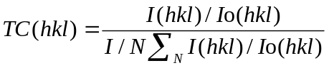 | (2)
Where I is the measured XRD peak intensity, I_{o} is the corresponding intensity given in JCPDS data file for the powder, and N is the number of reflections.
Fig. 1 shows the variation of the X-ray diffraction peaks as a result of increasing the substrate temperature of ZnO:1%In films from 773 to 873 K, the [101] peak intensity increases compared to the [002] peak, as the preferred orientation for undoped ZnO. This finding is reported also in literature [1,2], this may be attributed to indium atoms which may be impeding the growth of ZnO in the [002] direction at the applied deposition conditions.
Using Transmission Electron Microscopy TEM (see Fig. 2.), it could be shown that ZnO:In films consist typically of relatively large crystals, some of them have a crystallite size more than 160 nm, and with film thickness of about 270 nm. The same thickness value has been calculated for the same sample from the optical T-λ data. The crystals are well oriented along c direction, which is consistent with data obtained from XRD too. This large crystallite size combined with good orientation indicates that spray pyrolysis technique may be used to produce reasonably large single crystals [14-18]. The calculated crystallite size by Scherrer formula, is much smaller than those measured by TEM. This difference may be attributed to inconsistency of applying the Scherrer-method, which gives the average crystallite size over the plane, such as [002] .
The EDX-investigations of ZnO:1%In film showed that: Oxygen ≈ 49%, Zinc ≈ 49% and Indium ≈ 0.6% (the rest ≈ 1.4% attributed to the by-products and the substrate components).
As the substrate temperature T_{s} for ZnO:In increased, the transmittance is improved (Fig.3), and this can be partially attributed to the decreasing of the thickness from 420 nm to 350 nm as the temperature increased from 773 K to 873 K, table 1. At higher substrate temperatures the residual organic species (e.g. acetate) evaporate as volatile gases, the deposited crystallites become closer to each other allowing film densification on the expense of the film thickness. Also, there is a possibility that the upward heat flux may impede the incident sprayed fog that induces a decrease in the deposited layer thickness. The re-evaporation of the deposited material at higher substrate temperature is another probable cause for the thinning of the deposited film. The doping of ZnO with Indium lowered the transmittance from almost 90% for undoped to about 70% for the 3% Indium doped, see Fig.4.
ZnO films undoped and doped with Indium, at the same preparation conditions, have similar cut off wavelength λ_{g} ≈ 370 nm, which corresponds to an optical energy gap E_{g} ≈ 3.3 eV, see Fig.4.
Despite of the change of substrate temperature and doping concentration, all the (T-λ) curves of the investigated samples showed the same shape of the uv-absorption edge. This may be due to the small concentration of Indium in the films, as prooved by EDX.

Table 1. Thickness and Refractive Index (n) of Undoped and Indium Doped ZnO
 | Composition ZnO | Depos.  Temp.  T_{s}  [K] | Depos.  Time  t_{d}  [min.] | T%  visible range | thickness [nm] | n
1 | Undoped | 873 | 30 | 90 | 290 | 1.9
2 | ZnO:2%In | 873 | 30 | 85 | 350 | 1.9
3 | ZnO:2%In | 773 | 30 | 80 | 420 | 2.0
4 | ZnO:2%In | 873 | 20 | 90 | 230 | 1.9
5 | ZnO:2%In | 873 | 40 | 85 | 430 | 1.9
6 | ZnO:2%In | 873 | 60 | 80 | 630 | 1.9
7 | ZnO:3%In | 873 | 30 | 75 | 310 | 2.0

By using the mentioned software package (APAS) the thickness and refractive index (n) can be calculated from the T-λ curves, Table 1. The estimated refractive index for undoped and Indium doped ZnO was similar (n ≈ 2).
The atomic force microscopic picture AFM of ZnO:1%In can be seen in Fig.5, generally ZnO:In films are homogeneous and smooth.
By doping ZnO films with Indium it was possible to reduce the sheet resistance R_{s} from MΩ to kΩ, see Table 2.

Table 2. The sheet resistance and film thickness of undoped and doped ZnO
Compos.  ZnO | T_{s}  K | t_{d}  min. | Thick. nm. | R_{s}  KΩ
Undoped | 873 | 30 | 290 | 1000
1%In | 873 | 30 | 290 | 105
2%In | 873 | 30 | 350 | 7
2%In | 773 | 30 | 420 | 28
2%In | 873 | 20 | 230 | 36

It has been observed that the sheet resistance of the ZnO:In films decreases with increasing doping percentage. The resistance of the films has a minimum value at around 2.0 wt % In. For higher doping levels the sheet resistance starts to increase again. The decrease in the resistance may be explained as the indium atoms doped into ZnO lattice act as donors by supplying a single free electron when In³⁺ ions occupy Zn²⁺ ion sites. This in turn increases the free carrier concentration and at the end decreases the sheet resistance [19]. But with higher doping (> 3 wt%), a recombination process happens which induces an increase of the resistance.

Conclusion
Spray pyrolysis technique has been proved to be an effective tool to produce well oriented undoped and indium doped zinc oxide thin films onto glass substrates. The general examination of XRD pattern of undoped and indium doped ZnO films prepared by spray pyrolysis shows, that they consist of crystals with hexagonal Wurzite structure. The [100], [002] and [101] reflexes belong to the strongest in the diffractograms. ZnO doping with Indium up to 3% causes no additional peaks. By choosing of higher substrate temperatures during the deposition process, the peak intensity increases in the direction [101] compared to the [002] direction, which is the preferred orientation for undoped ZnO. The TEM studies revealed that the films consist of considerably large crystals, some of them with crystallite size more than 160 nm, and with a film thickness of about 270 nm. Similar thickness value could be derived by applying optical methods (~ 280 nm) for the same sample. This means that both methods are compatible for thickness determination. The observed large crystals indicate that spray pyrolysis technique may be used to produce single crystals. Further investigations are on the way. As the substrate temperature T_{s} for ZnO:In increased - the transmittance is improved. The atomic force microscopy indicates that the ZnO:In films are homogeneous. They have relatively low sheet resistance R_{s} in the kΩ range compared with undoped ZnO films, which have resistance values R_{s} in the range of MΩ.

Acknowledgements
The author would like to thank all the coworkers at National Research Center NRC, Dokki, Cairo, Egypt.

Corresponding author
M.O. Abou-Helal
Solid State Physics Dept., National Research Center, El-Behoos str., 12311Dokki, Cairo, Egypt
osamah4@hotmail.com, osamah4@tedata.net.eg, mabouhelal@mailer.scu.eun.eg

References
- D.J. Goyal, C. Agashe, M.G. Takwale and V.G. Bhide, Journal of Material Research, 8, 5 (1993) 1052-1056.
- M. Krunks and E. Mellikov, Thin Solid Films, 270 (1995) 33-36.
- J.F. Guillemoles, D. Lincot, P. Cowache and J. Vedel, Proc. 10th EC Photovoltaic Solar Energy Conf., Lisbon, Portugal, (1991) 609.
- M.L. Olvera, A. Maldonado, R. Asomaza, M. Konagai and M. Asomoza, Thin Solid Films, 229 (1993) 196.
- C. Mazon, J. Muci, A. Sa-Neto, A. Ortiz. Conde and F.J. Garcia, Proc. 22th IEEE PV Spec. Conf. P. (1991) 1156.
- T. Minami, H. Sato, H. Nanto, and S. Takata, Jpn. J. Appl. Phys. 24 (1985) L781.
- P. Souletie and B.W. Wessels, J. Mater. Res. 3 (1988) 740.
- J. Aranovich, A. Ortiz and R.H. Bube, J. Vac. Sci. Technol. 16 (1979) 994.
- A.S. Riad, S.A. Mahmoud, A.A. Ibrahim, Physica B, 296 (2001) 319-325.
- B.J. Lokhande, P.S. Patil, M.D. Uplane, Physica B, 302-303 (2001) 59-63.

- M.O. Abou-Helal, W.T., Seeber, Journal of Non-Crystalline Solids, 218 (1997) 139-145.
- P. Scherrer: Göttinger Nachr. 2 (1918) 98.
- A. Chitra, B.R. Marathe, M.G. Takwale, and V.G. Bhide, Thin Solid Films, 164 (1988) 261.
- T.V. Vimalkumar, N. Poornima, C. Sudha Kartha and K.P. Vijayakumar, Applied Surface Science, 256, 20, 1 August (2010), 6025-6028.
- Bengisu Ergin, Elif Ketenci and Ferhunde Atay, International Journal of Hydrogen Energy, 34, 12, June (2009), 5249-5254.
- J. Wienke and A.S. Booij, Thin Solid Films, 516, 14, 30 May (2008), 4508-4512.
- T. Prasada Rao and M.C. Santhoshkumar, Applied Surface Science, 255, 16, 30 May (2009), 7212-7215.
- M. Junaid Bushiri, S. Agouram, C. Reig, M.C. Martínez-Tomás, J. Jimenez, V. Hortelano and V. Muñoz-Sanjosé, Physics Procedia, 8, (2010), 14-17.
- B.J. Lokhande, P.S. Patil, and M.D. Uplane, Physica B, 302-303 (2001) 59-63.

7/28/2011

