**Transarterial Chemoembolization (Tace) Versus Combined Tace and Radiofrequency Thermal Ablation (Rfa) in the Treatment of Unresectable Non-Early Hepatocellular Carcinoma in Egyptian Patients**

SherifMoneirMohamed1, Mohamed Abd Elmoghny1, Mohamed Shaker Ghazy2 and MostafaH.Abd Elaleem3

Internal medicine Department1, Intervention radiology Department2, Tropical medicine department3, Faculty of medicine-Ain Shams University. [moh.mazen2006@yahoo.com](mailto:moh.mazen2006@yahoo.com)

**Abstract: Background and Aims:** Early detection of Hepatocellular Carcinoma (HCC) allows the application of potentially curative therapies such as resection, liver transplantation. But the majority of patients with HCC will still not be candidate for these curative therapies. The local, non surgical palliative therapies such as transcatheter hepatic arterial chemoembolization (TACE) , radiofrequency ablation (RFA), percutaneous ethanol injection , microwave, LASER and cryoablation provides good results but are unable to achieve response rates and outcomes comparable to those for surgical treatments. The aim of the present work was to evaluation of the effectiveness of TACE alone versus combined TACE and RFA in the treatment of unresectable non-early HCC. **Patients and Methods:** Forty patients with HCC were included in the study . Patients were divided into 2 groups. Group "A" was treated with TACE alone, and group "B" was treated with combined TACE and RFA. All cases were subjected to full history taking and clinical examination, Routine laboratory investigations and Triphasic CT abdomen before and after treatment. **Results:** Group B showed highly significant reduction in alpha fetoprotein (AFP) (60%) after treatment in comparison to in group A (40%) . on the other hand group A showed higher relapse rate after treatment (70%) in comparison to group B (20%) . The study showed that 1 year event free survival in group B was (80%) in comparison to( 30% ) in group A. also the 1 year survival rate in group B was ( 85% ) in comparison to ( 50% ) in group A . means that group B had a better event free and survival compared to group A. **Conclusion:** Combined TACE and RFA were more effective than TACE alone in treatment of HCC.

[Sherif Moneir Mohamed, Mohamed Abd Elmoghny, Mohamed Shaker Ghazy and MostafaH. Abd Elaleem. **Transarterial Chemoembolization (Tace) Versus Combined Tace and Radiofrequency Thermal Ablation (Rfa) in the Treatment of Unresectable Non-Early Hepatocellular Carcinoma in Egyptian Patients.** *J Am Sci* 2011;7(11): 506-515].(ISSN: 1545-1003). <http://www.jofamericanscience.org>. 63

**Keywords:** of Hepatocellular Carcinoma (HCC); liver transplantation; curative therapy

**1. Introduction**

Hepatocellular carcinoma is the fifth most common cause of all malignancies and causes approximately one million deaths each year . Most patients with HCC are not candidates for curative therapies such as resection or liver transplantation due to both tumor extension and underlying liver disease **(Corey and Pratt., 2009).** Minimally invasive techniques have recently emerged as alternatives for treatment of non resectable liver tumors. These include microwave, LASER, radiofrequency ablation, cryoablation, Ethanol injection and chemoembolization **(Bruixand Sherman, 2011).**

Radiofrequency ablation is a promising minimally invasive technique for the treatment of small HCC. This technique utilizes high frequency alternating current to heat tissue to the point of coagulation necrosis **(Singal and Marrero, 2010).** The major limitation of radiofrequency ablation is the inability to reliably create adequate volumes of complete destruction of large HCC**.** In addition, foci of viable tumor can persist even after apparently adequate thermal ablation **(Park*et al.,* 2010).** Hence strategies to increase the volume of induced tumor destruction are still required. In attempt to overcome this limitation, researchers are currently studying the effect of RFA combined with adjuvant such as percutanoeus ethanol installation, saline injection and embolization**. (Corey and Pratt, 2009)**

Transcatheter Hepatic Arterial Chemoembolization (TACE) is a well established technique combining intra-arterial chemotherapy with delivery of embolic agents in order to achieve an anti-tumor effect due to high local concentration and prolonged dwell time of the drug along with select ischemia. Chemoembolization can also produce significant results in term of tumor shrinkage and survival in many of this patient (**Shin, 2009).**

**Aim of the Work**

To compare the therapeutic effects of TACE versus that of combination therapy of TACE and RFA in the treatment of unresectable non-early HCC in cirrhotic patients.

**2. Subjects and Methods**

This study was carried out at the gastroenterology and interventional radiology departments at Ain Shams University hospital and AinShams University specialized Hospital .The study was conducted on 40 cirrhotic patients (Child-Pugh class A or B) with solitary HCC ≤ 8.0 cm in diameter, or multiple HCC ≤ 3 lesions,each ≤ 3.0 cm in diameter confirmed by ultrasound, contrast enhanced triphasic CT, AFP and histopathology in some patients.

The patients were divided into two groups. "Group A" included 20 patients treated by TACE alone, and "Group B" included 20 patients treated by TACE combined with RFA in two different occasions. The therapeutic effects in the two groups were compared.

All patients were subjected to full medical history and clinical examination, laboratory investigations including Liver function tests, Renal function tests, Complete blood count ,Hepatitis markers including (HBs Ag and HCV Ab) using ELISA technique ,alpha fetoprotein (AFP). Before and at one and every three months after the therapy, AbdominalUltrasonography (US), Doppler ultrasound to assess the patency of hepatic vessels . Baseline enhanced triphasic CT abdomen was performed before therapy and within one and three months after therapy to detect tumor dimension and vascularity. Complete resolution is indicated by lack of enhancement on both arterial and portal phase within the treated lesion as evidence by enhanced triphasic CT and by normalization of AFP (if elevated at base line). All patients were subjected tofollow up for 1year to detect recurrence and survival rate.

The following patients were excluded from the study: Patients with decompensated liver (Child C), renal impairment (S.cr > 2 mg/dl), Platelet count < 50,000/ mm3, Prothrombin activity less than 50%, Tumor not confined to one lobe of the liver, evidence of distant metastases, Portal vein thrombosis, vascular invasion, extensive arterio-venous shunting, and Technically inaccessible hepatic artery.

**Techniques of Treatment**

**A- Technique of TACE:**

Selective hepatic angiography: Coeliac arteriography and superior mesenteric arteriography was done to determine the vascular anatomy and portal blood flow and to identify the feeding arteries and the presence of intratumorarterio-venous shunting. A Catheter with a guide wire is introduced in the femoral artery and is passed retrograde under screen to the celiac trunk till reach the common hepatic artery .Then a mixture of anticancer drug|(Doxorubicin in oil emulsion in a dose of 40-100mg" depending on the tumor size and the state of liver function) with lipidol is slowly injected through the catheter into the tumor vascular bed under screen, lastly, the embolic material gelatin sponge "gel foam" is injected as a mixture with contrast medium and small amount of anticancer drug to occlude the tumor vascular bed and feeding arteries, this adds to the necrosis process and increases the retention of doxorubicin in the tumor tissue .Then Digital subtraction Angiography (DSA) should be done to confirm that tumor staining has disappeared  **(Shin., 2009).**Post TACE procedure care include : observation of the vital signs and the site of puncture for any bleeding, good hydration and medications as antiemetics, antibiotics, antipyretics and analgesics**.**

**B- Technique of RFA**

The RF generator delivers an alternative current at frequency of 450 KHZ with two electrodes, one called the active electrode which is in direct contact to the targeted tissues and the other is called the dispersive electrode which is applied on the patient's thigh "which not produce heat at this electrode " by this manner the whole body is involved into a closed electric circuit. **(Kim*et al.,* 2008)**

For adequate destruction of tumor tissue, it must be subjected to cytotoxic temperature, an essential objective of ablative therapy is achievement and maintenance of a50-100co temperature throughout the entire target volume for at least 4-6 minutes, however the relatively slow thermal conduction from the electrode surface through the tissues increases the duration of application to 10-30 minutes. Effective ablation can be achieved by optimizing heat production minimizing heat loss. **(Georgiades*et al.,* 2008)**

The patient must be Fasting for at least 6 hours and lying in supine position or left lateral decubitus . The procedure was performed with ultrasound guidance after good sedation. Small skin incision to facilitate passage of needle . Baseline tissue impedance was measured. Generator output was slowly increased to 450-1100 MA if an increase in impedance equal to or greater than 10 above base line the current was reduced in 50MA interval until stable impedance was observed this reduction was necessary to prevent tissue boiling.

Intensity2 = Watts / impedance

As radiofrequency energy was applied to the treatment probes a hyperechoic focus developed around the uninsulated portion of the electrodes, this was attributed to tissue vaporization and cavitation. The area of echogenecity was round most often progressively increased in size over the course of ablation and generally enveloped the entire tumor with variable extension in the surrounding liver by the end of the treatment. **(Kim*et al.,* 2008).**

Post RF procedure care include: Prophylactic antibiotics, allopurinol, Paracetamol and Plenty of fluid intake.

**C-Combined TACE and RFA:-**

TACE was performed first, one or two weeks after TACE therapy RFA was performed.

**Statistical Methodology**

Analysis of data was done by IBM computer using SPSS as follows: Description of quantitative variables as mean, SD and range and Description of qualitative variables as No and %.

* Chi- square test was used to compare qualitative variables
* Fisher exact test was used instead of chi-square when one expected cell or more <5.
* Unpaired t-test was used to compare two independent groups as regard a quantitative variable.
* Kaplan meire curve was used to find out the either overall or event free in relation to the follow up duration
* Log rank test was used to compare cumulative survival between both groups.
* Mann Whitney Willcoxon test was used instead of Unpaired t-test when SD > 50% (Non parametric data) *P*>0.05 insignificant, *P*<0.05 significant and *P*<0.01 highly significant .

**3. Results**

The study was conducted on 40 patients "30 males & 10 females with single HCC accompanying cirrhosis. The patients were divided into two groups "Group A" includes 20 patients their mean age 56 ± 20 range from 45 - 62 years and treated by TACE alone, and "Group B" include 20 patients their mean age 53.2 ± 16 range from 49 – 60 years old treated by TACE combined with RFA.

There was no statistically significant difference between the studied groups as regard age, gender, smoking and presenting symptoms, past history , laboratory data, US results, tumor size by CT (*P*>0.05).

Table (1): Comparison between both groups as regard tumor size

|  |  |  |
| --- | --- | --- |
| Group B  N=20 | Group A  N=20 | Tumor size (cm) |
| 1(5%) | 2(10%) | *3-4* |
| 1(5%) | 2(10%) | *4-5* |
| 6(30%) | 6(30%) | *5-6* |
| 6(30%) | 4(20%) | *6-7* |
| 6(30%) | 6(30%) | *7-8* |
| *P*>0.05 | | Significance |

There was no statistically significant difference between the studied groups as regard tumor size.

In the present study 22 patients "55%" had an AFP 10-500 ng/ml and 8 patients "20%" had an AFP > 500 ng/ml and 10 patients "25%" had an AFP < 10 ng/ml.

There was no statistically significant difference between both groups as regard AFP before therapy (*P*>0.05) (Figure1).on the other hand There was a statistically significant difference between both groups as regard AFP after therapy (*p*<0.05) (Figure 2). Alfa fetoprotein level was reduced in group B compared to group A with significant difference in between (*p*<0.05).

Theoverall relapse rate after 1year of follow up from the interventional treatment was higher in group A (70%) compared to group B (20%) with a statistically significant difference between both groups (*p*<0.05).



Figure (1): Comparison between both groups as regard AFP before therapy (*P*>0.5)



Figure (2): Comparison between both groups as regard AFP after therapy (*P*< 0.5)

Table (2): Comparison between both groups as regard relapse rate after1 year of follow up from the interventional treatment .

|  |  |  |
| --- | --- | --- |
| Group B  N=20 | Group A  N=20 | Relapse |
| 4(20%) | 14 (70%) | Yes |
| 16(80%) | 6 (30%) | No |
| *P*<0.05 | | Significance |

Table (3): Comparison between both groups as regard final outcome (mortality rate)

|  |  |  |
| --- | --- | --- |
| Group B  N=20 | Group A  N=20 | Outcome |
| 2(10%) | 4(20%) | Died |
| 18(90%) | 16(80%) | Alive |
| *P*>0.05 | | Significance |

This table shows that the mortality rate was higher in group A (20%) compared to group B (10%) but there was no statistically significant difference in between (*P*>0.05).

**Table (4) Relation between the event free survival and age among both groups**

|  |  |  |
| --- | --- | --- |
| Relapse  Yes No | | Age |
| 8(44.4%)  16(72.7%) | 10(55.6%)  6(27.3%) | **Age (yrs)**  >50  <50 |
| ***P*<0.05** | | **Significance** |

This table shows that patients with age >50 years had a higher relapse rate than patients with age < 50 years with significant association in between age and relapse rate .

**Table (5): Relation between the event free survival and gender among both groups**

|  |  |  |
| --- | --- | --- |
| Relapse  **Yes No** | | Gender |
| 12(40%)  10(100%) | 18(60%)  0 | **Gender**  M  F |
| ***p*<0.01** | | Significance |

This table shows that males had a higher relapse rate compared to females with highly significant difference in between (*P*<0.01).

**Table (6): Relation between the event free survival and tumor stage using Okuda staging**

|  |  |  |
| --- | --- | --- |
| Relapse  **Yes No** | | Stage |
| 24(92.3%)  4(28.6%) | 2(7.7%)  10(71.4%) | ***Stage***  ***I***  ***II*** |
| ***P*<0.01** | | Significance |

This table shows that advanced stage II cases had a higher relapse than stage I with highly significant relation in between.

**Table (7): Relation between the event free survival and tumor size**

|  |  |  |
| --- | --- | --- |
| Relapse  **Yes No** | | Tumor size |
| 17(60.7%)  4(33.3%) | 11(39.3%)  8(66.7%) | ***Size***  ***<7***  ≥7 |
| ***P*<0.01** | | ***Significance*** |

This table shows that larger tumors with size >7 cm may increase the liability for relapse rate than smaller tumors with size < 7 cm with highly significant relation in between.

****Figure (3) Kaplan Meier curve to find out the difference between both groups as regard the overall survivalover 1 year of follow up

Group B had a better survival compared to group A but this was not statistically significant (Log rank =1, *P*>0.05). 1year survival rate in group A= 50 % and in group B = 85%.

In the present study 30 patients were males and 10 patients were females with a ratio of 3:1, their mean age of 56 ± 20 years old in group A and 53.2 ± 16 years old in group B ranged from 45-62 years old. This agree with the results of **(Sherlock and Dooley 2002)** who found that the incidence of HCC increase with age and with **(Baig*et al.,* 2009)** who found that males are predominantly affected with 3:1 male to female ratio , may be due to hormonal factors as high testosterone levels in males and protective methoxyestradiol in females **(Montalto and Cervello., 2002).**

In the present study 22 patients "55%" had an AFP 10-500 ng/ml and 8 patients "20%" had an AFP > 500 ng/ml and 10 patients "25%" had an AFP < 10 ng/ml . This coincides with **(Baig*et al.,* 2009)** whofound that development of HCC is usually followed by steady rise in serum AFP levels.

There is marked reduction in AFP level after treatment in group B than in group A. This reduction in AFP level was consequent to tumor necrosis induced by treatment modalities and thus AFP level is a good tumor marker for monitoring the effect of treatment in patients with HCC. This result was in agreement with **(Mahmoud 2003)** whofound that AFP was decreased after treatment in "76 %"of patients and goeswith **(El – Sherif 2002)** who found a great reduction in the AFP levels after successful ablation of the tumor in patients with high baseline AFP.

Duration (month)

14

12

10

8

6

4

2

1,2

1,0

,8

,6

,4

,2

0,0

-,2

Group B

Group A

Figure (4) Kaplan Meier curve to find out the difference between both groups as regardevent free survival

Group B had a better event free survival compared to group A with statistically significant difference in between (Log rank =4.5 *P*<0.05) .1 year event free survival in group A= 30% and in group B=80%.

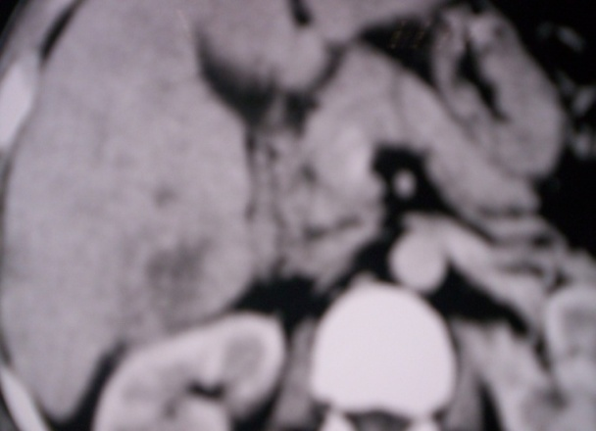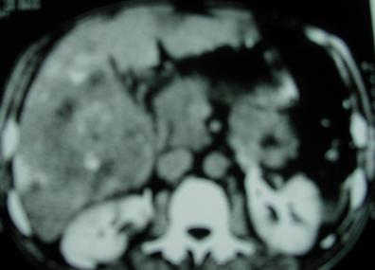**ggggygygygg**

**(b)**

**(a)**

**Figure (5): A case of HCC treated with TACE only** (a) spiral C.T before TACE revealed ill defined heterogeneous infiltrative mass. (b) Spiral C.T One month after treatment with TACE revealed increase size of the tumor in comparison to the previous CT and failed TACE.

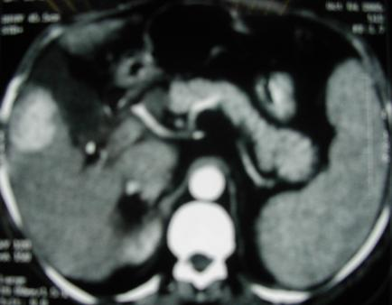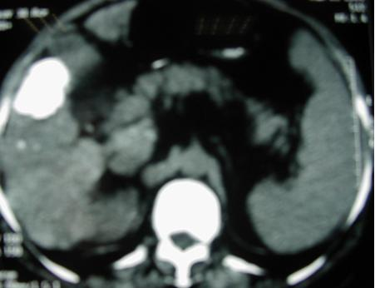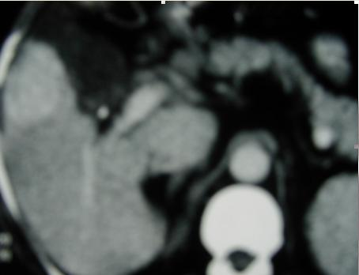

(c)

(b)

(a)

**Figure (6) a case of HCC treated with TACE** (a) spiral C.T before TACE revealed focal lesion measure 5.8 ×4 cm (b) C.T after one month showed good lipidol concentration and successful TACE (c) Follow up C.T abdomen after three months revealed two new focal lesions indicating regional progression in another site after eradicating the lesion by TACE.

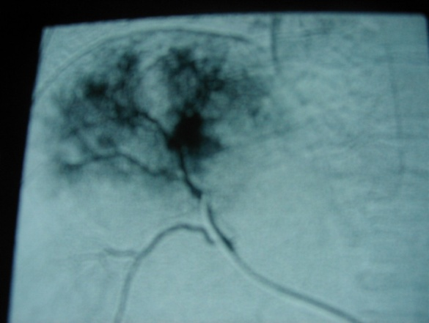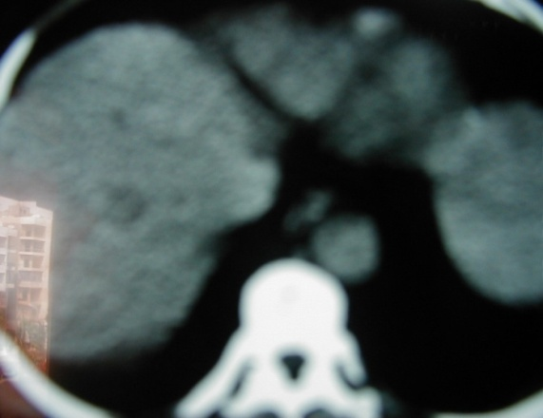

**(a)**

**(b)**

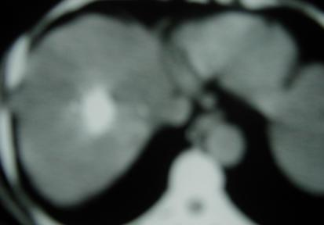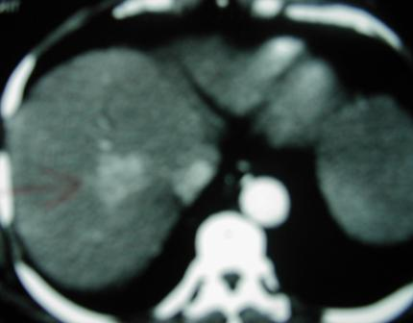

(c)

**(c)**

**(d)**

**Figure (7) A case of HCC treated by TACE** (a) spiral C.T abdomen revealed focal lesion measure about 4.5×4.5 cm (b) Angiography of hepatic focal lesion (c) TACE was done and Follow up spiral CT after one month revealed successfully embolizedhepatoma (d) Follow up spiral C.T after 3 months as compared the previous C.T much decrease size of the tumor with good ablation to the tumor.

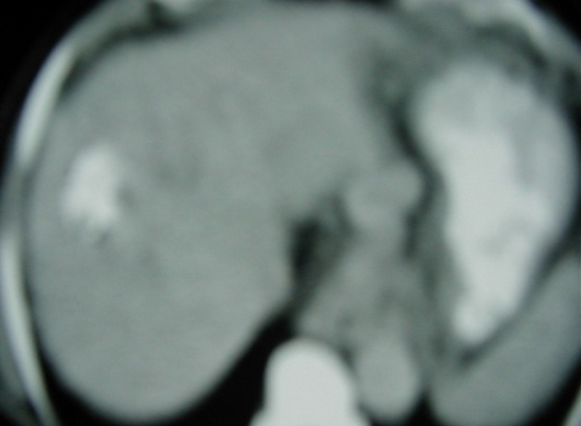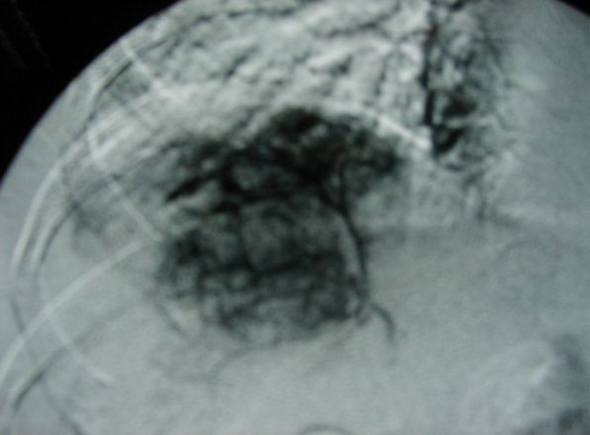

(b)

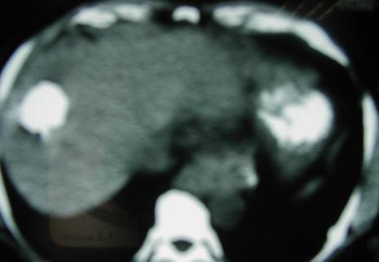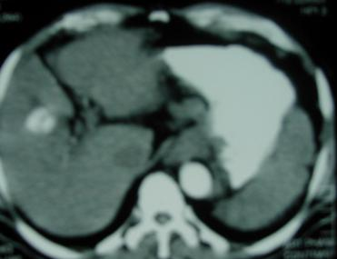

**(d)**

**(c)**

**Figure (8) A case of HCC treated by combined TACE followed by RFA**

**(a)** spiral C.T revealed solitary focal lesion measure 6 × 7 cm (b) TACE was done and spiral C.T abdomen revealed regression in the size after TACE to 4.5 × 5 cm c) Then underwent RFA and spiral CT after combined therapy showing further regression in the size of previously chemoembolized hepatic lesion compared to previous C.T d) Follow up spiral C.T after three months of combined treatment revealed good lipidol concentration within the previously treated lesion with complete ablation of the tumor and denovo lesion appearing in subsegment VI and segment measure 3.3 cm in diameter.

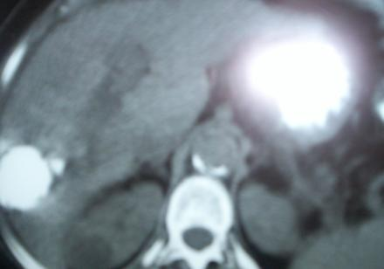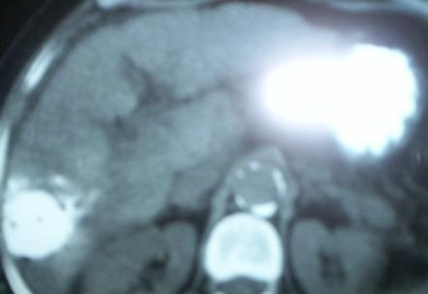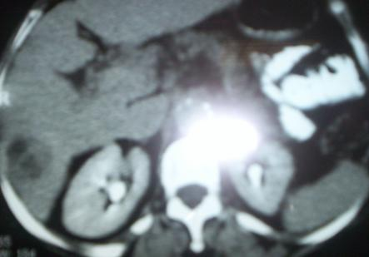

**(c)**

**(b)**

**Figure (9) A case of HCC treated by combined TACE and RFA** (a) spiral CT revealed ill defined focal hepatic lesion measure 10×7 cm (b) TACE was done spiral CT one month after TACE revealed residual tumor tissue is still present c) Then underwent RF ablation spiral CT revealed post TACE and RFA complete ablation of the lesion.

**4. Discussion**

In this study the relapse rateafter1 year of follow up from the interventional treatment was "70%" in group A in comparison to "20%" in group B And According to Kaplan Meier Curve the event free survival in group B more better than group A and also 1 year survival rate in group B "85%" in comparison to group A "50%". This agree with (**Veltri*et al.,* 2006**) who reported survival rates of 89.7% at 12 months in patients with unresectable non-early hepatocellular carcinoma treated with radiofrequency thermal ablation (RFA) after transarterial chemoembolization (TACE). And agree with **(Mark Bloomston 2002)** who reported that mean survival as determined by Kaplan – Meier survival analysis was twice as long in patients undergoing TACE with RFA compared with TACE alone Also this result was in agreement with **(Yamakado*et al.,* 2002)** who found that recurrence rate in patients treated with chemoembolization alone was "33%" and in patients treated with combined TACE and RFA "0%".and In agreement with **(Mark Bloomston*et al.,* 2002)** who reported "27%" recurrence rate in patients treated with combined TACE and RF and "57%" recurrence rate in patients treated with TACE alone. And also with **(Yamakado*et al.,* 2004)** who reported "15%" recurrence rate in combined TACE and RF in comparison to 43% recurrence rate in TACE alone.

The high relapse rate in patient treated with only TACE may be due to the microsatellite lesions and venous tumour emboli that were frequently found around HCC lesions. Socreation of the tumour free margin around the tumour is considered to contribute to good control of HCC lesions and decrease the recurrence rate ,Another possible explanation for therapeutic failures of TACE alone , that chemoembolization destroys the inner core tissue of the tumour which is supplied by an artery and leaves unaffected the periphery of the tumour, which is mostly nourished by portal veins, or TACE destroys only selected subpopulations of the tumor cells with preference for those that are metabolically more compromised while cell resistant to chemoembolization may carry on disease progression **(Sacco*et al.,*2009)**.

In this study the mortality rate was more in group A "20%" in comparison to group B "10%" this was in agreement with **(Mark Bloomston*et al.,* 2002)** who reported survival rate was twice as long in patients undergoing TACE with RFA compared with TACE alone. And also with **(Yamakado, 2002)** who reported "87%" survival rate in their group treated with combined TACE and RF and with **(Yamakado 2004)** who reported 1-year and 2-year survival rate were 100% and 93% respectively in patients with combined TACE and RF.

In this study relapse rate was higher in age > 50 years old "55.6%" in comparison to age < 50 years old "27.3%" and this was in agreement with **(Parker 1996)** found that the incidence and recurrence of HCC increase with age. And with **(Sherlock and Dooley 2002)** who reported that high incidence of HCC in the fifth decade of life.

In this study males show a higher relapse rate "60%" than female relapse rate "0%" with highly significant association in between gender and relapse rate. This agree with **(Sherlock and Dooley2002)** who reported high relapse rate in males than in females in ratio of 5:1 due to hormonal factors as high testosterone levels in males and protective methoxyestradiol in females.

In this study the advanced Okuda stage II cases had a higher relapse rate "71.4%" than Okuda stage I cases "7.7 %" with highly significant relation in between stage of the disease and relapse rate. This agree with **(Seong*et al.,* 2000)** who reported higher relapse rate in advanced Okuda stages "60%" than in early Okuda stages"26%". And with **(Yuen *et al.,* 2003)** who reported local therapies were effective in treatment for patients who have an early stage HCC and preserved liver function (Okuda stage I)and also with **(Yamakado*et al.,* 2002)** who reported that the actual recurrence rate was significantly higher in late Okuda stages "33%" in comparison to early Okuda stages "10%".

In this study tumor size > 7 cm was associated with higher relapse rate "66.7%" than tumor size ≤ 7 cm "39.3%" with highly significant relation in between tumor size and relapse rate .and it is recommended to use of combined TACE and RF in large tumor size that decrease tumor size and decrease relapse rate than treatment with TACE alone in large tumor. This agree with **(Kelvin and Poon., 2005)** who reported that when combining TACE with RFA, the ablation volume of coagulation necrosis can be significantly increased and may enable effective treatment for patients with large HCC. And also with **(Yamakado*et al.,* 2002)** who reported the useful therapeutic effects of combined TACE and RF not only for lesions 3 cm or smaller in size but also for lesions larger than 5 cm. This agree also with **(Rossi *et al.,* 2000)** who reported that the blockage of the hepatic artery during TACE increase the size of the area of thermal ablation by eliminating convection by blood flow and decreasing impedance in the tumor during RFA.

**Conclusions and Recommendations**

* Combined TACE and RFA were more effective than TACE alone and it is mandatory to use combined therapy in large lesions more than 5 cm
* We recommend that this study to be reconducted over a longer follow up period for about 3 – 5 years and on a larger number of patients
* Other comparative studies of other combined therapy as combined RFA and PEI, TACE and PEI, RFA and hepatic resection, to determine the most effective therapeutic combination in treatment of HCC

**Corresponding author**

**SherifMoneir Mohamed1**

Internal medicine Department, Faculty of medicine-Ain Shams University

[moh.mazen2006@yahoo.com](mailto:moh.mazen2006@yahoo.com)

**References**

1. Baig JA, Alam JM, Mahmood SR,*et al.,*2009. Hepatocellular carcinoma (HCC) and diagnostic significance of α-fetoprotein (AFP). J Ayub Med Coll Abbottabad,; 21(1):72-75.

## Bruix J and Sherman M., 2011. Management of hepatocellular carcinoma: An update.Hepatology; 53(3): 1020–1022.

1. Corey KE and Pratt DS., 2009. Review: Current status of therapy for hepatocellular carcinoma. TherapeuticAdvances in Gastroenterology; 2(1), 45-57.
2. El – Sherif, KH., 2002. Serial alpha – fetoprotein levels versus spiral C.T after radiofrequency ablation of hepatocellular carcinoma. MSC thesis 2002, tropical medicine, Cairo University.
3. [Georgiades CS](http://www.ncbi.nlm.nih.gov/pubmed?term=%22Georgiades%20CS%22%5BAuthor%5D), [Hong K](http://www.ncbi.nlm.nih.gov/pubmed?term=%22Hong%20K%22%5BAuthor%5D), [Geschwind JF](http://www.ncbi.nlm.nih.gov/pubmed?term=%22Geschwind%20JF%22%5BAuthor%5D)., 2008. Radiofrequency ablation and chemoembolization for hepatocellular carcinoma. [Cancer J.](http://www.ncbi.nlm.nih.gov/pubmed/18391617);14(2):117-22.
4. Kelvin KN and, Poon RT., 2005. Radiofrequency ablation for malignant liver tumor. Surgical Oncology; 14: 41 – 52.
5. Kim YJ, Raman SS, Yu NC *et al.,* 2008. Radiofrequency Ablation of Hepatocellular Carcinoma: Can subcapsular tumors be safely ablated? Am J Roentgenol.; 190(4):1029-1034.
6. Mahmaud, M., 2003. Comparative study between percutaneous ethanol injection and radiofrequency thermal ablation in treatment of hepatocellular carcinoma. MD thesis 2003, tropical medicine, Cairo University.
7. Mark Bloomston, MD, OdionBinitie, BS, ElieFraiji, MD. *et al.,*2002.Transcatheter arterial chemoembolization with or without radiofrequency ablation in the management of patients with advanced hepatic malignancy. Presented at 70th annual meeting, South Eastern Surgical Congress, February; 1-5.
8. Montalto G and cervello M ., 2002. Epidemiology, Risk factors and natural history of hepatocellular carcinoma. Ann NYAcadsci; 963: 13 – 20.
9. Park MJ , KimYS, Rhim H , *et al.,*2010. Prospective Analysis of the Pattern and Risk for Severe Vital Sign Changes During Percutaneous Radiofrequency Ablation of the Liver Under Opioid Analgesia. *AJR*; 194:799- 808.
10. Parker SL, Tong T, Baden S, *et al.,*1996. Cancer statistics. Cancer; 46 : 5.
11. Rossi S, Garbagnati F, Lencioni R, *et al.,*2000. Percutaneous radio-frequency thermal ablation of nonresectable hepatocellular carcinoma after occlusion of tumor blood supply. Radiology; 217: 119 – 126.
12. Sacco R, Bertini M, Petruzzi P, *et al.,* 2009. Clinical impactof selective transarterialchemoembolization on hepatocellular carcinoma: A cohort study. World J Gastroenterol: 15(15): 1843-1848**.**
13. Seong J, Keum KC, Park HC *et al.,* 2000. Combined transcatherter arterial chemoembolization and local radiofrequency of unresectable hepatocellular carcinoma. Int J radiatoncolBiophys , 47 (5) P: 1331 – 1335.
14. Sherlock S and Dooley, J (eds.). Diseases of the liver and biliary system(2002), eleventh edition., Blackwell scientific publications. London, Edinburgh, Boston.
15. Shin SW., 2009. The Current Practice of Transarterial Chemoembolization for the Treatment of Hepatocellular Carcinoma. Korean J Radiol.; 10:425-434 .
16. Singal AG and Marrero JA., 2010. Recent Advances in the Treatment of Hepatocellular Carcinoma. CurrOpinGastroenterol.; 26(3):189-195.
17. [Veltri A](http://www.ncbi.nlm.nih.gov/pubmed?term=%22Veltri%20A%22%5BAuthor%5D), [Moretto P](http://www.ncbi.nlm.nih.gov/pubmed?term=%22Moretto%20P%22%5BAuthor%5D), [Doriguzzi A](http://www.ncbi.nlm.nih.gov/pubmed?term=%22Doriguzzi%20A%22%5BAuthor%5D), *et al.,*2006. Radiofrequency thermal ablation (RFA) after transarterial chemoembolization (TACE) as a combined therapy for unresectable non-early hepatocellular carcinoma (HCC). [Eur Radiol.](http://www.ncbi.nlm.nih.gov/pubmed/16228211);16(3):661-669
18. Yamakado K, Nakatsuka A, Ohmori S, *et al.,* 2002. Radiofrequency ablation combined with chemoembolization in hepatocellular carcinoma: Treatment response based on tumor size and morphology. J VascintervRadiol; 13: 1225 – 1232.
19. Yamakado K, Nakatsuka A, Akebsoshi M, *et al.,* 2004. Combination therapy with radiofrequency ablation and transcatheter chemoembolization for the treatment of hepatocellular carcinoma. Short-term recurrences and survival, oncology reports; 11: 105 –109.
20. Yuen MF, Chan AO, Wing BCY, *et al.,*2003. Transarterial chemoembolization for inoperable, early stage hepatocellular carcinoma in patients with child – pugh grade A and B: Results of a comparative study in 96 chinese patients. The American Journal of Gasteroenterology (AJG).; 98 (5): 1181 – 1185.

10/10/2012