Salvage Radiotherapy Following Radical Prostatectomy: The Proper Timing and Clinical Benefits

Mohamed F. Sheta¹, MD, Esam A. Abo-Zena ¹, MD and Mohamed H. Radwan², MD

¹ Department of Clinical Oncology, Tanta University Hospital, Tanta, Egypt
²Department of Urology, Tanta University Hospital, Tanta, Egypt
Mohamed_sheta1@yahoo.com

Abstract: Background: For prostate cancer patients following radical prostatectomy (RP) the treatment options includes adjuvant radiation therapy and regular prostate-specific antigen (PSA) follow up with salvage radiotherapy (SRT) in case of biochemical recurrence (BCR). The objective of this study was to identify the proper timing of implementation of SRT. Methods: 34 prostate cancer (PC) patients who had been operated with RP and underwent regular PSA follow up were assigned to receive SRT upon BCR. Patient evaluation included assessment of freedom from progression (FFP) and overall survival (OS) after SRT and the optimal timing of initiation SRT following RP depending on PSA values. Results: In univariate analysis, both pre-SRT PSA ˂ 0.2 ng/ml compared to PSA ≥ 0.2ng/ml and post-SRT PSA nadir ˂ 0.1 ng/ml compared to PSA nadir ≥ 0.1 ng/ml ([HR]: 4.49, 95% CI: 1.56 to 12.91; P= 0.005) had significant correlation with PFS. The 3 years progression free survival was 84.6% and 37.3% for patients had pre SRT PSA ˂ 0.2 ng/ml and ≥ 0.2 ng/ml respectively (P =0.015). For post SRT PSA, the 3 years PFS was 68% and 22.2% for patients had post SRT PSA nadir ˂ 0.1 ng/ml and ≥ 0.1 ng/ml respectively ( P= 0.005). In multivariate analysis, post-SRT PSA (P= 0.031) was independently significantly related to PFS. Conclusions: The current study proved the importance of pre-salvage radiotherapy PSA level of ˂ 0.2 ng/ml and post-salvage radiotherapy PSA nadir ˂ 0.1 ng/ml as a potentially useful markers of good prognosis in biochemical recurrent PC and how far these parameters are really predicting much better outcomes.
[Mohamed F. Sheta, Esam A. Abo-Zena, and Mohamed H. Radwan. Salvage Radiotherapy Following Radical Prostatectomy: The Proper Timing and Clinical Benefits. J Am Sci 2018;14(1):1-8]. ISSN 1545-1003 (print); ISSN 2375-7264 (online). http://www.jofamericanscience.org. 1. doi:10.7537/marsjas140118.01.

Keywods: Salvage Radiotherapy, Radical Prostatectomy, Proper Timing, Clinical Benefits

1. Introduction
Radical prostatectomy (RP) is one of the first-line therapy options for prostate cancer. The best results are obtained with organ-confined disease. Recurrence correlates with risk factors such as extra-prostatic tumor extension, a high Gleason score, positive surgical margins, a short prostate-specific antigen (PSA) doubling time and also post- RP persistence of PSA [1, 2]. Approximately one in five PC patients who undergo RP will recur [3] with higher rates of recurrence, 40%–60%, among patients with adverse pathological risk factors [4].
For patients with adverse pathologic features, adjuvant radiation therapy (ART), given before a rise in PSA level, may be an appropriate line of treatment with many randomized trials have shown improved biochemical progression free survival and overall survival for such approach [5, 6, 7]. However, Ghia et al. [8] and Schreiber et al. [9] reported that only ˂ 20% of qualifying patients for ART will actually receive ART. Instead of giving ART, many physicians choose to observe these patients closely with serial PSA tests and offer radiotherapy selectively, as a salvage treatment upon a rise in PSA after RP. From the physician perspective, the predominant reasons for favoring close observation with selective salvage radiotherapy (SRT) over ART for patients with adverse prognostic factors after RP include RT toxicity, the risk of overtreatment with ART (i.e. a proportion of patients who would not develop biochemical failure after RP despite poor prognostic factors), and the perceived equivalent effectiveness of SRT and ART [10].
The objective of this study was to reveal the proper timing of implementation SRT for patients who preferred PSA follow up following RP. We were concern about the pre-SRT PSA and the patients’ PSA response to SRT as parameters that predict long-term progression free survival and overall survival.

2. Patients and Methods
Patients and Study Design
This is prospective clinical trial had been conducted in Clinical Oncology Department and Urology Department, Faculty of Medicine, Tanta University from January 2011 to March 2015. This study included 34 patients who had been operated with RP for PC, underwent regular PSA follow up, and received SRT upon BCR. Exclusion criteria included severe co-morbidities, prior adjuvant radiation therapy, prior hormonal therapy or chemotherapy, and overt metastases. All patients provided written informed consent prior to enrollment into the study. The Ethics Committee at our Faculty of Medicine, Tanta University granted protocol approval.
Urology Department participation
All patients underwent transrectal core biopsy for histopathological diagnosis and determination of Gleason score (GS), PSA analysis, and pelvic MRI and bone scan to make sure that the disease is still loco-regional. Patients underwent RP and referred to the Clinical Oncology Department.
Clinical Oncology Department participation
Patients with adverse prognostic factors for recurrence had been informed about the pros and cons of ART and SRT treatment lines, and for those who preferred ART; they had been excluded from the trial. Regular PSA follow up was done and once BCR had been documented, the initiation of SRT was arranged.
Salvage radiotherapy
Salvage radiotherapy was prescribed for PSA recurrence defined by Kinoshita et al. [11] who defined BCR as three consecutive elevations of PSA above 0.1 ng/ml.SRT was applied based on 3D planning with 1 cm safety margins. The prescribed dose to the prostatic fossa plus the seminal vesicles was 70.2 Gy [range: 59.4–70.2; median applied dose 66.6 Gy].
Patient assessment
Following SRT, PSA analysis was done monthly. We adopted the Post-SRT progression criteria proposed by Stephenson et al. [12] who defined a rising PSA 0.2 ng/ml or more above the achieved nadir to be the landmark of progression.
Study End Points
The primary end point would be freedom from progression (FFP) and overall survival (OS) after SRT following RP in the event of BCR. The secondary end point would be the optimal timing of initiation SRT following RP depending on PSA values.
Statistical Analyses
The primary outcomes were the percentage change in the PSA level from post-SRT baseline. Values are reported as means unless indicated otherwise. Changes were tested for significance using one-sample Student t tests. Univariate regression models were fit for changes in PSA level. Next, multivariate models were fit using all explanatory variables to identify those that were independently predictive. Overall-survival (OS) rates were calculated from the date of start of SRT to the time of the last follow-up visit or death using the Kaplan-Meier method [13] with SPSS [Statistical package] (version 21.0). Progression-free survival (PFS) was the time elapsed from the date of initiation of SRT to the date of first evidence of disease progression or death in the absence of disease progression. Kaplan Meier method is used for estimating survival. The 95% confidence intervals (95% CIs) were calculated with the exact method. All data were included in the efficacy analyses. All P values were 2 sided and P ≤ 0.05 were considered to be statistically significant.

3. Results

Table (1): BCR Patient Characteristics
Character | Patients (N=34)  No. (%)
Age group  >60 years  ≤ 60 years  Median age  Mean age,  Range | 23 (67.6)  11 (32.4)  63 yeas  63.8 yeas  51-75 years
Performance Status (ECOG)  0-1  2 | 25 (73.5)  9 (26.5)
Pathological Tumor status  pT₂  pT_{3a}  pT_{3b}  pT₄ | 20 (58.8)  11 (32.4)  2 (5.9)  1 (2.9)
Pre-RP PSA, ng/mL  Median, 9.9(5-38)  < 10  10 – 20  >20 | 17 (50)  12 (35.3)  5 (14.7)
Gleason score on biopsy  ≤6  =7  8-10 | 20 (58.8)  10 (29.4)  4 (11.8)
Surgical margins  Negative (R0)  Positive (R1)  Unknown (Rx) | 28 (82.4)  5 (14.7)  1 (2.9)
Pre-SRT PSA, ng/mL  Median  ˂0.2  ≥0.2 | 0.3 (0.15-3.2)  13 (38.2)  21 (61.8)
Post-SRT PSA, ng/mL  Median  ˂0.1  ≥0.1 | 0.08( 0.01-2.2)  25 (73.5%).  9 (26.5%)
Comorbidity  0  1 or more | 23 (67.6)  11 (32.4)
Abbreviations: BCR denotes biochemical recurrence; ECOG denotes Eastern Cooperative Oncology Group; RP denotes radical prostatectomy; PSA denotes prostate-specific antigen; SRT denotes salvage radiotherapy.

Between January 2011 and March 2015, 59 patients with PC underwent RP. Among patients with risk factors for recurrence, 3 patients preferred ART and excluded from the trial. Another 2 patients maintained persistent high PSA following RP and considered to be a local residual disease and referred directly to SRT and excluded from the trial. All the remaining 54 patients underwent regular PSA follow up. Thirty four patients developed BCR and received SRT. BCR Patient characteristics are listedintable1. BCR occurred after a median time of 10 months (range 5–24 months) post-RP. The median delay from BCR to salvage radiotherapy was 45days. SRT was given at a median PSA of 0.3 ng/ml. The median follow up after SRT was 36 months (range 19 to 46 months).
Response to SRT
After SRT, 25 patients (73.5%) achieved a PSA nadir <0.1 ng/ml while the remaining 9 patients (26.5%) maintained higher values. The correlation between pre- and post- SRT PSA values was evident with 84% of patients (11/13) with pre- SRT PSA ˂ 0.2 ng/ml achieved PSA nadir ˂0.1 ng/ml while only 67% of patients (14/21) with pre- SRT PSA ≥ 0.2ng/ml achieved PSA nadir ˂0.1 ng/ml revealing that the early implementation of SRT resulted in more deep response. All PSA responses were confirmed at least 4 weeks after first observation.
Progression free survival following SRT was suspended when PSA ≥ 0.2 ng/ml above nadir and rising further. The 3-year progression free survival and overall survival for all patients treated with salvage radiotherapy were 55.7% & 90.5% respectively (Figures 1 & 2).
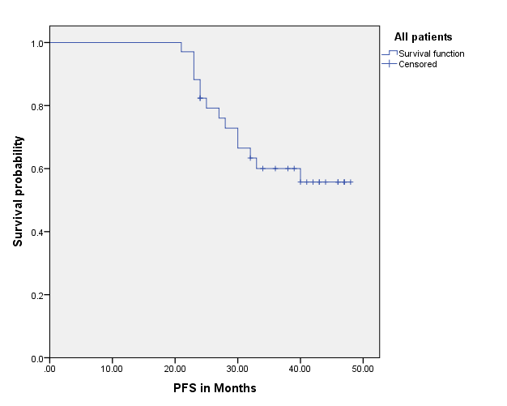
Figure 1: Progression free survival for all patients.

Table (2): Prgression free survival and Univariate cox analyses of progression free in relation to patient and tumor characteristics as well as to treatment modality
Variable | 3 years PFS % | P | HR | 95% CI | P
Age  > 60 vs  ≤ 60 | 41.7  81.8 | 0.094 | 3.34 | 0.74 to 15.07 | 0.118
Performance status, ECOG  2 vs  0-1 | 11.1  72.9 | ˂ 0.0001* | 6.17 | 2.05 to 18.62 | 0.001*
Pathological stage  T3,4 vs  T2 | 28.6  76.8 | 0.001* | 5.41 | 1.67 to 17.55 | 0.005*
Pre-RP PSA, ng/mL  ≥ 10 vs  ˂ 10 | 52.9  57.6 | 0.514 | 1.42 | 0.49 to 4.08 | 0.521
Gleason score  ≥ 7 vs  ˂7 | 21.4  79.2 | 0.002* | 5.17 | 1.61 to 16.67 | 0.006*
Surgical margins  R1 vs  R0 | 0.00  68.5 | ˂ 0.0001* | 6.59 | 1.98 to 21.94 | 0.002*
Pre-SRT PSA, ng/mL  ≥ 0.2 vs  ˂ 0.2 | 37.3  84.6 | 0.005* | 6.88 | 1.11 to 32.58 | 0.015*
Post-SRT PSA, ng/mL  ≥ 0.1 vs  ˂ 0.1 | 22.2  68.0 | 0.002* | 4.49 | 1.56 to 12.91 | 0.005*
Abbreviations: CI denotes confidence interval; HR denotes hazard ratio; ECOG denotes Eastern Cooperative Oncology Group; RP denotes radical prostatectomy; PSA denotes prostate-specific antigen; SRT denotes salvage radiotherapy.
*P ˂ 0.05.

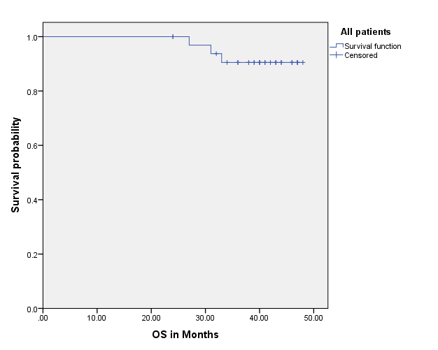
Figure 2: Overall survival for all patients.

Regarding other parameters which could affect PFS following SRT; the performance status, pathological stage, Gleason score, and surgical margin were significantly related to PFS while age and pre-RP PSA were not significantly related to PFS in univariate analysis (Table 2).
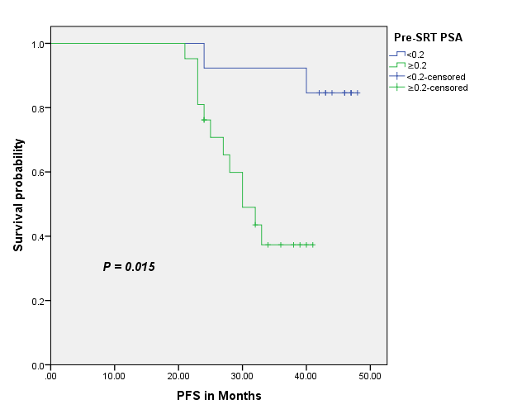
Figure 3: Progression free survival in relation to pre-SRT PSA level.

In univariate analysis, both pre-SRT PSA (hazard ratio [HR]: 6.88, 95% CI: 1.11 to 32.58; P= 0.015) and post-SRTPSA ([HR]: 4.49, 95% CI: 1.56 to 12.91; P= 0.005) PSA had significant correlation with PFS (Table 2). The 3 years progression free survival was 84.6% and 37.3% for patients had pre SRT PSA ˂0.2 ng/ml and ≥0.2 ng/ml respectively (P= 0.015) (Table 2, Figure 3). For post SRT PSA, the 3 years PFS was 68% and 22.2% for patients had post SRT PSA nadir ˂0.1ng/ml and ≥0.1 ng/ml respectively ( P= 0.005) (Table 2, Figure 4).

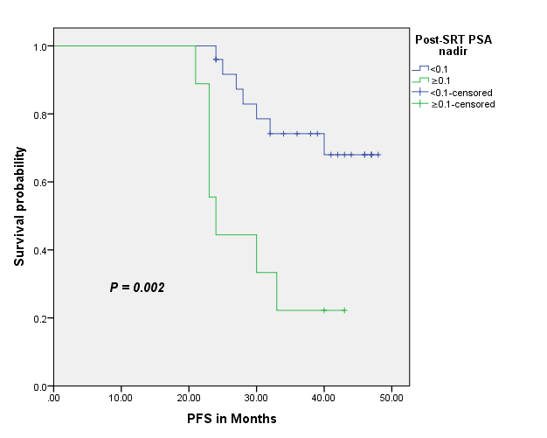
Figure 4: Progression free survival in relation to post-SRT PSA level.

In multivariate analysis, post-SRT PSA (P= 0.031) and Gleason score (P= 0.022), were independently significantly related to PFS (Table 3). As regard the other parameters, Pre-SRT PSA, performance status, pathological stage and surgical margin were not significantly related to PFS (Table 3).

Table (3). Multivariate Hazard Ratios From Cox Proportional Hazards for PFS
Variable | HR | 95% CI | P
Performance status (ECOG) ( 2 vs 0-1 ) | 2.66 | 0.57 to 12.42 | 0.214
Pathological stage ( T3,4 vs T2 ) | 2.63 | 0.03 to 04.47 | 0.442
Gleason score ( ≥ 7 vs ≤ 6 ) | 5.96 | 1.29 to 27.61 | 0.022*
Surgical margins ( R1 vs R0 ) | 4.83 | 0.65 to 36.04 | 0.124
Pre-SRTPSA, ng/mL ( ≥ 0.2 vs ˂ 0.2 ) | 3.33 | 0.46 to 24.15 | 0.234
Post-SRT PSA, ng/mL ( ≥ 0.1 vs ˂ 0.1 ) | 8.12 | 1.21 to 54.37 | 0.031*
Abbreviations: CI denotes confidence interval; HR denotes hazard ratio; ECOG denotes Eastern Cooperative Oncology Group; PSA denotes prostate-specific antigen; SRT denotes salvage radiotherapy.
*P ˂ 0.05.

Regarding the impact of pre-SRT PSA and post-SRT PSA parameters on OS, both affected the 3-year OS favorably. The 3-year OS for patients had pre SRT PSA ˂ 0.2 ng/ml and those ≥ 0.2ng/ml was 100% and 83.9% respectively, however, the difference was insignificant (p=0.137) ((Figure 5). For post SRT PSA, the 3 years OS was 95.7% and 77.8% for patients had post SRT PSA nadir ˂ 0.1 ng/ml and ≥ 0.1 ng/ml respectively and the difference was significant (P= 0.124) (Figure 6).

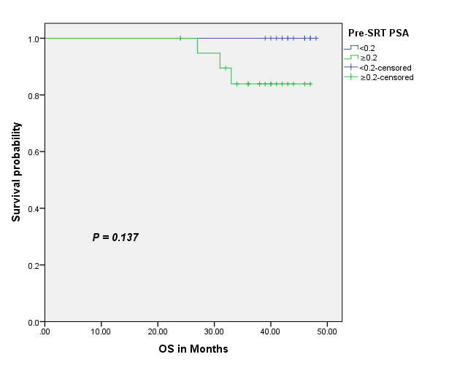
Figure 5: Overall survival in relation to pre-SRT PSA level.

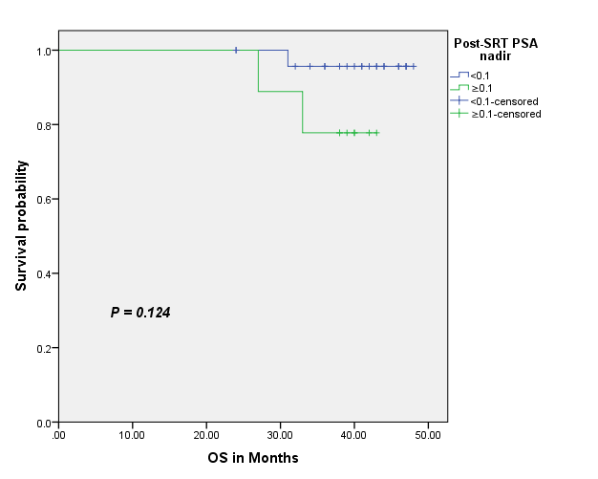
Figure6: Overall survival in relation to post-SRT PSA level.

4. Discussion
Radical prostatectomy is a well-established treatment modality that provides excellent control in localized prostate cancer. However, a significant proportion of patients will develop biochemical recurrence following surgery depending on the selection criteria used at the time of surgery [14, 15].
All Patients with risk factors for recurrence in our study had been given the choice between ART or SRT upon BCR after they had been informed about the pros and cons of both treatment strategies. Enrollment in this study required official agreement for treatment protocol. Another point which needed to be addressed openly and adequately was the role of the urologist in case of BCR. Many urologists recognize BCR after surgery as it represents occult metastatic disease and these patients should be offered androgen deprivation therapy, mostly surgical castration, which offers a limited possibility of long-term disease control, rather than SRT which represents the only potentially hope for cure. This point in particular was the reason to conduct this trial in collaboration with Urology department.
The American Urological Association (AUA) defined BCR after RP as a two consecutive PSA greater than 0.2 ng/ml [16]. However, ultrasensitive PSA assays have improved detection level down to 0.01 ng/ml and many researchers adopted a lower level for BCR like Kinoshita et al [11] who defined BCR as three consecutive elevations of PSA above 0.1 ng/ml.
It is well recognized that clinical recurrence is usually preceded by PSA progression [17]. Therefore, initiating salvage radiotherapy upon biochemical evidence of disease is now backed up by international guidelines. However, the appropriate PSA level to trigger SRT is not yet defined uniformly [1, 18]. Studies in prostate cancer field have shown conflicting data about the optimal timing to initiate SRT. Stephenson et al. [12] observed freedom from progression after six years in 48% of the patients with a pre-salvage radiotherapy PSA up to 0.5 ng/ml but only 26% in men with a higher PSA level. Briganti et al. [19] reported that salvage radiotherapy at a median PSA of 0.22 ng/ml yielded results nearly identical with adjuvant radiotherapy. European Guidelines suggest that salvage radiotherapy might be initiated, at PSA levels of 0.1–0.3 ng/ml, if a continuous PSA increase has been documented [20], and Siegmann et al. [21] reported that a cut-off at 0.28 ng/ml distinguished high risk (39%) and low risk (22%) of post-salvage radiotherapy BCR.
In our study we considered a PSA > 0.1ng /ml to be the BCR value. We focused on the pre-salvage radiotherapy PSA values and on the patients’ PSA response to SRT as parameters that predict outcomes and support the early implementation of SRT. We considered a pre SRT PSA cutoff 0.2 ng/ml for analysis and the PSA response to SRT was classified into PSA nadir ˂ 0.1 ng/ml and ≥ 0.1 ng/ml.
The 3-year progression free survival and overall survival for all patients treated with salvage radiotherapy were 55.7% & 90.5% respectively. The PFS was close to that reported by Do et al. [22] and Laurent et al. [23] but better than reported in other trials [24, 25] which basically could be related to the longer duration of follow up in these trials as all reported the 5-yearrather than the 3-year PFS. The good response with SRT represented a viable option following BCR after RP and should be recommended instead of ADT which would waste an effective potentially curative treatment line besides it might be never needed. These reasons should encourage urologists to prefer SRT over orchiectomy in PC with BCR.
Univariate analysis revealed that all the pre-SRT PSA, post-SRT PSA, PS, pathological stage, Gleason score, and surgical margin were significantly related to PFS while in multivariate analysis, only post-SRT PSA and Gleason score were significantly correlated with PFS.
The influence of pre SRT PSA level whether < 0.2 or ≥ 0.2 ng/ml on progression free survival was significant in univariate analysis but not in multivariate one in our trial. Despite this insignificant correlation in multivariate analysis, there was a deeper response with early implementation of SRT which definitely translated into improvement in PFS. Many researchers revealed the importance of initiating SRT for BCR at a low PSA values. Stephenson et al [12], Siegmann et al [21], and Terai A et al [26] reported worse PFS with pre SRT PSA more than 0.5 ng/ml, 0.28 ng/ml, and 0.15 ng/ml than lower values respectively. However, the exact value of PSA for the initiation of SRT have not clearly defined specially with the new ultrasensitive PSA assays which can detect PSA level down to 0.01 ng/ml.
The influence of PSA response to SRT whether achieved PSA nadir < 0.1 or ≥ 0.1 ng/ml on PFS was significant in univariate and multivariate analysis in our study. These results were in agreement with other studies which reported that achieving a post- salvage radiotherapy PSA nadir <0.1 ng/ml is a favorable prognostic marker [27,28, 29].
Our study revealed other factors rather than pre- and post-SRT PSA values that affected failure after SRT. The performance status, pathological stage, Gleason score, and surgical margin were significantly related to PFS in univariate analysis with only Gleason score was significant prognosticator in multivariate one. Several trials like Briganti et al. [30], Moreira et al. [31], and Stephenson et al. [12] reported the influence of pathological stage, Gleason score, and surgical margin on the outcomes after SRT. These factors were in common with that predicted BCR following RP reflecting the whole course of disease and the biological nature of the tumor.
In conclusion, our study emphasized the importance of pre-salvage radiotherapy PSA level of ˂0.2 ng/ml and post-salvage radiotherapy PSA nadir ˂0.1 ng/ml as a potentially useful markers of good prognosis in biochemical recurrent PC and how far these parameters are really predicting much better outcomes. However, larger number of cases and longer follow up period are necessary to confirm their independent prognostic value in a multivariate analysis.

Compliance with Ethical Standards
Conflict of Interest
The author Mohamed F. Sheta declared that he has no conflict of interest. The author Esam A. Abo-Zena declared that he has no conflict of interest. The author Mohamed H. Radwan declared that he has no conflict of interest.

Ethical approval
All procedures performed in studies involving human participants were in accordance with the ethical standards of the institutional and/or national research committee and with the 1964 Helsinki declaration and its later amendments or comparable ethical standards.

Informed consent:
Informed consent was obtained from all individual participants included in the study.

Reference
    - Heidenreich A, Bastian PJ, Bellmunt J, et al. EAU guidelines on prostate cancer. Part II: treatment of advanced, relapsing, and castration-resistant prostate cancer. Eur Urol 2014; 65: 467–79.
    - Wiegel T, Bartkowiak D, Bottke D, et al. Prostate-specific antigen persistence after radical prostatectomy as a predictive factor of clinical relapse-free survival and overall survival: 10-year data of the ARO 96–02 trial. Int J Radiat Oncol Biol Phys 2015; 91: 288–94.
    - Han M, Partin AW, Pound CR, et al. . Long-term biochemical disease-free and cancer-specific survival following anatomic radical retropubic prostatectomy. The 15-year Johns Hopkins experience, UrolClin North Am, 2001, vol. 28 (pg. 555-565).
    - Swanson GP, Riggs M, Hermans M. Pathologic findings at radical prostatectomy: risk factors for failure and death, Urol Oncol , 2007, vol. 25 (pg. 110-114).
    - Wiegel T, Bottke D, Steiner U, et al. . Phase III postoperative adjuvant radiotherapy after radical prostatectomy compared with radical prostatectomy alone in pT3 prostate cancer with postoperative undetectable prostate-specific antigen: ARO 96-02/AUO AP 09/95, J Clin Oncol , 2009, vol. 27 (pg.2924-2930).
    - Thompson IM, Tangen CM, Paradelo J, et al. . Adjuvant radiotherapy for pathologically advanced prostate cancer: a randomized clinical trial, JAMA , 2006, vol.296 (pg.2329-2335).
    - Thompson IM, Tangen CM, Paradelo J, et al. . Adjuvant radiotherapy for pathological T3N0M0 prostate cancer significantly reduces risk of metastases and improves survival: long-term followup of a randomized clinical trial, J Urol , 2009, vol. 181 (pg. 956-962).
    - Ghia AJ, Shrieve DC, Tward JD. Adjuvant radiotherapy use and patterns of care analysis for margin-positive prostate adenocarcinoma with extracapsular extension: postprostatectomy adjuvant radiotherapy: a SEER analysis, Urology , 2010, vol. 76 (pg. 1169-1174).
    - Schreiber D, Rineer J, Yu JB, et al.. Analysis of pathologic extent of disease for clinically localized prostate cancer after radical prostatectomy and subsequent use of adjuvant radiation in a national cohort, Cancer , 2010, vol. 116 (pg.5757-5766).
    - Nielsen ME, Trock BJ, Walsh PC. Salvage or adjuvant radiation therapy: counseling patients on the benefits, J Natl Compr Canc Netw , 2010, vol. 8 (pg. 228-237).
    - Kinoshita H, Kamoto T, Nishiyama H, Nakamura E, Matsuda T, Ogawa O. Prostate specific antigen nadir determined using ultra-sensitive prostate specific antigen as a predictor of biochemical progression after radical prostatectomy in Japanese males. Int J Urol. 2007; 14:930– 934.
    - Stephenson AJ, Scardino PT, Kattan MW, et al. Predicting the outcome of salvage radiation therapy for recurrent prostate cancer after radical prostatectomy. J Clin Oncol 2007; 25: 2035–41.
    - Kaplan EL, Meier P. Nonparametric estimation from incomplete observations. J Am Stat Assoc1958; 53: 457-81. DOI:10.1080/01621459.1958.10501452.
    - Moul JW. Prostate specific antigen only progression of prostate cancer. J Urol. 2000;163:1632–42.
    - Han M, Partin AW, Zahurak M, et al. Biochemical (prostate specific antigen) recurrence probability following radical prostatectomy for clinically localized prostate cancer. J Urol. 2003;169:517–23.
    - Cookson MS, Aus G, Burnett AL, et al. Variation in the definition of biochemical recurrence in patients treated for localized prostate cancer: the American Urological Association Prostate Guidelines for Localized Prostate Cancer Update Panel report and recommendations for a standard in the reporting of surgical outcomes. J Urol. 2007;177:540–545.
    - Stephenson AJ, Kattan MW, Eastham JA, et al. Defining biochemical recurrence of prostate cancer after radical prostatectomy: a proposal for a standardized definition. J Clin Oncol 2006; 24: 3973–8.
    - Valicenti RK, Thompson Jr I, Albertsen P, et al. Adjuvant and salvage radiation therapy after prostatectomy: American Society for Radiation Oncology/ American Urological Association guidelines. Int J Radiat Oncol Biol Phys 2013; 86: 822–8.
    - Briganti A, Wiegel T, Joniau S, et al. Early salvage radiation therapy does not compromise cancer control in patients with p T3N0 prostate cancer after radical prostatectomy: results of a match-controlled multi-institutional analysis. Eur Urol 2012;62:472–87.
    - Heidenreich A, Bastian PJ, Bellmunt J, et al. EAU guidelines on prostate cancer. part 1: screening, diagnosis, and local treatment with curative intent-update 2013. Eur Urol 2014;65:124–37.
    - Siegmann A, Bottke D, Faehndrich J, et al. Salvage radiotherapy after prostatectomy – what is the best time to treat? Radiother Oncol 2012;103:239–43.
    - Do T, Parker RG, Do C, et al: Salvage radiotherapy for biochemical and clinical failures following radical prostatectomy. Cancer J Sci Am 4:324–330, 1998.
    - Laurent Q, Pierre M-A, Vincent R, et al. Salvage radiotherapy for patients with PSA relapse after radical prostatectomy: a single institution experience. BMC Cancer. 2008; 8: 26.
    - Chawla AK, Thakral HK, Zietman AL, Shipley WU. Salvage radiotherapy after radical prostatectomy for prostate adenocarcinoma: analysis of efficacy and prognostic factors. Urology. 2002;59:726–731.
    - Neuhof DH, Bischof T, Sroka-Perez M, Hohenfellner G, Debus MJ. Long-term results and predictive factors of three-dimensional conformal salvage radiotherapy for biochemical relapse after prostatectomy. Int J Radiat Oncol Biol Phys. 2007;67:1411–1417.
    - Terai A, Matsui Y, Yoshimura K, Arai Y, Dodo Y. Salvage radiotherapy for biochemical recurrence after radical prostatectomy. BJU Int. 2005;96:1009–1013.
    - Geinitz H, Riegel MG, Thamm R, et al. Outcome after conformal salvage radiotherapy in patients with rising prostate-specific antigen levels after radical prostatectomy. Int J Radiat Oncol Biol Phys 2012; 82: 1930–7.
    - Jackson WC, Johnson SB, Foster B, et al. Combining prostate-specific antigen nadir and time to nadir allows for early identification of patients at highest risk for development of metastasis and death following salvage radiation therapy. Pract Radiat Oncol 2014; 4: 99–107.
    - Wiegel T, Lohm G, Bottke D, et al. Achieving an undetectable PSA after radiotherapy for biochemical progression after radical prostatectomy is an independent predictor of biochemical outcome–results of a retrospective study. Int J Radiat Oncol Biol Phys 2009; 73: 1009–16.
    - Briganti A, Karnes RJ, Joniau S, et al. Prediction of outcome following early salvage radiotherapy among patients with biochemical recurrence after radical prostatectomy. Eur Urol 2014; 66: 479–86.
    - Moreira DM, Jayachandran J, Presti Jr JC, et al. Validation of a nomogram to predict disease progression following salvage radiotherapy after radical prostatectomy: results from the SEARCH database. BJU Int 2009; 104: 1452–6.

12/13/2017

