Assessing Sediment Loading from Agricultural Croplands in the Great Lakes Basin

Da Ouyang ¹, Jon Bartholic ¹, James Selegean ²

1.

Institute of Water Research, Michigan State University, East Lansing, MI 48824, USA
2.
US Army Corps of Engineers - Detroit District, Great Lakes Hydraulics and Hydrology Office, Detroit, MI, USA

ouyangda@msu.edu

Abstract: Soil erosion and sedimentation is one of the main environmental concerns in the Great Lakes Basin. Sediment dredging projects cost over $20 million in the Great Lakes each year. Sediment transport models are being developed to assist State and local resource agencies in reducing sediment and pollutants loading to navigation channels and Areas of Concerns (AOCs), and thus in reducing the costs for navigation maintenance and sediment remediation. To archive sediment reduction goals, it is important to identify areas with high sediment yield that can be of dredging concern. Controlling sediment loads also requires knowledge and quantitative assessment of soil erosion and the sediment transport process. An overall analysis on Great Lakes tributaries was conducted to assess and compare their relative loadings of sediments, state of conservation practices, and their potential for further reductions to sediment and contaminant loadings. GIS-Based erosion model and sediment delivery model were used to estimate the potential sediment loading from agricultural croplands with different practice scenarios in the Great Lakes Basin. Over 100 sub-watersheds based on U.S. Geological Survey’s 8-digit watersheds were analyzed. Watersheds as potentially high contributors of sediment to the Great Lakes have been assessed. [The Journal of American Science. 2005;1(2):14-21].

Keywords: soil erosion; sedimentation; modeling; GIS; Great Lakes; watershed

Introduction

Soil erosion and sedimentation causes substantial waterway damages and water quality degradation, and remains as one of the main environmental concerns in the Great Lakes Basin. It is also very costly in sediment removal. According to the US Army Corp of Engineers (D. A. Beranek), there are approximately 35 projects dredged in the Great Lakes each year. That involves 3.8 million cubic yards of sediment which cost $20.6 million. In prioritizing high potential sediment contributing areas or watersheds, information is needed for identifying those areas. Sediment transport models are being developed to assist State and local resource agencies in reducing sediment and pollutants loading to navigation channels and Areas of Concerns (AOCs), and thus in reducing the costs for navigation maintenance and sediment remediation. Use of models in identifying areas with high sediment yield that can be of dredging concern and controlling sediment loads requires knowledge and quantitative assessment of soil erosion and the sediment transport process. A number of factors such as drainage area size, basin slope, climate, land use/land cover affect sediment delivery processes. As monitored sediment data is not readily available in many cases, modeling of erosion and sediment delivery ratios is an important and practical approach to estimate sediment loading. Using Geographical Information System (GIS) technology and GIS data layers such as digital elevation model (DEM), land use/cover and soils, models can be used to simulate soil erosion, sediment delivery and loading for identifying high contributing areas in a large basin. One of the modeling approaches is to integrate GIS with erosion/sedimentation models for spatial analysis in order to identify contributing areas.
A number of models have been developed to estimate the sediment delivery ratio and sediment yield. They can generally be grouped into two categories. One is called statistical or empirical models such as the Revised Universal Soil Loss Equation (RUSLE). These models are statistically established and are based on observed data, and are usually easy to use and are computationally efficient. Another category of models can be called parametric, deterministic, or physically based models. These models are developed based on the fundamental hydrological and sedimentological processes. They may provide detailed temporal and spatial simulation but usually require extensive data input. Agricultural Nonpoint Source Pollution Model (AGNPS) (Young, et al. 1987) requires 22 parameters for each grid cell and there is a limitation for the number of cells in running the model. Hydrologic model CASC2D and the Gridded Surface/Subsurface Hydrologic Analysis (GSSHA) (Ogden and Heilig, 2001; Downer et al. 2002) require an even larger quantity of input data. Hourly input values of meteorological and radiation variables are required for continuous simulations. Calibration and verification of data records may take weeks and months depending on the watershed. Other models such as Soil and Water Assessment Tool (SWAT) (Arnold et. al. 1996) and Chemicals, Runoff, and Erosion From Agricultural Management Systems (CREAMS) (Frere et al. 1980) also require many input data. Some of input data are not readily available for such a large basin as the Great Lakes Basin.
This study aimed to use GIS-Based models to assess Great Lakes tributaries to compare their relative loadings of sediments, state of conservation practices, and their potential for further reductions to sediment and contaminant loadings from new or improved conservation and pollution prevention initiatives.

Methods

Soil erosion model RUSLE and sediment delivery model SEDMOD are used in this study. Revised Universal Soil Loss Equation (RUSLE) (Renard et al. 1997) developed by the United States Department of Agriculture (USDA) is the most widely used erosion model. It is a revised version of original USLE (Wishmeier and Smith, 1978) which had been tested and used for many years. RUSLE estimates an annual average soil loss in tons per acre per year. The equation has a general format with the product of six factors:
A = R * K * LS * C * P
where A = estimated average soil loss in tons per acre per year
R = rainfall-runoff erosivity factor
K = soil erodibility factor
L = slope length factor
S = slope steepness factor
C = cover-management factor
P = support practice factor
Although a number of sediment delivery ratio (SDR) models were developed in the past three decades, most of them are spatially lumped statistical models (Walling, 1983). A recently developed GIS-based SDR model, Spatially Explicit Delivery MODel (SEDMOD) (Fraser, 1999) is one of few spatially distributed SDR models available today.
SEDMOD is implemented with Arc/Info GIS and can be used to calculate a site-specific delivery ratio for nonpoint source pollutants (Fraser et al., 1998; Fraser, 1999). It takes into account six important parameters that affect sediment transport. These six parameters are flow-path slope gradient, flow-path slope shape, flow-path hydraulic roughness, stream proximity, soil texture, and overland flow. SEDMOD uses a cell-based model with GRID in Arc/Info GIS. A raster GIS layer or a grid is first created for each of six parameters to represent their effects on sediment transport process. A linear weighting model was used to estimate the delivery potential which created a composite raster GIS layer. Basic data layers required in SEDMOD include clay content, DEM, and land use/land cover. Optional data layers include streams which can be derived from DEM if not available, and saturated soil transmissivity in inches per hour. A number of secondary data layers are derived from the basic data layers. Vegetation roughness is derived from land cover. The roughness layer is created by reclassifying the landuse/land cover layer using Manning’s roughness obtained from literature. DEM is used to derive a number of data layers including slope and slope shape, and cell travel distance. Soil moisture index is derived from DEM and soils.
The sediment delivery ratio in SEDMOD is calculated based on the drainage area as the baseline with an adjustment to the local conditions. It can be expressed as follows:
SDR = 39 A –1/8 + Δ DP
Where SDR = sediment delivery ratio
A = watershed area in square km
Δ DP = difference between the composite delivery potential and its mean value
Delivery Potential layer can determined as follows:
DP = (SG)r(SG)w + (SS)r(SS)w + (SR)r(SR)w + (SP)r(SP)w + (ST)r(ST)w + (OF)r(OF)w
Where SG = slope gradient
SS = slope shape
SR = surface roughness
SP = stream proximity
ST = soil texture
OF = overland flow index
r = parameter rating (1-100)
w = weighting factor (0-1)
After gross soil loss and sediment delivery ratio are determined, sediment load can be estimated as follows:
SY = A * SDR
Where SY = Sediment Yield
A = Gross Soil Loss
SDR = Sediment Delivery Ratio
GIS-based RUSLE and GIS-based sediment delivery model are used to estimate sediment loading in the basin. The total soil loss and sediment load are calculated by summing up individual cells in the watershed. The approach was used in a study by Ouyang (2001).
A diagram that illustrates the modeling process is shown below:

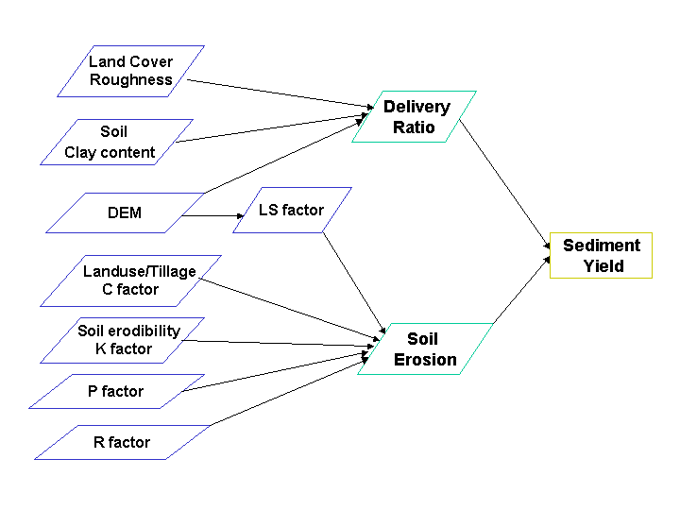
Figure 1. Modeling approach using RUSLE and SEDMOD

Data sources and data processing:
Most of datasets that are required to run the models were obtained from readily available sources. Watershed boundaries, Digital Elevation Model (DEM), STATSGO Soils, Landuse and Land Cover are downloaded from the EPA’s BASINS’ website http://www.epa.gov/OST/BASINS/. These data sets were originally produced by USGS and USDA. The secondary datasets are obtained by processing the raw datasets and/or generated by the model. The secondary datasets include data layers for Rainfall-Runoff Erosivity Factor (R), Soil Erodibility factor (K), Tolerable Soil Loss (T), Slope and slope length factor (LS), clay content, surface roughness, and soil moisture.
The data layer for Rainfall-Runoff Erosivity factor (R) was generated from the county R factor data included in RUSLE2 program. RUSLE2 is a new version of RUSLE with a window-based interface.
Soil clay content is one of the required input data for SEDMOE. It was calculated from data in STATSGO (State Soil Geographic Database) which was compiled by the Natural Resources Conservation Service, USDA. An area-weighted average method was used to calculate the clay content for the top soils. The clay content was first averaged from the high and low values. Then the average clay content was calculated from the averaged clay content for each component and averaged it again based on the percentage of the component in the soil map unit. It can be expressed as follows:
clay1 = (clay1_high + clay1_low) / 2 [ for soil component 1]
clay2 = (clay2_high + clay2_low) / 2 [ for soil component 2]
Average clay for a map unit = [clay1 * (component1)% + clay2 * (component2)% + ....]
This method was used to calculate all soil map units. Soil Erosivity Factor (K) was calculated in a similar way.
L factor and S factor are usually considered together to combine the effect of slope and slope-length, which basically reflects the terrain on a given site. For this project, an approach developed by Moore and Burch (1985) is used to compute LS factor. They developed an equation to compute length-slope factor:
LS = (As / 22.13)^{m} * (sin β / 0.0896)^{n}
where:
m = 0.4 – 0.6 and n = 1.2 – 1.3.
LS = computed LS factor.
As = specific catchment area, i.e. the upslope contributing area per unit width of contour (or rill), in m² / m.
β = slope angle in degrees.
Tan β = slope (in percentrise) / 100
β = Atan (Tan β)
Soil surface roughness data layer was generated from landuse/land cover data by re-classifying the landuse types to Manning’s roughness values (n) based on the pervious studies from Engman (1986). Table 1 liststhe Manning’s roughness n values under various conditions:

Table 1. Manning’s roughness values for various field conditions (Engman, 1986)
Field condition |  | Manning’s Roughness value
Fallow | Smooth, rain packed | 0.01-0.03
Fallow | Medium, freshly disked | 0.1-0.3
Fallow | Rough turn plowed | 0.4-0.7
Cropped | Grass and pasture | 0.05-0.15
Cropped | Clover | 0.08-0.25
Cropped | Small grain | 0.1-0.4
Cropped | Row crops | 0.07-0.2

Results and Discussion

SEDMOD is limited to run one watershed at a time. It takes a large amount of computing time when running a large watershed. Due to the large amount of data and time required to run each watershed, several computers were used to run the model. A batch program has been designed to continuously run the model for watersheds on each computer. All data layers were converted to 30 x 30 meter resolution to be consistent in modeling using GIS grids.

Sediment Delivery Ratio
Sediment Delivery Ratio (SDR) layers were first calculated using SEDMOD. SDR for each cell was calculated which can be interpreted as a percentage of sediment load over gross soil loss. Unlike other sediment delivery ratio models which give one delivery ratio for the entire watershed, SEDMOD provides a site-specific evaluation for the sediment delivery ratios. The SDR layer is an intermediate layer that was used to calculate sediment load.

Soil Erosion
Soil erosion was calculated using RUSLE. A program has been written to run RUSLE in GIS Arc/Info environment. Soil erosion was calculated in tons per acre per year. The total soil loss in the watershed was calculated by summing up each cells in the watershed. Previous studies have shown that agricultural cropland is the most important contributor for soil erosion and sediment loading (USEPA, 2000). Our calculation was focused on the agricultural croplands in the Great Lakes watersheds.
Among various factors used in RUSLE, the site-specific cover-management factor (C) is most difficult to obtain. In order to compare the effect of different tillage practices on the soil erosion and sediment loading while lacking of site-specific C factor data, it was assumed that the same tillage practice was used for all agricultural croplands in the same watershed. We have chosen three C factors to represent the three typical tillage practices: conventional tillage such as fall plow, reduced tillage (i.e. mulch with 30% coverage) and no till. Soil erosion and sediment delivery were calculated based on the three different tillage practices. The table below shows the averaged erosion and sediment from agricultural croplands (Table 2).

Sediment Load
Sediment load was calculated based on the results from RUSLE (soil loss) and SEDMOD (sediment delivery ratio). It was calculated on cell-by-cell basis and then totaled for the watershed. Figure 2 shows the estimated total sediment load from the agricultural croplands in the Great Lakes Basin. Table 3 shows the estimated sediment delivery from agricultural cropland under different tillage practices in the Great Lakes Basin.
The estimated total sediment load was estimated 15.6 million tons per year are from agricultural croplands under conventional tillage in the Great Lakes Basin. It was estimated that 7.1 million tons per year under reduced tillage and 2.6 millions per year under no till. Similar to soil erosion, the results show that conservation tillage can reduce sediment load significantly. That can be translated to large cost reduction used for dredging projects if the soil erosion is reduced on the land.

Table 2. Estimated Average Soil Erosion and Sediment Delivery under different tillage practices in the Great Lakes Basin
Tillage Practices | Average Erosion Rate  (tons/acre/yr)
Conventional Tillage | 1.8
Reduced Tillage | 0.8
No Till | 0.3

Table 3. Estimated Sediment Delivery from Agricultural Cropland under Different Tillage Practices in the Great Lakes Basin
Tillage Practices | Average Sediment Delivery  (tons/acre/yr)
Conventional Tillage | 0.4
Reduced Tillage | 0.2
No Till | 0.1
Figure 2. Estimated Total Sediment Load from Agricultural Croplands with Different Tillage Practices in the Great Lakes Basin

While no actual sediment load data is available to verify for the entire basin, some data is collected from the dredging projects conducted the US Army Corps of Engineers. Table 5 shows sediment dredged from some selected watersheds in Michigan (data from 1990 to 2003). The overall trend of sediment dredged is consistent with from modeled.

Basinwide, there is approximately 8.5 million tons sediment dredged each year while it is estimated based on the model that over 7.1 million tons sediment is loaded from agricultural cropland based on the medium modeling results (reduced tillage practices). It should be noted that sediments from other land uses such as forestry and urban, and from other sources such as gully erosion, stream bank erosion, and wind erosion are not taken into account in the calculation.
Based on the modeling results, we have listed the top 10 watersheds that have relatively high potentials in contributing sediment load to the Great Lakes. It should be noted that this ranking was based on our modeling with an assumption that same tillage practice was used for all watersheds. If a watershed has high soil erosion potential but implemented best management practices, the soil erosion can be lower and ranking can be different. In addition, the calculation was based on the watersheds delineated by the U.S. Geological Survey (i.e. 8-digit watersheds). If the watershed is delineated differently, the total soil erosion and sediment load will be different from the results provided in this study.
The total amount of sediment load for each sub-watershed in the Great Lakes Basin is shown on the map (Figure 3). The map illustrates the potentially high contributing watersheds in the basin. For each sub-watershed, a detailed map can be generated for showing the potential high risk areas (Figure 4). By overlaying with roads and rivers, the map can provide useful information for decision makers to prioritize and implement Best Management Practices (BMPs) to reduce erosion and sediment load to the stream systems.

Table 4. The top 10 watersheds with potentially high sediment loading

Ranking | Total Sediment  (tons/yr)
1 | Maumee River, OH, IN
2 | Seneca River, NY
3 | Grand River, MI
4 | Saginaw River, MI
5 | St. Joseph River, MI, IN
6 | Upper Genesee River, NY
7 | Sandusky River, OH
8 | Wolf River, WI
9 | Manitowoc-Sheboygan River, WI
10 | Kalamazoo River, MI

Table 5. Estimated sediment load and reported sediment dredged in selected harbors since 1990.

 | Sediment Dredged  since 1990 (tons) | Modeling results  (tons / yr.)
Saginaw River | 7,000,000 | 430,000
St. Joseph River | 1,200,000 | 280,000
Muskegon River | 770,000 | 110,000
Great Lakes Basin (total) | 8.5 x 10⁶ per year | 7.1 x 10⁶ per year

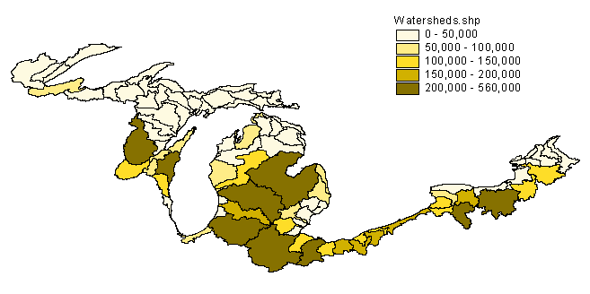

Figure 3. Estimated Sediment Load in Great Lakes Subwaterhseds

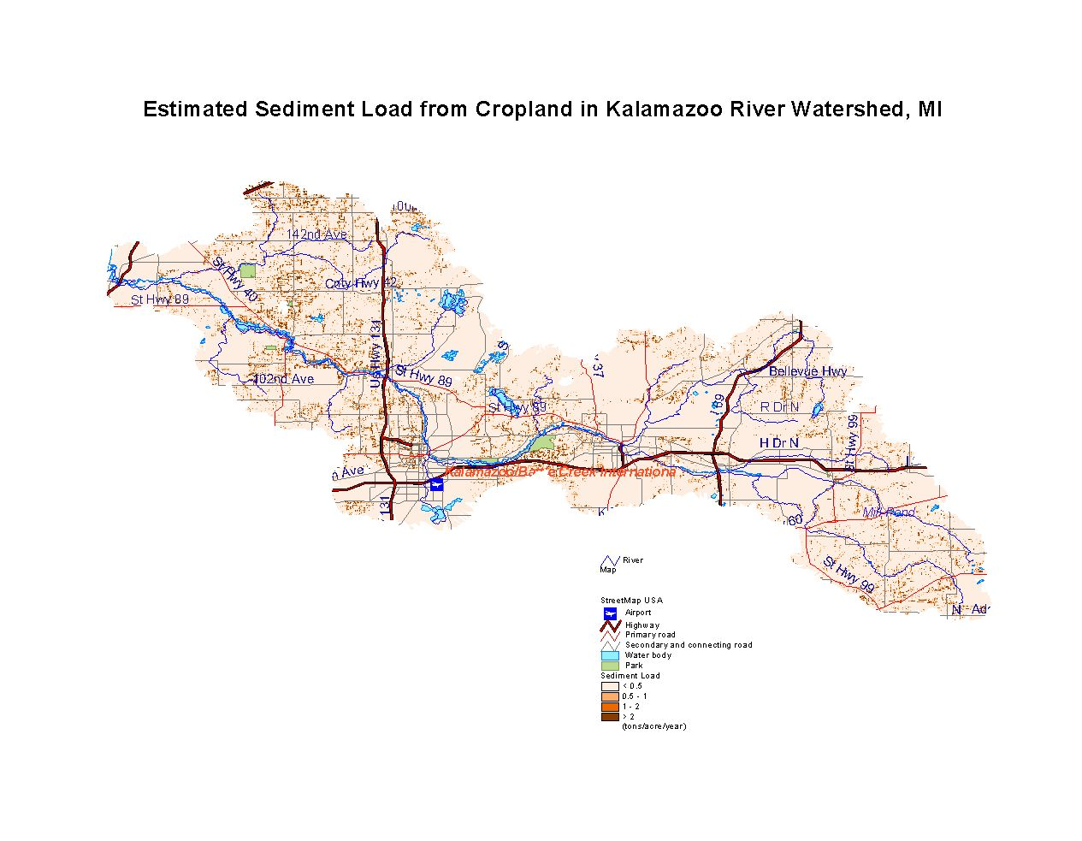
Figure 4. Estimated Sediment Load from Cropland in Kalamazoo River Watershed, MI

References
- Arnold JG, Williams JR, Srinivasan R, King KW. SWAT – Soil and Water Assessment Tool. SWAT User’s Manual. Texas A & M University. Temple, TX. 1996.
- Beranek DA. Engineering and Technical Services, U.S. Army Engineer Division, Great Lakes and Ohio River, Great Lakes Region, Chicago, IL (http://bigfoot.wes.army.mil/6525.html)
- Downer CW, Ogden FL, Martin W, Harmon RS. Theory, Development, and Applicability of the Surface Water Hydrologic Model CASC2D, Hydrological Processes 2002;16(2):255-75.
- Engman ET. Roughness Coefficients for Routing Surface Runoff. Journal of Irrigation and Drainage Engineering 1986;112(1):39-53.
- Fraser RH. SEDMOD: A GIS-Based Delivery Model for Diffuse Source Pollutants. Ph.D. Dissertation. Yale University. 1999.
- Fraser RH, Barten PK, Pinney DAK. Predicting Stream Pathogen Loading from Livestock Using a Geographical Information System-Based Delivery Model. Journal of Environmental Quality 1998;27:935-45.
- Frere MH, Ross JD, Lane LJ. The nutrient submodel. In: Knisel, W. (ed.). CREAMS, A Field Scale Model for Chemicals, Runoff, and Erosion From Agricultural Management Systems. U.S. Department of Agriculture, Conservation Research Report 26, 1980;1(4):65-86.
- Hoover KA, Foley MG, Heasler PG, Boyer EW. Sub-Grid-Scale Characterization of Channel Lengths for Use in Catchment Modeling. Water Resources Research 1991;27(11):2865-73.
- Lovejoy SB, Lee JG, Randhir TO, Engel BA. Research Needs for Water Quality Management in the 21st Century. Journal of Soil and Water Conservation1997:18-21.
- Moore ID, Grayson RB. Terrain-Based Catchment Partitioning and Runoff Prediction Using Vector Elevation Data. Water Resources Research 1991;27(6):1177-91.
- Moore LD, Burch GL. Physical Basis of the Length-slope Factor in the Universal Soil Loss Equation. Soil Sci Soc Am J 1985;50:1294-8.
- Ogden FL, Heilig A. Two-Dimensional Watershed-Scale Erosion Modeling with CASC2D, in Landscape Erosion and Evolution Modeling, (Harmon RS and Doe III WW, eds.), Kluwer Academic Publishers, New York, ISBN 0-306-4618-6, 2001:535.
- Ouyang D. Modeling Sediment and phosphorus loading in a Small Agricultural Watershed. Ph.D. Dissertation. Michigan State University. 2001.
- Ouyang D, Bartholic J. Web-based application for soil erosion prediction. An International Symposium – Soil Erosion Research for the 21st Century. Honolulu, HI. 2001.
- Renard KG, Foster GR, Weesies GA, McCool DK, Yoder DC. Predicting Soil Erosion by Water: A Guide to Conservation Planning With the Revised Universal Soil Loss Equation (RUSLE). U.S. Department of Agriculture, Agriculture Handbook No. 703. 1997.
- U.S. Environmental Protection Agency. Water Quality Conditions in the United States – A profile from the 1998 National Water Quality Inventory Report to Congress. EPA841-F-00-006. Office of Water, Washington, D.C. 2000.
- Walling DE. The Sediment Delivery Problem. Journal of Hydrology. 1983;65:209-237.
- Wishmeier WH, Smith DD. Predicting Rainfall Erosion Losses – A Guide To Conservation Planning. U.S. Department of Agriculture, Agriculture Handbook No. 537. 1978.
- Young RA, Onstad CA, Bosch DD, Anderson WP. AGNPS (Agricultural Non-point source Pollution Model): A Watershed Analysis Tool, Conservation Research Report, USDA ARS, Washington, DC. 1987.

