Proposed Experiments to Detect the E-Matrix Frame

Ken H. Seto

KHS Publishing, 260 Yorkshire Lane, Xenia, OH 45385, USA
kenseto@erinet.com; http://www.erinet.com/kenseto/book.html
Telephone: 937-372-5298

Abstract: A new model of the universe called Model Mechanics has been formulated. Model Mechanics is able to explain all the processes of nature by positing the existence of the E-Matrix frame. Although past experiments failed to detect absolute motion and thus implies that the E-Matrix frame does not exist. However, new interpretations of those past experiments revealed that the design of these experiments might not be capable of detecting absolute motion. The proposed experiments in this paper give us a sure way to detect the E-Matrix if it exists. [The Journal of American Science. 2005;1(2):22-27].

Introduction

A new model of the universe called Model Mechanics [1,2,3] has been formulated. Model Mechanics is based on the idea that space (pure void) is fill with a stationary and structured light- conducting medium called the E-Matrix. Motions of objects in the E-Matrix are called absolute motions. It was posited that absolute motions of objects in the E-Matrix should be detectable. However, numerous past attempts to detect absolute motion were failures. The most notable of these is the Michelson-Morley Experiment (MMX) [4]. In this experiment a light beam was split into two parts that were directed along the two arms of the instrument at right angles to each other, the two beams being reflected back to recombine and form interference fringes. Any shift in the interference fringes as the apparatus is rotated would mean the detection of absolute motion of the apparatus. To everyone's chagrin, the MMX produced a null result. However, the MMX null result does not mean that there is no absolute motion of the apparatus. In their interpretation of the MMX null result Michelson-Morley failed to ask the relevant question: What is the direction of absolute motion of the apparatus with respect to the defined horizontal plane of the light rays that will produce a null result for all the orientations of the horizontal arms? The answer to this question is: If the apparatus is moving vertically then a null result will be obtained for all the orientations of the horizontal arms. What this mean is that the MMX as designed is not capable of detecting the absolute motion of the apparatus. In order to detect absolute motion using the MMX, the plane of the arms must be oriented vertically. This conclusion is supported by the observed gravitational red shift (gravitational potential) in the vertical direction.
The new interpretation of the MMX null result gives rise to a new concept for the propagation of light as follows:
How does light get from point A to point B? The current assumption is that, locally, light travels in a straight line towards the target, and that, in a train of light pulses, the first pulse hits the target is the first one the source generated. These assumptions both make sense if the target is stationary relative to the light pulses, but if the target moves the second assumption could be erroneous. Figure 3 describes a thought experiment that is currently used by physicists to derive the time dilation equation. A light clock is constructed of two mirrors parallel to each other with light pulses bouncing between them. In one period of the clock, a light pulse travels up to the top mirror and returns back to the bottom mirror. The diagram shows that the light pulse is presumed to travel a slant path when the light clock is in motion. This is not a realistic description of the actual event. It raises the question: How does light know when to follow a vertical path and when to follow one of the infinite numbers of slant paths? It is more realistic to say that light will always follow the perpendicular path on its way to the upper mirror. The reason is that the vertical path is the direction where all the light pulses are directed. Figure 4 shows this: the first pulse of a train of pulses follows the original path AB, but the pulse detected at “E” travels the path CE.
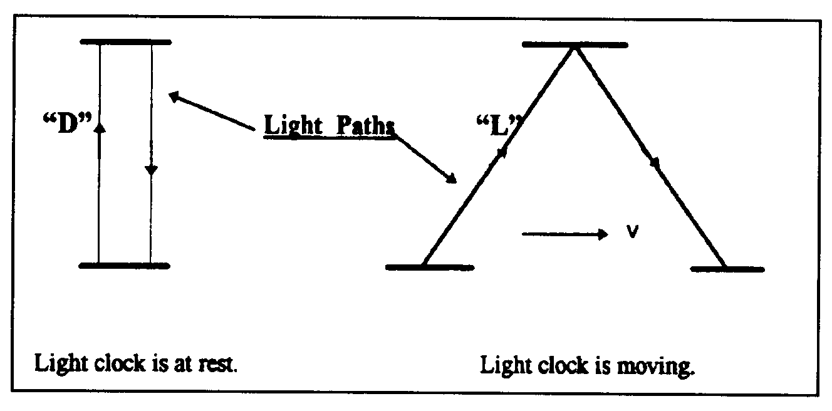
Figure 3. Light paths in a light clock at rest and in motion.

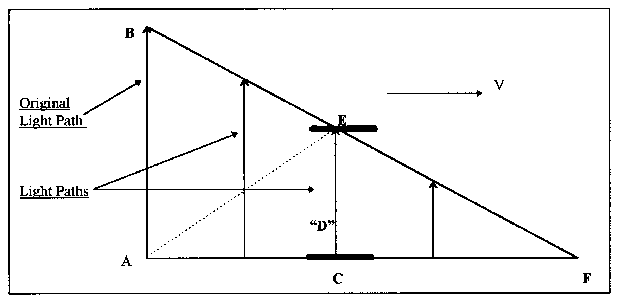

Figure 4. Current physics says that AE is the path that light follows to the upper mirror and the angle of this path is depended on the length AC that is depended on the speed of the light clock.

With this description of the light paths, the first pulse is never detected at “E." The light pulse detected at “E” is generated by the source at a later time. It turns out that this description of light paths is also capable of giving us the time dilation equation by using the Pythagorean theorem. The reason is that the original light path (AB) is equal to the assumed light path (AE) and both are the radii of a light sphere at the point of origin “A". It is noteworthy that as the speed of the mirrors approaches light speed a light pulse will take a longer time to reach the upper mirror. When the mirrors are moving at the speed of light, no light pulse is able to reach the upper mirror at all. Current physics interprets this situation as time standing still at the speed of light. The new interpretation is that time keeps on ticking at all speeds of the light clock. The amount of time (duration) passed depends on the length of the original light path AB divided by the speed of light ‘c’. This new interpretation suggests that absolute time for a moving frame is not slowed or dilated as currently assumed. The specific amount of absolute time (duration) required for light to travel the original light path AB is equal in all frames. A light clock runs slow when it is in motion because it is not catching the first light pulses, but rather some later one. The lower elapsed time recorded by a moving clock because the passage of time is not fully detected when the clock is in a state of motion.
The new interpretation of the MMX null result and the new concept for the propagation of light enable us to design the following experiments to detect absolute motion:

Experimental Set Up:

- Two sets of cesium clocks A1, A2 and B1, B2 are located at the middle of a 120 meters long straight rail track. Distances of 25 meters and 50 meters on both sides of the mid-point are marked off with a physical ruler.
- Each set of clocks is equipped with a laser light sources and a beam splitter that splits the laser beam into two continuous beams. One beam goes to detector “A” and the other goes to detector “B”.
- Each set of clocks is equipped with a shutter that allows the two laser beams to pass through it for any desired time intervals.
- Each set of clocks is equipped with a circular surface detector and the detecting surface can vary from 3 mm to 20 cm in diameter.
- Each set of clock is equipped with a reflecting mirror.
- A1 and B1 are not running. A2 and B2 are synchronized and running.

Experiment Group #1: To Detect The Absolute Motion Of The Distant Clock At 50 Meters
- Move both sets of clocks simultaneously in the opposite directions at a rate of 10 meters/day (1 day = 86,400 seconds) and stop them at the 25 meters marks (after 2.5 days). The clocks are now 50 meters apart.
- Both detecting surfaces are set at 3mm in diameter.
- Do the following experiments from A’s location.
- A trial of the experiment is consisted of an opening and closing of the shutter for a specific time interval. The following trials at the following time intervals are made: 1 second, 2 seconds, 3 seconds, 4 seconds, 5 seconds, 6 seconds, 7 seconds, 8 seconds, 9 seconds and 10 seconds. The trials are conducted from A’s location.
- Laser beam A will activate and de-activate clock A1 for each trial and the results are identified as T’a1, T’a2, T’a3, T’a4, T’a5, T’a6, T’a7, T’a8, T’a9 and T’a10.
- Laser beam B will activate and de-activate clock B1 for each trial and the results are identified as T’b1, T’b2, T’b3, T’b4, T’b5, T’b6, T’b7, T’b8, T’b9 and T’b10.
- The difference in activation time between clocks A1 and B1 for each trial is identified as follows: ∆T’1, ∆T’2, ∆T’3, ∆T’4, ∆T’5, ∆T’6, ∆T’7, ∆T’8, ∆T’9, and ∆T’10.
- Increase the detecting surface to 20 cm in diameter then perform a trial using the 1-second time interval to establish that there is no difference in activation time between A1 and B1 for this large detecting surface. Now reduce the diameter of the detecting surface gradually to find the diameter where the activation time between A1 and B1 start to show a difference. Call this critical diameter$D_{\text{50}}$.
- Cover the detecting surface completely with a 20 cm diameter dish. A slit of 2mm wide is cut from the center of the dish to the outer rim of the dish. Slowly rotate the dish to find the direction of absolute motion of the detector. That direction is evident when the slit is in line with the direction of absolute motion of the detector and activates the clock B1 for the same amount of time as the shutter opening and closing at A’s location.
- Repeat the above experiments from the “B” location.

The SRT Predictions For Group #1 Experiments:
  - The activation time for the B1 clock is the same as that for the A1 clock for all trials.
  - The difference in activation time between A1 and B1 is zero for each trial. ∆T’1=∆T’2=∆T’3=∆T’4=∆T’5=∆T’6=∆T’7=∆T’8=∆T’9=∆T’10=0.
  - Increase the diameter of the detecting surface will have no effect on activation time on the B1 clock for each trial.
  - There is no absolute motion of clock B1 and therefore there is no direction of absolute motion.
  - Repeating the above experiments from the B location will get the same results as above.

The Model Mechanical Predictions For Group #1 Experiments:
- The activation time for the B1 clock is less than that for the A1 clock for each trial. This is due to the B1 clock is in a state of absolute motion in the vertical direction while the laser is in transit from A to B.
- The difference in activation time between A1 and B1 is the same for each trial and it is greater than zero.
- Increase the diameter of the detecting surface will bring the activation time for the B1 clock equal to that of the A1 clock.
- The absolute motion of the clock B1 ($V_{\text{50}}$) can be calculated using the following equation:
$V_{\text{50}}$$=\frac{D_{\text{50}}}{2ΔT1}$ [15]
- The direction of absolute motion of the B1 clock is vertical.
- Repeating the above experiments from the “B” location will get the same results as above.

Experiment Group #2: To Measure The One-Way And Two-Way Speed Of Light at 50 Meters Apart
- The clocks A2 and B2 are 50 meters apart and are still synchronized according to SRT and Model Mechanics.
- Measure the one-way speed of light using clocks A2 and B2 from the “A” location.
- Measure the one-way speed of light using clocks B2 and A2 from the “B” location.
- Measure the two-way speed of light using clock A2.
- Measure the two-way speed of light using clock B2.

The SRT Predictions For Group #2 Experiments:
- The one-way speed of light is c as measured from the “A” location.
- The one-way speed of light is c as measured from the “B” location.
- The one-way speed of light is isotropic.
- The two-way speed of light is c using clock A2.
- The two-way speed of light is c using clock B2.
- The two-way speed of light is isotropic.

The Model Mechanical Predictions For Group #2 Experiments:
- The value for the one-way speed of light is less than c as measured from the “A” location.
- The value for the one-way speed of light is less than c as measured from the “B” location.
- The one-way speed of light is isotropic. In other words, the value for the one-way speed of light from A→B is equal to from B→A.
- The calculated value for the one-way speed of light can be make to equal to c by reducing the measured flight time by a factor of (∆T’1).
- The two-way speed of light is c using clock A2.
- The two-way speed of light is c using clock B2.
- The two-way speed of light is isotropic.

Experiment Group #3:To Detect The Absolute Motion Of The Distant Clock At 100 Meters

Move both sets of clocks at the 25 meters marks simultaneously in the opposite directions at a rate of 10 meters/day and stop them at the 50 meters marks (after 2.5 days). The clocks are now 100 meters apart.
- Both detecting surfaces are set at 3mm in diameter.
- Do the following experiments from A’s location.
- A trial of the experiment is consisted of an opening and closing of the shutter for a specific time interval. The following trials at the following time intervals are made: 1 second, 2 seconds, 3 seconds, 4 seconds, 5 seconds, 6 seconds, 7 seconds, 8 seconds, 9 seconds and 10 seconds. The trials are conducted from A’s location.
- Laser beam A will activate and de-activate clock A1 for each trial and the results are identified as T”a1, T”a2, T”a3, T”a4, T”a5, T”a6, T”a7, T”a8, T”a9 and T”a10.
- Laser beam B will activate and de-activate clock B1 for each trial and the results are identified as T”b1, T”b2, T”b3, T”b4, T”b5, T”b6, T”b7, T”b8, T”b9 and T”b10.
- The difference in activation time between clocks A1 and B1 for each trial is identified as ∆T”1, ∆T”2, ∆T”3, ∆T”4, ∆T”5, ∆T”6, ∆T”7, ∆T”8, ∆T”9, and ∆T”10.
- Increase the detecting surface to 20 cm in diameter then perform a trial using the 1-second time interval to establish that there is no difference in activation time between A1 and B1 for this large detecting surface. Now reduce the diameter of the detecting surface gradually to find the diameter where the activation time between A1 and B1 start to show a difference. Call this critical diameter$D_{\text{100}}$.
- Cover the detecting surface completely with a 20 cm diameter dish. A slit of 3mm wide is cut from the center of the dish to the outer rim of the dish. Slowly rotate the dish to find the direction of absolute motion of the detector. That direction is evident when the slit is in line with the direction of absolute motion of the detector and activates the clock B1 for the same amount of time as the shutter opening and closing at A’s location.
- Repeat the above experiments from the “B” location.

The SRT Predictions For Group #3 Experiments:
- The difference in activation time between A1 and B1 is zero for each trial. ∆T”1=∆T”2=∆T”3=∆T”4=∆T”5=∆T”6=∆T”7=∆T”8=∆T”9=∆T”10=0.
- Increase the diameter of the detecting surface will have no effect on activation time on the B1 clock for each trial.
- There is no absolute motion of clock B1 and therefore there is no direction of absolute motion.
- Repeating the above experiments from the B location will get the same results as above.

The Model Mechanical Predictions For Group #3 Experiments:
  - The activation time for the A1 clock is greater than that for the B1 clock for each trial. This is due to the B1 clock is in a state of absolute motion in the vertical direction while the laser is in transit from A to B.
  - The difference in activation time between A1 and B1 is the same for each trial.
  - ∆T”1=∆T”2=∆T”3=∆T”4=∆T”5=∆T”6=∆T”7=∆T”8=∆T”9=∆T”10
  - Increase the diameter of the detecting surface will bring the activation time for the B1 clock equal to that of the A1 clock.
  - The absolute motion of the clock B1 ($V_{\text{100}}$) can be calculated using the following equation:
$V_{\text{100}}$$=\frac{D_{\text{100}}}{2{ΔT}^{'}1}$ [15]
  - The direction of absolute motion of the B1 clock is vertical.
  - Repeating the above experiments from the “B” location will get the same results as above.

Experiment Group #4: To Measure The One-Way And Two-Way Speed Of Light
- The clocks A2 and B2 are 100 meters apart and are still synchronized according to SRT and Model Mechanics.
- Measure the one-way speed of light using clocks A2 and B2 from the “A” location.
- Measure the one-way speed of light using clocks B2 and A2 from the “B” location.
- Measure the two-way speed of light using clock A2.
- Measure the two-way speed of light using clock B2.

The SRT Predictions For Group #4 Experiments:
  - The one-way speed of light is c as measured from the “A” location.
  - The one-way speed of light is c as measured from the “B” location.
  - The one-way speed of light is isotropic.
  - The two-way speed of light is c using clock A2.
  - The two-way speed of light is c using clock B2.
  - The two-way speed of light is isotropic.

The Model Mechanical Predictions For Group #4 Experiments:
  - The value for the one-way speed of light is less than c as measured from the “A” location.
  - The value for the one-way speed of light is less than c as measured from the “B” location.
  - The one-way speed of light is isotropic. In other words, the value for the one-way speed of light from A→B is equal to from B→A.
  - The calculated value for the one-way speed of light can be make to equal to c by reducing the measured flight time by a factor of (∆T”1).
  - The two-way speed of light is c using clock A2.
  - The two-way speed of light is c using clock B2.
  - The two-way speed of light is isotropic.

Conclusion:

Model Mechanics is able to explain all the processes of nature by positing the existence of the E-Matrix frame. Motion of objects in the E-Matrix is called absolute motion. Although past experiments failed to detect absolute motion and thus implies that the E-Matrix frame does not exist. However, new interpretations of those past experiments revealed that the design of these experiments might not be capable of detecting absolute motion. The proposed experiments in this paper give us a sure way to detect the E-Matrix if it exists.

Correspondence to:
Ken H. Seto
KHS Publishing
260 Yorkshire Lane
Xenia, OH 45385, USA
Telephone: 937-372-5298
Email: kenseto@erinet.com http://www.erinet.com/kenseto/book.html

References
- Seto KH. The Physics of Absolute Motion. ISBN0-9647136-1-6, KHS Publishing, P. 57-70. http://www.erinet.com/kenseto/book.html.
- Seto KH. The Current State of Our Universe. Galilean Electrodynamics 2000;2:40.
- Seto KH. Unification of Physics. Journal of the Theoretics. P. 1-2. http://www.journaloftheoretics.com/Links/Papers/Seto.pdf.
- Michelson AA, Morley EW. On the Relative Motion of the Earth And the Luminiferous Ether. Am J Sci, Third Series 1887;34:333-45.

