Study on High-voltage Pulsed Electric Fields Sterilization Mechanism Experiment

Junlong Fang ^{1,2}， Zailin Piao ¹， Xihai Zhang ²
1. Shenyang Agricultural University, Shenyang，Liaoning 110161, China，swanhaha@163.com
2. Engineering College, Northeast Agricultural University， Harbin, Heilongjiang 150030, China

Abstract：This experiment used fluorescent pseudomonas as target cell, which was operated 180 s in the PEF of 30 kV, 50 Hz. By observing the difference of the bacteria before and after the disposal by using the TEM, it is found that the cell walls of the treated bacteria were broken, the irreversible perforations were formed on the cell membrane, the cell inclusions and cell fragments were leaked. As a result, the cytoplasm and nucleolus substances flow away and the cell died. By analyzing and discussing the high-voltage pulsed electric fields sterilization mechanism, this paper reveals that the pulsed electric fields sterilization technique can sterilize effectively, which can maintain the food’s quality and reduce the sterilization cost in maximum. This method can be adapted to liquid foods such as syrup, milk, soup stuff and liquid egg, and so on. [The Journal of American Science. 2006;2(2):39-43].

Key words：Pulsed electric fields；Sterilization mechanism；Pseudomonas fluorescents; TEM

Introduction
In the traditional pasteurization, food is heated up to a certain temperature to make the protein inside the cell curdle and denaturalize, and then the cell dies. Although in this heating process, contaminative microorganisms are killed, the color, smell, taste, and nurture of the food are, at the same time, degraded. Moreover, through this method, expected effects will not be attained if the food is sensitive to heat or has some special requirements. In order to complement the deficiency of the traditional ways of sterilization to meet people's need, several new energy saving techniques which can rapidly and effectively kill the poisonous microorganism in food and give rise to the quality of the food are brought to being.${}^{[1]}$
New cold sterilizing techniques include sterilizing with PEF, ultrasonic wave, high voltage, infrared ray and strong impulse of light. However, ultraviolet radiation is only effective in sterilizing on the surface, and the temperature can also be very high in the process of sterilizing with microwave. Easily to be managed, PEF is now widely attended and is one of the methods that we can expect to apply in industry^{[2]}.
The PEF method, with extremely short time (µs-msOM) of sterilization, consumes very low power, being only one thousandth of the total power consumed in the high temperature method, and far less than the power cost in the ultrasonic wave, the microwave or others^{3]}. Besides, in the PEF method, it is the high voltage other than the current used to sterilize, thus in the whole course, the temperature rarely rises and so the defect of high temperature can be avoided. Generally speaking, in the PEF method, the rise of the temperature is less than 5℃ and the effect of sterilization is obvious, if the condition of sterilization well controlled. The sterilizing rate can get quite close to the commercial requirement and this method can be best fit the food most sensitive to high temperature, since PEF barely affect the quality of food^{[3,4]}.
Hence the technique of PEF is regarded as a potential and economical way of sterilization, which retains the nutrition of food in the process of sterilization, and keeps the food as fresh as possible^{[4,5]}. With the purpose to apply this technique better, the mechanism of PEF sterilization is looked into in this paper.

1. Experiment on the Mechanism of High Voltage Pulsed Field Sterilization
1.1 Materials
Target Cell: Fluorescence pseudomonas (provided by the Microorganism Research Center of the Chinese Academy of Sciences). It has a wide distribution in nature and propagates quickly under the temperature of 4℃. It is one main kind of bacteria that lead to decay in milk and egg food kept under low temperature.

1.2 Main Facilities and Equipment
1.2.1 High Voltage Pulsed Generator
The self-constructed high-voltage pulsed generator’s parameter: peak voltage 30 kv, an exponential attenuating wave, variable frequency. Refer to Figure 1 for the principle chart of the pulse generator^{[6]}.

1.2.2 Treatment Chamber
The treatment chamber holds a space of 60×60×3 mm³. Two paralleled electrodes made of stainless steel and with the thickness of 1mm are used here. The discharging chamber is made of high temperature resisting material PTFE (Polytetrafluoroethylene). The treatment chamber should be sterilized first with high temperature to ensure the accuracy of data. Refer to Figure 2 and Figure 3 for the chamber^{[7]}.

1.2.3 Transmission Electron Microscope (TEM)
The electron microscope, with the type of TEM-1200EX, is provided by Life Science and Biology Research Centre’s Electron Microscopy Room in Northeast Agricultural University.

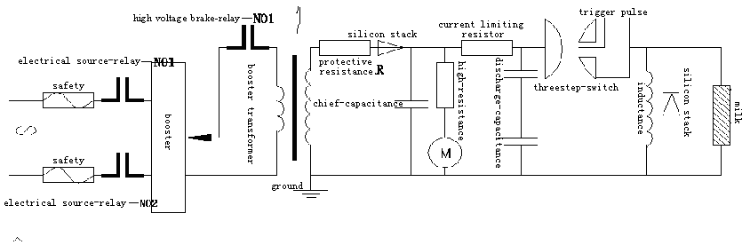
Figure 1. The principle chart of the pulse generator

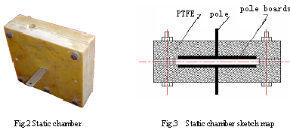

1.3 Methods
1.3.1 Sample Preparation
Cultivate the activated fluorescence pseudomonas, provided by the Microorganism Research Center of the Chinese Academy of Sciences under 37℃ in a shaker. Check until the concentration of the bacteria cumulates up to 10⁷-10⁸ cfu/ml.

1.3.2 Sample Processing
Inject the sample into the treatment chamber using sterile injector for the purpose of least pollution. Connect the two electrodes derivative wire of the high-voltage pulsed generator with clips to the derivative terminal of the treatment chamber.
Switch on the electrical source and high voltage brake and then adjust the high-voltage pulsed generator’s parameters as follows: output voltage 30 kv, discharging frequency 50 Hz, and action time180 s. Then press the ignition switch to generate high voltage pulse in the treatment chamber. The timing-relay switches cuts off the electrical source when it is the preset time. This will lead to the cease of the system. Take out the sample in the treatment chamber also using a sterile injector after the voltage drops to 0 V.

2. Results of the Experiment and Analysis
2.1 Observe the Cells Using TEM
The outcome with amplification of 20 K through the TEM: figure 4 depicts target cell without PEF processing, and Figure 5 and Figure 6 depict target cells processed by PEF.

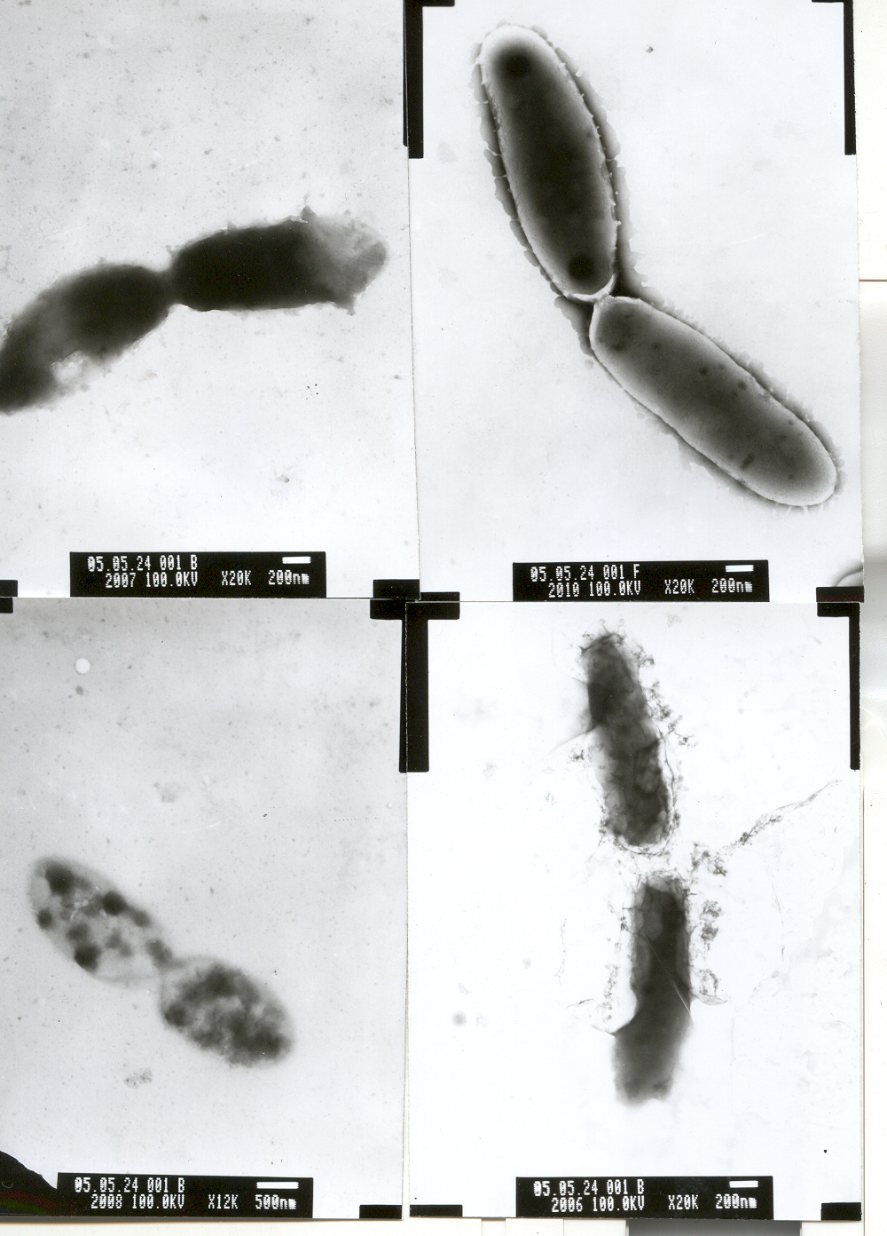 | 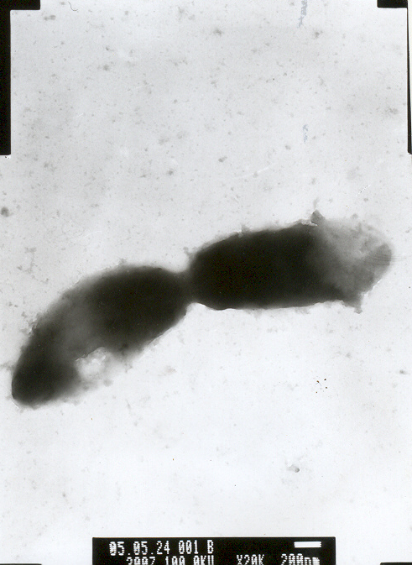
Fig. 4 Cell of untreated | Fig. 5 Cell of PEF treated 1 | Fig. 6 Cell of PEF treated 2

2.2 Analyses of the Experiment Results
There is an animated material interchange between the living cells and the outside environment, and the cell membrane integrity was an extremely vital role guaranteeing the normal cell activity. When the microorganism is set in the high-voltage pulsed electric fields and the electric-field intensity achieved a certain value (model is 20-100 kV/cm), the cell membrane can be destroyed, thus causes the cell content divulge, and bring death to the cell^{[8,9]}.
From the TEM observation we can see that after PEF processing the cell walls of the bacteria are destroyed, leaving unrepairable electrical perforations on the cell membrane which results in the leakage of what in the cell. The perforations are observed on different parts of the bacteria, which is also the situation with dying cells. It showing destruction of the membrane, leading to the leakage of cytoplasm and karyon, results in the death of the cells. Typical shape of dead cells, leakage of cytoplasm, disintegration of karyon, and the cell fragments, all these observed through TEM provide most reliable evidence to the judgment of dead cells. The experiment results reveal that voltage pulsed field has deadly effect on microorganism.
After the TEM observation and the PEF sterilization mechanism supposition in the existed literature, at first we suppose the cell is spherical, and the cell membrane is considered to be filled with the insulation medium as an electric capacity. The normal cell membrane potential difference is probably 10 mV between membranes^{[10,11]}. The electric charges distributing in the cell membranes resulting in the cell membrane potential difference, together with the field intensity and the cell radius, they become proportion. The increase of voltage between the cell membrane has caused cell membrane thickness reducing. If the field intensity is further increased, and voltage between the cell membrane reaches the critical voltage (approximately 1 V), it will brings on the electric breakdown. If we suppose that penetration can cause the cell membrane to have the pore, then we pour the electric conduction solution into the pore, all this will conduced the electric charge discharging, thus causes the cell membrane destruction. If eyelets produced in the cell membrane are very few, the electric breakdown will be reversible. Except higher than the critical field intensity and the long time function, there is no way can enable the cell membrane to have compared wide range of penetration. If both the size and quantity of the eyelet in the cell membrane are very big, the electric breakdown becomes irreversible, and the cell membrane structure will be completely destroyed^{[12-14]}.

2.2.1 Check of the Sample
Detect the disposed sample with TEM. The detection method: the disposed sample is dual fixed by glutaraldehyde-osmic acid, namely the sample is fixed first for two hours under 4℃ with 2.5% glutaraldehyde (25% glutaraldehyde 1ml, double distilled water 4ml, 0.2mol/L phosphoric acid cushion fluid 5ml, the pH value 7.3-7.4) then further did by osmic acid. Latter use the acetone to dehydrate and the epoxy resin to imbed , the ultra thin slice and the acetic acid medlar acid electron dyes again, use TEM to observe.

3. Conclusions
We can conclude through the observation of fluorescence pseudomonas form to high-voltage pulsed electric fields processing under the TEM that, the cell wall has been destructed after pulsed electric fields processing, and has formed electricity perforations the cell membrane, thus causes the cell content to divulge, cell contraction and final cell death. It explaines that the high-voltage pulsed electric fields which has the relative ideal sterilization effect may definitely be used in food sterilization. It may maintain food quality to the maximum limit, specially suits to the sterilization processing of fruit juice, milk, liquid food and so-on liquid state egg.

Correspondence to:
Junlong Fang
59 Wood Street
Gongbin Road, Xiangfang District
Harbin, Heilongjiang 150030, China
Telephone: 01186-451-5519-0147
Cellular phone: 01186-13359709975
E-mail: swanhaha@163.com

References
[1] Li Qingke, Zhang Changli, Fang Junlong, Antiseptic Research of Liquid Food under High Voltage Pulse [J]. The Agricultural Mechanization Research, 2003, (2): 100-101.
[2] Zehra Ayhan, Hye Won Yeam, Q. Howard Zhang, et, al.. Flavor, Color, and Vitamin C retention of Pulsed Electric Field processed orange juice in different packaging materials [J]. Agric. Food Chem. 2001, (49): 669-674.
[3] Tu Shunming, The New Technology of Food Sterilizes [M]. Beijing: Chinese light industry publishing house, 2004.
[4] M.P.J.Grandreau, T.Hankey, J.Petry, et al.. Pulsed power systems for food and waster water processing [J]. Diversified Technologies, Inc. 2,002 (1) 1-4.
[5] S.Jeyamkondan, D.S.Jayas, and R.A.Holley. Pulsed Eelectric Field processing of foods: A Review Journal of Food Frotecton. 1,999, 62 (9):1088-1096.
[6] Li Qingke High Voltage Antiseptic Technology Research [D]. Harbin: The Engineering College of the Northeast Agricultural University, 2003.
[7] Zhang Xihai Pulsed electric fields Sterilization Mechanism and Experimental Equipment Research [D]. Harbin: The Engineering College of the Northeast Agricultural University, 2005.
[8] Zhang, Q. H., Qiu, X. and Sharma, S. K. Recent development in Pulsed Electric Field processing [J]. Washington, DC. National Food Processors Association. New Technologies Yearbook. 1997, (2): 31-42.
[9] Siquan Li, M.S. Pulsed Electric Field processing of functional foods [D]. The Ohio State University, 2003.
[10] Li Gang, Luan Hai. High-voltage pulse application in Food Industry [J]. Harbin Commercial University journal, 2.003,19 (2): 206-212.
[11] Zimmermann, U. and Benz, R. Dependence of the electrical breakdown voltage on the charging time in Valonia Utricularis [J]. Membrane Biol. 1980, 53:33-43.
[12] Shi Chunlan. The Research and Progresses of High Voltage Pulse Antiseptic Theory [J]. Chongqing University journal 2002, 25 (4):28-31.
[13] Schoenbach, K. H., Peterkin, F. E, at el. The effect of Pulsed Electric Fields on biological cells: Experiments and Applications [J]. IEEE Trans Plasma Sci. 1997, 25 (2):284-292.
[14] Tsong, T. Y. Electrical modulation of membrane proteins: Enforced conformational oscillations and biological energy Signals [J]. Annu Rev Biophys Chem. 1990, 19:83-106.

