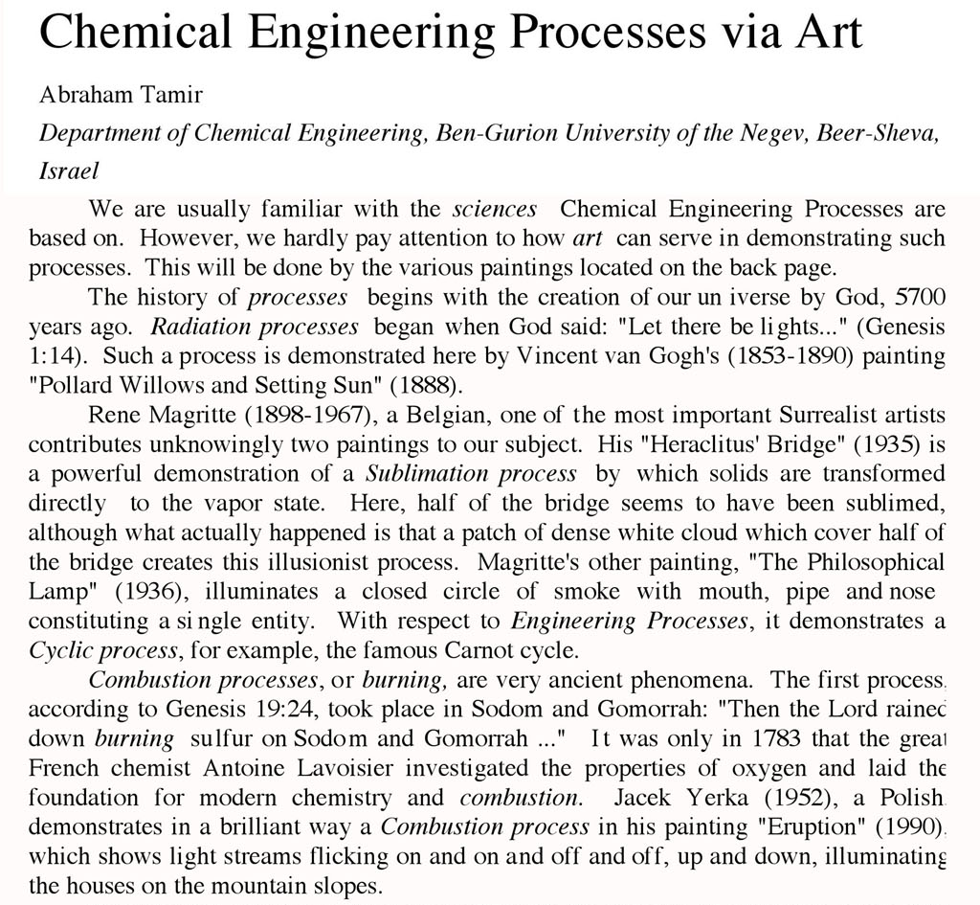

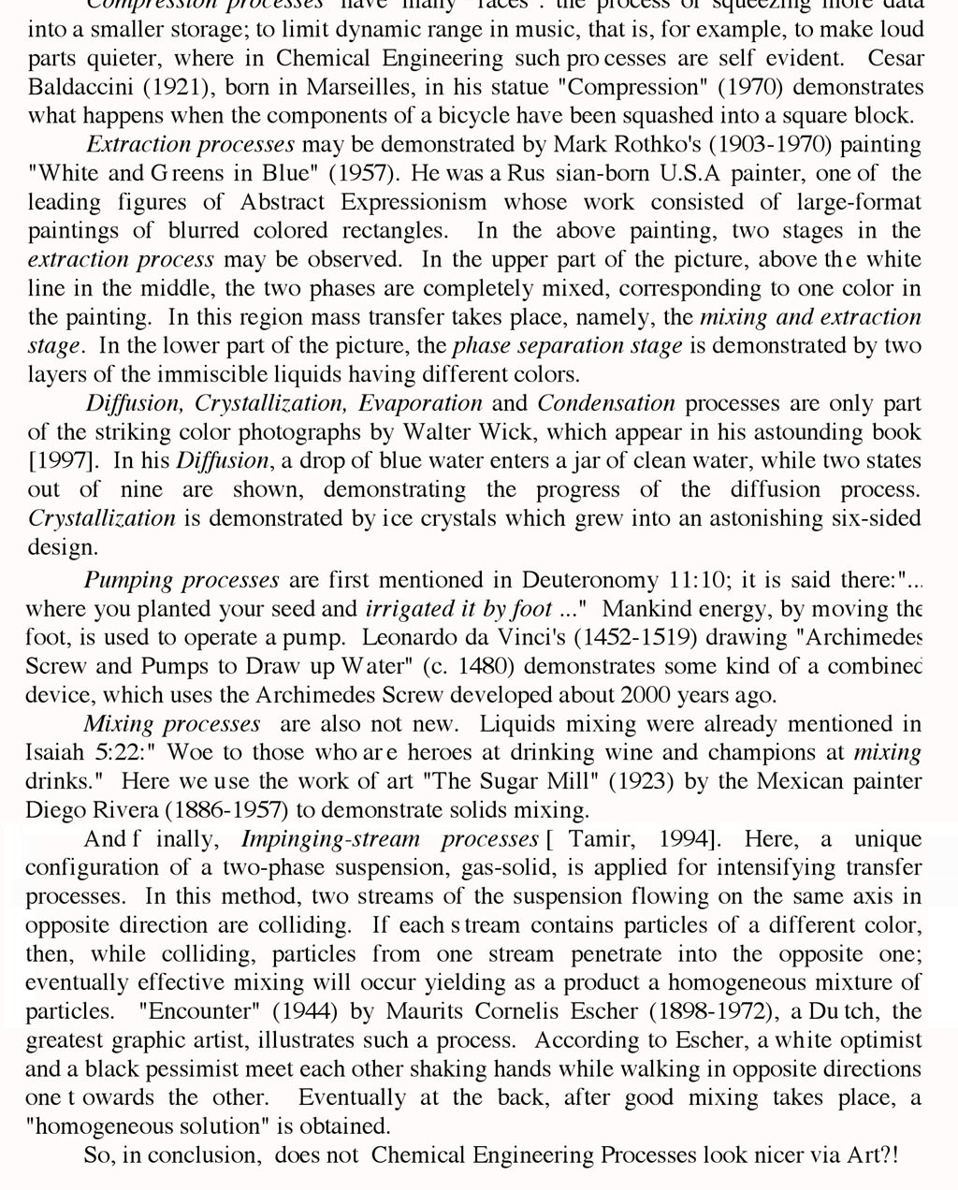

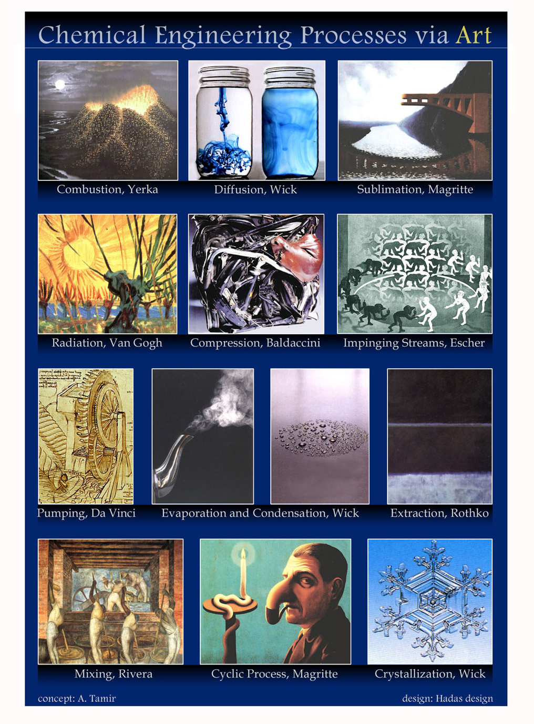

Correspondence to: Abraham Tamir, Professor
Department of Chemical Engineering at Ben-Gurion University of the Negev, P.O. Box 653, Beer-Sheva 84105, Israel, Telephone: 972-8-646-1111, Email: atamir@bgu.ac.il, Websites: http://www.bgu.ac.il/museum; http://www.bgu.ac.il/museum/tmoaas

