Application of Different Methods of Natural Aeration of Wastewater and their Influence on the Treatment Efficiency of the Biological Filtration

Tarek Ismail Sabry ¹, Walid Hamdy^{*2} and Saleem S. AlSaleem³

¹ Sanitary Engineering, Ain Shams University, Egypt.
² Sanitary Engineering, Helwan University, Egypt.
³Al Qassim Research Station, King Abdulaziz City for Science and Technology, KSA.
awawalid@yahoo.com

Abstract: The main objective of the proposed study is to examine the performance and the feasibility of using three different natural aeration methods (AM). The first two methods are the spray aerator (AM1) and the cascade aerator (AM2). The third method, the curtain aerator (AM3), is a new aeration technique that has different dynamic movement of wastewater falls (physical scrubbing action of aeration) for the aerobic treatment of raw sewage. The study investigates the most effective and suitable natural aeration system among these three methods for use in rural areas of developing countries where high costs of construction, operation, and maintenance of high-rate energy-intensive conventional aeration system technologies are the main bottleneck. The influences of the investigated natural aeration systems on the biological filtrations system are also investigated. The experimental results indicate an increasing in the aeration during the whole experimental by 21 %, 29 %, and 27 % for the AM1, AM2, and AM3 aeration systems, respectively; in respect with dissolved oxygen saturation. The results also showed that the amount of DO added to wastewater was influenced by both the surface loading rate (m³/m².hr) of the aeration method and the splash movement of wastewater through the surface of the different methods As well, it was observed that cascade aerator (AM2), and the curtain aerator (AM3) had better removal efficiency in BOD, COD, and TSS compared with the spray aerator (AM1).
[Tarek Ismail Sabry, Walid Hamdy and Saleem S. AlSaleem. Application of Different Methods of Natural Aeration of Wastewater and their Influence on the Treatment Efficiency of the Biological Filtration. Journal of American Science 2010;6(12):944-952]. (ISSN: 1545-1003). http://www.americanscience.org.

Key Words: Natural aeration; wastewater treatment; biological filter; low-cost technology; rural developing countries.

1. Introduction:
A wide range of high to low technologies is available for sewage treatment in small communities. A common method for the management of sewage in small communities is by using high-rate energy-intensive wastewater treatment technologies; such as activated sludge. These methods consume high energy during operation due to the use of mechanical aeration (air blowers and air compressors) as the most common means of increasing dissolved oxygen (DO) concentrations in wastewater. In addition, energy-intensive aeration systems require regular maintenance and skilled labors for their operation.
Extended aeration is a typical example for using the high-rate energy-intensive wastewater treatment technologies in small communities. This system is commonly used in small plants for flows of 370 m³/d or less (such as schools, villages, and subdivisions) (Shun Dar Lin - 2007).
In developing countries, the high costs of construction, operation, and maintenance of high-rate energy-intensive wastewater treatment technologies represent a major challenge for the governments of these countries to install such systems in small communities. This has created considerable pressure to the government in these countries to find an alternative low cost treatment solution (Claude E. Boyd -1998) & (Matter-Müller et al. -1981).
Three methods are commonly used for aeration; gravity aeration (natural aeration), mechanical aeration and diffused air aeration. If site constraints and hydraulic conditions permit gravity flow, the least costly method to raise dissolved oxygen levels is with the use of gravity aeration (Sanjib et al. - 2010; Tchobanoglous, et al. 2003).
In the gravity aeration of wastewater, the aeration process brings wastewater and air into close contact by exposing drops or thin sheets of wastewater to the air. Oxygen diffuses from the air into the wastewater and helps to increase the DO content of the wastewater (Sanjib et al. - 2010). The efficiency of the natural aeration process depends almost entirely on the amount of surface contact between the air and wastewater (mrwa - 2010). This contact is controlled primarily by the size of the wastewater drop or air bubble. In addition; the efficiency of the natural aeration process depends on the geometry shape of natural aeration type, material properties and flow conditions (Sanjib et al. - 2010).
Many types of natural aeration have been used such as Cascade Aerators, Cone Aerators, Slat and Coke Aerators, Draft Aerators, and Spray Aerators (mrwa - 2010), (Twort, A. C. - 2000). The naturally aerated biological filter is one of the most low energy consumption techniques for the aerobic treatment of wastewater.
This study focus on the optimization of the natural aeration; and testing a new aeration method that uses vertical corrugated sheets (CURTAIN) to maximize irregular dynamic movement of wastewater drops to increase the wastewater surface area that is exposed to air.

2. Materials and methods
As mentioned previously, the main objective of this study is to optimize three different methods of natural aeration (spray aerator, cascade aerator, curtain aerator), and to evaluate their effect on the performance of the biological filter.
Raw wastewater obtained from the sump that receives the wastewater from toilets and kitchens in a labor compound in Al Qassim Research Station in the Kingdum of Saudi Arabia (KSA), is used as the wastewater source during the experimental runs. The physical and chemical properties of the raw wastewater are presented in table 1.

Table 1: The physical and chemical properties of the raw wastewater:
Measuring parameters | Description (Av. ± Standard Deviation)
Total suspended solids (mg/l) | 135 ± 82
BOD (mg/l) | 352 ± 239
COD (mg/l) | 411 ± 298
pH | 6.6 ± 0.34
A significant (considerable) variation in the organic strength of the raw wastewater was observed, due to the low number of staff members working in the compound (10 persons).
Three methods of wastewater aerations were tested ahead of biological filter media of two layers (Figure 1). The three aeration methods are
- SPRAY NOZZLE method 1 (AM1),
- CASCADE (waste-waterfall) method 2 (AM2) which is shown in Figure 2,
- CURTAIN method (AM3). This is a new method of aeration as it shown in Figure (2). The idea of this method is to use vertical corrugated sheets to maximize irregular dynamic movement of drops that increase the wastewater surface area exposed to air.
The effect of the surface loading rate (m³/m².hr) on the aeration performance under the three methods were investigated in order to get the best dynamic movement of wastewater drop that has optimum physical scrubbing action of aeration.
For fair comparison, the total exposed surface area of AM2 and AM3 were selected to be equal. First, the total exposed surface area of AM3 was measured and found to be 0.2 m². The cascade was then designed to have same exposed area as that of the curtain. The number of plates were 5 and the exposed surface area of each plate was equal to 0.04 m² (0.15 * 0.27 m). For AM1, the number of nozzles was 10 and the area of each nozzle was equal to 4.15*10⁻⁶ m².

Experimental Set-Up
The schematic diagram of the experiment setup is presented in Figure (3). The treatment unit consisted of the following units:
- Primary settling tank (PST) (0.62 m, 1.0 m, 0.5 m depth).
- Wastewater from the primary settling tank was equally distributed (by weir) into three biological filters through the three methods of aeration. The height of the three aeration methods (the distance between the primary settling tank and the biological filters) is 1m.
- Three identical biological filters (BF) (0.6 m width, 2.0 m length, 1.5 m depth) filled with two layers of media.
- Three identical final settling tanks (FST) (0.34 m, 0.5 m, 0.42 m depth).
The biological filters (BF) were identically filled with two layers of biological media with the following properties:
- Upper Media of "0.75" cm depth; characterized by medium surface area with bigger voids ratio than that of the lower media Sluices of used drinking water bottles arranged in a spherical shape have been used to minimize the media cost.
- Lower Media of "0.75" cm depth; characterized by large surface area with lower voids ratio than that of the upper media. Gravel media sieved into particles of 5/8”-1 ½” (15-37 mm) was used. The reason for using these sizes is to retain the most active biological solids for long periods of time (Sabry et al. - 2004).
In order to enhance the growing up of a quality biomass, the three biological filters (BF1, BF2, and BF3) were seeded at the beginning of the experiment with 100 liters of the activated sludge that is distributed equally among the three filters identically. The source of the used activated sludge is the return activated sludge pump station in the wastewater treatment plant of Buraidah city, Al Qassim region, KSA.
The added activated sludge had the following Characteristics:
Total suspended solids (TSS) = 5120 g/m³ of sludge
Volatile Suspended Solids (VSS) = 3510 g/m³ of sludge
Settleable solids measured by Imhoff cone = 820 ml/L after 0.5 hr settling.
The filters were kept running for three weeks until it reached steady state conditions before starting changing surface loading rate from 0.5 to 1.5 m³/m²/hr.

Analytical Methods
To evaluate the performance of each method, wastewater samples were collected at the inlet and outlet of the PST and the outlet of the FST. The samples were analyzed and the following physico-chemical characteristics were investigated:
- The wastewater flow.
- Temperature.
- pH.
- Dissolved oxygen concentration.
- The 5 days biochemical oxygen demand (BOD₅).
- The chemical oxygen demand (COD)
- Total suspended solid (TSS).
All parameters were measured according to the American Standard Methods for the examination of water and wastewater (APHA, 19th Edition, 1995).
The concentration of dissolved oxygen was used to estimate whether the process is over or under aerated. The pH test gave an indication of the amount of carbon dioxide removal. The temperature is important as the saturation point of oxygen increases as the temperature decreases; therefore special attention was given to put the three aeration systems under identical conditions to avoid temperature influence.

Operational conditions
The aeration efficiency “E_{T}” of any hydraulic structure at any temperature “T” (ºC) is expressed using the following equation (Sanjib et al. - 2010; Toombes et al. - 2004):
E_{T} = (C_{DS} – C_{US})/ (C_{SAT} – C_{US})…………………….1
Where; C_{DS}, C_{US}, and C_{SAT} represent dissolved oxygen concentration at downstream, upstream the three used natural aeration method and at saturation, respectively.

The three aeration systems were run under three different loading rates. A summary of operation conditions for each run is presented in table 2

Table 2: The physical and chemical properties of the raw wastewater:
Measuring parameters | Description (Av. ± Standard Deviation)
Total suspended solids (mg/l) | 135 ± 82
BOD (mg/l) | 352 ± 239
COD (mg/l) | 411 ± 298
pH | 6.6 ± 0.34

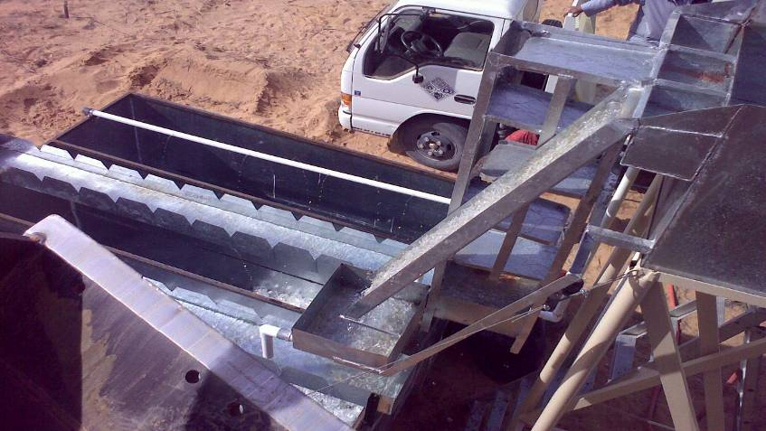
Figure 1: An over view for the pilot system


Curtain Aeration Methods
Cascade Aeration Methods
Figure 2: An over view for the Cascade & Curtain Aeration methods

Sludge outlet
Sludge outlet
Primary Settling Tank
Final Settling Tanks
(3 tanks)
Biological Filter
Effluent
Cascade Aerator
Curtain Aerator
Spray Aerator
Figure 3: A schematic diagram of the Semi-pilot System

3. Results
The experiment ran for 6 months continuously (24h/d), and was carried out in an ambient temperature. All the temperature measurements were conducted during day light. For each collected sample from the influent (after the primary treatments) the pH value was measured. The average pH value was 6.96, 7.14, and 7.12 after AM1, AM2, and AM3, respectively.
The results of the three natural aeration methods at different surface loading rate (run "1", 2, and 3) will be presented and analyzed in the following subsections.

Results of Dissolved Oxygen concentration at Run 1 (S.L.R. = 0.5 m³/m²/hr):
The DO concentration upstream of the three used natural aeration systems ranged from a minimum value equal to 0.4 mg/L to maximum value of 2 mg/L.
For the first natural aeration system (AM1), the DO concentration ranged from a minimum value of 1.58 mg/L to a maximum value of 4.31 mg/L (figure 4), with an average value equal to 2.9 mg/L. In case of AM2, the DO concentration ranged from a minimum value of 1.59 mg/L to a maximum value of 4.61 mg/L (figure 4), with average value equal to 3.0 mg/L. For AM3, the DO concentration ranged from a minimum value of 1.46 mg/L to a maximum value of 4.64 mg/L (figure 4), with average equal to 2.9 mg/L.
In summary, the three aeration systems increase the DO concentration from an average value, upstream the natural aeration methods, equal to 1.6 mg/l, to an average value, downstream AM1; AM2; AM3, equal to 2.9 mg/L; 3.0 mg/L; and 2.9 mg/L, respectively.
No significant difference under run 1 was observed between the three aeration systems. The DO after the three systems follows the same pattern of the DO downstream the primary sedimentation tank (upstream the three methods). The drop in DO concentration during the period from (25-30) was due to high influent COD.
A sudden increase in the DO concentration was noted between day 10 and 15, which was a result of the increasing wind in this period of time. As a result, the effective contact between air and wastewater is expected to improve, due to the increase in the splash movement of wastewater, by increasing the wastewater velocity.
Results of Dissolved Oxygen concentration at Run 2 (S.L.R. = 1 m³/m²/hr):
The DO concentration upstream of the three used natural aeration systems ranged from a minimum value equal to 0.76 mg/L to a maximum value equal to 1.94 mg/L.
For the first natural aeration system (AM1), the DO concentration ranged from a minimum value equal to 2.85 mg/L to a maximum value equal to 4.59 mg/L (figure 5), with an average value equal to 3.5 mg/L. For AM2, the DO concentration ranged from a minimum value equal to 3.04 mg/L to a maximum value equal to 6.06 mg/L (figure 5), with an average value equal to 4.3 mg/L. While for AM3, the DO concentration ranged from a minimum value equal to 2.83 mg/L to a maximum value equal to 5.94 mg/L (figure 5), with an average value equal to 4.1 mg/L.
A similar behavior to run 1 was observed, except for a slight increase in the DO in all the three systems as a result of increasing the SLR,
No significant difference was noted under this run between the three aeration systems. The DO concentration downstream the three methods following the same pattern of the DO downstream the primary sedimentation (upstream the three methods), except the high peak after day 25, which was a result of the increasing wind in the end of this run.

Figure 4: DO Concentration Before and After Aeration Methods SLR =0.5 m³/m².d

Figure 5: DO Concentration Before and After Aeration Methods SLR = 1 m³/m².d

Results of Dissolved Oxygen concentration at Run 3 (S.L.R. = 1.5 m³/m²/hr):
The DO concentration upstream the three used natural aeration systems ranged from a minimum value equal to 0.5 mg/L to maximum value equal to 1.3 mg/L.
For the first natural aeration system AM1 the DO concentration ranged from a minimum value equal to 2.09 mg/L to maximum value equal to 2.58 mg/L (figure 6), with an average value equal to 2.3 mg/L. For AM2 the DO concentration ranged from a minimum value equal to 1.96 mg/L to maximum value of 3.53 mg/L (figure 6), with an average value equal to 2.8 mg/L (Figure 7). While, forAM3the DO concentration was ranged from a minimum value equal to 1.99 mg/L to maximum value equal to 3.26 mg/L (figure 6), with an average value equal to 2.9 mg/L.
The difference in behavior of the three aeration systems can be clearly distinguished.
The difference in behavior of the three aeration systems can be clearly distinguished. Systems 1 has lower performance efficiency; while system 2&3 are similar and have significantly better performance under this run conditions (higher case of SLR). Similar to Run 1 & 2, the DO concentration downstream the three methods following the same pattern of the DO downstream the primary sedimentation (upstream the three methods).

Figure 6: DO Concentration Before and After Aeration Methods SLR =1.5 m³/m².d

Results of BOD, COD, and TSS:
The removal efficiency of BOD, COD, and TSS during the experiment were low. This can be attributed to the insufficient biomass concentration in the biological filtration. It should be noted, however, that even though removal efficiencies were relatively low, it was impacted positively by the amount of DO added to wastewater by the different aeration methods. The average BOD removal efficiency for the three runs through the biological systems BF1, BF2, and BF3 during the overall performance of the three pilots was 17.2 %, 29.8 %, and 23.7 %, respectively. For TSS, the average removal efficiency for the three runs was 22.8 %, 27.2 %, and 39.9 % for the biological systems BF1, BF2, and BF3, respectively. The average COD removal efficiency for the three runs was 17.2 %, 23.5 %, and 24.6 % for the biological systems BF1, BF2, and BF3, respectively (Figure 7).
Modification in the design of biological filter (dimensions of media, type of media, operation cycle, recirculation, etc) were considered for future research activities (phase 2 in the project) to improve the removal efficiency of BOD, COD and TSS.

Figure 7: Overall average BOD, COD, and TSS removal efficiency for the 3 runs

4. Discussions:
Adding DO values to the wastewater after the three aeration methods were influenced by changing the SLR from 0.5 m³/m².hr (Run 1) to 1 m³/m².hr (Run2). At SLR = 0.5 m³/m².hr; the average DO added to the wastewater by AM1, AM2, AM3 were increased by 18, 20, 18 %, respectively. While, at SLR = 1 m³/m².hr the average DO added to the wastewater by AM1, AM2, AM3 were increased by 27, 37, 34 %, respectively (Figure 8).
This can be attributed to the wastewater falling velocity and the splash movement through the aeration methods. At SLR = 0.5 m³/m².hr, the wastewater falling velocity and the splash movement was low compared to that at SLR = 1 m³/m².hr. At SLR = 1 m³/m².hr, the wastewater falling velocity increased leading to an increase in the contact exposing time between air and wastewater, and the splash movement through the aeration methods were also increased, which affect positively the amount of DO added to the wastewater
On the other hand, the average DO values that added to wastewater after aerations methods at SLR = 1.5 m³/m².hr (Run 3) were less than that of 1.0 m³/m².hr (Run 2). The averages DO at SLR 1.5 m³/m².hr after AM1, AM2, AM3 increased by 21, 29, 30 %, respectively (Figure 8). This can be attributed to that the wastewater falling velocity at SLR = 1.5 m³/m².hr was too high to permit a suitable contact exposing time between air and wastewater.
In conclusion, the effective contact between air and wastewater is expected to improve, due to the increasing of hydraulic loading rate, and therefore increasing in the splash movement of wastewater, by increasing the velocity. The splash movement keeps increasing, until it reaches an optimum value for the hydraulic loading rate, and then decrease with the increase of the velocity, due to insufficient wastewater contact exposing time with air. These results are in agreement with a previous study (Sanjib et al. - 2010). They found that at a higher hydraulic loading rate, the flow approaches the transition zone and thereby aeration efficiency decrease.

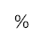
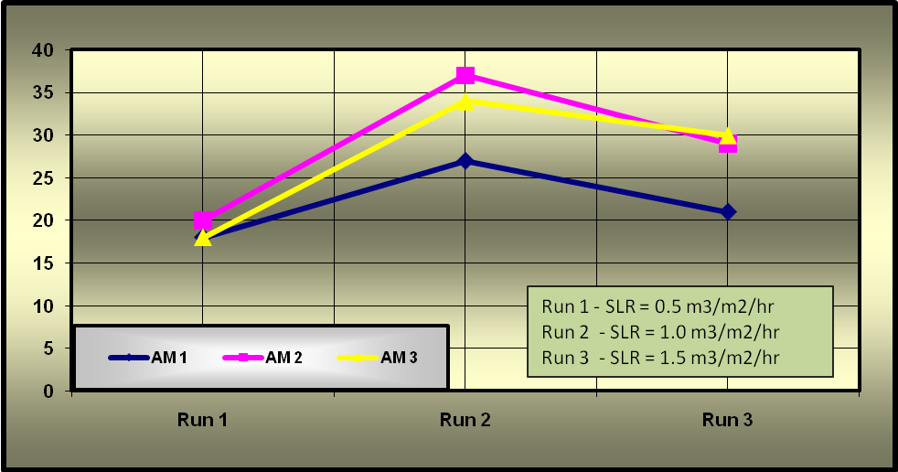

Figure 8: Average increasing ratio in aeration at different SLR

Power requirements for maintaining a completely mixed flow regime with mechanical aerators in an activated sludge system; vary from 20 to 40 Kw/1000 m³, depending on the type and design of the aerator and the geometry of the tank (Metcalf & Eddy - 2004). Whereas, in the natural aeration methods, for increasing one meter in the pump head to build head for cascade or curtain methods, the increasing in the power consumption for each 1000 m³ is as follows:
P = [(Ɣ Q H / ɳ) / 1000 ]…………………………..2
Where;
P = Input power (Kw/1000 m³)
Ɣ = 9810 N/m³
ɳ = 65 – 75 %
Q = 1000 m³/d = 0.01157 m³/s
H = 1.0 m
Power=[((9810 N/m³ * 0.01157 m³/s * 1.0 m)/0.75)/1000] = 0.151 Kw/1000 m³
As a conclusion, the natural aeration consumes about 90 % less than the mechanical aerators.
Hydrogen sulfide is most efficiently removed by the scrubbing action of aeration. This removal is dependent on the pH of the wastewater. The hydrogen sulfide can be easily removed at a pH of 6 or less (mrwa - 2010). Since the pH of the wastewater after the PST were always between 6.02 and 7.54 during the whole experiment, the hydrogen sulfide was expected to ionize, therefore, precluding removal by aeration.

5. Conclusion:
The following points summarize the main conclusions of this study:
- Improvement in DO concentration was observed in all the natural aeration systems investigated in this study at different SLR.
- The effective contact between air and wastewater is expected to improve, due to the increasing of SLR, The splash movement keeps increasing, until it reaches an optimum value for the hydraulic loading rate, and then decrease with the increase of the velocity, due to insufficient wastewater contact exposing time with air.
- The new tested aeration system (Curtain-AM3), proved efficiency in increasing DO content of the wastewater, due to its corrugated sheets that maximize irregular dynamic movement of wastewater drops, and then increased the wastewater surface area that exposes to the air.
- Matching between DO downstream the primary sedimentation tank and final DO achieved downstream natural aeration systems will be mainly dependent on the physical process and the base line of the DO downstream primary sedimentation (Upstream natural aeration system).
- A significant improvement in the performance of the natural aeration systems were observed during the study as a result of increasing wind speed. Therefore, attention should be made for the orientation of natural aeration systems to make use the wind force potential.
- Natural aerations systems employed, lead to a reduction of 90 % in the consumed energy compared to the mechanical aerators.
ACKNOWLEDGEMENT
This research work is a research grant with title “Application of Different Methods of Natural Aeration of Wastewater and their Influence on the Treatment Efficiency of the Biological Filtration"” which is sponsored by scientific research unit in Qassim University, Saudi Arabia.

Corresponding author
Walid Hamdy
Assistant Professor of Sanitary Engineering, Helwan University, Egypt
awawalid@yahoo.com

6. References:
- APHA, 19th Edition, 1995; Standard Methods for the Examination of Water and Wastewater handbook.
- Claude E. Boyd (1998), Pond water aeration systems. Aqua cultural Engineering, Volume 18, Issue 1, July 1998, Pages 9-40.
- Matter-Müller, C., Gujer, W.; Giger, W. (1981): Transfer of volatile substances from water to the atmosphere. Water Research, Volume 15, Issue 11, 1981, Pages 1271-1279.
- Metcalf & Eddy2004. Wastewater Engineering, Treatment and Reuse. Fourth Edition.
- Minnesota Rural Water Association (2010), Aeration; http://www.mrwa.com/OP-Aeration.pdf.
- Sabry, T., 2010. Evaluation of decentralized treatment of sewage employing Upflow Septic Tank/Baffled Reactor [USBR] in developing countries. Journal of Hazardous Materials, ELSEVIER, 174: 500–505
- Sanjib Moulick, Naresh V. Tambada, Basant K. Sngh and B. C. Mal (2010). Aeration Characteristics of a Rectangular Stepped Cascade. Water Science and Technology.
- Shun Dar Lin (2007): Water & Wastewater Calculations Manual. Second Edition.
- Tchobanoglous, G., Burton, F. L. & Stensel, H. D. 2003. Wastewater Engineering: Treatment and Reuse, 4th edition. Metcalf & Eddy, Inc., Tata Mcgraw-Hill Publishing Company Limited, p.1819.
- Toombes, L. & Chanson, H. (2005). Air-water mass transfer on a stepped waterway. J. Environ. Eng. 131(10), 1377-1386.
- Twort, A. C., Ratnayaka, Don D.; Brandt, M. J. (2000): Specialized and advanced water treatment processes. Water Supply (Fifth Edition), 2000, Pages 370-428.

11/1/2010

