Plasma Human Epidermal Growth Factor Receptor-2 levels (HER-2) and HER-2 codon 655 polymorphism in Females Suffering from Breast Cancer

Mohamed K. A. Radwan¹ , Hala M.T. El-Mougy², Omayma H.M. Sarhan², Wafaa M.E. Abdel Fatah² and Ola M.R. Khorshid³

¹Department of Medical Biochemistry, Faculty of Medicine, Al-Azhar University, Egypt.
²Department of Medical Biochemistry, Faculty of Medicine (Girls), Al-Azhar University, Egypt.
³Medical Oncology, National Cancer Institute, Cairo University, Egypt.
doctorman80@yahoo.com

Abstract: HER-2 proto-oncogene plays an important role in the regulation of normal breast growth and its alteration is associated with carcinogenesis and poor prognosis of breast cancer. HER-2 gene polymorphisms is suggested to be the principal mechanism of HER-2 gene amplification , protein over-expression and increased plasma HER-2 “the truncated product of the receptor that is released into the circulation” in breast cancer. In this study we explored the HER-2 gene polymorphisms and plasma HER-2 in 40 breast cancer females and 20 healthy control subjects. Patients were classified equally into 2 groups, early breast cancer and locally advanced breast cancer. The results of the study showed a highly significant increase of mutant genotypes AG/GG in locally advanced breast cancer (LABC) group but not in early breast cancer patients (EBC) compared to control group. This genotype was significantly higher in LABC compared to EBC. Mutant AG/GG genotypes were significantly associated with lymph node positivity and increased immunohistochemical expression of HER-2. Regarding allele distribution, mutant G allele was significantly higher in LABC but not in EBC compared to control and it was significantly higher in LABC than in EBC. Plasma HER-2 was significantly elevated in LABC compared to control but not in EBC compared to control group. Within breast cancer patients, plasma HER-2 was significantly elevated in carriers of the AG/GG genotype than in AA genotype carriers. In conclusion, the present study supported the hypothesis that HER-2 gene polymorphism and plasma HER-2 are important predictive and prognostic factors in breast cancer.
[Mohamed K. A. Radwan, Hala M.T. El-Mougy, Omayma H.M. Sarhan, Wafaa M.E. Abdel Fatah, and Ola M.R. Khorshid. Plasma Human Epidermal Growth Factor Receptor-2 levels (HER-2) and HER-2 codon 655 polymorphism in Females Suffering from Breast Cancer. Journal of American Science. 2012; 8(4): 546-552]. (ISSN: 1545-1003). http://www.americanscience.org. 72

Key words: HER-2 gene polymorphism, breast cancer.

1. Introduction
Breast cancer is the most common type of cancer and the most common cause of cancer-related mortality among women worldwide (Hortobagyi et al., 2005). In women, breast cancer accounts for 26% of new cases of cancer and 15% of cancer deaths, second to lung cancer (Jemal et al., 2007). In Egypt, breast cancer is the first in females representing 37% of all female cancers presenting to National Cancer Institute, Cairo University (Elatar, 2002).
Oncogenes refer to genes whose activation can contribute to the development of cancer. HER-2 gene is a proto-oncogene found on chromosome 17q21.1 of mRNA size 4.5 kb. It encodes a protein (a185-KDa) tyrosine kinase receptor (Van Der Geer et al., 1994). HER-2 gene activation occurs by gene amplification so more of the protein encoded by the gene is present, so its function is enhanced(Downward, 2003).
In breast cancer, HER-2 oncogene is involved in modulating the cell signaling system (Nahta et al., 2003). HER-2 overexpression is seen in about 25% of breast cancers and has been associated with metastatic phenotype, endocrine therapy unresponsiveness, and poor prognosis ( Menard et al., 2003).
HER-2 receptor has no identified ligand but is able to form a heterodimer with other receptors of the HER family allowing the participation of HER-2 in signal transduction even in absence of cognate ligand. The heterodimer containing HER-2 appears to show high signaling potency, which may explain the significant role of HER-2 in oncogenic phenotyping (Buzdar et al., 1996). HER-2 can also be activated by complexing with other membrane receptors such as insulin-like growth factor receptor I (Nahta et al., 2005).
Aim of the study:
The aim was to evaluate the utility of plasma HER-2 as a predictive and prognostic tumor marker in breast cancer of female patients, to clarify the possible relationship of HER-2 Ile655Val polymorphism and plasma levels of HER-2 with breast cancer development and to correlate their association with clinicopathological characteristics, different prognostic and predictive factors.

2. Patients and Methods
- The study included 60 female subjects with age ranged from 25-60 years old, collected from National Cancer Institute, Cairo University.
- They were divided equally into 3 groups. Group 1: patients with early stage breast cancer, group 2: patients with locally advanced stage breast cancer, and control group; include apparently healthy females with no evidence of neoplastic disease. Patients were diagnosed and pathologically proven as breast cancer.
- Blood samples were collected from all subjects on EDTA tubes then lymphocyte separation was done.
- Genomic DNA was extracted from the buffy coat by PCR using QIAamp DNA blood mini kit (Qiagen, Germany).
- Estimation of plasma HER-2 was done by ELIZA (Xie et al., 2000).
- The PCR product underwent a purification step then it was digested by BSMA I restriction enzyme then the product of digestion was run in agarose gel.
3. Results
Genotypes: The mutant AG/GG genotype (Ileu655Val/Val655Val) was insignificantly increased in EBC (50%) in comparison to control group (40%) (,Figure 1), significantly increased in LABC (95%) in comparison to control group (40%) (, Figure 3), and significantly increased LABC (95%) in comparison to EBC (50%) ( Table 3, Figure 5)

Alleles: The mutant G allele (Valine) was insignificantly increased in EBC (27.5%) compared to control group (25%) (, Figure 2), significantly increased in LABC (80%) compared to control group (25%) (, Figure 4), and significantly increased in LABC (80%) compared to EBC (27.5%), (Table 3, Figure 6).

Table 1: HER-2 Gene polymorphism and Allele distribution in control and early breast cancer groups.
Variables | Control  (n=20) | EBC  (n=20) | OR | CI(95%) | P value
HER-2 gene  AA  AG/GG | 12(60%)  8(40%) | 10(50%)  10(50%) | 1.5 | 0.4-5 | 0.51  N.S
HER-2 Allele  A  G | 30(75%)  10(25%) | 29(72.5%)  11(27.5%) | 1.1 | 0.4-3.1 | 0.7  N.S
A: Normal allele.
G: Mutant allele.
AA: Normal Ile/Ile. Genotype.
AG: Heterozygous mutant genotype.
GG: Homozygous mutant genotype.

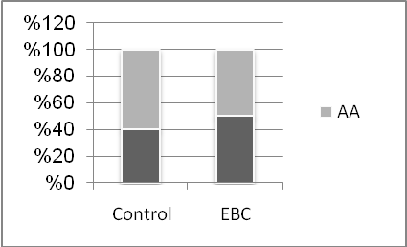
Figure 1: Genotype distribution in control and early breast cancer groups.

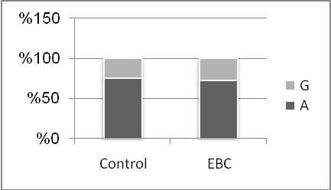
Figure 2 : Allele distribution in control and early breast cancer groups.

Table 2: HER-2 Gene polymorphism and Allele distribution in control group and locally advanced breast cancer group.
Variables | Control  (n=20) | LABC  (n=20) | OR | CI(95%) | P value
HER-2 gene  AA  AG/GG | 12(60%)  8(40%) | 1(5%)  19(95%) | 28.5 | 3.1-257 | <0.001  HS
HER-2 Allele  A  G | 30(75%)  10(25%) | 8(20%)  32(80%) | 12 | 4.1-34.4 | <0.001  HS

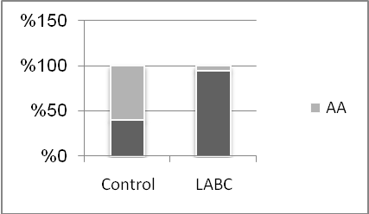
Figure 3: Genotype distribution in locally advanced breast cancer and control groups

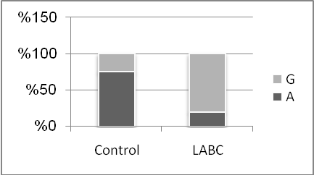
Figure 4 : Allele distribution in locally advanced breast cancer and control groups

Table 3: HER-2 Gene polymorphism and Allele distribution in early and locally advanced breast cancer groups.
Variables | EBC  (n=20) | LABC  (n=20) | OR | CI(95%) | P value
HER-2 gene  AA  AG/GG | 10(50%)  10(50%) | 1(5%)  19(95%) | 19 | 2.1-170 | 0.001  V.H S.
HER-2 Allele  A  G | 29(72.5%)  11(27.5%) | 8(20%)  32(80%) | 10.5 | 3.7-29 | 0.001  V.H S.

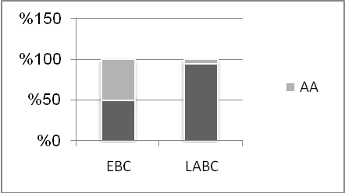
Figure 5: Genotype distribution in early and locally advanced breast cancer groups.

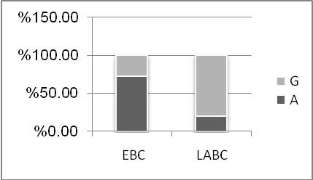
Figure 6: Allele distribution in early and locally advanced breast cancer.

Plasma HER-2 was insignificantly increased in EBC (7.3 ng/ml) compared to control group (3.8 ng/ml) (Table 4,Figure 7), significantly increased in LABC (50.9 ng/ml) compared to control group(3.8 ng/ml)(Table 5, Figure 8), and significantly increased in LABC (50.9 ng/ml) in comparison to EBC (7.3 ng/ml) (Table 6, Figure 9).

Table 4: Mean±SD of plasma HER-2 Level in early breast cancer and control groups.
Variable | Control  (n=20) | EBC  (n=20) | P value
Plasma HER-2(ng/ml) | 3.8±.5 | 7.3±1.03 | 0.08 N.S.

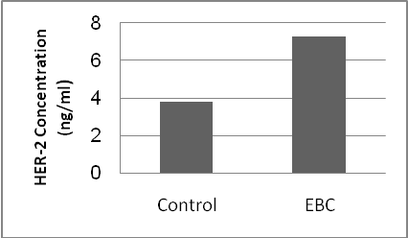
Figure 7: Mean plasma HER-2(ng/ml) in early breast cancer and control groups.

Table 5: Mean Plasma HER-2 Level in control and locally advanced breast cancer.
Variable | Control  (n=20) | LABC  (n=20) | P value
Plasma HER-2(ng/ml)  mean±SD | 3.8±.5 | 50.9±11.3 | <0.001  HS

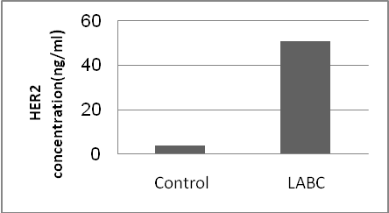
Figure 8: Mean plasma HER-2(ng/ml) in locally advanced breast cancer and control.

Table 6: Mean Plasma HER-2 Level in early and locally advanced breast cancer.
Variable | EBC  (n=20) | LABC  (n=20) | P value
Plasma HER-2(ng/ml)  mean±SD | 7.3±1.03 | 50.9±11.3 | <0.001  HS

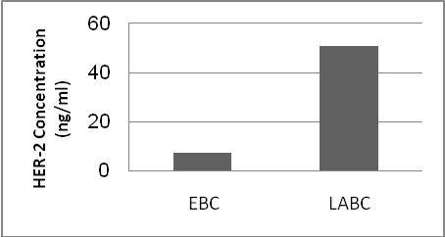
Figure 9: Mean Plasma HER-2 Level in early and locally advanced breast cancer.

There is non-significant correlation between age, body mass index, family history, menopausal state, ER, estrogen receptors and progesterone receptors expression with genotypes (Table 7 & 8).There was a significant correlation between lymph node positivity, HER2 protein overexpression in breast tissue and plasma HER2 with different genotypes (). No significant correlation between plasma HER-2 and either age or body mass index (Figures 11&12).

Table 7: Correlation between HER-2 genotypes and age, body mass index, family history and menopausal status in patients.
Variables | AA  (n=11) | AG/GG  (n=29) | P value
Age (mean±SD)years | 46.04±11.05 | 45.5±8.2 | 0.8  NS
BMI (mean±SD) | 30.5±6.2 | 28.4±6.5 | 0.2  NS
FH Yes  No | 1(9%)  10(91%) | 3(10.3%)  26(89.7%) | 0.9  NS
Menopause  Premenopause  Postmenopause | 5 (45.5%)  6 (54.5%) | 16(55%)  13(45%) | 0.7  NS
AA=Normal genotype. AG=Heterozygous mutant genotype. GG=Homozygous mutant genotype. BMI=Body mass index. FH=Family history.

Table 8: Correlation between HER-2 genotypes and clinicopathological criteria.
 | AA  (n=11) | AG/ GG  (n=29) | OR | CI | P value
ER Negative  Positive | 5(45.5%)  6(54.5%) | 12(41.4%)  17(58.6%) | 1.18 | 0.2-4.7 | 0.5 NS
PR Negative  Positive | 7(63.6%)  4(36.4%) | 11(37.9%)  18(62.1%) | 2.8 | 0.6-12 | 0.1 S  Non-significant
LN Negative  Positive | 8(72.7 %)  3 (27.3%) | 10 (34.5%)  19(65.5%) | 5 | 1.09-23.4 | 0.032 S
HER-2 IHC  Negative  Positive | 7 (63.6%)  4 (36.4%) | 8(27.6%)  21(72.4%) | 4.5 | 1.05-20 | 0.04 S

Table 9: Correlation between mean plasma HER-2 Level(ng/ml) and genotypes.
Variable | AA  (n=11) | AG/GG  (n=29) | P value
Plasma HER-2  (mean±SD)  (ng/ml) | 10.5±2.1 | 36.1±6.2 | 0.001 (HS)

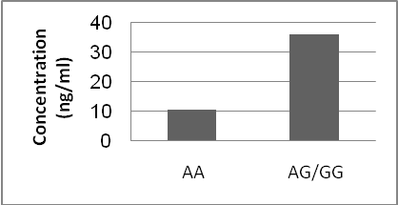
Figure 10: Correlation between Plasma HER-2 Level(ng/ml) and genotypes.

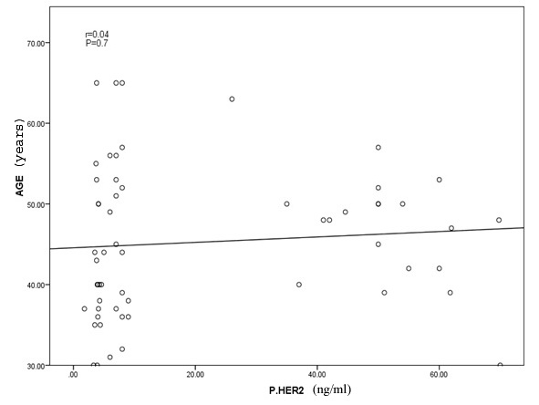
Figure 11: Correlation between plasma HER2 and age in breast cancer patients.

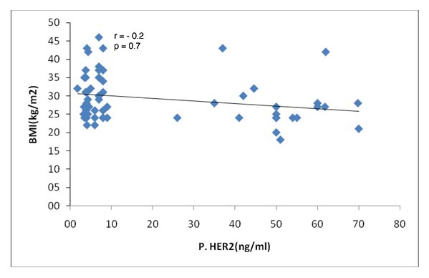
Figure 12: Correlation between plasma HER2 level(ng/ml) and body mass index(kg/m²) in breast cancer patients.
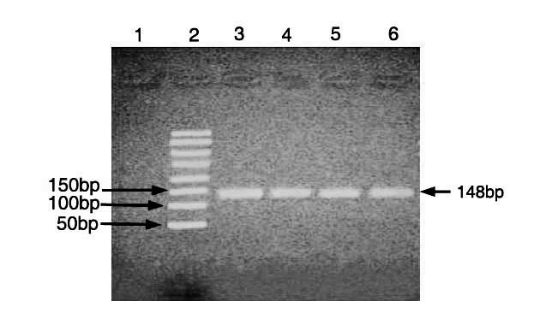
Figure 13: Gel electrophoresis of the PCR product.
Lane 1: negative control. Lane 2: 50 bp ladder.
Lane 2,3,4,5, and 6: PCR product 148 bp.
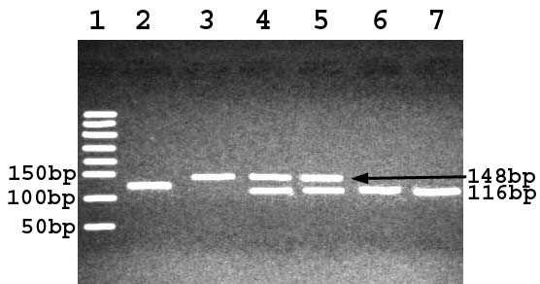
Figure 14: Analysis of the HER2 genotypes–restriction fragment length polymorphism of the PCR product.
Lane 1: 50-bpladder.
Lane 2, 6, and 7: HER2 homozygous mutant (Val/Val, GG) 116 and 32bp bands.
Lane 3: normal homozygous (Ile/Ile, AA)148 bp.
Lane 4 and 5: heterozygous (Ile/Val, AG)148bp,116 bp and 32 bp.

4. Discussion
Breast cancer is currently the most frequent malignancy in female population. According to the National Cancer Institute, Cairo, Egypt, breast cancer is the first most common malignancy in women constitutes 37.5% of all reported tumors in Egyptian females (Elatar, 2002).
Most of the excess familial risks associated with breast cancer are likely to be genetic in origin (Abbott et al., 2001). However, only about a third of this risk is accounted for by known genes, the most important being human epidermal growth factor receptor-1, BRCA1 and BRCA2, while the remainder might be explained by a combination of weakly predisposing alleles (Pharoah et al., 2002).
Human epidermal growth factor receptor- 2 (HER-2), also known as c-erbB-2 is a member of the epidermal growth factor receptor family, mapped on chromosome 17q21-q22 (Akiyama et al., 1986).
HER-2 overexpression is seen in about 25% of breast cancers and has been associated with metastatic phenotype, endocrine therapy unresponsiveness, and poor prognosis ( Menard et al., 2003).
One common variant, a single nucleotide polymorphism in the transmembrane coding region of the HER-2 gene at codon 655 (Ile655Val) encoding either isoleucine (Ile: ATC) or valine (Val: GTC), has been reported in different cancer types. Changing the existing isoleucine (Ile: ATC) to valine (Val: GTC) at codon 655, suggests an increased dimerization, autophosphorylation of HER-2 and tyrosine kinase activity, which may cause the transformation of cells (Takano et al., 1995).
The results of this study showed that there is a non-significant differences in mutant genotypes AG/GG of HER-2 gene between early breast cancer group(EBC) and control group(OR = 1.5, 95% CI = 0.4 - 5, P = 0.51 ). But there is a significant increase in mutant genotypes AG/GG between locally advanced breast cancer group(LABC) and control group (OR=28.5 95% CI=3.1-257, P=<0.001). These data suggest that among breast cancer patients, the carriers of HER-2 AG/GG genotypes are more likely to be advanced and that these genotypes are not associated with the incidence of breast cancer per se, but with its progression.
In this work, there is significant increase in mutant G allele in LABC group compared to control group(OR=12, 95%CI 4.1-34.4, P= <0.001), while no statistical significant difference was found between EBC group and control group (OR 1.1, 95% CI=0.4-3.1, P=0.7).
Regarding the correlation between different genotypes of HER-2 gene and different clinicopathological factors considered in this study, estrogen receptors expression in breast tissue, were not correlated with different genotypes of HER2 gene(OR= 1.8, 95% CI=0.4-4.7, P= 0.52). Progesterone receptors expression in breast tissue, also were not correlated to different genotypes of HER2 gene(OR= 2.8 95% CI=0.6-12, P= 0.1). Lymph node positivity showed significant increase with AG/GG genotypes indicating that these genotypes are related to disease progression. (OR= 5, 95% CI=1.09-23.4, P= 0.03). HER-2 protein over-expression showed significant increase with AG/GG genotypes (OR= 4.5 95% CI=1.05-20, P= 0.04).
These results were in accordance with XIE et al. (2000) who suggested that, polymorphisms of the HER-2 gene may be important susceptibility biomarkers for breast cancer risk in Chinese women. Zubor et al.(2006),Also revealed relatively high frequency of the G (mutant) allele among the women population of the Slovak republic and that HER-2 polymorphism was associated with a significantly increased risk of breast cancer in homozygotes for G allele (GG genotype). In agreement with our results, Pinto et al. (2004) found a twofold increase in risk of breast cancer in women who are carriers of a Val allele. Tao et al. (2009) and Lu et al. (2010) found that HER-2 codon 655 Val allele was associated with an increased risk of breast cancer, and single nucleotide polymorphism at HER-2 codon 655 could be considered as a susceptibility biomarker for breast cancer for Asian females.
On the other hand, Benusiglio et al.(2005) found that there were no differences in genotype frequencies between cases and controls. Qu et al.(2008) found that Ile655Val polymorphism of the HER-2 gene do not alter its activity and may not be associated with increased breast cancer risk among Chinese women.
As regards plasma HER-2 level we reported a statistically significant increase in its mean value in LABC group compared to control group ( P=<0.001) but no significant difference between control and EBC group( P=0.08). Also there is significant increase of plasma HER-2 in LABC group compared to EBC group (P=<0.001).These data suggest that plasma HER-2 contributes not only to the development, but also to the high stage and dissemination of breast cancer.
As regards correlation between Plasma HER-2 and different genotypes, plasma HER-2 showed significant increase in mutated genotypes (AG/GG) (P=0.001). These findings are consistent with results of Leitzel et al. 1992.
In the present study, we found a strong positive association between plasma HER-2 levels and the immunohistological expression of this protein in the tumor This is in accordance with studies of Moreno-Aspitia et al. (2008) and Imoto et al. (2006) which demonstrated that although various methods have been used to determine HER-2 expression, similar results have been reported regarding HER-2 overexpression in tumors and its plasma level.
There is increasing evidence that plasma levels of HER-2 reflect tumor maintenance and aggressiveness in breast cancer patients. In this regards, recent studies have demonstrated an association between high plasma levels of HER-2 and other clinicopathological characteristics indicative of tumor progression. The current study indicates that high plasma levels of HER-2 were associated with advanced clinical stages (higher plasma HER-2 in LABC group) and higher incidence of lymph node positivity in breast cancer patients. This findings are consistent with that of Singhai et al. (2011) and Thriveni et al.(2007) who demonstrated that plasma HER-2 contributes not only to the development, but also to the stage and dissemination of breast cancer.
On the other hand, in a study by Kong et al. (2006), neither HER-2 overexpression nor raised plasma HER-2 levels were significantly associated with any of the clinicopathological characteristics of breast cancer patients. Also, Leyland-jones and Smith (2011) showed that concentrations of plasma HER2 are not consistently related to patient outcomes; therefore, there is insufficient evidence to support the clinical use of plasma HER2 testing.
In this study, no correlation could be established between the expression of plasma HER-2 and steroid hormone receptors content. This is consistent with reports by Imoto et al. (2006).
In conclusion, there is a great controversy about the role of HER-2 polymorphism as a risk factor of breast cancer.

Corresponding author
Dr. Mohamed K. A. Radwan
Department of Medical Biochemistry, Faculty of Medicine, Al-Azhar University, Egypt.
E.mail: doctorman80@yahoo.com

References
Abbott S, Armstrong M and Baker K (2001): Familial breast cancer: collaborative reanalysis of individual data from 52 epidemiological studies including 58,209 women with breast cancer and 101,986 women without the disease Lancet; 358:1389-1399.
Akiyama T, Sudo C, Ogawara H, Toyoshima K and and YamamotoT (1986): The product of the human c-erbB-2 gene: a 185-kilodalton glycoprotein with tyrosine kinase activity. Science; 232: 1644–6.
Benusiglio PR, Lesueur F, Luccarini C, Donald M, Conroy, Douglas F, Nick E, Alison M, Paul D and Bruce AJ (2005):Common ERBB2 Polymorphisms and Risk of Breast Cancer in a White British Population: a Case-Control Study. Breast Cancer Res.; 7(2): 204-209.
Buzdar AU, Plourde PV, and Hortobagyi GN (1996): Aromatase inhibitors in metastatic breast cancer. Semin Oncol.; 23:28-32.
Downward J (2003): Targeting RAS signaling pathways in cancer therapy. Nat Rev Cancer; 3:11-22.
Elatar I. (2002): Cancer registration. Cairo, Egypt. National Cancer Institute.
Hortobagyi GN, de la Garza Salazar J, Pritchard K, Amadori D, Haidinger R, Hudis C, Khaled H, and Albain K (2005): The global breast cancer burden: Variations in epidemiology and survival. Clin Breast Cancer; 6:391-401.
Imoto S, Wada N, Hasebe T Atsushi Ochiai T and Kitoh T(2006): Serum c-erbB-2 protein is a useful marker for monitoring tumor recurrence of the breast. Int J Cancer; 120: 357–361.
Jemal A, Siegel R, Ward E, Murray T, Jiaquan Xu J and Thun (2007): Cancer statistics. CA Cancer J Clin.; 57:43-66.
Kong S-Y, Kang JH, Kwon Y, Kang HS, Chung KW, Kang SH, Lee DH, Ro J, and Lee ES (2006): Serum HER-2 concentration in patients with primary breast cancer. J Clin Pathol; 59: 373–376.
Leitzel K, Teramoto Y, Sampson E, Mauceri J, Langton BC, Demers L, Podczaski E, Harvey H, Shambaugh S and Volas G (1992): Elevated soluble c-erbB-2 antigen levels in the serum and effusions of a proportion of breast cancer patients. J Clin Oncol.; 10: 1436–1443.
Leyland-jones B and Smith B (2011): Serum HER2 testing in patients with HER2 positive breast cancer: The death knell tolls. Thelancet; 12:286-295.
Lu S, Wang Z , Liu H and Hao X(2010):HER2 Ile655Val polymorphism contributes to breast cancer risk: evidence from 27 case–control studies. Breast Cancer Res Treat;124:771–778
Menard S, Pupa SM, Campiglio M and Tagliabue E (2003): Biologic and therapeutic role of HER2 in cancer. Oncogene; 22:6570-6578.
Moreno-Aspitia, A. C. Dueck, W. L. Lingle, L (2008): Serum HER2 (sHER2) levels in early-stage HER2 neu (+) breast cancer (HER2+BC): J Clin Oncol 26 suppl; Abstr 529
Nahta R, Hortobagyi GN and Esteva FJ. (2003): Growth factor receptors in breast cancer: Potential for therapeutic intervention. The Oncologist.; 8:5-17.
Nahta R, Yuan LX and Zhang B (2005): Insulin-like growth factor-I receptor/human epidermal growth factor receptor 2 heterodimerization contributes to trastuzumab resistance of breast cancer cells. Cancer Res; 65(23):11118–11128.
Papewallis J, Nikitin A, and Rajewsky M ( 1991): G to A polymorphism at amino acid codon 655 of the human erbB- 2/Her-2 gene. Nucleic Acids Res.; 19: 5452.
Pharoah PD, Antoniou A, Bobrow M, Zimmern RL, Easton DF and Ponder B (2002): Polygenic susceptibility to breast cancer and implications for prevention. Nat Genet; 31:33-36.
Pinto d,VasconcelosA, Costa A, Pereira D , Rodrigues H , Lopes C and Medeiros R (2004): HER2 polymorphism and breast cancer risk in Portugal. European J. Cancer Prevention; 13: 177–181.
Singhai R, Patil A and Patil V(2011): Cancer biomarker HER-2/neu in breastcancer in Indian women. Breast Cancer: Targets and Therapy;3:21-26
Takano K, Ogasahara K, Fujii S and Yutani K (1995): Contribution of hydrophobic residues to the stability of human lysozyme: calorimetric studies and X-ray structural analysis of the five isoleucine to valine mutants. J. Mol. Biol.; 254: 62–76.
Tao W, Wang C, Han R and Jiang H (2009): HER2 codon 655 polymorphism and breast cancer risk: a meta-analysis. Breast Cancer Res Treat; 114:371–376
Thriveni K, Deshmane V, Bapsy PP, Krishnamoorthy L and Ramaswamy G (2007): Clinical utility of serum human epidermal receptor- 2/neu detection in breast cancer patients. Indian J Med Res.; 125: 137–142.
Van De Geer P, Hunter T, and Lindberg RA. (1994): Receptor protein tyrosine kinase and their signal transduction pathway. Ann Rev Cell Biol., 10:251-337.
Xie D, Shu X, Deng Z, Wen WQ, Creek KE, Dai Q, Gao YT, Jin F and Zheng W(2000): Population-based, case-control study of HER-2 genetic polymorphism and breast cancer risk. J Natl Cancer Inst., 92: 412–417.
Zubor P, Vojvodova A and Danko J (2006): Her-2 [Ile655Val] polymorphis in association with breast cancer risk: a population-based case-control study in Slovakia. Neoplasma; 3(1): 49–55.

