An International Journal

The Journal of American Science

(J Am Sci)

ISSN 1545-1003 (print); ISSN 2375-7264 (online), Monthly

Volume 21 - Number 6 (Cumulated No. 208), June 25, 2025

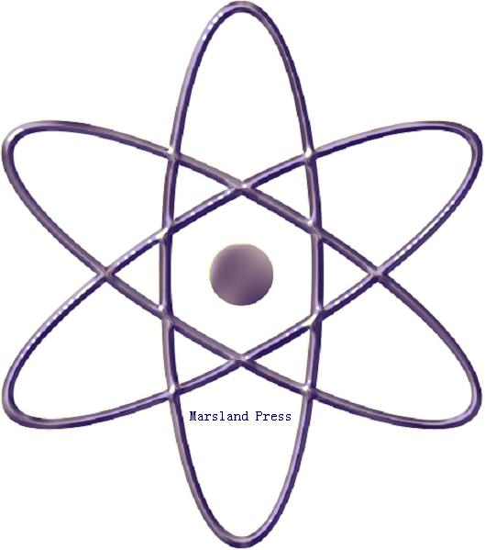

Marsland Press

310 West 18th Street, New York, NY 10011, USA

http://www.jofamericanscience.org.
http://www.sciencepub.net
editor@sciencepub.net
editor@americanscience.org;
americansciencej@gmail.com

718-404-5362

The Journal of American Science
(J Am Sci)

ISSN 1545-1003 (print); ISSN 2375-7264 (online); Monthly

The Journal of American Science is an international peer reviewed journal with a purpose to enhance our natural and scientific knowledge dissemination in the world. Any valuable paper that describes natural phenomena and existence or any reports that convey scientific research and pursuit is welcome. Papers submitted could be reviews, objective descriptions, research reports, opinions/debates, news, letters, and other types of writings that are nature and science related. All the manuscripts will be processed in a professional peer review. After the peer review, the journal will make the best efforts to publish the accepted valuable works as soon as possible.

Marsland Press
310 West 18th Street, New York, NY 10011, USA

http://www.jofamericanscience.org.
http://www.sciencepub.net
editor@sciencepub.net
editor@americanscience.org;
americansciencej@gmail.com
718-404-5362

ISSN 1545-1003
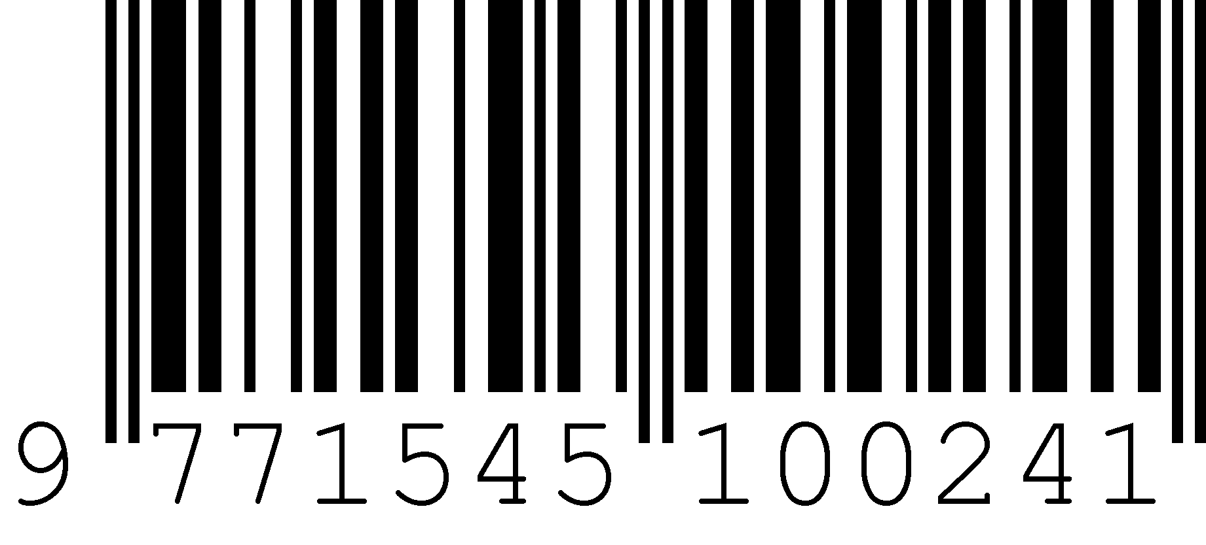
© 2025 Marsland Press

